UNITED STATES
SECURITIES AND EXCHANGE COMMISSION
Washington, D.C. 20549

FORM 8-K

CURRENT REPORT
Pursuant to Section 13 or 15(d) of the Securities Exchange Act of 1934

Date of Report (Date of earliest event reported): July 17, 2026



HF FOODS GROUP INC.
(Exact name of registrant as specified in its charter)
Delaware  State or other Jurisdiction of  incorporation ) |  |  | 001-38180  (Commission  File No.) |  |  | 81-2717873  (IRS Employer  Identification No)
6325 South Rainbow Boulevard, Suite 420  Las Vegas, Nevada  (Address of principal executive offices) |  |  | 89118  (Zip Code)

Registrant’s telephone number, including area code: (888)-905-0998

Not Applicable
(Former name or former address, if changed since last report)

Check the appropriate box below if the Form 8-K filing is intended to simultaneously satisfy the filing obligation of the registrant under any of the following provisions:

☐ Written communications pursuant to Rule 425 under the Securities Act (17 CFR 230.425)

☐ Soliciting material pursuant to Rule 14a-12 under the Exchange Act (17 CFR 240.14a-12)

☐ Pre-commencement communications pursuant to Rule 14d-2(b) under the Exchange Act (17 CFR 240.14d-2(b))

☐ Pre-commencement communications pursuant to Rule 13e-4(c) under the Exchange Act (17 CFR 240.13e-4(c))

Securities registered pursuant to Section 12(b) of the Act:
Title of each class |  |  | Trading Symbol |  |  | Name of each exchange on which registered
Common Stock, $0.0001 par value |  |  | HFFG |  |  | Nasdaq Capital Market
Preferred Share Purchase Rights |  |  | N/A |  |  | Nasdaq Capital Market

Indicate by check mark whether the registrant is an emerging growth company as defined in Rule 405 of the Securities Act of 1933 (§230.405 of this chapter) or Rule 12b-2 of the Securities Exchange Act of 1934 (§240.12b-2 of this chapter).

Emerging growth company ☐

If an emerging growth company, indicate by check mark if the registrant has elected not to use the extended transition period for complying with any new or revised financial accounting standards provided pursuant to Section 13(a) of the Exchange Act. ☐

Item 1.01. Entry into a Material Definitive Agreement.

On July 17, 2026, HF Foods Group Inc. (the "Company”) entered into a Securities Purchase Agreement (the "Agreement") by and among the Company, HF Acquisition Newco Inc., a Delaware corporation and wholly-owned subsidiary of the Company (the "Buyer"), HF Toro Canada Holdings Inc., a British Columbia limited company (“Searay AcquisitionCo" and, together with the Company and the Buyer, the "Buyer Entities"), Searay Foods Inc., a corporation formed under the laws of British Columbia ("Searay Canada"), Morgan Foods Inc., a corporation formed under the laws of British Columbia ("Morgan Foods" and, together with Searay Canada, the "Company Group"); the sellers named therein (the "Sellers"), and Jackie Chi Fai Chan, solely in his capacity as the representative of the Sellers, pursuant to which the Buyer Entities will acquire 100% of the issued and outstanding securities of the Company Group from the Sellers (the “Transaction"). Pursuant to the Agreement, the Sellers, who together are the legal and beneficial owners of 100% of the issued and outstanding securities of the Company Group, agreed to sell all of such securities to the Buyer Entities. At the closing of the Transaction (the "Closing"), Searay AcquisitionCo will have purchased the Company Securities of both Searay Canada and Morgan Foods from the applicable Sellers. As a result of the transaction, Searay Canada and Morgan Foods will be wholly-owned subsidiaries of the Company.

Under the terms of the Agreement, the aggregate base purchase price is CAD$47,921,740 (equal to five times the baseline Adjusted EBITDA of CAD$9,556,348, plus CAD$140,000), payable as (i) CAD$38,365,392 in cash (subject to customary post-closing adjustments) and (ii) 1,701,871 shares of the Company's common stock to be deposited in escrow. In addition, the Sellers are eligible to receive contingent earnout payments based on achievement of specified EBITDA targets over a two- to three-year period following the closing. The Agreement also contains customary representations, warranties, covenants, and indemnification provisions.

The Closing is expected to occur no later than the second business day following the satisfaction or waiver of customary closing conditions set forth in the Agreement, including the receipt of required regulatory approvals, and in no event later than August 31, 2026, unless earlier terminated or extended in accordance with the terms of the Agreement.

In connection with the Agreement, certain key employees of the Company Group, including a Seller, entered into employment agreements with a subsidiary of the Company.

The foregoing description of the Agreement does not purport to be complete and is qualified in its entirety by reference to the full text of the Agreement, a copy of which is filed as Exhibit 10.1 to this Current Report on Form 8-K and is incorporated herein by reference.

Item 3.02 Unregistered Sales of Equity Securities.

The disclosure included in Item 1.01 of this Current Report on Form 8-K is incorporated herein by reference. The issuances of shares of the Common Stock in Item 1.01 above will be exempt from the registration requirements of the Securities Act of 1933, as amended, in accordance with Regulation S and Regulation D thereunder.

Item 8.01 Other Events.

On July 23, 2026, the Company issued a press release announcing the Transaction. A copy of the press release is filed as Exhibit 99.1 to this Current Report on Form 8-K and incorporated herein by reference.

Item 9.01. Financial Statements and Exhibits.

Exhibit No. |  |  |  |  |  | Description
10.1 |  |  |  |  |  | Securities Purchase Agreement, dated as of July 17, 2026, by and among HF Foods Group Inc., HF Acquisition Newco Inc., HF Toro Canada Holdings Inc., Searay Foods Inc., Morgan Foods Inc., the Sellers named therein, and Jackie Chi Fai Chan, as Sellers Representative.*†
99.1 |  |  |  |  |  | Press release, dated July 23, 2026
104.0 |  |  |  |  |  | Cover Page Interactive Data File (embedded within the Inline XBRL document)

* Schedules and similar attachments have been omitted pursuant to Item 601(b)(5)of Regulation S-K. The Company hereby undertakes to furnish copies of any of the omitted schedules upon request by the SEC; provided, however, that the Company may request confidential treatment pursuant to Rule 24b-2 of the Exchange Act for any schedules so furnished.

†Certain portions of this exhibit have been omitted in accordance with Regulation S-K Item 601(b)(10)(iv) because they are both (i) not material to investors and (ii) the type of information that the Company customarily and actually treats as private or

confidential, and have been marked with ‘‘[***]’’ to indicate where omissions have been made. The Company agrees to furnish supplementally an unredacted copy of the exhibit to the SEC upon its request.

SIGNATURES

Pursuant to the requirements of the Securities Exchange Act of 1934, the registrant has duly caused this report to be signed on its behalf by the undersigned hereunto duly authorized.

 |  |  | HF FOODS GROUP INC.
Date: July 23, 2026 |  |  | /s/ Paul McGarry
 |  |  | Paul McGarry
 |  |  | Chief Financial Officer
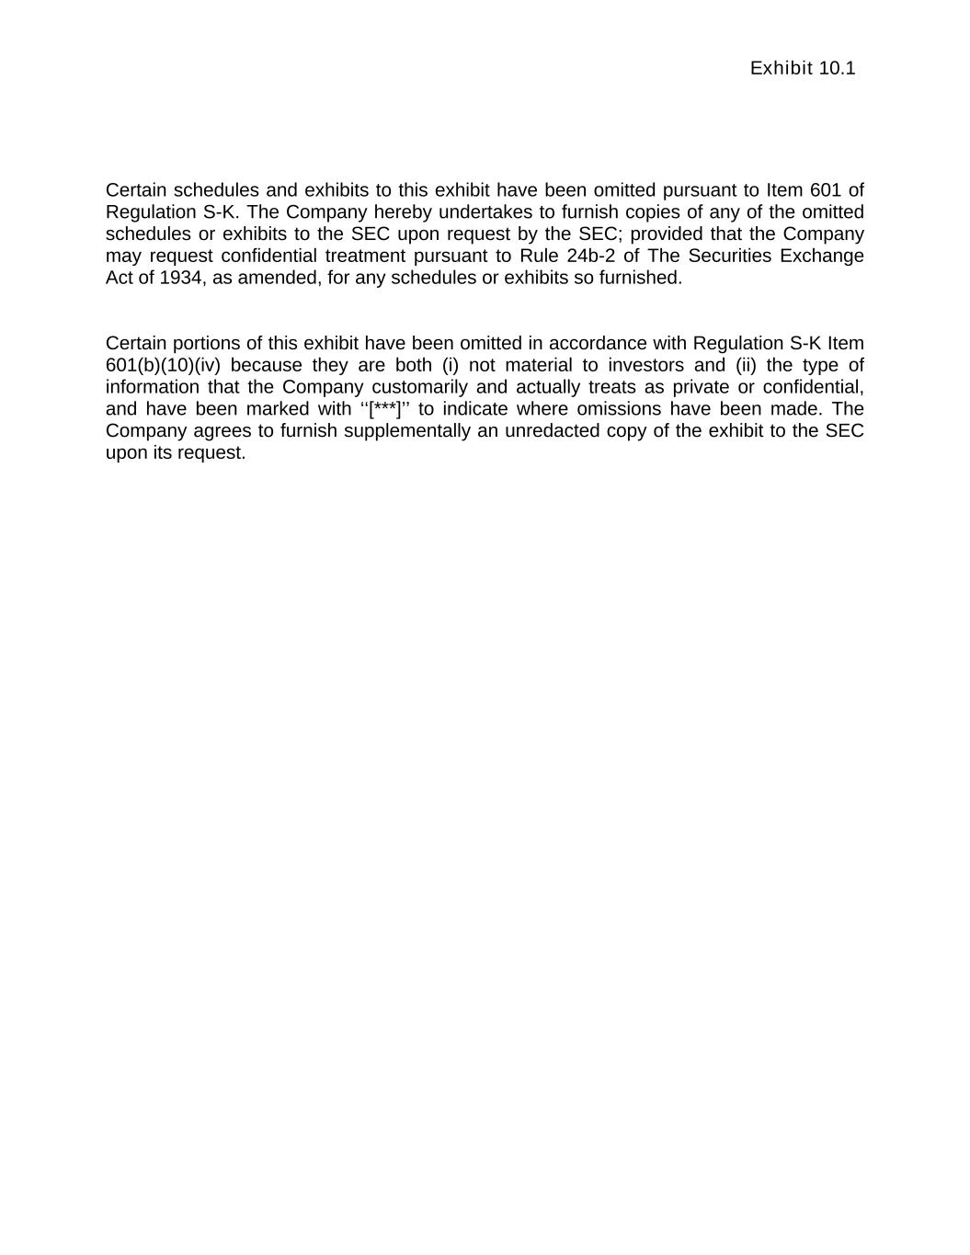

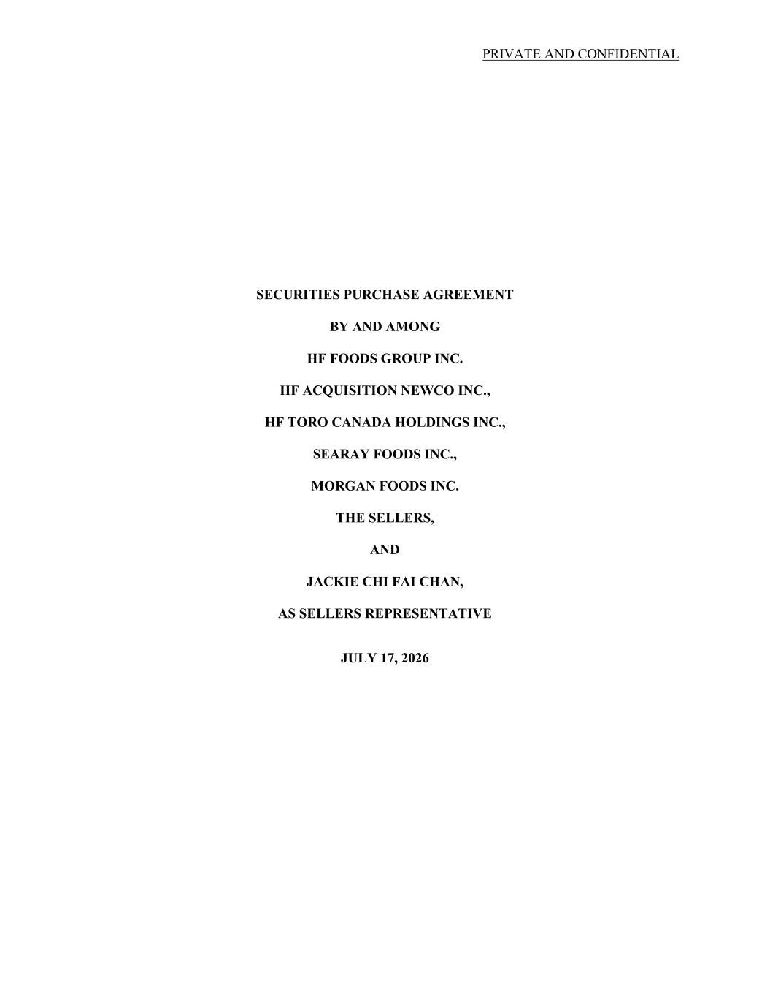
PRIVATE AND CONFIDENTIAL SECURITIES PURCHASE AGREEMENT BY AND AMONG HF FOODS GROUP INC. HF ACQUISITION NEWCO INC., HF TORO CANADA HOLDINGS INC., SEARAY FOODS INC., MORGAN FOODS INC. THE SELLERS, AND JACKIE CHI FAI CHAN, AS SELLERS REPRESENTATIVE JULY 17, 2026

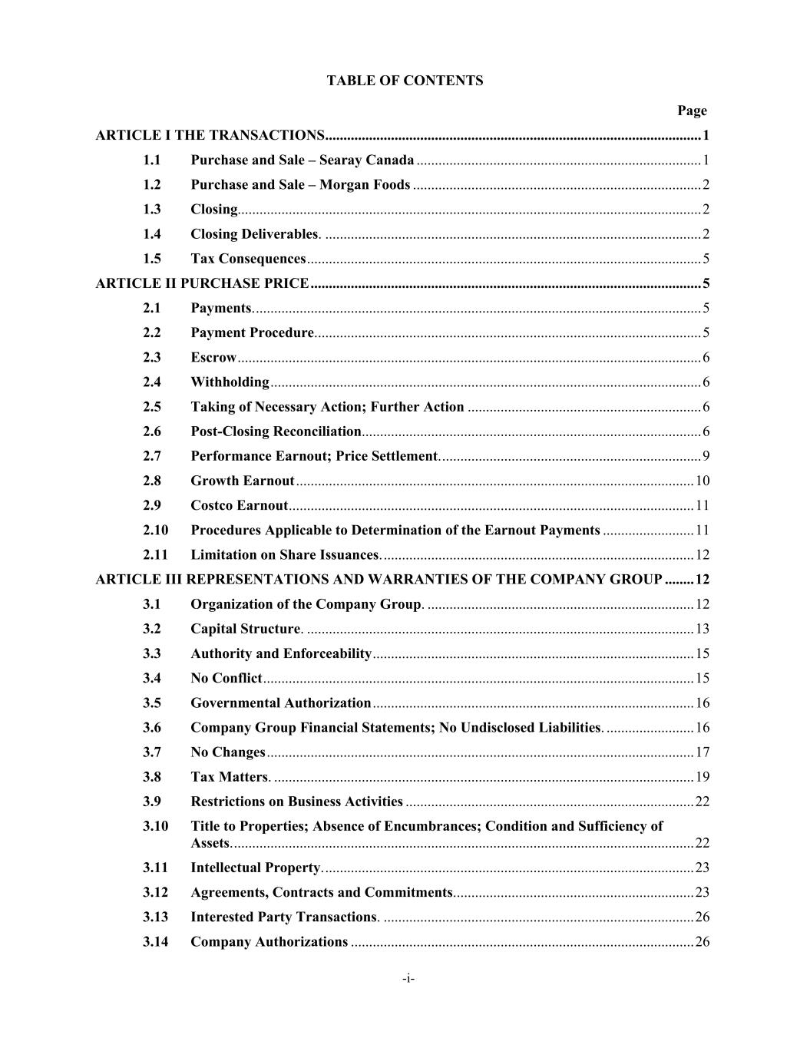
TABLE OF CONTENTS Page -i- ARTICLE I THE TRANSACTIONS ....................................................................................................... 1 1.1 Purchase and Sale – Searay Canada .............................................................................. 1 1.2 Purchase and Sale – Morgan Foods ............................................................................... 2 1.3 Closing............................................................................................................................... 2 1.4 Closing Deliverables. ....................................................................................................... 2 1.5 Tax Consequences ............................................................................................................ 5 ARTICLE II PURCHASE PRICE ........................................................................................................... 5 2.1 Payments. .......................................................................................................................... 5 2.2 Payment Procedure. ......................................................................................................... 5 2.3 Escrow ............................................................................................................................... 6 2.4 Withholding ...................................................................................................................... 6 2.5 Taking of Necessary Action; Further Action ................................................................ 6 2.6 Post-Closing Reconciliation............................................................................................. 6 2.7 Performance Earnout; Price Settlement. ....................................................................... 9 2.8 Growth Earnout ............................................................................................................. 10 2.9 Costco Earnout ............................................................................................................... 11 2.10 Procedures Applicable to Determination of the Earnout Payments ......................... 11 2.11 Limitation on Share Issuances. ..................................................................................... 12 ARTICLE III REPRESENTATIONS AND WARRANTIES OF THE COMPANY GROUP ........ 12 3.1 Organization of the Company Group. ......................................................................... 12 3.2 Capital Structure. .......................................................................................................... 13 3.3 Authority and Enforceability ........................................................................................ 15 3.4 No Conflict ...................................................................................................................... 15 3.5 Governmental Authorization ........................................................................................ 16 3.6 Company Group Financial Statements; No Undisclosed Liabilities. ........................ 16 3.7 No Changes ..................................................................................................................... 17 3.8 Tax Matters. ................................................................................................................... 19 3.9 Restrictions on Business Activities ............................................................................... 22 3.10 Title to Properties; Absence of Encumbrances; Condition and Sufficiency of Assets. .............................................................................................................................. 22 3.11 Intellectual Property. ..................................................................................................... 23 3.12 Agreements, Contracts and Commitments. ................................................................. 23 3.13 Interested Party Transactions. ..................................................................................... 26 3.14 Company Authorizations .............................................................................................. 26

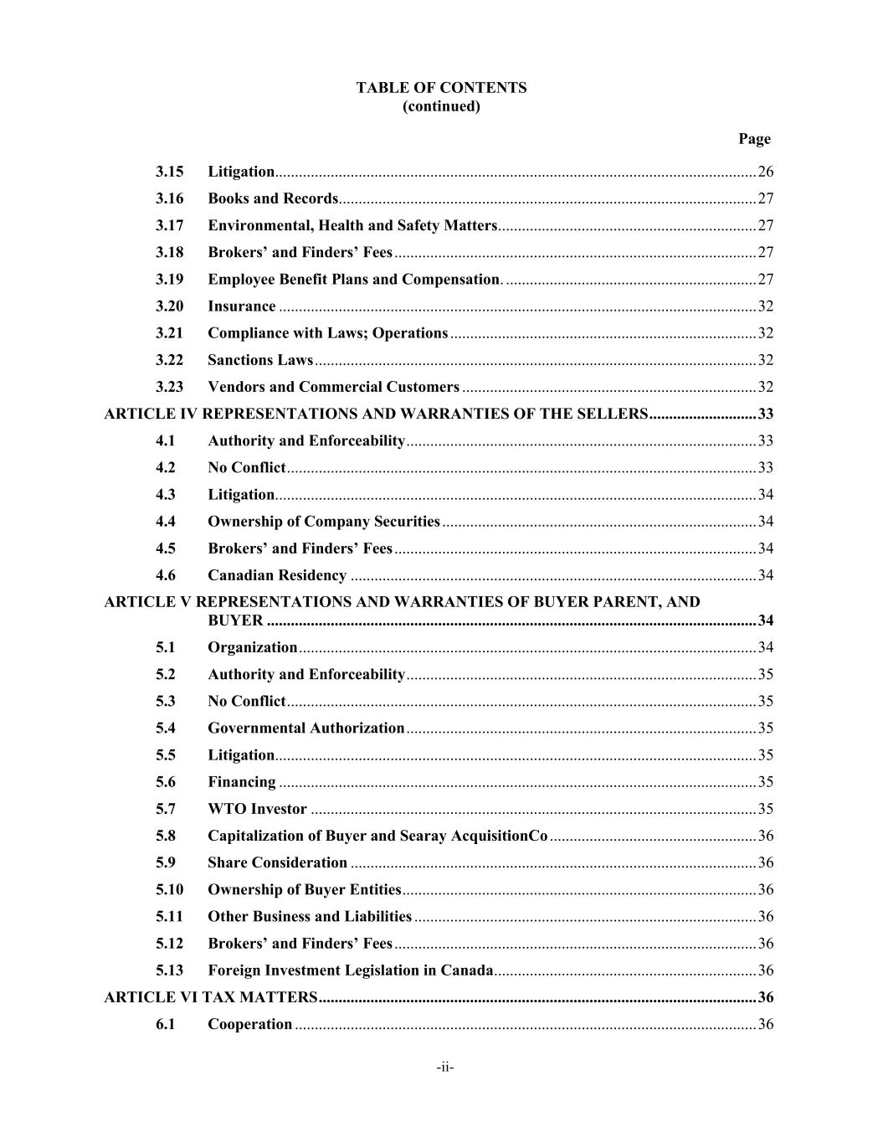
TABLE OF CONTENTS (continued) Page -ii- 3.15 Litigation......................................................................................................................... 26 3.16 Books and Records. ........................................................................................................ 27 3.17 Environmental, Health and Safety Matters ................................................................. 27 3.18 Brokers’ and Finders’ Fees ........................................................................................... 27 3.19 Employee Benefit Plans and Compensation. ............................................................... 27 3.20 Insurance ........................................................................................................................ 32 3.21 Compliance with Laws; Operations ............................................................................. 32 3.22 Sanctions Laws ............................................................................................................... 32 3.23 Vendors and Commercial Customers .......................................................................... 32 ARTICLE IV REPRESENTATIONS AND WARRANTIES OF THE SELLERS ........................... 33 4.1 Authority and Enforceability ........................................................................................ 33 4.2 No Conflict ...................................................................................................................... 33 4.3 Litigation......................................................................................................................... 34 4.4 Ownership of Company Securities ............................................................................... 34 4.5 Brokers’ and Finders’ Fees ........................................................................................... 34 4.6 Canadian Residency ...................................................................................................... 34 ARTICLE V REPRESENTATIONS AND WARRANTIES OF BUYER PARENT, AND BUYER ........................................................................................................................... 34 5.1 Organization ................................................................................................................... 34 5.2 Authority and Enforceability ........................................................................................ 35 5.3 No Conflict ...................................................................................................................... 35 5.4 Governmental Authorization ........................................................................................ 35 5.5 Litigation......................................................................................................................... 35 5.6 Financing ........................................................................................................................ 35 5.7 WTO Investor ................................................................................................................ 35 5.8 Capitalization of Buyer and Searay AcquisitionCo .................................................... 36 5.9 Share Consideration ...................................................................................................... 36 5.10 Ownership of Buyer Entities ......................................................................................... 36 5.11 Other Business and Liabilities ...................................................................................... 36 5.12 Brokers’ and Finders’ Fees ........................................................................................... 36 5.13 Foreign Investment Legislation in Canada .................................................................. 36 ARTICLE VI TAX MATTERS .............................................................................................................. 36 6.1 Cooperation .................................................................................................................... 36

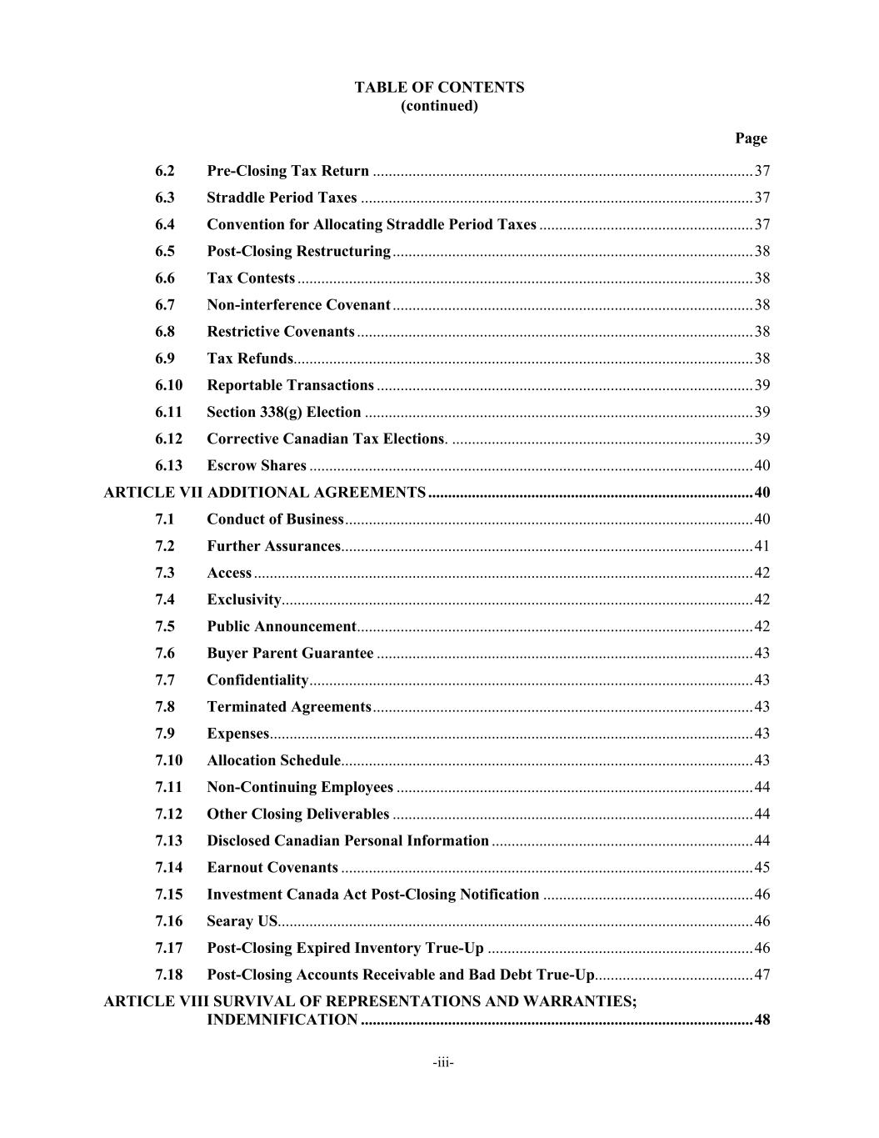
TABLE OF CONTENTS (continued) Page -iii- 6.2 Pre-Closing Tax Return ................................................................................................ 37 6.3 Straddle Period Taxes ................................................................................................... 37 6.4 Convention for Allocating Straddle Period Taxes ...................................................... 37 6.5 Post-Closing Restructuring ........................................................................................... 38 6.6 Tax Contests ................................................................................................................... 38 6.7 Non-interference Covenant ........................................................................................... 38 6.8 Restrictive Covenants .................................................................................................... 38 6.9 Tax Refunds.................................................................................................................... 38 6.10 Reportable Transactions ............................................................................................... 39 6.11 Section 338(g) Election .................................................................................................. 39 6.12 Corrective Canadian Tax Elections. ............................................................................ 39 6.13 Escrow Shares ................................................................................................................ 40 ARTICLE VII ADDITIONAL AGREEMENTS .................................................................................. 40 7.1 Conduct of Business ....................................................................................................... 40 7.2 Further Assurances ........................................................................................................ 41 7.3 Access .............................................................................................................................. 42 7.4 Exclusivity....................................................................................................................... 42 7.5 Public Announcement .................................................................................................... 42 7.6 Buyer Parent Guarantee ............................................................................................... 43 7.7 Confidentiality ................................................................................................................ 43 7.8 Terminated Agreements ................................................................................................ 43 7.9 Expenses .......................................................................................................................... 43 7.10 Allocation Schedule ........................................................................................................ 43 7.11 Non-Continuing Employees .......................................................................................... 44 7.12 Other Closing Deliverables ........................................................................................... 44 7.13 Disclosed Canadian Personal Information .................................................................. 44 7.14 Earnout Covenants ........................................................................................................ 45 7.15 Investment Canada Act Post-Closing Notification ..................................................... 46 7.16 Searay US........................................................................................................................ 46 7.17 Post-Closing Expired Inventory True-Up ................................................................... 46 7.18 Post-Closing Accounts Receivable and Bad Debt True-Up........................................ 47 ARTICLE VIII SURVIVAL OF REPRESENTATIONS AND WARRANTIES; INDEMNIFICATION ................................................................................................... 48

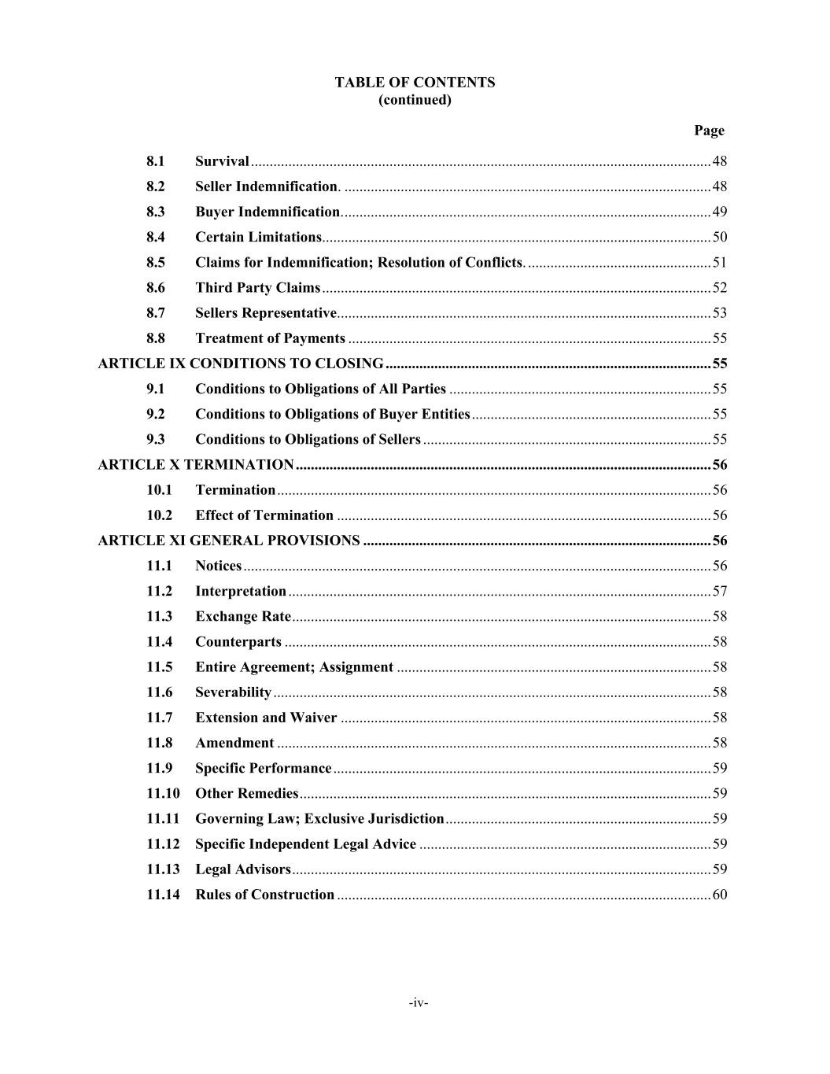
TABLE OF CONTENTS (continued) Page -iv- 8.1 Survival ........................................................................................................................... 48 8.2 Seller Indemnification. .................................................................................................. 48 8.3 Buyer Indemnification. .................................................................................................. 49 8.4 Certain Limitations. ....................................................................................................... 50 8.5 Claims for Indemnification; Resolution of Conflicts. ................................................. 51 8.6 Third Party Claims ........................................................................................................ 52 8.7 Sellers Representative. ................................................................................................... 53 8.8 Treatment of Payments ................................................................................................. 55 ARTICLE IX CONDITIONS TO CLOSING ....................................................................................... 55 9.1 Conditions to Obligations of All Parties ...................................................................... 55 9.2 Conditions to Obligations of Buyer Entities ................................................................ 55 9.3 Conditions to Obligations of Sellers ............................................................................. 55 ARTICLE X TERMINATION ............................................................................................................... 56 10.1 Termination .................................................................................................................... 56 10.2 Effect of Termination .................................................................................................... 56 ARTICLE XI GENERAL PROVISIONS ............................................................................................. 56 11.1 Notices ............................................................................................................................. 56 11.2 Interpretation ................................................................................................................. 57 11.3 Exchange Rate ................................................................................................................ 58 11.4 Counterparts .................................................................................................................. 58 11.5 Entire Agreement; Assignment .................................................................................... 58 11.6 Severability ..................................................................................................................... 58 11.7 Extension and Waiver ................................................................................................... 58 11.8 Amendment .................................................................................................................... 58 11.9 Specific Performance ..................................................................................................... 59 11.10 Other Remedies .............................................................................................................. 59 11.11 Governing Law; Exclusive Jurisdiction ....................................................................... 59 11.12 Specific Independent Legal Advice .............................................................................. 59 11.13 Legal Advisors ................................................................................................................ 59 11.14 Rules of Construction .................................................................................................... 60

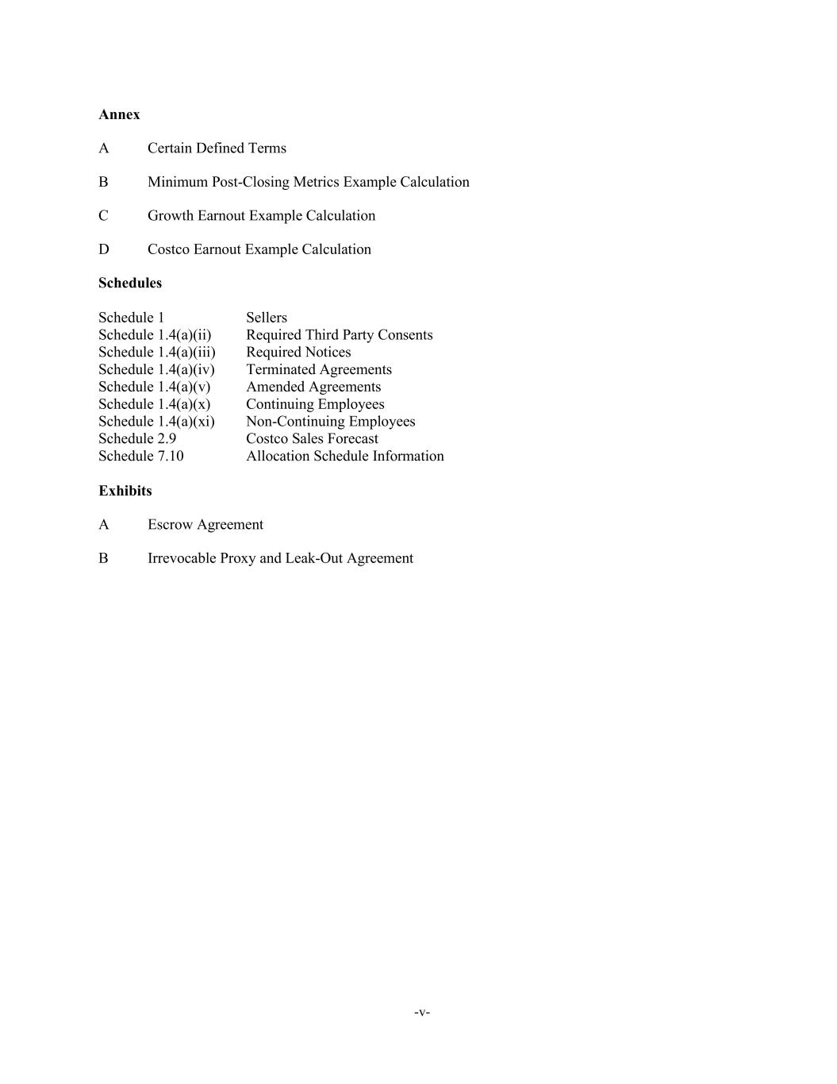
-v- Annex A Certain Defined Terms B Minimum Post-Closing Metrics Example Calculation C Growth Earnout Example Calculation D Costco Earnout Example Calculation Schedules Schedule 1 Sellers Schedule 1.4(a)(ii) Required Third Party Consents Schedule 1.4(a)(iii) Required Notices Schedule 1.4(a)(iv) Terminated Agreements Schedule 1.4(a)(v) Amended Agreements Schedule 1.4(a)(x) Continuing Employees Schedule 1.4(a)(xi) Non-Continuing Employees Schedule 2.9 Costco Sales Forecast Schedule 7.10 Allocation Schedule Information Exhibits A Escrow Agreement B Irrevocable Proxy and Leak-Out Agreement

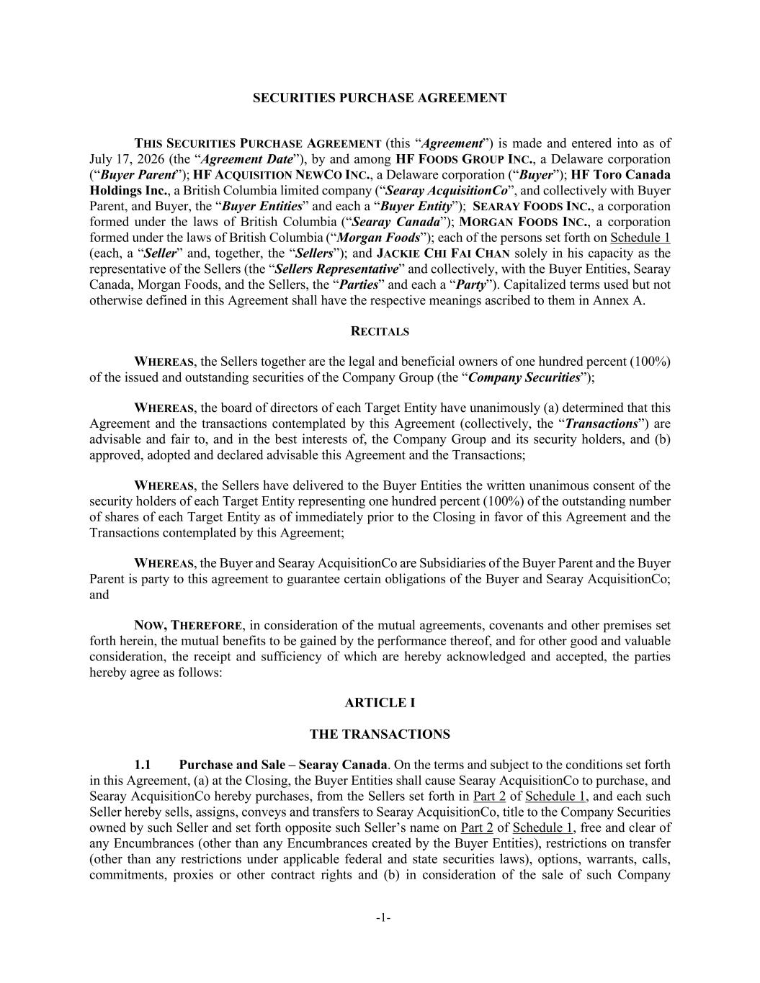
-1- SECURITIES PURCHASE AGREEMENT THIS SECURITIES PURCHASE AGREEMENT (this “Agreement”) is made and entered into as of July 17, 2026 (the “Agreement Date”), by and among HF FOODS GROUP INC., a Delaware corporation (“Buyer Parent”); HF ACQUISITION NEWCO INC., a Delaware corporation (“Buyer”); HF Toro Canada Holdings Inc., a British Columbia limited company (“Searay AcquisitionCo”, and collectively with Buyer Parent, and Buyer, the “Buyer Entities” and each a “Buyer Entity”); SEARAY FOODS INC., a corporation formed under the laws of British Columbia (“Searay Canada”); MORGAN FOODS INC., a corporation formed under the laws of British Columbia (“Morgan Foods”); each of the persons set forth on Schedule 1 (each, a “Seller” and, together, the “Sellers”); and JACKIE CHI FAI CHAN solely in his capacity as the representative of the Sellers (the “Sellers Representative” and collectively, with the Buyer Entities, Searay Canada, Morgan Foods, and the Sellers, the “Parties” and each a “Party”). Capitalized terms used but not otherwise defined in this Agreement shall have the respective meanings ascribed to them in Annex A. RECITALS WHEREAS, the Sellers together are the legal and beneficial owners of one hundred percent (100%) of the issued and outstanding securities of the Company Group (the “Company Securities”); WHEREAS, the board of directors of each Target Entity have unanimously (a) determined that this Agreement and the transactions contemplated by this Agreement (collectively, the “Transactions”) are advisable and fair to, and in the best interests of, the Company Group and its security holders, and (b) approved, adopted and declared advisable this Agreement and the Transactions; WHEREAS, the Sellers have delivered to the Buyer Entities the written unanimous consent of the security holders of each Target Entity representing one hundred percent (100%) of the outstanding number of shares of each Target Entity as of immediately prior to the Closing in favor of this Agreement and the Transactions contemplated by this Agreement; WHEREAS, the Buyer and Searay AcquisitionCo are Subsidiaries of the Buyer Parent and the Buyer Parent is party to this agreement to guarantee certain obligations of the Buyer and Searay AcquisitionCo; and NOW, THEREFORE, in consideration of the mutual agreements, covenants and other premises set forth herein, the mutual benefits to be gained by the performance thereof, and for other good and valuable consideration, the receipt and sufficiency of which are hereby acknowledged and accepted, the parties hereby agree as follows: ARTICLE I THE TRANSACTIONS 1.1 Purchase and Sale – Searay Canada. On the terms and subject to the conditions set forth in this Agreement, (a) at the Closing, the Buyer Entities shall cause Searay AcquisitionCo to purchase, and Searay AcquisitionCo hereby purchases, from the Sellers set forth in Part 2 of Schedule 1, and each such Seller hereby sells, assigns, conveys and transfers to Searay AcquisitionCo, title to the Company Securities owned by such Seller and set forth opposite such Seller’s name on Part 2 of Schedule 1, free and clear of any Encumbrances (other than any Encumbrances created by the Buyer Entities), restrictions on transfer (other than any restrictions under applicable federal and state securities laws), options, warrants, calls, commitments, proxies or other contract rights and (b) in consideration of the sale of such Company

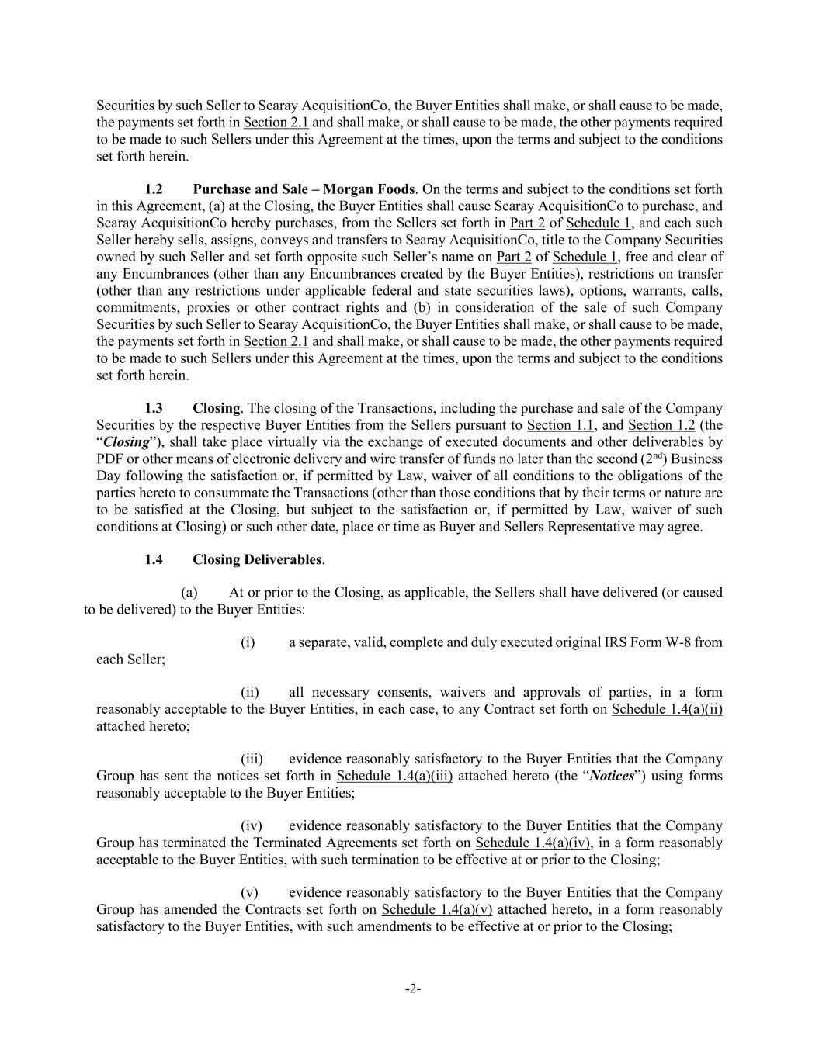
-2- Securities by such Seller to Searay AcquisitionCo, the Buyer Entities shall make, or shall cause to be made, the payments set forth in Section 2.1 and shall make, or shall cause to be made, the other payments required to be made to such Sellers under this Agreement at the times, upon the terms and subject to the conditions set forth herein. 1.2 Purchase and Sale – Morgan Foods. On the terms and subject to the conditions set forth in this Agreement, (a) at the Closing, the Buyer Entities shall cause Searay AcquisitionCo to purchase, and Searay AcquisitionCo hereby purchases, from the Sellers set forth in Part 2 of Schedule 1, and each such Seller hereby sells, assigns, conveys and transfers to Searay AcquisitionCo, title to the Company Securities owned by such Seller and set forth opposite such Seller’s name on Part 2 of Schedule 1, free and clear of any Encumbrances (other than any Encumbrances created by the Buyer Entities), restrictions on transfer (other than any restrictions under applicable federal and state securities laws), options, warrants, calls, commitments, proxies or other contract rights and (b) in consideration of the sale of such Company Securities by such Seller to Searay AcquisitionCo, the Buyer Entities shall make, or shall cause to be made, the payments set forth in Section 2.1 and shall make, or shall cause to be made, the other payments required to be made to such Sellers under this Agreement at the times, upon the terms and subject to the conditions set forth herein. 1.3 Closing. The closing of the Transactions, including the purchase and sale of the Company Securities by the respective Buyer Entities from the Sellers pursuant to Section 1.1, and Section 1.2 (the “Closing”), shall take place virtually via the exchange of executed documents and other deliverables by PDF or other means of electronic delivery and wire transfer of funds no later than the second (2nd) Business Day following the satisfaction or, if permitted by Law, waiver of all conditions to the obligations of the parties hereto to consummate the Transactions (other than those conditions that by their terms or nature are to be satisfied at the Closing, but subject to the satisfaction or, if permitted by Law, waiver of such conditions at Closing) or such other date, place or time as Buyer and Sellers Representative may agree. 1.4 Closing Deliverables. (a) At or prior to the Closing, as applicable, the Sellers shall have delivered (or caused to be delivered) to the Buyer Entities: (i) a separate, valid, complete and duly executed original IRS Form W-8 from each Seller; (ii) all necessary consents, waivers and approvals of parties, in a form reasonably acceptable to the Buyer Entities, in each case, to any Contract set forth on Schedule 1.4(a)(ii) attached hereto; (iii) evidence reasonably satisfactory to the Buyer Entities that the Company Group has sent the notices set forth in Schedule 1.4(a)(iii) attached hereto (the “Notices”) using forms reasonably acceptable to the Buyer Entities; (iv) evidence reasonably satisfactory to the Buyer Entities that the Company Group has terminated the Terminated Agreements set forth on Schedule 1.4(a)(iv), in a form reasonably acceptable to the Buyer Entities, with such termination to be effective at or prior to the Closing; (v) evidence reasonably satisfactory to the Buyer Entities that the Company Group has amended the Contracts set forth on Schedule 1.4(a)(v) attached hereto, in a form reasonably satisfactory to the Buyer Entities, with such amendments to be effective at or prior to the Closing;

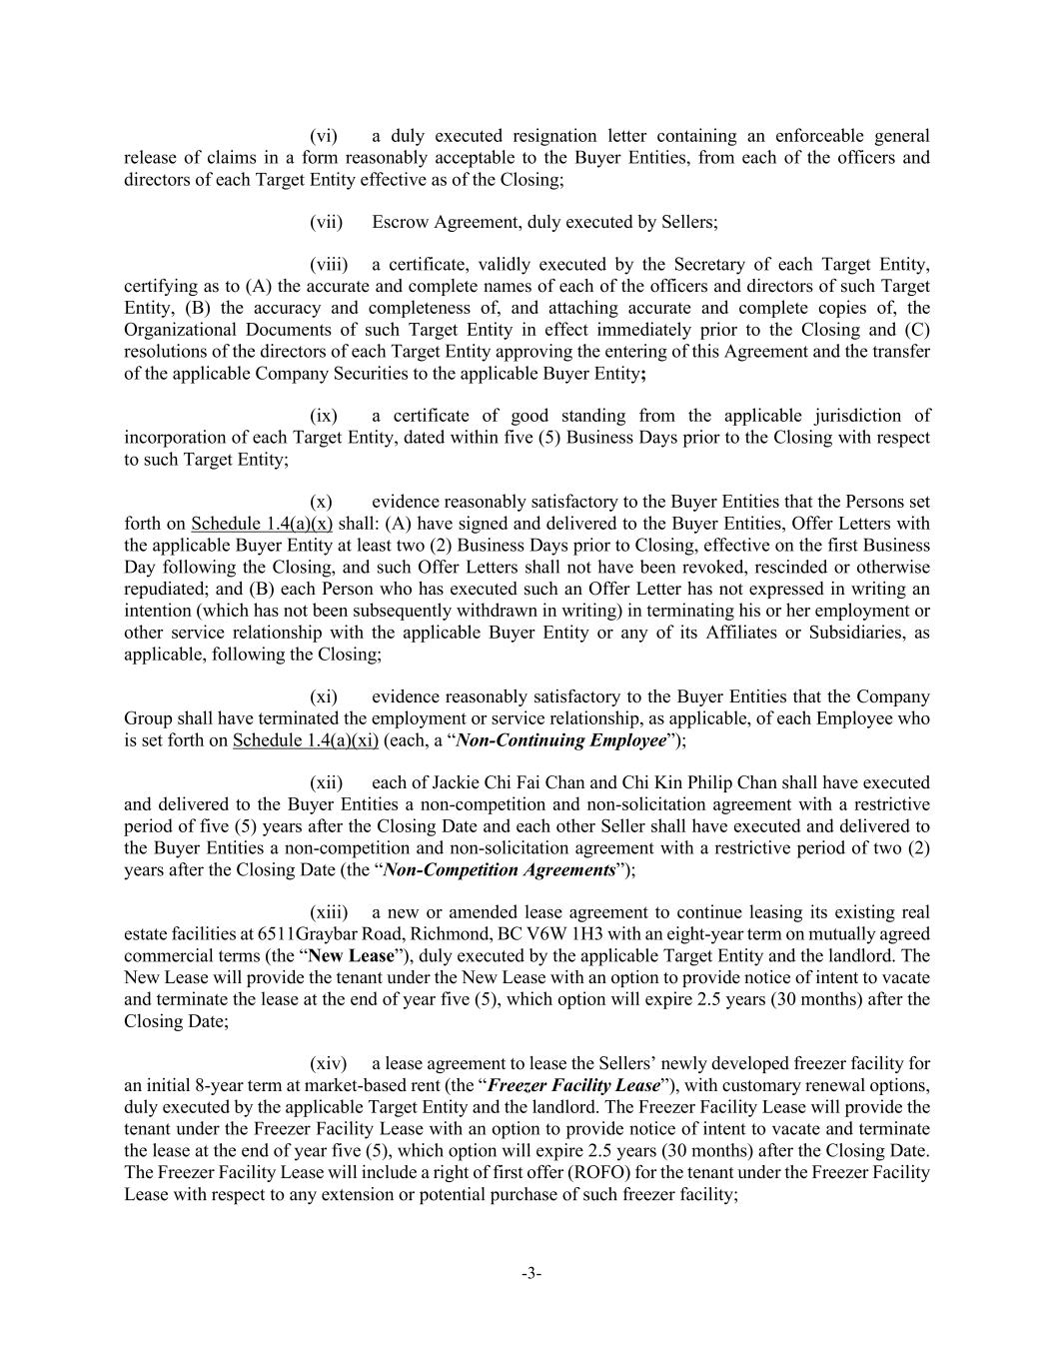
-3- (vi) a duly executed resignation letter containing an enforceable general release of claims in a form reasonably acceptable to the Buyer Entities, from each of the officers and directors of each Target Entity effective as of the Closing; (vii) Escrow Agreement, duly executed by Sellers; (viii) a certificate, validly executed by the Secretary of each Target Entity, certifying as to (A) the accurate and complete names of each of the officers and directors of such Target Entity, (B) the accuracy and completeness of, and attaching accurate and complete copies of, the Organizational Documents of such Target Entity in effect immediately prior to the Closing and (C) resolutions of the directors of each Target Entity approving the entering of this Agreement and the transfer of the applicable Company Securities to the applicable Buyer Entity; (ix) a certificate of good standing from the applicable jurisdiction of incorporation of each Target Entity, dated within five (5) Business Days prior to the Closing with respect to such Target Entity; (x) evidence reasonably satisfactory to the Buyer Entities that the Persons set forth on Schedule 1.4(a)(x) shall: (A) have signed and delivered to the Buyer Entities, Offer Letters with the applicable Buyer Entity at least two (2) Business Days prior to Closing, effective on the first Business Day following the Closing, and such Offer Letters shall not have been revoked, rescinded or otherwise repudiated; and (B) each Person who has executed such an Offer Letter has not expressed in writing an intention (which has not been subsequently withdrawn in writing) in terminating his or her employment or other service relationship with the applicable Buyer Entity or any of its Affiliates or Subsidiaries, as applicable, following the Closing; (xi) evidence reasonably satisfactory to the Buyer Entities that the Company Group shall have terminated the employment or service relationship, as applicable, of each Employee who is set forth on Schedule 1.4(a)(xi) (each, a “Non-Continuing Employee”); (xii) each of Jackie Chi Fai Chan and Chi Kin Philip Chan shall have executed and delivered to the Buyer Entities a non-competition and non-solicitation agreement with a restrictive period of five (5) years after the Closing Date and each other Seller shall have executed and delivered to the Buyer Entities a non-competition and non-solicitation agreement with a restrictive period of two (2) years after the Closing Date (the “Non-Competition Agreements”); (xiii) a new or amended lease agreement to continue leasing its existing real estate facilities at 6511Graybar Road, Richmond, BC V6W 1H3 with an eight-year term on mutually agreed commercial terms (the “New Lease”), duly executed by the applicable Target Entity and the landlord. The New Lease will provide the tenant under the New Lease with an option to provide notice of intent to vacate and terminate the lease at the end of year five (5), which option will expire 2.5 years (30 months) after the Closing Date; (xiv) a lease agreement to lease the Sellers’ newly developed freezer facility for an initial 8-year term at market-based rent (the “Freezer Facility Lease”), with customary renewal options, duly executed by the applicable Target Entity and the landlord. The Freezer Facility Lease will provide the tenant under the Freezer Facility Lease with an option to provide notice of intent to vacate and terminate the lease at the end of year five (5), which option will expire 2.5 years (30 months) after the Closing Date. The Freezer Facility Lease will include a right of first offer (ROFO) for the tenant under the Freezer Facility Lease with respect to any extension or potential purchase of such freezer facility;

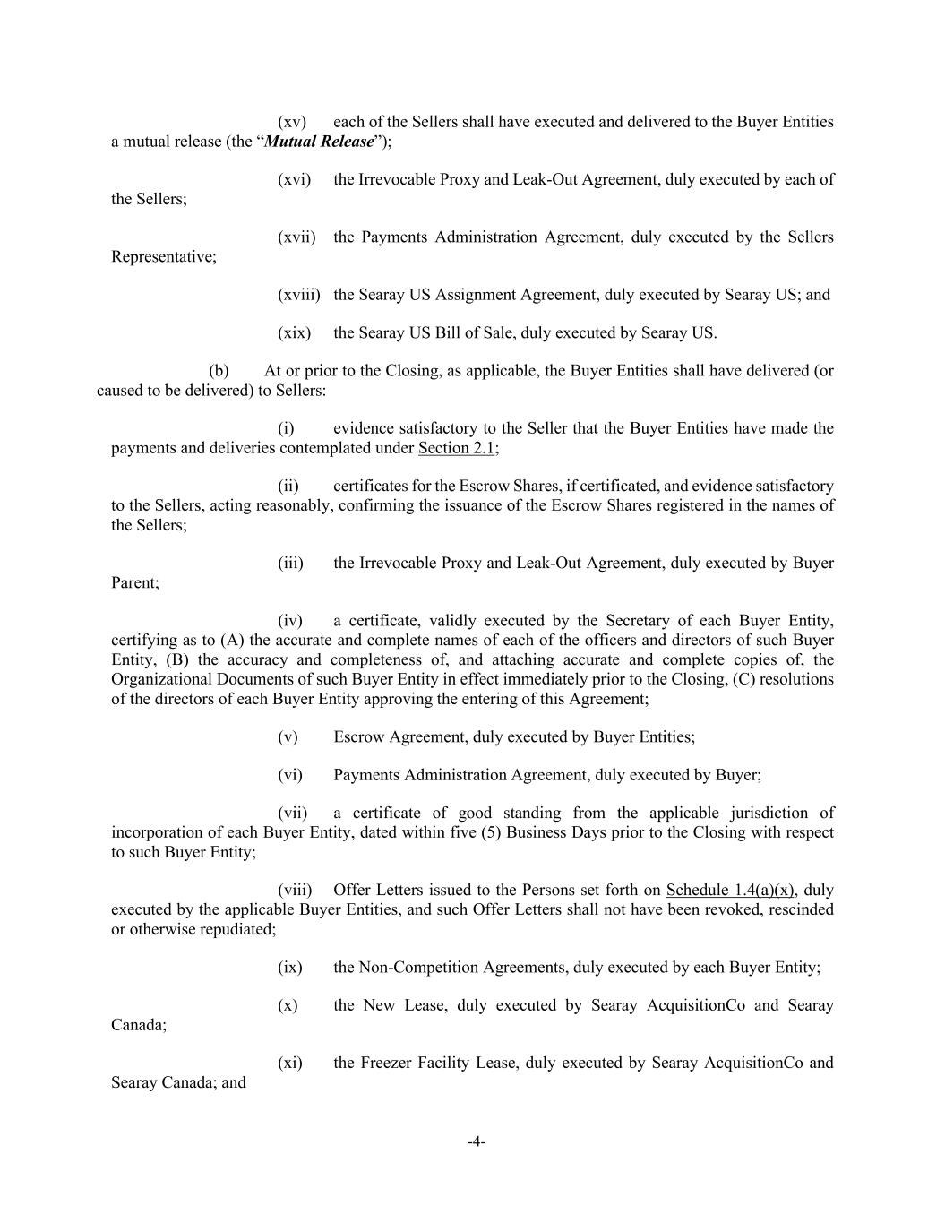
-4- (xv) each of the Sellers shall have executed and delivered to the Buyer Entities a mutual release (the “Mutual Release”); (xvi) the Irrevocable Proxy and Leak-Out Agreement, duly executed by each of the Sellers; (xvii) the Payments Administration Agreement, duly executed by the Sellers Representative; (xviii) the Searay US Assignment Agreement, duly executed by Searay US; and (xix) the Searay US Bill of Sale, duly executed by Searay US. (b) At or prior to the Closing, as applicable, the Buyer Entities shall have delivered (or caused to be delivered) to Sellers: (i) evidence satisfactory to the Seller that the Buyer Entities have made the payments and deliveries contemplated under Section 2.1; (ii) certificates for the Escrow Shares, if certificated, and evidence satisfactory to the Sellers, acting reasonably, confirming the issuance of the Escrow Shares registered in the names of the Sellers; (iii) the Irrevocable Proxy and Leak-Out Agreement, duly executed by Buyer Parent; (iv) a certificate, validly executed by the Secretary of each Buyer Entity, certifying as to (A) the accurate and complete names of each of the officers and directors of such Buyer Entity, (B) the accuracy and completeness of, and attaching accurate and complete copies of, the Organizational Documents of such Buyer Entity in effect immediately prior to the Closing, (C) resolutions of the directors of each Buyer Entity approving the entering of this Agreement; (v) Escrow Agreement, duly executed by Buyer Entities; (vi) Payments Administration Agreement, duly executed by Buyer; (vii) a certificate of good standing from the applicable jurisdiction of incorporation of each Buyer Entity, dated within five (5) Business Days prior to the Closing with respect to such Buyer Entity; (viii) Offer Letters issued to the Persons set forth on Schedule 1.4(a)(x), duly executed by the applicable Buyer Entities, and such Offer Letters shall not have been revoked, rescinded or otherwise repudiated; (ix) the Non-Competition Agreements, duly executed by each Buyer Entity; (x) the New Lease, duly executed by Searay AcquisitionCo and Searay Canada; (xi) the Freezer Facility Lease, duly executed by Searay AcquisitionCo and Searay Canada; and

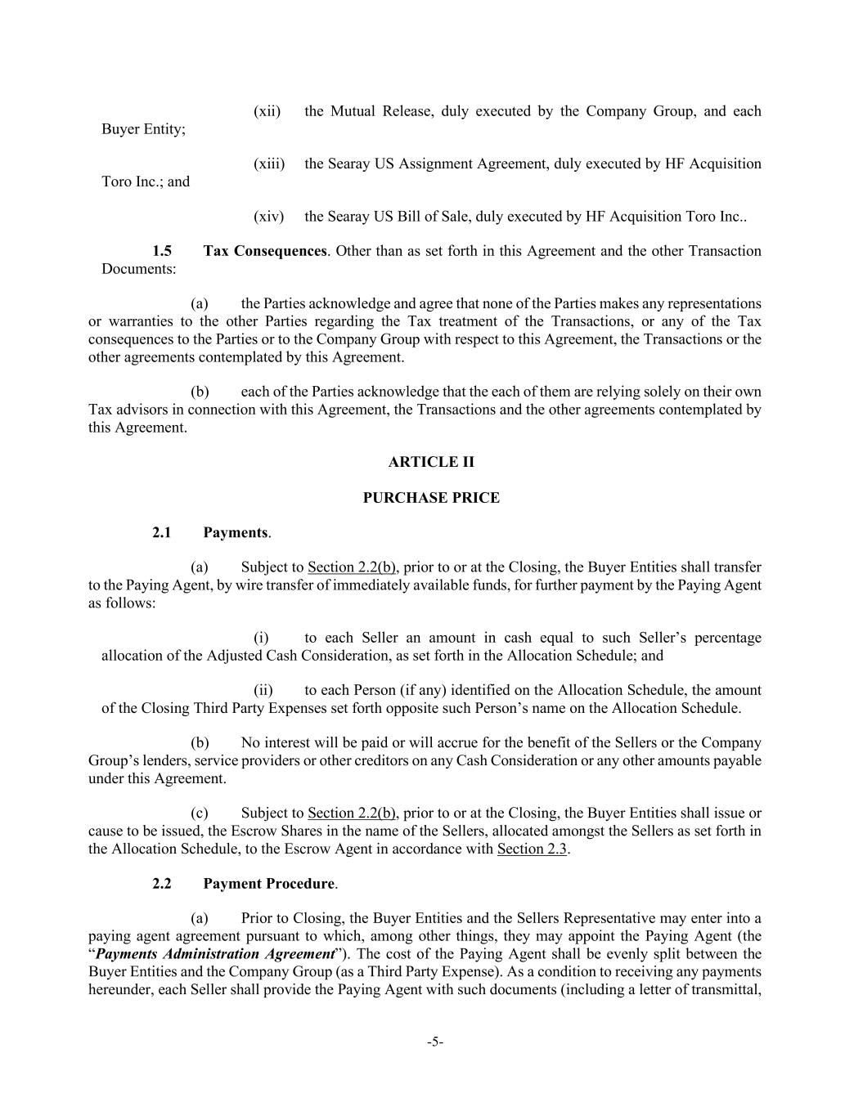
-5- (xii) the Mutual Release, duly executed by the Company Group, and each Buyer Entity; (xiii) the Searay US Assignment Agreement, duly executed by HF Acquisition Toro Inc.; and (xiv) the Searay US Bill of Sale, duly executed by HF Acquisition Toro Inc.. 1.5 Tax Consequences. Other than as set forth in this Agreement and the other Transaction Documents: (a) the Parties acknowledge and agree that none of the Parties makes any representations or warranties to the other Parties regarding the Tax treatment of the Transactions, or any of the Tax consequences to the Parties or to the Company Group with respect to this Agreement, the Transactions or the other agreements contemplated by this Agreement. (b) each of the Parties acknowledge that the each of them are relying solely on their own Tax advisors in connection with this Agreement, the Transactions and the other agreements contemplated by this Agreement. ARTICLE II PURCHASE PRICE 2.1 Payments. (a) Subject to Section 2.2(b), prior to or at the Closing, the Buyer Entities shall transfer to the Paying Agent, by wire transfer of immediately available funds, for further payment by the Paying Agent as follows: (i) to each Seller an amount in cash equal to such Seller’s percentage allocation of the Adjusted Cash Consideration, as set forth in the Allocation Schedule; and (ii) to each Person (if any) identified on the Allocation Schedule, the amount of the Closing Third Party Expenses set forth opposite such Person’s name on the Allocation Schedule. (b) No interest will be paid or will accrue for the benefit of the Sellers or the Company Group’s lenders, service providers or other creditors on any Cash Consideration or any other amounts payable under this Agreement. (c) Subject to Section 2.2(b), prior to or at the Closing, the Buyer Entities shall issue or cause to be issued, the Escrow Shares in the name of the Sellers, allocated amongst the Sellers as set forth in the Allocation Schedule, to the Escrow Agent in accordance with Section 2.3. 2.2 Payment Procedure. (a) Prior to Closing, the Buyer Entities and the Sellers Representative may enter into a paying agent agreement pursuant to which, among other things, they may appoint the Paying Agent (the “Payments Administration Agreement”). The cost of the Paying Agent shall be evenly split between the Buyer Entities and the Company Group (as a Third Party Expense). As a condition to receiving any payments hereunder, each Seller shall provide the Paying Agent with such documents (including a letter of transmittal,

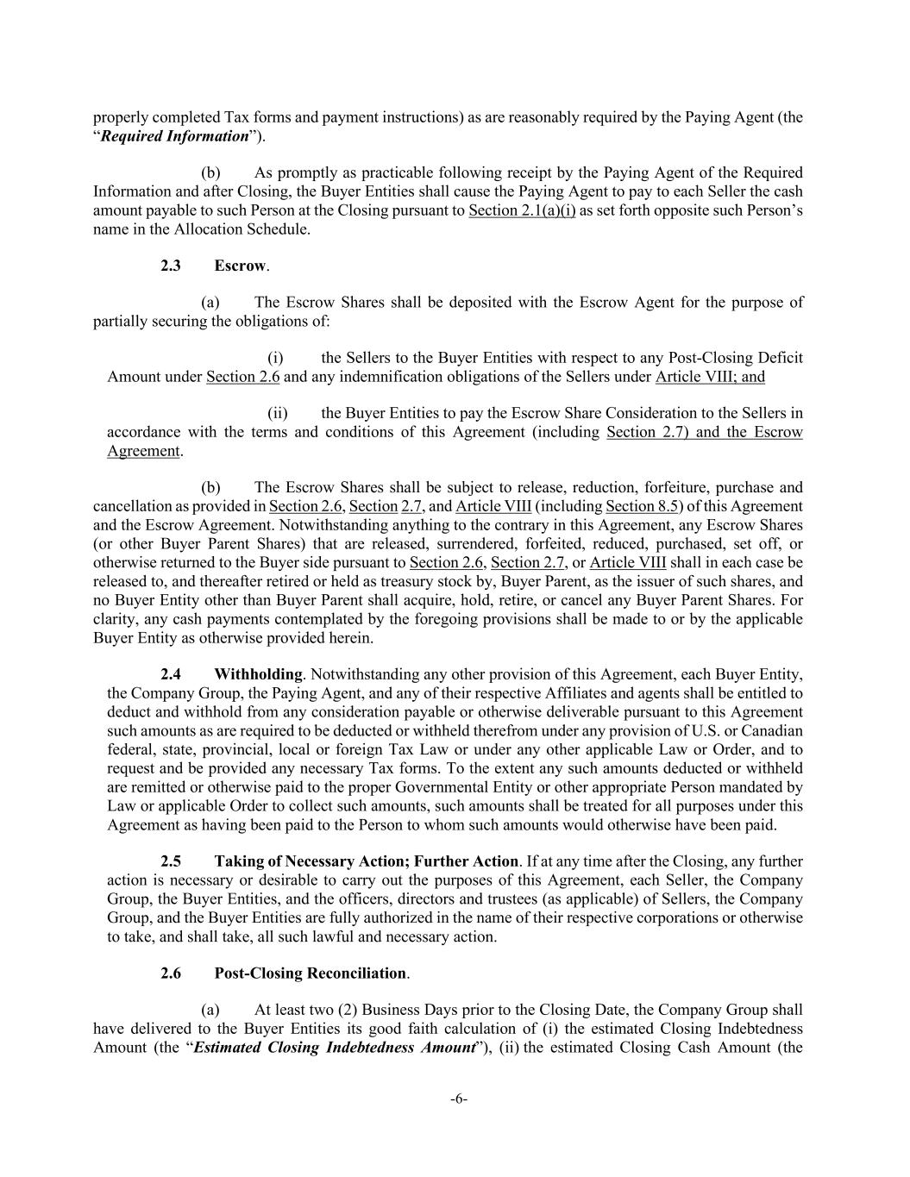
-6- properly completed Tax forms and payment instructions) as are reasonably required by the Paying Agent (the “Required Information”). (b) As promptly as practicable following receipt by the Paying Agent of the Required Information and after Closing, the Buyer Entities shall cause the Paying Agent to pay to each Seller the cash amount payable to such Person at the Closing pursuant to Section 2.1(a)(i) as set forth opposite such Person’s name in the Allocation Schedule. 2.3 Escrow. (a) The Escrow Shares shall be deposited with the Escrow Agent for the purpose of partially securing the obligations of: (i) the Sellers to the Buyer Entities with respect to any Post-Closing Deficit Amount under Section 2.6 and any indemnification obligations of the Sellers under Article VIII; and (ii) the Buyer Entities to pay the Escrow Share Consideration to the Sellers in accordance with the terms and conditions of this Agreement (including Section 2.7) and the Escrow Agreement. (b) The Escrow Shares shall be subject to release, reduction, forfeiture, purchase and cancellation as provided in Section 2.6, Section 2.7, and Article VIII (including Section 8.5) of this Agreement and the Escrow Agreement. Notwithstanding anything to the contrary in this Agreement, any Escrow Shares (or other Buyer Parent Shares) that are released, surrendered, forfeited, reduced, purchased, set off, or otherwise returned to the Buyer side pursuant to Section 2.6, Section 2.7, or Article VIII shall in each case be released to, and thereafter retired or held as treasury stock by, Buyer Parent, as the issuer of such shares, and no Buyer Entity other than Buyer Parent shall acquire, hold, retire, or cancel any Buyer Parent Shares. For clarity, any cash payments contemplated by the foregoing provisions shall be made to or by the applicable Buyer Entity as otherwise provided herein. 2.4 Withholding. Notwithstanding any other provision of this Agreement, each Buyer Entity, the Company Group, the Paying Agent, and any of their respective Affiliates and agents shall be entitled to deduct and withhold from any consideration payable or otherwise deliverable pursuant to this Agreement such amounts as are required to be deducted or withheld therefrom under any provision of U.S. or Canadian federal, state, provincial, local or foreign Tax Law or under any other applicable Law or Order, and to request and be provided any necessary Tax forms. To the extent any such amounts deducted or withheld are remitted or otherwise paid to the proper Governmental Entity or other appropriate Person mandated by Law or applicable Order to collect such amounts, such amounts shall be treated for all purposes under this Agreement as having been paid to the Person to whom such amounts would otherwise have been paid. 2.5 Taking of Necessary Action; Further Action. If at any time after the Closing, any further action is necessary or desirable to carry out the purposes of this Agreement, each Seller, the Company Group, the Buyer Entities, and the officers, directors and trustees (as applicable) of Sellers, the Company Group, and the Buyer Entities are fully authorized in the name of their respective corporations or otherwise to take, and shall take, all such lawful and necessary action. 2.6 Post-Closing Reconciliation. (a) At least two (2) Business Days prior to the Closing Date, the Company Group shall have delivered to the Buyer Entities its good faith calculation of (i) the estimated Closing Indebtedness Amount (the “Estimated Closing Indebtedness Amount”), (ii) the estimated Closing Cash Amount (the

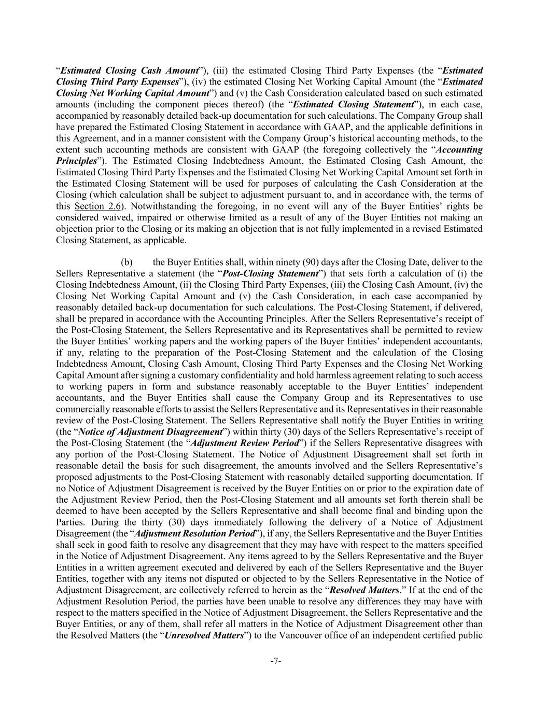
-7- “Estimated Closing Cash Amount”), (iii) the estimated Closing Third Party Expenses (the “Estimated Closing Third Party Expenses”), (iv) the estimated Closing Net Working Capital Amount (the “Estimated Closing Net Working Capital Amount”) and (v) the Cash Consideration calculated based on such estimated amounts (including the component pieces thereof) (the “Estimated Closing Statement”), in each case, accompanied by reasonably detailed back-up documentation for such calculations. The Company Group shall have prepared the Estimated Closing Statement in accordance with GAAP, and the applicable definitions in this Agreement, and in a manner consistent with the Company Group’s historical accounting methods, to the extent such accounting methods are consistent with GAAP (the foregoing collectively the “Accounting Principles”). The Estimated Closing Indebtedness Amount, the Estimated Closing Cash Amount, the Estimated Closing Third Party Expenses and the Estimated Closing Net Working Capital Amount set forth in the Estimated Closing Statement will be used for purposes of calculating the Cash Consideration at the Closing (which calculation shall be subject to adjustment pursuant to, and in accordance with, the terms of this Section 2.6). Notwithstanding the foregoing, in no event will any of the Buyer Entities’ rights be considered waived, impaired or otherwise limited as a result of any of the Buyer Entities not making an objection prior to the Closing or its making an objection that is not fully implemented in a revised Estimated Closing Statement, as applicable. (b) the Buyer Entities shall, within ninety (90) days after the Closing Date, deliver to the Sellers Representative a statement (the “Post-Closing Statement”) that sets forth a calculation of (i) the Closing Indebtedness Amount, (ii) the Closing Third Party Expenses, (iii) the Closing Cash Amount, (iv) the Closing Net Working Capital Amount and (v) the Cash Consideration, in each case accompanied by reasonably detailed back-up documentation for such calculations. The Post-Closing Statement, if delivered, shall be prepared in accordance with the Accounting Principles. After the Sellers Representative’s receipt of the Post-Closing Statement, the Sellers Representative and its Representatives shall be permitted to review the Buyer Entities’ working papers and the working papers of the Buyer Entities’ independent accountants, if any, relating to the preparation of the Post-Closing Statement and the calculation of the Closing Indebtedness Amount, Closing Cash Amount, Closing Third Party Expenses and the Closing Net Working Capital Amount after signing a customary confidentiality and hold harmless agreement relating to such access to working papers in form and substance reasonably acceptable to the Buyer Entities’ independent accountants, and the Buyer Entities shall cause the Company Group and its Representatives to use commercially reasonable efforts to assist the Sellers Representative and its Representatives in their reasonable review of the Post-Closing Statement. The Sellers Representative shall notify the Buyer Entities in writing (the “Notice of Adjustment Disagreement”) within thirty (30) days of the Sellers Representative’s receipt of the Post-Closing Statement (the “Adjustment Review Period”) if the Sellers Representative disagrees with any portion of the Post-Closing Statement. The Notice of Adjustment Disagreement shall set forth in reasonable detail the basis for such disagreement, the amounts involved and the Sellers Representative’s proposed adjustments to the Post-Closing Statement with reasonably detailed supporting documentation. If no Notice of Adjustment Disagreement is received by the Buyer Entities on or prior to the expiration date of the Adjustment Review Period, then the Post-Closing Statement and all amounts set forth therein shall be deemed to have been accepted by the Sellers Representative and shall become final and binding upon the Parties. During the thirty (30) days immediately following the delivery of a Notice of Adjustment Disagreement (the “Adjustment Resolution Period”), if any, the Sellers Representative and the Buyer Entities shall seek in good faith to resolve any disagreement that they may have with respect to the matters specified in the Notice of Adjustment Disagreement. Any items agreed to by the Sellers Representative and the Buyer Entities in a written agreement executed and delivered by each of the Sellers Representative and the Buyer Entities, together with any items not disputed or objected to by the Sellers Representative in the Notice of Adjustment Disagreement, are collectively referred to herein as the “Resolved Matters.” If at the end of the Adjustment Resolution Period, the parties have been unable to resolve any differences they may have with respect to the matters specified in the Notice of Adjustment Disagreement, the Sellers Representative and the Buyer Entities, or any of them, shall refer all matters in the Notice of Adjustment Disagreement other than the Resolved Matters (the “Unresolved Matters”) to the Vancouver office of an independent certified public

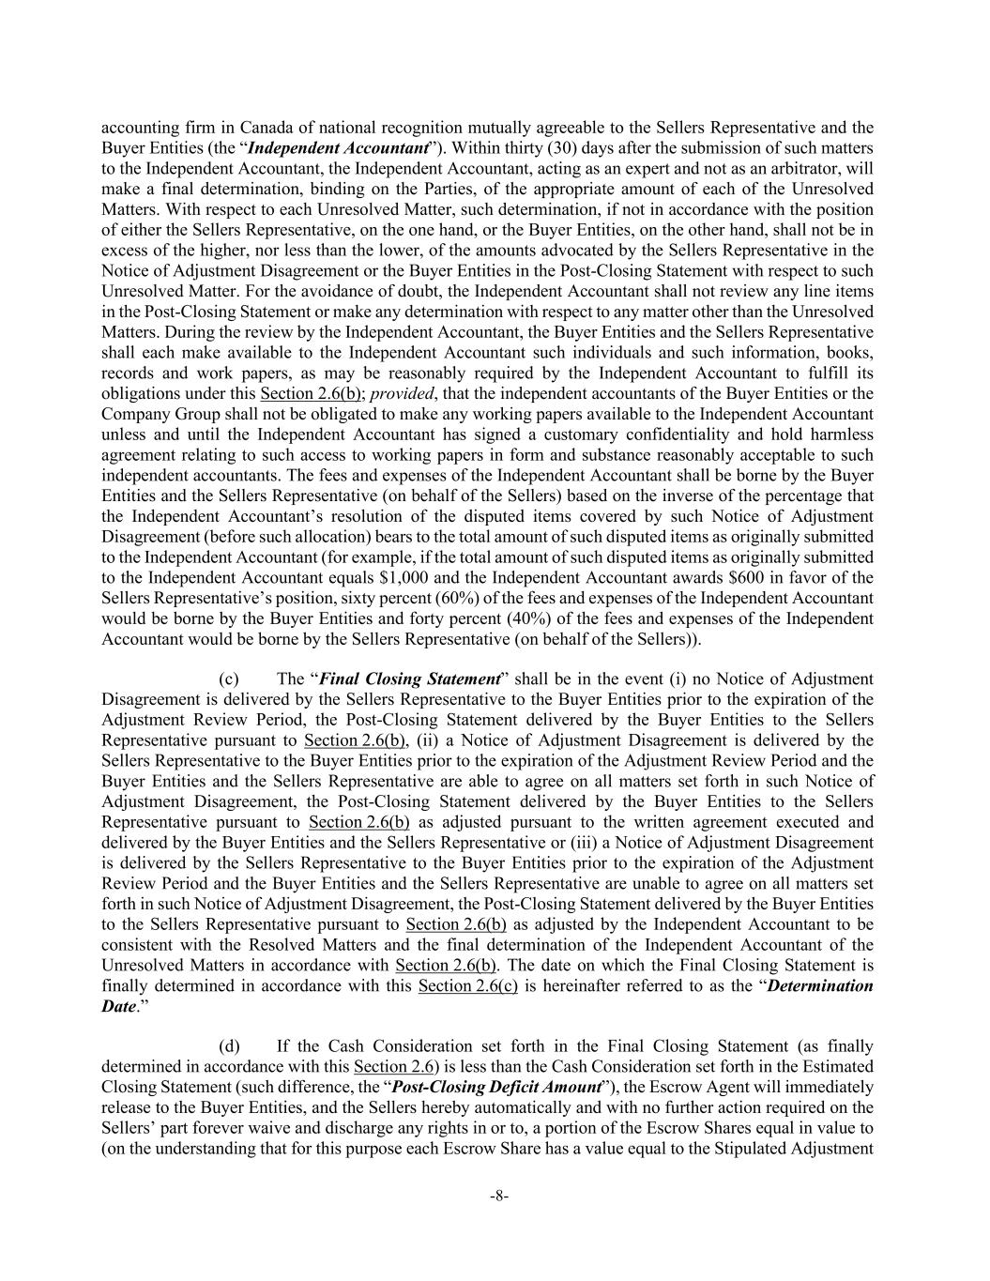
-8- accounting firm in Canada of national recognition mutually agreeable to the Sellers Representative and the Buyer Entities (the “Independent Accountant”). Within thirty (30) days after the submission of such matters to the Independent Accountant, the Independent Accountant, acting as an expert and not as an arbitrator, will make a final determination, binding on the Parties, of the appropriate amount of each of the Unresolved Matters. With respect to each Unresolved Matter, such determination, if not in accordance with the position of either the Sellers Representative, on the one hand, or the Buyer Entities, on the other hand, shall not be in excess of the higher, nor less than the lower, of the amounts advocated by the Sellers Representative in the Notice of Adjustment Disagreement or the Buyer Entities in the Post-Closing Statement with respect to such Unresolved Matter. For the avoidance of doubt, the Independent Accountant shall not review any line items in the Post-Closing Statement or make any determination with respect to any matter other than the Unresolved Matters. During the review by the Independent Accountant, the Buyer Entities and the Sellers Representative shall each make available to the Independent Accountant such individuals and such information, books, records and work papers, as may be reasonably required by the Independent Accountant to fulfill its obligations under this Section 2.6(b); provided, that the independent accountants of the Buyer Entities or the Company Group shall not be obligated to make any working papers available to the Independent Accountant unless and until the Independent Accountant has signed a customary confidentiality and hold harmless agreement relating to such access to working papers in form and substance reasonably acceptable to such independent accountants. The fees and expenses of the Independent Accountant shall be borne by the Buyer Entities and the Sellers Representative (on behalf of the Sellers) based on the inverse of the percentage that the Independent Accountant’s resolution of the disputed items covered by such Notice of Adjustment Disagreement (before such allocation) bears to the total amount of such disputed items as originally submitted to the Independent Accountant (for example, if the total amount of such disputed items as originally submitted to the Independent Accountant equals $1,000 and the Independent Accountant awards $600 in favor of the Sellers Representative’s position, sixty percent (60%) of the fees and expenses of the Independent Accountant would be borne by the Buyer Entities and forty percent (40%) of the fees and expenses of the Independent Accountant would be borne by the Sellers Representative (on behalf of the Sellers)). (c) The “Final Closing Statement” shall be in the event (i) no Notice of Adjustment Disagreement is delivered by the Sellers Representative to the Buyer Entities prior to the expiration of the Adjustment Review Period, the Post-Closing Statement delivered by the Buyer Entities to the Sellers Representative pursuant to Section 2.6(b), (ii) a Notice of Adjustment Disagreement is delivered by the Sellers Representative to the Buyer Entities prior to the expiration of the Adjustment Review Period and the Buyer Entities and the Sellers Representative are able to agree on all matters set forth in such Notice of Adjustment Disagreement, the Post-Closing Statement delivered by the Buyer Entities to the Sellers Representative pursuant to Section 2.6(b) as adjusted pursuant to the written agreement executed and delivered by the Buyer Entities and the Sellers Representative or (iii) a Notice of Adjustment Disagreement is delivered by the Sellers Representative to the Buyer Entities prior to the expiration of the Adjustment Review Period and the Buyer Entities and the Sellers Representative are unable to agree on all matters set forth in such Notice of Adjustment Disagreement, the Post-Closing Statement delivered by the Buyer Entities to the Sellers Representative pursuant to Section 2.6(b) as adjusted by the Independent Accountant to be consistent with the Resolved Matters and the final determination of the Independent Accountant of the Unresolved Matters in accordance with Section 2.6(b). The date on which the Final Closing Statement is finally determined in accordance with this Section 2.6(c) is hereinafter referred to as the “Determination Date.” (d) If the Cash Consideration set forth in the Final Closing Statement (as finally determined in accordance with this Section 2.6) is less than the Cash Consideration set forth in the Estimated Closing Statement (such difference, the “Post-Closing Deficit Amount”), the Escrow Agent will immediately release to the Buyer Entities, and the Sellers hereby automatically and with no further action required on the Sellers’ part forever waive and discharge any rights in or to, a portion of the Escrow Shares equal in value to (on the understanding that for this purpose each Escrow Share has a value equal to the Stipulated Adjustment

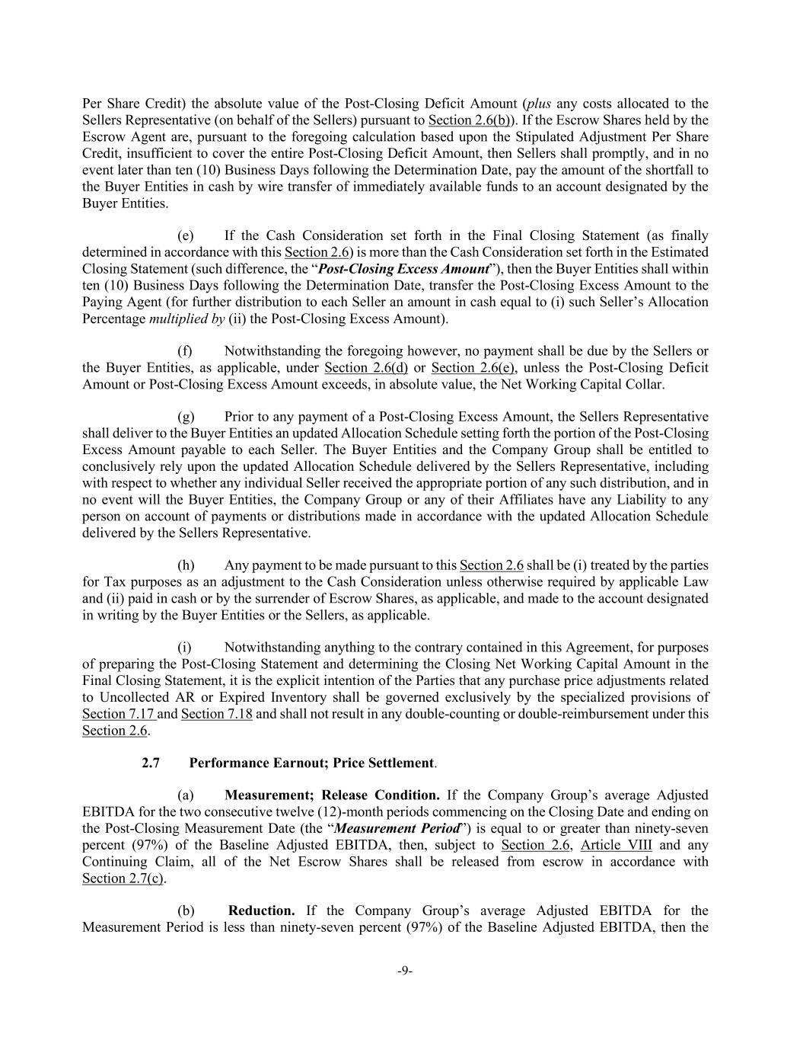
-9- Per Share Credit) the absolute value of the Post-Closing Deficit Amount (plus any costs allocated to the Sellers Representative (on behalf of the Sellers) pursuant to Section 2.6(b)). If the Escrow Shares held by the Escrow Agent are, pursuant to the foregoing calculation based upon the Stipulated Adjustment Per Share Credit, insufficient to cover the entire Post-Closing Deficit Amount, then Sellers shall promptly, and in no event later than ten (10) Business Days following the Determination Date, pay the amount of the shortfall to the Buyer Entities in cash by wire transfer of immediately available funds to an account designated by the Buyer Entities. (e) If the Cash Consideration set forth in the Final Closing Statement (as finally determined in accordance with this Section 2.6) is more than the Cash Consideration set forth in the Estimated Closing Statement (such difference, the “Post-Closing Excess Amount”), then the Buyer Entities shall within ten (10) Business Days following the Determination Date, transfer the Post-Closing Excess Amount to the Paying Agent (for further distribution to each Seller an amount in cash equal to (i) such Seller’s Allocation Percentage multiplied by (ii) the Post-Closing Excess Amount). (f) Notwithstanding the foregoing however, no payment shall be due by the Sellers or the Buyer Entities, as applicable, under Section 2.6(d) or Section 2.6(e), unless the Post-Closing Deficit Amount or Post-Closing Excess Amount exceeds, in absolute value, the Net Working Capital Collar. (g) Prior to any payment of a Post-Closing Excess Amount, the Sellers Representative shall deliver to the Buyer Entities an updated Allocation Schedule setting forth the portion of the Post-Closing Excess Amount payable to each Seller. The Buyer Entities and the Company Group shall be entitled to conclusively rely upon the updated Allocation Schedule delivered by the Sellers Representative, including with respect to whether any individual Seller received the appropriate portion of any such distribution, and in no event will the Buyer Entities, the Company Group or any of their Affiliates have any Liability to any person on account of payments or distributions made in accordance with the updated Allocation Schedule delivered by the Sellers Representative. (h) Any payment to be made pursuant to this Section 2.6 shall be (i) treated by the parties for Tax purposes as an adjustment to the Cash Consideration unless otherwise required by applicable Law and (ii) paid in cash or by the surrender of Escrow Shares, as applicable, and made to the account designated in writing by the Buyer Entities or the Sellers, as applicable. (i) Notwithstanding anything to the contrary contained in this Agreement, for purposes of preparing the Post-Closing Statement and determining the Closing Net Working Capital Amount in the Final Closing Statement, it is the explicit intention of the Parties that any purchase price adjustments related to Uncollected AR or Expired Inventory shall be governed exclusively by the specialized provisions of Section 7.17 and Section 7.18 and shall not result in any double-counting or double-reimbursement under this Section 2.6. 2.7 Performance Earnout; Price Settlement. (a) Measurement; Release Condition. If the Company Group’s average Adjusted EBITDA for the two consecutive twelve (12)-month periods commencing on the Closing Date and ending on the Post-Closing Measurement Date (the “Measurement Period”) is equal to or greater than ninety-seven percent (97%) of the Baseline Adjusted EBITDA, then, subject to Section 2.6, Article VIII and any Continuing Claim, all of the Net Escrow Shares shall be released from escrow in accordance with Section 2.7(c). (b) Reduction. If the Company Group’s average Adjusted EBITDA for the Measurement Period is less than ninety-seven percent (97%) of the Baseline Adjusted EBITDA, then the

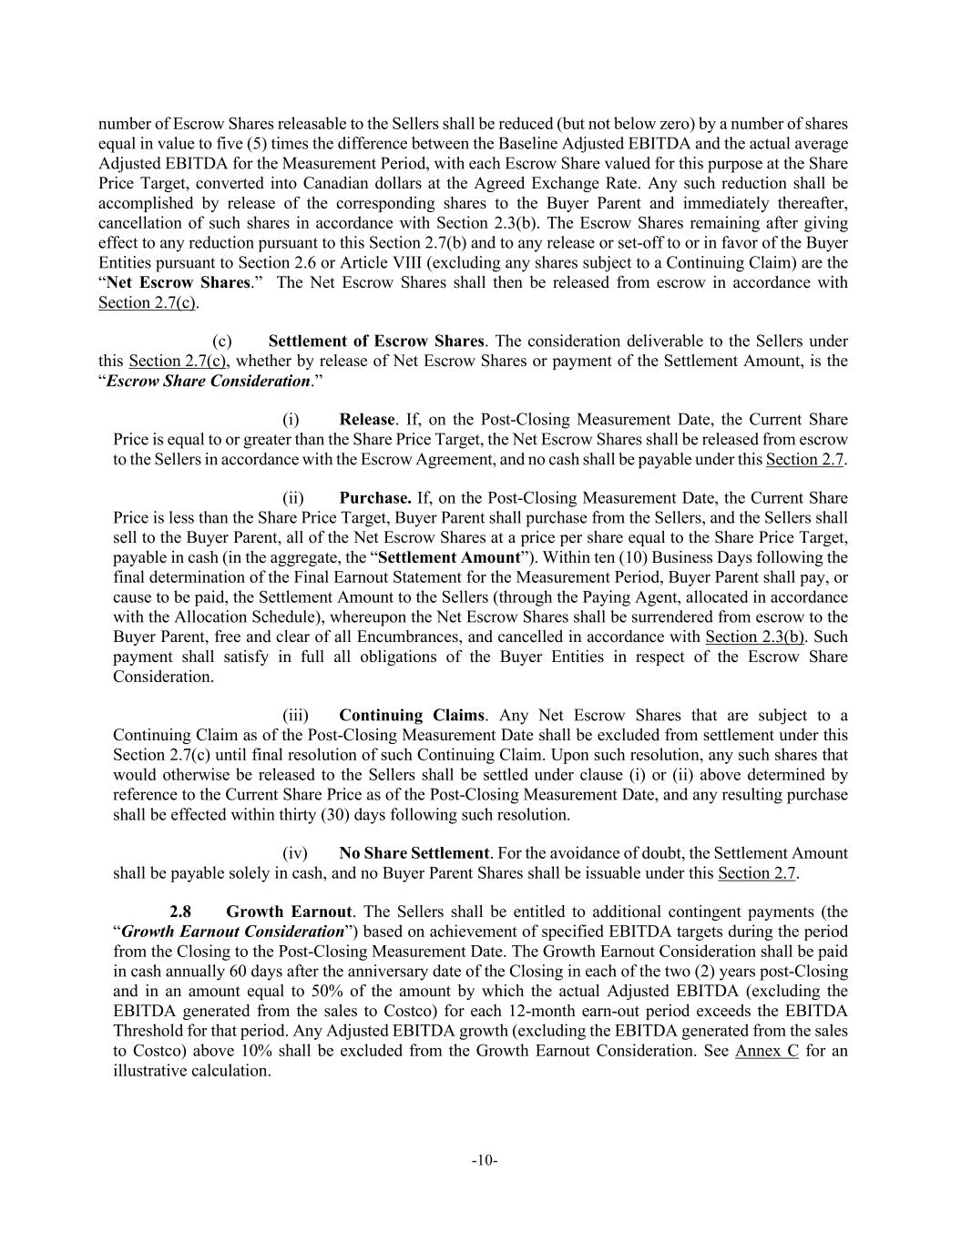
-10- number of Escrow Shares releasable to the Sellers shall be reduced (but not below zero) by a number of shares equal in value to five (5) times the difference between the Baseline Adjusted EBITDA and the actual average Adjusted EBITDA for the Measurement Period, with each Escrow Share valued for this purpose at the Share Price Target, converted into Canadian dollars at the Agreed Exchange Rate. Any such reduction shall be accomplished by release of the corresponding shares to the Buyer Parent and immediately thereafter, cancellation of such shares in accordance with Section 2.3(b). The Escrow Shares remaining after giving effect to any reduction pursuant to this Section 2.7(b) and to any release or set-off to or in favor of the Buyer Entities pursuant to Section 2.6 or Article VIII (excluding any shares subject to a Continuing Claim) are the “Net Escrow Shares.” The Net Escrow Shares shall then be released from escrow in accordance with Section 2.7(c). (c) Settlement of Escrow Shares. The consideration deliverable to the Sellers under this Section 2.7(c), whether by release of Net Escrow Shares or payment of the Settlement Amount, is the “Escrow Share Consideration.” (i) Release. If, on the Post-Closing Measurement Date, the Current Share Price is equal to or greater than the Share Price Target, the Net Escrow Shares shall be released from escrow to the Sellers in accordance with the Escrow Agreement, and no cash shall be payable under this Section 2.7. (ii) Purchase. If, on the Post-Closing Measurement Date, the Current Share Price is less than the Share Price Target, Buyer Parent shall purchase from the Sellers, and the Sellers shall sell to the Buyer Parent, all of the Net Escrow Shares at a price per share equal to the Share Price Target, payable in cash (in the aggregate, the “Settlement Amount”). Within ten (10) Business Days following the final determination of the Final Earnout Statement for the Measurement Period, Buyer Parent shall pay, or cause to be paid, the Settlement Amount to the Sellers (through the Paying Agent, allocated in accordance with the Allocation Schedule), whereupon the Net Escrow Shares shall be surrendered from escrow to the Buyer Parent, free and clear of all Encumbrances, and cancelled in accordance with Section 2.3(b). Such payment shall satisfy in full all obligations of the Buyer Entities in respect of the Escrow Share Consideration. (iii) Continuing Claims. Any Net Escrow Shares that are subject to a Continuing Claim as of the Post-Closing Measurement Date shall be excluded from settlement under this Section 2.7(c) until final resolution of such Continuing Claim. Upon such resolution, any such shares that would otherwise be released to the Sellers shall be settled under clause (i) or (ii) above determined by reference to the Current Share Price as of the Post-Closing Measurement Date, and any resulting purchase shall be effected within thirty (30) days following such resolution. (iv) No Share Settlement. For the avoidance of doubt, the Settlement Amount shall be payable solely in cash, and no Buyer Parent Shares shall be issuable under this Section 2.7. 2.8 Growth Earnout. The Sellers shall be entitled to additional contingent payments (the “Growth Earnout Consideration”) based on achievement of specified EBITDA targets during the period from the Closing to the Post-Closing Measurement Date. The Growth Earnout Consideration shall be paid in cash annually 60 days after the anniversary date of the Closing in each of the two (2) years post-Closing and in an amount equal to 50% of the amount by which the actual Adjusted EBITDA (excluding the EBITDA generated from the sales to Costco) for each 12-month earn-out period exceeds the EBITDA Threshold for that period. Any Adjusted EBITDA growth (excluding the EBITDA generated from the sales to Costco) above 10% shall be excluded from the Growth Earnout Consideration. See Annex C for an illustrative calculation.

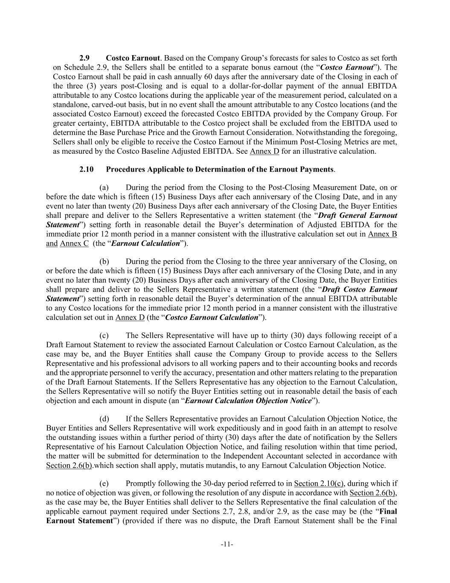
-11- 2.9 Costco Earnout. Based on the Company Group’s forecasts for sales to Costco as set forth on Schedule 2.9, the Sellers shall be entitled to a separate bonus earnout (the “Costco Earnout”). The Costco Earnout shall be paid in cash annually 60 days after the anniversary date of the Closing in each of the three (3) years post-Closing and is equal to a dollar-for-dollar payment of the annual EBITDA attributable to any Costco locations during the applicable year of the measurement period, calculated on a standalone, carved-out basis, but in no event shall the amount attributable to any Costco locations (and the associated Costco Earnout) exceed the forecasted Costco EBITDA provided by the Company Group. For greater certainty, EBITDA attributable to the Costco project shall be excluded from the EBITDA used to determine the Base Purchase Price and the Growth Earnout Consideration. Notwithstanding the foregoing, Sellers shall only be eligible to receive the Costco Earnout if the Minimum Post-Closing Metrics are met, as measured by the Costco Baseline Adjusted EBITDA. See Annex D for an illustrative calculation. 2.10 Procedures Applicable to Determination of the Earnout Payments. (a) During the period from the Closing to the Post-Closing Measurement Date, on or before the date which is fifteen (15) Business Days after each anniversary of the Closing Date, and in any event no later than twenty (20) Business Days after each anniversary of the Closing Date, the Buyer Entities shall prepare and deliver to the Sellers Representative a written statement (the “Draft General Earnout Statement”) setting forth in reasonable detail the Buyer’s determination of Adjusted EBITDA for the immediate prior 12 month period in a manner consistent with the illustrative calculation set out in Annex B and Annex C (the “Earnout Calculation”). (b) During the period from the Closing to the three year anniversary of the Closing, on or before the date which is fifteen (15) Business Days after each anniversary of the Closing Date, and in any event no later than twenty (20) Business Days after each anniversary of the Closing Date, the Buyer Entities shall prepare and deliver to the Sellers Representative a written statement (the “Draft Costco Earnout Statement”) setting forth in reasonable detail the Buyer’s determination of the annual EBITDA attributable to any Costco locations for the immediate prior 12 month period in a manner consistent with the illustrative calculation set out in Annex D (the “Costco Earnout Calculation”). (c) The Sellers Representative will have up to thirty (30) days following receipt of a Draft Earnout Statement to review the associated Earnout Calculation or Costco Earnout Calculation, as the case may be, and the Buyer Entities shall cause the Company Group to provide access to the Sellers Representative and his professional advisors to all working papers and to their accounting books and records and the appropriate personnel to verify the accuracy, presentation and other matters relating to the preparation of the Draft Earnout Statements. If the Sellers Representative has any objection to the Earnout Calculation, the Sellers Representative will so notify the Buyer Entities setting out in reasonable detail the basis of each objection and each amount in dispute (an “Earnout Calculation Objection Notice”). (d) If the Sellers Representative provides an Earnout Calculation Objection Notice, the Buyer Entities and Sellers Representative will work expeditiously and in good faith in an attempt to resolve the outstanding issues within a further period of thirty (30) days after the date of notification by the Sellers Representative of his Earnout Calculation Objection Notice, and failing resolution within that time period, the matter will be submitted for determination to the Independent Accountant selected in accordance with Section 2.6(b).which section shall apply, mutatis mutandis, to any Earnout Calculation Objection Notice. (e) Promptly following the 30-day period referred to in Section 2.10(c), during which if no notice of objection was given, or following the resolution of any dispute in accordance with Section 2.6(b), as the case may be, the Buyer Entities shall deliver to the Sellers Representative the final calculation of the applicable earnout payment required under Sections 2.7, 2.8, and/or 2.9, as the case may be (the “Final Earnout Statement”) (provided if there was no dispute, the Draft Earnout Statement shall be the Final

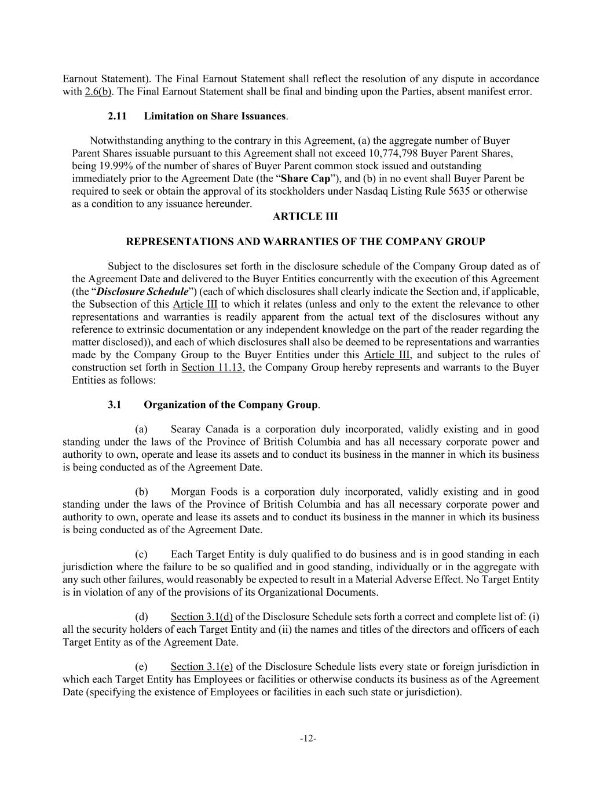
-12- Earnout Statement). The Final Earnout Statement shall reflect the resolution of any dispute in accordance with 2.6(b). The Final Earnout Statement shall be final and binding upon the Parties, absent manifest error. 2.11 Limitation on Share Issuances. Notwithstanding anything to the contrary in this Agreement, (a) the aggregate number of Buyer Parent Shares issuable pursuant to this Agreement shall not exceed 10,774,798 Buyer Parent Shares, being 19.99% of the number of shares of Buyer Parent common stock issued and outstanding immediately prior to the Agreement Date (the “Share Cap”), and (b) in no event shall Buyer Parent be required to seek or obtain the approval of its stockholders under Nasdaq Listing Rule 5635 or otherwise as a condition to any issuance hereunder. ARTICLE III REPRESENTATIONS AND WARRANTIES OF THE COMPANY GROUP Subject to the disclosures set forth in the disclosure schedule of the Company Group dated as of the Agreement Date and delivered to the Buyer Entities concurrently with the execution of this Agreement (the “Disclosure Schedule”) (each of which disclosures shall clearly indicate the Section and, if applicable, the Subsection of this Article III to which it relates (unless and only to the extent the relevance to other representations and warranties is readily apparent from the actual text of the disclosures without any reference to extrinsic documentation or any independent knowledge on the part of the reader regarding the matter disclosed)), and each of which disclosures shall also be deemed to be representations and warranties made by the Company Group to the Buyer Entities under this Article III, and subject to the rules of construction set forth in Section 11.13, the Company Group hereby represents and warrants to the Buyer Entities as follows: 3.1 Organization of the Company Group. (a) Searay Canada is a corporation duly incorporated, validly existing and in good standing under the laws of the Province of British Columbia and has all necessary corporate power and authority to own, operate and lease its assets and to conduct its business in the manner in which its business is being conducted as of the Agreement Date. (b) Morgan Foods is a corporation duly incorporated, validly existing and in good standing under the laws of the Province of British Columbia and has all necessary corporate power and authority to own, operate and lease its assets and to conduct its business in the manner in which its business is being conducted as of the Agreement Date. (c) Each Target Entity is duly qualified to do business and is in good standing in each jurisdiction where the failure to be so qualified and in good standing, individually or in the aggregate with any such other failures, would reasonably be expected to result in a Material Adverse Effect. No Target Entity is in violation of any of the provisions of its Organizational Documents. (d) Section 3.1(d) of the Disclosure Schedule sets forth a correct and complete list of: (i) all the security holders of each Target Entity and (ii) the names and titles of the directors and officers of each Target Entity as of the Agreement Date. (e) Section 3.1(e) of the Disclosure Schedule lists every state or foreign jurisdiction in which each Target Entity has Employees or facilities or otherwise conducts its business as of the Agreement Date (specifying the existence of Employees or facilities in each such state or jurisdiction).

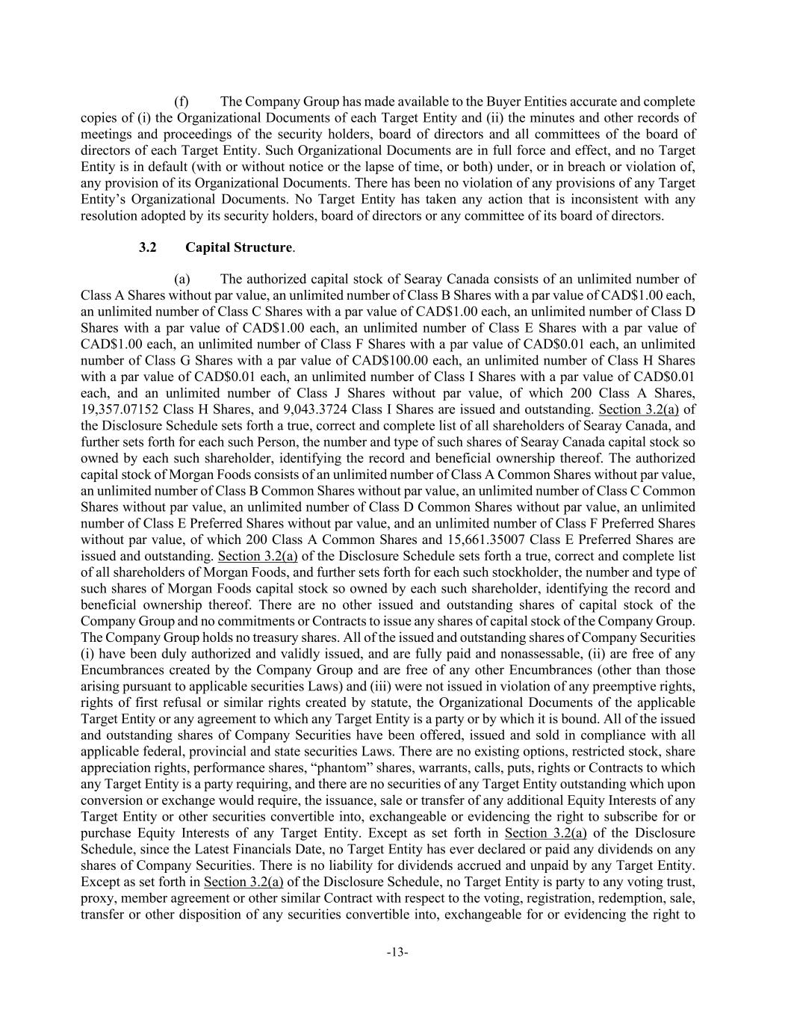
-13- (f) The Company Group has made available to the Buyer Entities accurate and complete copies of (i) the Organizational Documents of each Target Entity and (ii) the minutes and other records of meetings and proceedings of the security holders, board of directors and all committees of the board of directors of each Target Entity. Such Organizational Documents are in full force and effect, and no Target Entity is in default (with or without notice or the lapse of time, or both) under, or in breach or violation of, any provision of its Organizational Documents. There has been no violation of any provisions of any Target Entity’s Organizational Documents. No Target Entity has taken any action that is inconsistent with any resolution adopted by its security holders, board of directors or any committee of its board of directors. 3.2 Capital Structure. (a) The authorized capital stock of Searay Canada consists of an unlimited number of Class A Shares without par value, an unlimited number of Class B Shares with a par value of CAD$1.00 each, an unlimited number of Class C Shares with a par value of CAD$1.00 each, an unlimited number of Class D Shares with a par value of CAD$1.00 each, an unlimited number of Class E Shares with a par value of CAD$1.00 each, an unlimited number of Class F Shares with a par value of CAD$0.01 each, an unlimited number of Class G Shares with a par value of CAD$100.00 each, an unlimited number of Class H Shares with a par value of CAD$0.01 each, an unlimited number of Class I Shares with a par value of CAD$0.01 each, and an unlimited number of Class J Shares without par value, of which 200 Class A Shares, 19,357.07152 Class H Shares, and 9,043.3724 Class I Shares are issued and outstanding. Section 3.2(a) of the Disclosure Schedule sets forth a true, correct and complete list of all shareholders of Searay Canada, and further sets forth for each such Person, the number and type of such shares of Searay Canada capital stock so owned by each such shareholder, identifying the record and beneficial ownership thereof. The authorized capital stock of Morgan Foods consists of an unlimited number of Class A Common Shares without par value, an unlimited number of Class B Common Shares without par value, an unlimited number of Class C Common Shares without par value, an unlimited number of Class D Common Shares without par value, an unlimited number of Class E Preferred Shares without par value, and an unlimited number of Class F Preferred Shares without par value, of which 200 Class A Common Shares and 15,661.35007 Class E Preferred Shares are issued and outstanding. Section 3.2(a) of the Disclosure Schedule sets forth a true, correct and complete list of all shareholders of Morgan Foods, and further sets forth for each such stockholder, the number and type of such shares of Morgan Foods capital stock so owned by each such shareholder, identifying the record and beneficial ownership thereof. There are no other issued and outstanding shares of capital stock of the Company Group and no commitments or Contracts to issue any shares of capital stock of the Company Group. The Company Group holds no treasury shares. All of the issued and outstanding shares of Company Securities (i) have been duly authorized and validly issued, and are fully paid and nonassessable, (ii) are free of any Encumbrances created by the Company Group and are free of any other Encumbrances (other than those arising pursuant to applicable securities Laws) and (iii) were not issued in violation of any preemptive rights, rights of first refusal or similar rights created by statute, the Organizational Documents of the applicable Target Entity or any agreement to which any Target Entity is a party or by which it is bound. All of the issued and outstanding shares of Company Securities have been offered, issued and sold in compliance with all applicable federal, provincial and state securities Laws. There are no existing options, restricted stock, share appreciation rights, performance shares, “phantom” shares, warrants, calls, puts, rights or Contracts to which any Target Entity is a party requiring, and there are no securities of any Target Entity outstanding which upon conversion or exchange would require, the issuance, sale or transfer of any additional Equity Interests of any Target Entity or other securities convertible into, exchangeable or evidencing the right to subscribe for or purchase Equity Interests of any Target Entity. Except as set forth in Section 3.2(a) of the Disclosure Schedule, since the Latest Financials Date, no Target Entity has ever declared or paid any dividends on any shares of Company Securities. There is no liability for dividends accrued and unpaid by any Target Entity. Except as set forth in Section 3.2(a) of the Disclosure Schedule, no Target Entity is party to any voting trust, proxy, member agreement or other similar Contract with respect to the voting, registration, redemption, sale, transfer or other disposition of any securities convertible into, exchangeable for or evidencing the right to

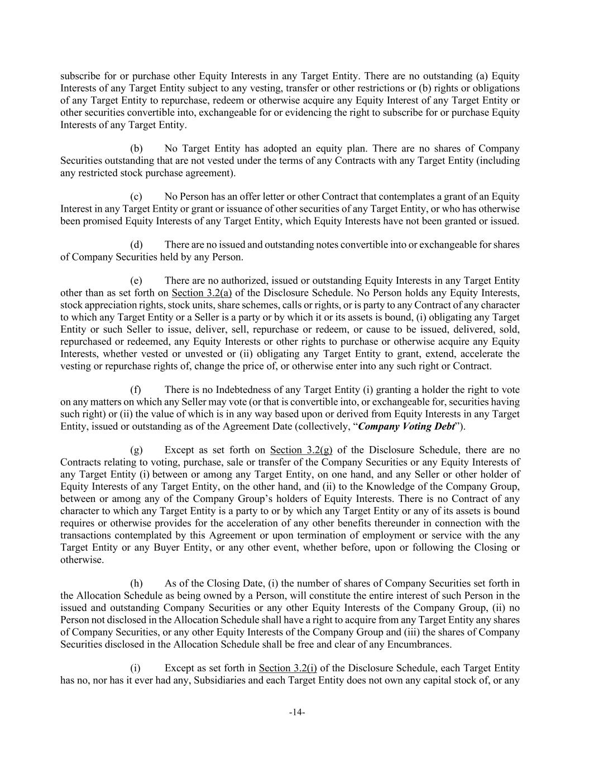
-14- subscribe for or purchase other Equity Interests in any Target Entity. There are no outstanding (a) Equity Interests of any Target Entity subject to any vesting, transfer or other restrictions or (b) rights or obligations of any Target Entity to repurchase, redeem or otherwise acquire any Equity Interest of any Target Entity or other securities convertible into, exchangeable for or evidencing the right to subscribe for or purchase Equity Interests of any Target Entity. (b) No Target Entity has adopted an equity plan. There are no shares of Company Securities outstanding that are not vested under the terms of any Contracts with any Target Entity (including any restricted stock purchase agreement). (c) No Person has an offer letter or other Contract that contemplates a grant of an Equity Interest in any Target Entity or grant or issuance of other securities of any Target Entity, or who has otherwise been promised Equity Interests of any Target Entity, which Equity Interests have not been granted or issued. (d) There are no issued and outstanding notes convertible into or exchangeable for shares of Company Securities held by any Person. (e) There are no authorized, issued or outstanding Equity Interests in any Target Entity other than as set forth on Section 3.2(a) of the Disclosure Schedule. No Person holds any Equity Interests, stock appreciation rights, stock units, share schemes, calls or rights, or is party to any Contract of any character to which any Target Entity or a Seller is a party or by which it or its assets is bound, (i) obligating any Target Entity or such Seller to issue, deliver, sell, repurchase or redeem, or cause to be issued, delivered, sold, repurchased or redeemed, any Equity Interests or other rights to purchase or otherwise acquire any Equity Interests, whether vested or unvested or (ii) obligating any Target Entity to grant, extend, accelerate the vesting or repurchase rights of, change the price of, or otherwise enter into any such right or Contract. (f) There is no Indebtedness of any Target Entity (i) granting a holder the right to vote on any matters on which any Seller may vote (or that is convertible into, or exchangeable for, securities having such right) or (ii) the value of which is in any way based upon or derived from Equity Interests in any Target Entity, issued or outstanding as of the Agreement Date (collectively, “Company Voting Debt”). (g) Except as set forth on Section 3.2(g) of the Disclosure Schedule, there are no Contracts relating to voting, purchase, sale or transfer of the Company Securities or any Equity Interests of any Target Entity (i) between or among any Target Entity, on one hand, and any Seller or other holder of Equity Interests of any Target Entity, on the other hand, and (ii) to the Knowledge of the Company Group, between or among any of the Company Group’s holders of Equity Interests. There is no Contract of any character to which any Target Entity is a party to or by which any Target Entity or any of its assets is bound requires or otherwise provides for the acceleration of any other benefits thereunder in connection with the transactions contemplated by this Agreement or upon termination of employment or service with the any Target Entity or any Buyer Entity, or any other event, whether before, upon or following the Closing or otherwise. (h) As of the Closing Date, (i) the number of shares of Company Securities set forth in the Allocation Schedule as being owned by a Person, will constitute the entire interest of such Person in the issued and outstanding Company Securities or any other Equity Interests of the Company Group, (ii) no Person not disclosed in the Allocation Schedule shall have a right to acquire from any Target Entity any shares of Company Securities, or any other Equity Interests of the Company Group and (iii) the shares of Company Securities disclosed in the Allocation Schedule shall be free and clear of any Encumbrances. (i) Except as set forth in Section 3.2(i) of the Disclosure Schedule, each Target Entity has no, nor has it ever had any, Subsidiaries and each Target Entity does not own any capital stock of, or any

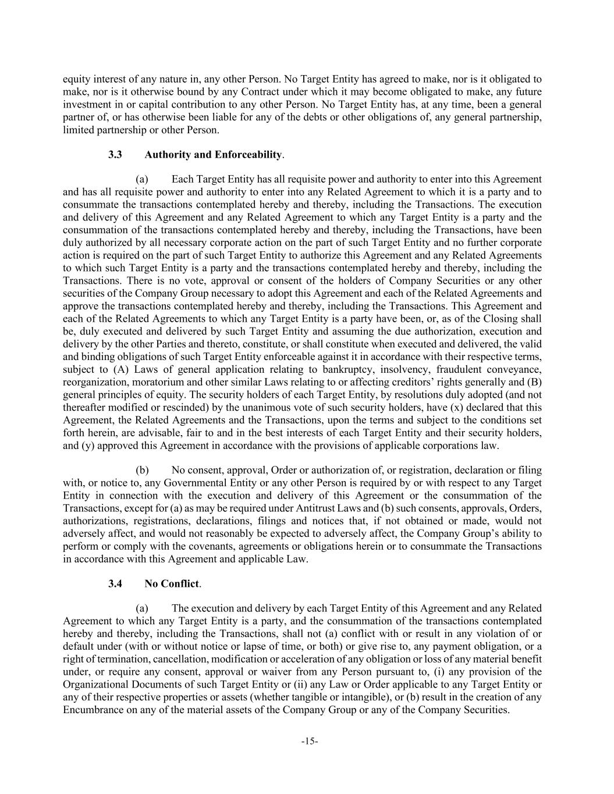
-15- equity interest of any nature in, any other Person. No Target Entity has agreed to make, nor is it obligated to make, nor is it otherwise bound by any Contract under which it may become obligated to make, any future investment in or capital contribution to any other Person. No Target Entity has, at any time, been a general partner of, or has otherwise been liable for any of the debts or other obligations of, any general partnership, limited partnership or other Person. 3.3 Authority and Enforceability. (a) Each Target Entity has all requisite power and authority to enter into this Agreement and has all requisite power and authority to enter into any Related Agreement to which it is a party and to consummate the transactions contemplated hereby and thereby, including the Transactions. The execution and delivery of this Agreement and any Related Agreement to which any Target Entity is a party and the consummation of the transactions contemplated hereby and thereby, including the Transactions, have been duly authorized by all necessary corporate action on the part of such Target Entity and no further corporate action is required on the part of such Target Entity to authorize this Agreement and any Related Agreements to which such Target Entity is a party and the transactions contemplated hereby and thereby, including the Transactions. There is no vote, approval or consent of the holders of Company Securities or any other securities of the Company Group necessary to adopt this Agreement and each of the Related Agreements and approve the transactions contemplated hereby and thereby, including the Transactions. This Agreement and each of the Related Agreements to which any Target Entity is a party have been, or, as of the Closing shall be, duly executed and delivered by such Target Entity and assuming the due authorization, execution and delivery by the other Parties and thereto, constitute, or shall constitute when executed and delivered, the valid and binding obligations of such Target Entity enforceable against it in accordance with their respective terms, subject to (A) Laws of general application relating to bankruptcy, insolvency, fraudulent conveyance, reorganization, moratorium and other similar Laws relating to or affecting creditors’ rights generally and (B) general principles of equity. The security holders of each Target Entity, by resolutions duly adopted (and not thereafter modified or rescinded) by the unanimous vote of such security holders, have (x) declared that this Agreement, the Related Agreements and the Transactions, upon the terms and subject to the conditions set forth herein, are advisable, fair to and in the best interests of each Target Entity and their security holders, and (y) approved this Agreement in accordance with the provisions of applicable corporations law. (b) No consent, approval, Order or authorization of, or registration, declaration or filing with, or notice to, any Governmental Entity or any other Person is required by or with respect to any Target Entity in connection with the execution and delivery of this Agreement or the consummation of the Transactions, except for (a) as may be required under Antitrust Laws and (b) such consents, approvals, Orders, authorizations, registrations, declarations, filings and notices that, if not obtained or made, would not adversely affect, and would not reasonably be expected to adversely affect, the Company Group’s ability to perform or comply with the covenants, agreements or obligations herein or to consummate the Transactions in accordance with this Agreement and applicable Law. 3.4 No Conflict. (a) The execution and delivery by each Target Entity of this Agreement and any Related Agreement to which any Target Entity is a party, and the consummation of the transactions contemplated hereby and thereby, including the Transactions, shall not (a) conflict with or result in any violation of or default under (with or without notice or lapse of time, or both) or give rise to, any payment obligation, or a right of termination, cancellation, modification or acceleration of any obligation or loss of any material benefit under, or require any consent, approval or waiver from any Person pursuant to, (i) any provision of the Organizational Documents of such Target Entity or (ii) any Law or Order applicable to any Target Entity or any of their respective properties or assets (whether tangible or intangible), or (b) result in the creation of any Encumbrance on any of the material assets of the Company Group or any of the Company Securities.

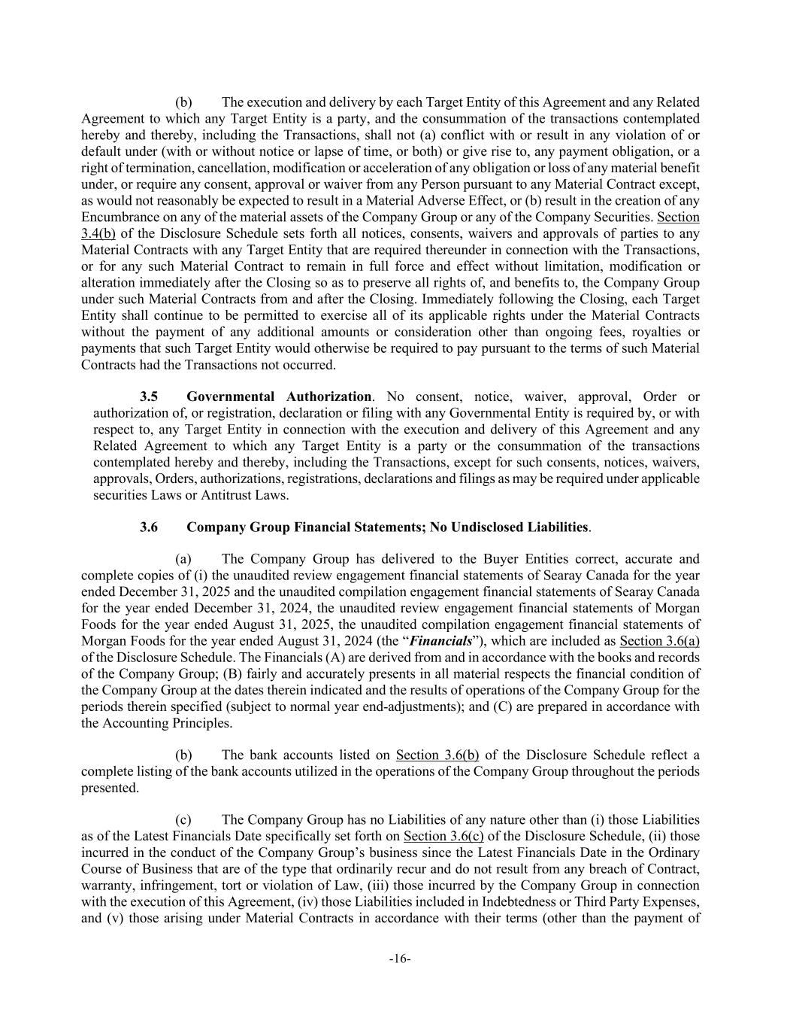
-16- (b) The execution and delivery by each Target Entity of this Agreement and any Related Agreement to which any Target Entity is a party, and the consummation of the transactions contemplated hereby and thereby, including the Transactions, shall not (a) conflict with or result in any violation of or default under (with or without notice or lapse of time, or both) or give rise to, any payment obligation, or a right of termination, cancellation, modification or acceleration of any obligation or loss of any material benefit under, or require any consent, approval or waiver from any Person pursuant to any Material Contract except, as would not reasonably be expected to result in a Material Adverse Effect, or (b) result in the creation of any Encumbrance on any of the material assets of the Company Group or any of the Company Securities. Section 3.4(b) of the Disclosure Schedule sets forth all notices, consents, waivers and approvals of parties to any Material Contracts with any Target Entity that are required thereunder in connection with the Transactions, or for any such Material Contract to remain in full force and effect without limitation, modification or alteration immediately after the Closing so as to preserve all rights of, and benefits to, the Company Group under such Material Contracts from and after the Closing. Immediately following the Closing, each Target Entity shall continue to be permitted to exercise all of its applicable rights under the Material Contracts without the payment of any additional amounts or consideration other than ongoing fees, royalties or payments that such Target Entity would otherwise be required to pay pursuant to the terms of such Material Contracts had the Transactions not occurred. 3.5 Governmental Authorization. No consent, notice, waiver, approval, Order or authorization of, or registration, declaration or filing with any Governmental Entity is required by, or with respect to, any Target Entity in connection with the execution and delivery of this Agreement and any Related Agreement to which any Target Entity is a party or the consummation of the transactions contemplated hereby and thereby, including the Transactions, except for such consents, notices, waivers, approvals, Orders, authorizations, registrations, declarations and filings as may be required under applicable securities Laws or Antitrust Laws. 3.6 Company Group Financial Statements; No Undisclosed Liabilities. (a) The Company Group has delivered to the Buyer Entities correct, accurate and complete copies of (i) the unaudited review engagement financial statements of Searay Canada for the year ended December 31, 2025 and the unaudited compilation engagement financial statements of Searay Canada for the year ended December 31, 2024, the unaudited review engagement financial statements of Morgan Foods for the year ended August 31, 2025, the unaudited compilation engagement financial statements of Morgan Foods for the year ended August 31, 2024 (the “Financials”), which are included as Section 3.6(a) of the Disclosure Schedule. The Financials (A) are derived from and in accordance with the books and records of the Company Group; (B) fairly and accurately presents in all material respects the financial condition of the Company Group at the dates therein indicated and the results of operations of the Company Group for the periods therein specified (subject to normal year end-adjustments); and (C) are prepared in accordance with the Accounting Principles. (b) The bank accounts listed on Section 3.6(b) of the Disclosure Schedule reflect a complete listing of the bank accounts utilized in the operations of the Company Group throughout the periods presented. (c) The Company Group has no Liabilities of any nature other than (i) those Liabilities as of the Latest Financials Date specifically set forth on Section 3.6(c) of the Disclosure Schedule, (ii) those incurred in the conduct of the Company Group’s business since the Latest Financials Date in the Ordinary Course of Business that are of the type that ordinarily recur and do not result from any breach of Contract, warranty, infringement, tort or violation of Law, (iii) those incurred by the Company Group in connection with the execution of this Agreement, (iv) those Liabilities included in Indebtedness or Third Party Expenses, and (v) those arising under Material Contracts in accordance with their terms (other than the payment of

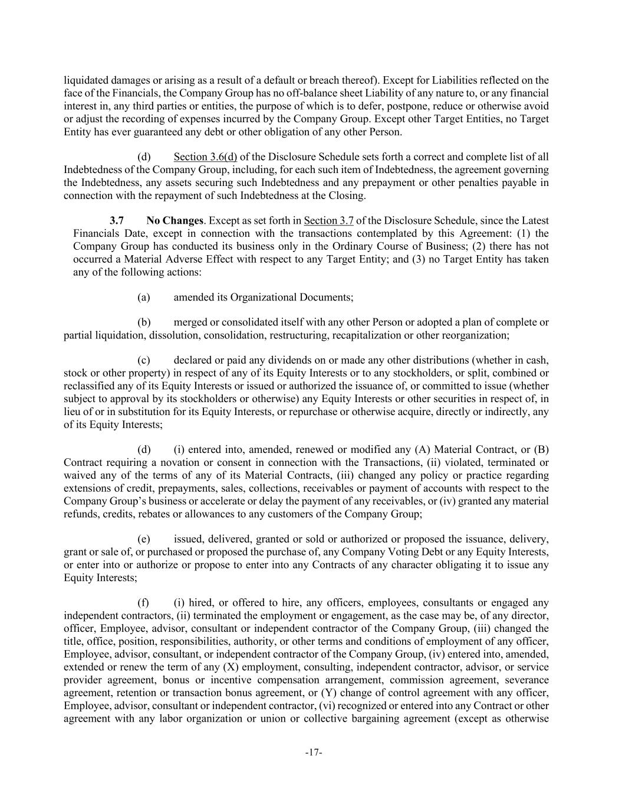
-17- liquidated damages or arising as a result of a default or breach thereof). Except for Liabilities reflected on the face of the Financials, the Company Group has no off-balance sheet Liability of any nature to, or any financial interest in, any third parties or entities, the purpose of which is to defer, postpone, reduce or otherwise avoid or adjust the recording of expenses incurred by the Company Group. Except other Target Entities, no Target Entity has ever guaranteed any debt or other obligation of any other Person. (d) Section 3.6(d) of the Disclosure Schedule sets forth a correct and complete list of all Indebtedness of the Company Group, including, for each such item of Indebtedness, the agreement governing the Indebtedness, any assets securing such Indebtedness and any prepayment or other penalties payable in connection with the repayment of such Indebtedness at the Closing. 3.7 No Changes. Except as set forth in Section 3.7 of the Disclosure Schedule, since the Latest Financials Date, except in connection with the transactions contemplated by this Agreement: (1) the Company Group has conducted its business only in the Ordinary Course of Business; (2) there has not occurred a Material Adverse Effect with respect to any Target Entity; and (3) no Target Entity has taken any of the following actions: (a) amended its Organizational Documents; (b) merged or consolidated itself with any other Person or adopted a plan of complete or partial liquidation, dissolution, consolidation, restructuring, recapitalization or other reorganization; (c) declared or paid any dividends on or made any other distributions (whether in cash, stock or other property) in respect of any of its Equity Interests or to any stockholders, or split, combined or reclassified any of its Equity Interests or issued or authorized the issuance of, or committed to issue (whether subject to approval by its stockholders or otherwise) any Equity Interests or other securities in respect of, in lieu of or in substitution for its Equity Interests, or repurchase or otherwise acquire, directly or indirectly, any of its Equity Interests; (d) (i) entered into, amended, renewed or modified any (A) Material Contract, or (B) Contract requiring a novation or consent in connection with the Transactions, (ii) violated, terminated or waived any of the terms of any of its Material Contracts, (iii) changed any policy or practice regarding extensions of credit, prepayments, sales, collections, receivables or payment of accounts with respect to the Company Group’s business or accelerate or delay the payment of any receivables, or (iv) granted any material refunds, credits, rebates or allowances to any customers of the Company Group; (e) issued, delivered, granted or sold or authorized or proposed the issuance, delivery, grant or sale of, or purchased or proposed the purchase of, any Company Voting Debt or any Equity Interests, or enter into or authorize or propose to enter into any Contracts of any character obligating it to issue any Equity Interests; (f) (i) hired, or offered to hire, any officers, employees, consultants or engaged any independent contractors, (ii) terminated the employment or engagement, as the case may be, of any director, officer, Employee, advisor, consultant or independent contractor of the Company Group, (iii) changed the title, office, position, responsibilities, authority, or other terms and conditions of employment of any officer, Employee, advisor, consultant, or independent contractor of the Company Group, (iv) entered into, amended, extended or renew the term of any (X) employment, consulting, independent contractor, advisor, or service provider agreement, bonus or incentive compensation arrangement, commission agreement, severance agreement, retention or transaction bonus agreement, or (Y) change of control agreement with any officer, Employee, advisor, consultant or independent contractor, (vi) recognized or entered into any Contract or other agreement with any labor organization or union or collective bargaining agreement (except as otherwise

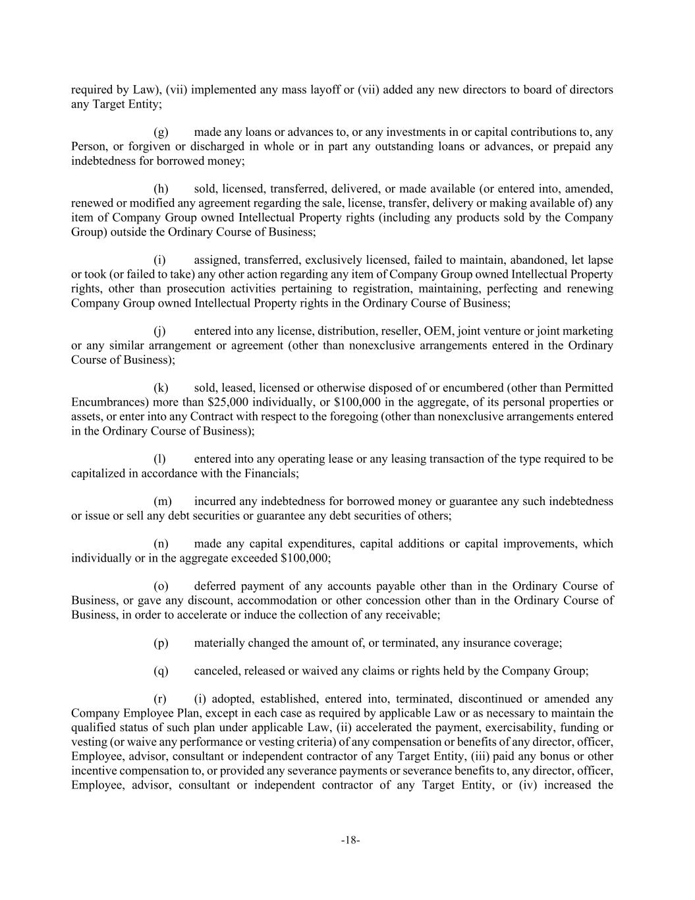
-18- required by Law), (vii) implemented any mass layoff or (vii) added any new directors to board of directors any Target Entity; (g) made any loans or advances to, or any investments in or capital contributions to, any Person, or forgiven or discharged in whole or in part any outstanding loans or advances, or prepaid any indebtedness for borrowed money; (h) sold, licensed, transferred, delivered, or made available (or entered into, amended, renewed or modified any agreement regarding the sale, license, transfer, delivery or making available of) any item of Company Group owned Intellectual Property rights (including any products sold by the Company Group) outside the Ordinary Course of Business; (i) assigned, transferred, exclusively licensed, failed to maintain, abandoned, let lapse or took (or failed to take) any other action regarding any item of Company Group owned Intellectual Property rights, other than prosecution activities pertaining to registration, maintaining, perfecting and renewing Company Group owned Intellectual Property rights in the Ordinary Course of Business; (j) entered into any license, distribution, reseller, OEM, joint venture or joint marketing or any similar arrangement or agreement (other than nonexclusive arrangements entered in the Ordinary Course of Business); (k) sold, leased, licensed or otherwise disposed of or encumbered (other than Permitted Encumbrances) more than $25,000 individually, or $100,000 in the aggregate, of its personal properties or assets, or enter into any Contract with respect to the foregoing (other than nonexclusive arrangements entered in the Ordinary Course of Business); (l) entered into any operating lease or any leasing transaction of the type required to be capitalized in accordance with the Financials; (m) incurred any indebtedness for borrowed money or guarantee any such indebtedness or issue or sell any debt securities or guarantee any debt securities of others; (n) made any capital expenditures, capital additions or capital improvements, which individually or in the aggregate exceeded $100,000; (o) deferred payment of any accounts payable other than in the Ordinary Course of Business, or gave any discount, accommodation or other concession other than in the Ordinary Course of Business, in order to accelerate or induce the collection of any receivable; (p) materially changed the amount of, or terminated, any insurance coverage; (q) canceled, released or waived any claims or rights held by the Company Group; (r) (i) adopted, established, entered into, terminated, discontinued or amended any Company Employee Plan, except in each case as required by applicable Law or as necessary to maintain the qualified status of such plan under applicable Law, (ii) accelerated the payment, exercisability, funding or vesting (or waive any performance or vesting criteria) of any compensation or benefits of any director, officer, Employee, advisor, consultant or independent contractor of any Target Entity, (iii) paid any bonus or other incentive compensation to, or provided any severance payments or severance benefits to, any director, officer, Employee, advisor, consultant or independent contractor of any Target Entity, or (iv) increased the

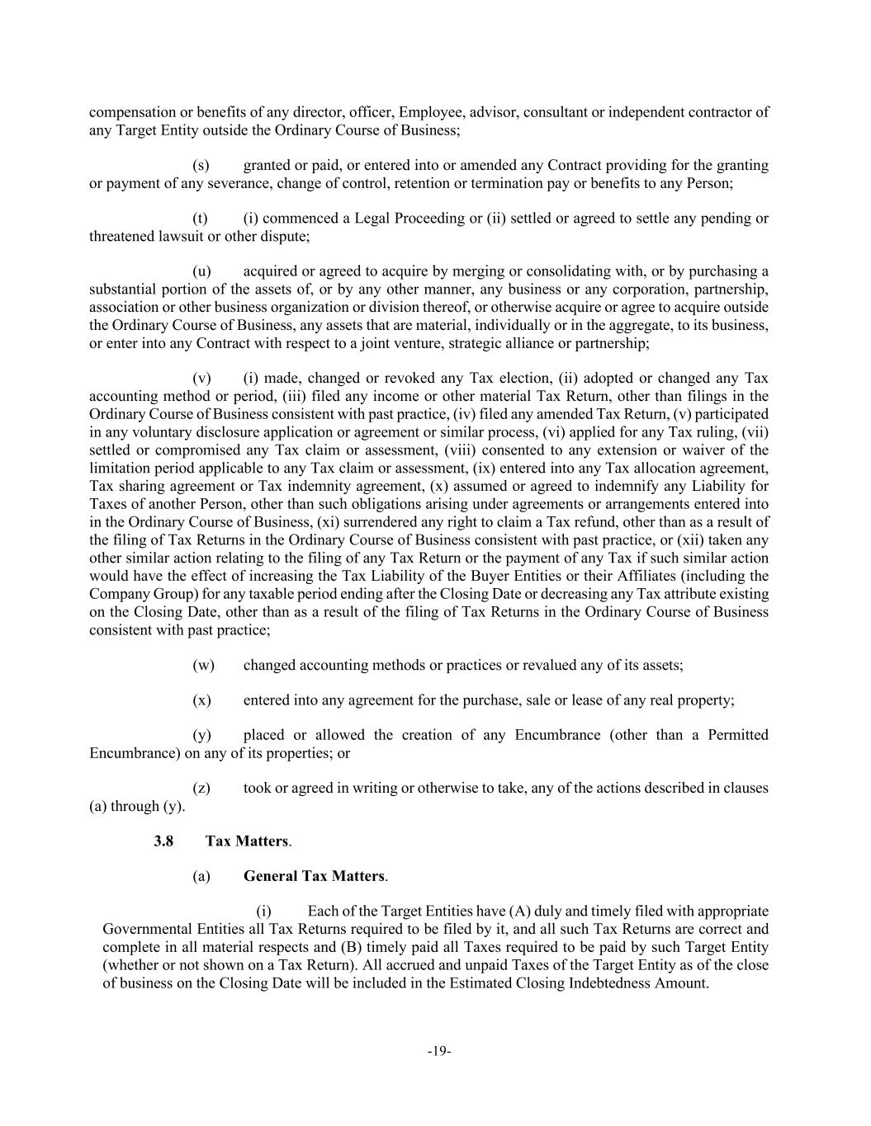
-19- compensation or benefits of any director, officer, Employee, advisor, consultant or independent contractor of any Target Entity outside the Ordinary Course of Business; (s) granted or paid, or entered into or amended any Contract providing for the granting or payment of any severance, change of control, retention or termination pay or benefits to any Person; (t) (i) commenced a Legal Proceeding or (ii) settled or agreed to settle any pending or threatened lawsuit or other dispute; (u) acquired or agreed to acquire by merging or consolidating with, or by purchasing a substantial portion of the assets of, or by any other manner, any business or any corporation, partnership, association or other business organization or division thereof, or otherwise acquire or agree to acquire outside the Ordinary Course of Business, any assets that are material, individually or in the aggregate, to its business, or enter into any Contract with respect to a joint venture, strategic alliance or partnership; (v) (i) made, changed or revoked any Tax election, (ii) adopted or changed any Tax accounting method or period, (iii) filed any income or other material Tax Return, other than filings in the Ordinary Course of Business consistent with past practice, (iv) filed any amended Tax Return, (v) participated in any voluntary disclosure application or agreement or similar process, (vi) applied for any Tax ruling, (vii) settled or compromised any Tax claim or assessment, (viii) consented to any extension or waiver of the limitation period applicable to any Tax claim or assessment, (ix) entered into any Tax allocation agreement, Tax sharing agreement or Tax indemnity agreement, (x) assumed or agreed to indemnify any Liability for Taxes of another Person, other than such obligations arising under agreements or arrangements entered into in the Ordinary Course of Business, (xi) surrendered any right to claim a Tax refund, other than as a result of the filing of Tax Returns in the Ordinary Course of Business consistent with past practice, or (xii) taken any other similar action relating to the filing of any Tax Return or the payment of any Tax if such similar action would have the effect of increasing the Tax Liability of the Buyer Entities or their Affiliates (including the Company Group) for any taxable period ending after the Closing Date or decreasing any Tax attribute existing on the Closing Date, other than as a result of the filing of Tax Returns in the Ordinary Course of Business consistent with past practice; (w) changed accounting methods or practices or revalued any of its assets; (x) entered into any agreement for the purchase, sale or lease of any real property; (y) placed or allowed the creation of any Encumbrance (other than a Permitted Encumbrance) on any of its properties; or (z) took or agreed in writing or otherwise to take, any of the actions described in clauses (a) through (y). 3.8 Tax Matters. (a) General Tax Matters. (i) Each of the Target Entities have (A) duly and timely filed with appropriate Governmental Entities all Tax Returns required to be filed by it, and all such Tax Returns are correct and complete in all material respects and (B) timely paid all Taxes required to be paid by such Target Entity (whether or not shown on a Tax Return). All accrued and unpaid Taxes of the Target Entity as of the close of business on the Closing Date will be included in the Estimated Closing Indebtedness Amount.

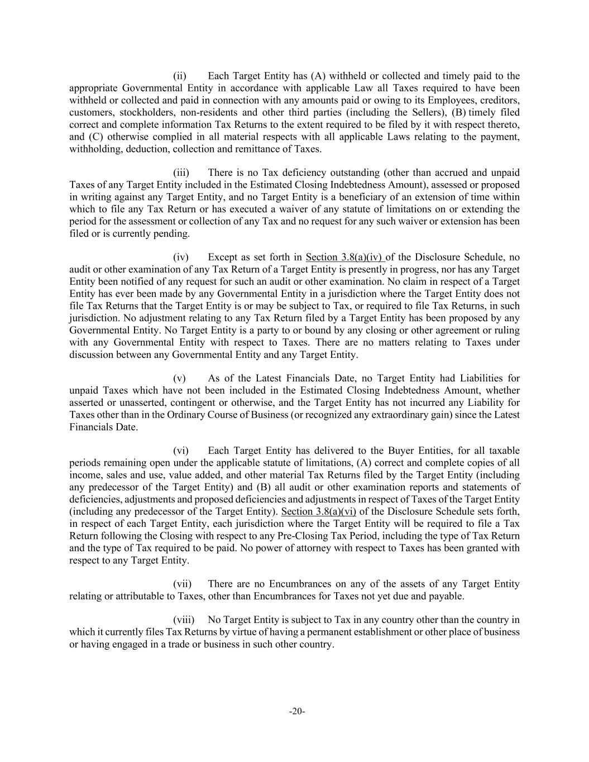
-20- (ii) Each Target Entity has (A) withheld or collected and timely paid to the appropriate Governmental Entity in accordance with applicable Law all Taxes required to have been withheld or collected and paid in connection with any amounts paid or owing to its Employees, creditors, customers, stockholders, non-residents and other third parties (including the Sellers), (B) timely filed correct and complete information Tax Returns to the extent required to be filed by it with respect thereto, and (C) otherwise complied in all material respects with all applicable Laws relating to the payment, withholding, deduction, collection and remittance of Taxes. (iii) There is no Tax deficiency outstanding (other than accrued and unpaid Taxes of any Target Entity included in the Estimated Closing Indebtedness Amount), assessed or proposed in writing against any Target Entity, and no Target Entity is a beneficiary of an extension of time within which to file any Tax Return or has executed a waiver of any statute of limitations on or extending the period for the assessment or collection of any Tax and no request for any such waiver or extension has been filed or is currently pending. (iv) Except as set forth in Section 3.8(a)(iv) of the Disclosure Schedule, no audit or other examination of any Tax Return of a Target Entity is presently in progress, nor has any Target Entity been notified of any request for such an audit or other examination. No claim in respect of a Target Entity has ever been made by any Governmental Entity in a jurisdiction where the Target Entity does not file Tax Returns that the Target Entity is or may be subject to Tax, or required to file Tax Returns, in such jurisdiction. No adjustment relating to any Tax Return filed by a Target Entity has been proposed by any Governmental Entity. No Target Entity is a party to or bound by any closing or other agreement or ruling with any Governmental Entity with respect to Taxes. There are no matters relating to Taxes under discussion between any Governmental Entity and any Target Entity. (v) As of the Latest Financials Date, no Target Entity had Liabilities for unpaid Taxes which have not been included in the Estimated Closing Indebtedness Amount, whether asserted or unasserted, contingent or otherwise, and the Target Entity has not incurred any Liability for Taxes other than in the Ordinary Course of Business (or recognized any extraordinary gain) since the Latest Financials Date. (vi) Each Target Entity has delivered to the Buyer Entities, for all taxable periods remaining open under the applicable statute of limitations, (A) correct and complete copies of all income, sales and use, value added, and other material Tax Returns filed by the Target Entity (including any predecessor of the Target Entity) and (B) all audit or other examination reports and statements of deficiencies, adjustments and proposed deficiencies and adjustments in respect of Taxes of the Target Entity (including any predecessor of the Target Entity). Section 3.8(a)(vi) of the Disclosure Schedule sets forth, in respect of each Target Entity, each jurisdiction where the Target Entity will be required to file a Tax Return following the Closing with respect to any Pre-Closing Tax Period, including the type of Tax Return and the type of Tax required to be paid. No power of attorney with respect to Taxes has been granted with respect to any Target Entity. (vii) There are no Encumbrances on any of the assets of any Target Entity relating or attributable to Taxes, other than Encumbrances for Taxes not yet due and payable. (viii) No Target Entity is subject to Tax in any country other than the country in which it currently files Tax Returns by virtue of having a permanent establishment or other place of business or having engaged in a trade or business in such other country.

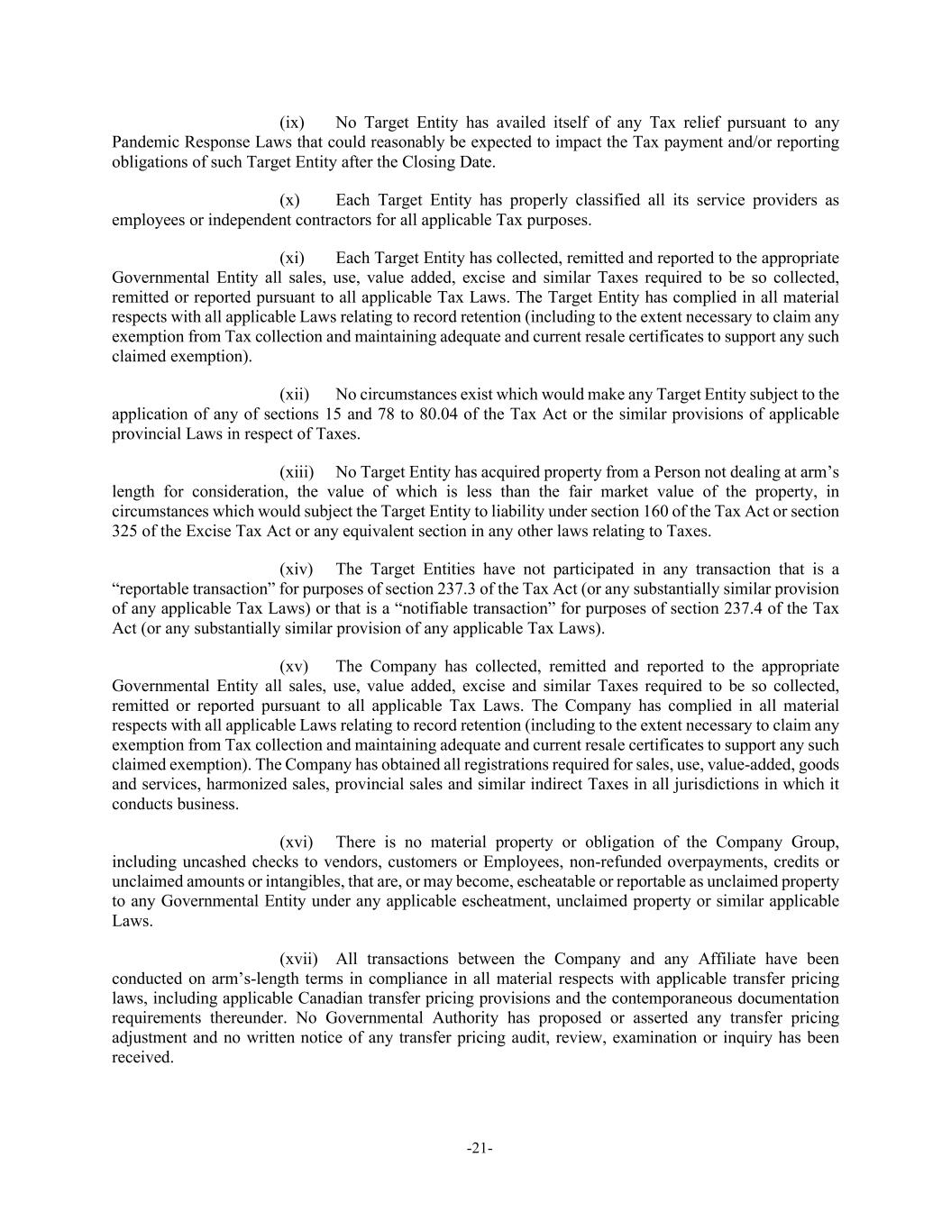
-21- (ix) No Target Entity has availed itself of any Tax relief pursuant to any Pandemic Response Laws that could reasonably be expected to impact the Tax payment and/or reporting obligations of such Target Entity after the Closing Date. (x) Each Target Entity has properly classified all its service providers as employees or independent contractors for all applicable Tax purposes. (xi) Each Target Entity has collected, remitted and reported to the appropriate Governmental Entity all sales, use, value added, excise and similar Taxes required to be so collected, remitted or reported pursuant to all applicable Tax Laws. The Target Entity has complied in all material respects with all applicable Laws relating to record retention (including to the extent necessary to claim any exemption from Tax collection and maintaining adequate and current resale certificates to support any such claimed exemption). (xii) No circumstances exist which would make any Target Entity subject to the application of any of sections 15 and 78 to 80.04 of the Tax Act or the similar provisions of applicable provincial Laws in respect of Taxes. (xiii) No Target Entity has acquired property from a Person not dealing at arm’s length for consideration, the value of which is less than the fair market value of the property, in circumstances which would subject the Target Entity to liability under section 160 of the Tax Act or section 325 of the Excise Tax Act or any equivalent section in any other laws relating to Taxes. (xiv) The Target Entities have not participated in any transaction that is a “reportable transaction” for purposes of section 237.3 of the Tax Act (or any substantially similar provision of any applicable Tax Laws) or that is a “notifiable transaction” for purposes of section 237.4 of the Tax Act (or any substantially similar provision of any applicable Tax Laws). (xv) The Company has collected, remitted and reported to the appropriate Governmental Entity all sales, use, value added, excise and similar Taxes required to be so collected, remitted or reported pursuant to all applicable Tax Laws. The Company has complied in all material respects with all applicable Laws relating to record retention (including to the extent necessary to claim any exemption from Tax collection and maintaining adequate and current resale certificates to support any such claimed exemption). The Company has obtained all registrations required for sales, use, value-added, goods and services, harmonized sales, provincial sales and similar indirect Taxes in all jurisdictions in which it conducts business. (xvi) There is no material property or obligation of the Company Group, including uncashed checks to vendors, customers or Employees, non-refunded overpayments, credits or unclaimed amounts or intangibles, that are, or may become, escheatable or reportable as unclaimed property to any Governmental Entity under any applicable escheatment, unclaimed property or similar applicable Laws. (xvii) All transactions between the Company and any Affiliate have been conducted on arm’s-length terms in compliance in all material respects with applicable transfer pricing laws, including applicable Canadian transfer pricing provisions and the contemporaneous documentation requirements thereunder. No Governmental Authority has proposed or asserted any transfer pricing adjustment and no written notice of any transfer pricing audit, review, examination or inquiry has been received.

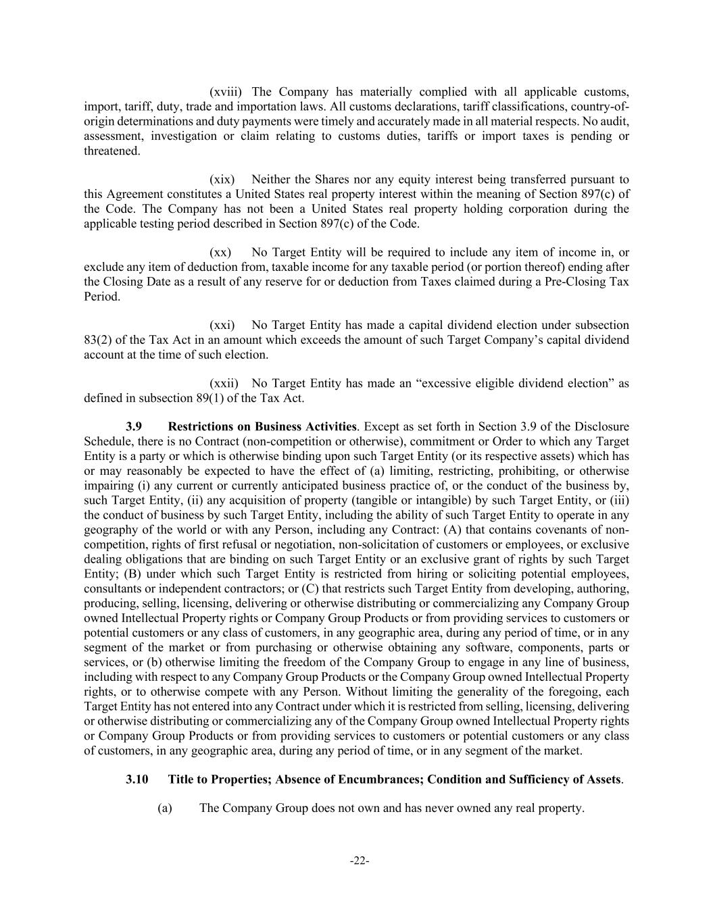
-22- (xviii) The Company has materially complied with all applicable customs, import, tariff, duty, trade and importation laws. All customs declarations, tariff classifications, country-of- origin determinations and duty payments were timely and accurately made in all material respects. No audit, assessment, investigation or claim relating to customs duties, tariffs or import taxes is pending or threatened. (xix) Neither the Shares nor any equity interest being transferred pursuant to this Agreement constitutes a United States real property interest within the meaning of Section 897(c) of the Code. The Company has not been a United States real property holding corporation during the applicable testing period described in Section 897(c) of the Code. (xx) No Target Entity will be required to include any item of income in, or exclude any item of deduction from, taxable income for any taxable period (or portion thereof) ending after the Closing Date as a result of any reserve for or deduction from Taxes claimed during a Pre-Closing Tax Period. (xxi) No Target Entity has made a capital dividend election under subsection 83(2) of the Tax Act in an amount which exceeds the amount of such Target Company’s capital dividend account at the time of such election. (xxii) No Target Entity has made an “excessive eligible dividend election” as defined in subsection 89(1) of the Tax Act. 3.9 Restrictions on Business Activities. Except as set forth in Section 3.9 of the Disclosure Schedule, there is no Contract (non-competition or otherwise), commitment or Order to which any Target Entity is a party or which is otherwise binding upon such Target Entity (or its respective assets) which has or may reasonably be expected to have the effect of (a) limiting, restricting, prohibiting, or otherwise impairing (i) any current or currently anticipated business practice of, or the conduct of the business by, such Target Entity, (ii) any acquisition of property (tangible or intangible) by such Target Entity, or (iii) the conduct of business by such Target Entity, including the ability of such Target Entity to operate in any geography of the world or with any Person, including any Contract: (A) that contains covenants of non- competition, rights of first refusal or negotiation, non-solicitation of customers or employees, or exclusive dealing obligations that are binding on such Target Entity or an exclusive grant of rights by such Target Entity; (B) under which such Target Entity is restricted from hiring or soliciting potential employees, consultants or independent contractors; or (C) that restricts such Target Entity from developing, authoring, producing, selling, licensing, delivering or otherwise distributing or commercializing any Company Group owned Intellectual Property rights or Company Group Products or from providing services to customers or potential customers or any class of customers, in any geographic area, during any period of time, or in any segment of the market or from purchasing or otherwise obtaining any software, components, parts or services, or (b) otherwise limiting the freedom of the Company Group to engage in any line of business, including with respect to any Company Group Products or the Company Group owned Intellectual Property rights, or to otherwise compete with any Person. Without limiting the generality of the foregoing, each Target Entity has not entered into any Contract under which it is restricted from selling, licensing, delivering or otherwise distributing or commercializing any of the Company Group owned Intellectual Property rights or Company Group Products or from providing services to customers or potential customers or any class of customers, in any geographic area, during any period of time, or in any segment of the market. 3.10 Title to Properties; Absence of Encumbrances; Condition and Sufficiency of Assets. (a) The Company Group does not own and has never owned any real property.

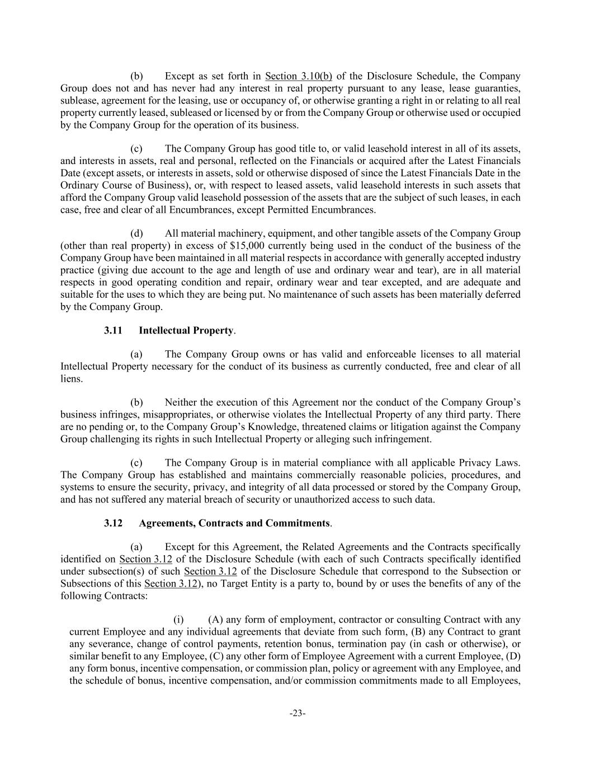
-23- (b) Except as set forth in Section 3.10(b) of the Disclosure Schedule, the Company Group does not and has never had any interest in real property pursuant to any lease, lease guaranties, sublease, agreement for the leasing, use or occupancy of, or otherwise granting a right in or relating to all real property currently leased, subleased or licensed by or from the Company Group or otherwise used or occupied by the Company Group for the operation of its business. (c) The Company Group has good title to, or valid leasehold interest in all of its assets, and interests in assets, real and personal, reflected on the Financials or acquired after the Latest Financials Date (except assets, or interests in assets, sold or otherwise disposed of since the Latest Financials Date in the Ordinary Course of Business), or, with respect to leased assets, valid leasehold interests in such assets that afford the Company Group valid leasehold possession of the assets that are the subject of such leases, in each case, free and clear of all Encumbrances, except Permitted Encumbrances. (d) All material machinery, equipment, and other tangible assets of the Company Group (other than real property) in excess of $15,000 currently being used in the conduct of the business of the Company Group have been maintained in all material respects in accordance with generally accepted industry practice (giving due account to the age and length of use and ordinary wear and tear), are in all material respects in good operating condition and repair, ordinary wear and tear excepted, and are adequate and suitable for the uses to which they are being put. No maintenance of such assets has been materially deferred by the Company Group. 3.11 Intellectual Property. (a) The Company Group owns or has valid and enforceable licenses to all material Intellectual Property necessary for the conduct of its business as currently conducted, free and clear of all liens. (b) Neither the execution of this Agreement nor the conduct of the Company Group’s business infringes, misappropriates, or otherwise violates the Intellectual Property of any third party. There are no pending or, to the Company Group’s Knowledge, threatened claims or litigation against the Company Group challenging its rights in such Intellectual Property or alleging such infringement. (c) The Company Group is in material compliance with all applicable Privacy Laws. The Company Group has established and maintains commercially reasonable policies, procedures, and systems to ensure the security, privacy, and integrity of all data processed or stored by the Company Group, and has not suffered any material breach of security or unauthorized access to such data. 3.12 Agreements, Contracts and Commitments. (a) Except for this Agreement, the Related Agreements and the Contracts specifically identified on Section 3.12 of the Disclosure Schedule (with each of such Contracts specifically identified under subsection(s) of such Section 3.12 of the Disclosure Schedule that correspond to the Subsection or Subsections of this Section 3.12), no Target Entity is a party to, bound by or uses the benefits of any of the following Contracts: (i) (A) any form of employment, contractor or consulting Contract with any current Employee and any individual agreements that deviate from such form, (B) any Contract to grant any severance, change of control payments, retention bonus, termination pay (in cash or otherwise), or similar benefit to any Employee, (C) any other form of Employee Agreement with a current Employee, (D) any form bonus, incentive compensation, or commission plan, policy or agreement with any Employee, and the schedule of bonus, incentive compensation, and/or commission commitments made to all Employees,

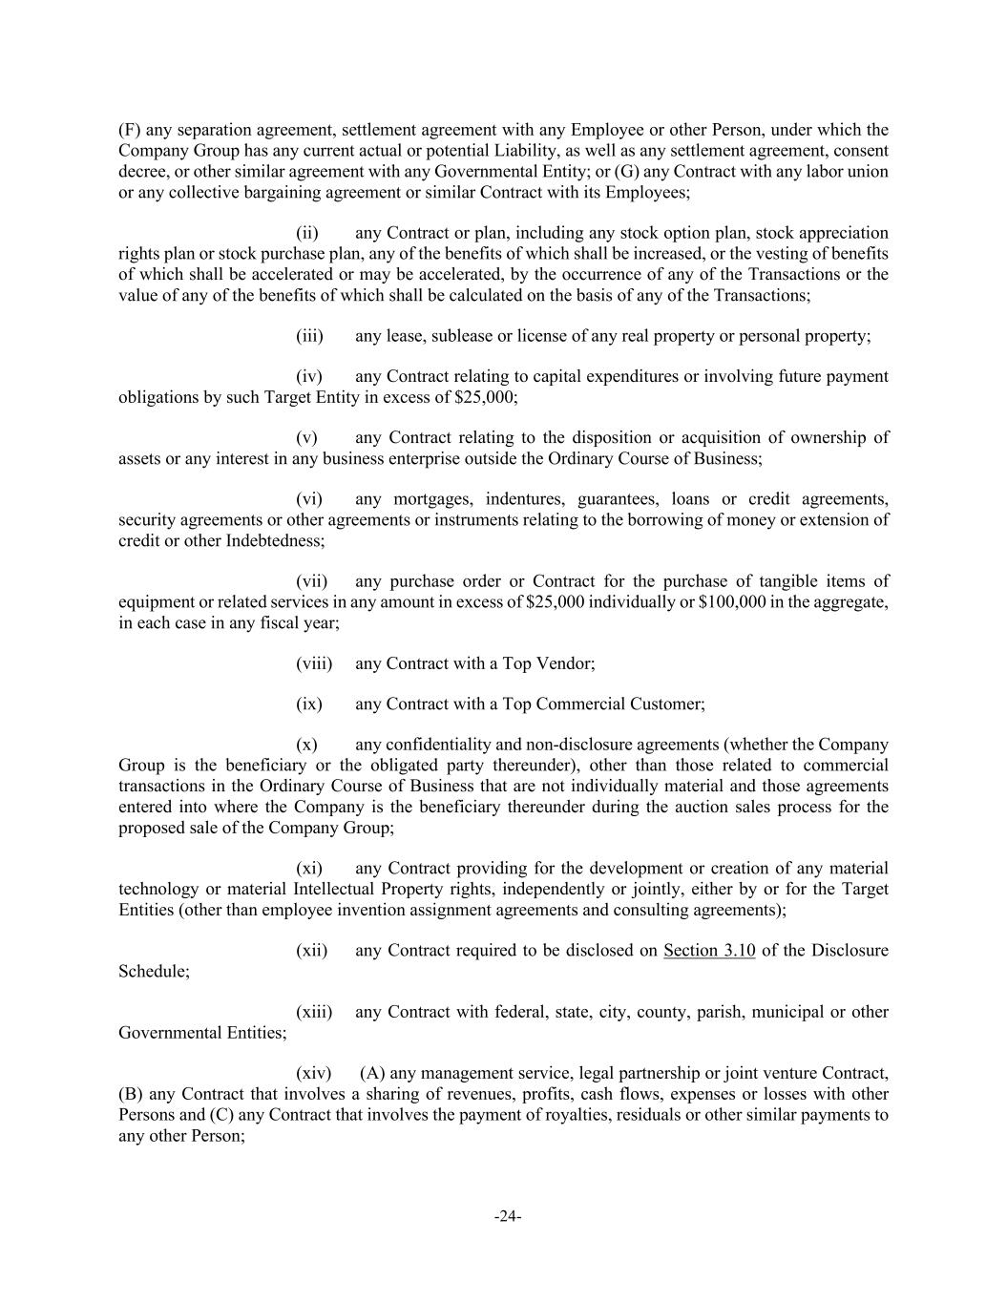
-24- (F) any separation agreement, settlement agreement with any Employee or other Person, under which the Company Group has any current actual or potential Liability, as well as any settlement agreement, consent decree, or other similar agreement with any Governmental Entity; or (G) any Contract with any labor union or any collective bargaining agreement or similar Contract with its Employees; (ii) any Contract or plan, including any stock option plan, stock appreciation rights plan or stock purchase plan, any of the benefits of which shall be increased, or the vesting of benefits of which shall be accelerated or may be accelerated, by the occurrence of any of the Transactions or the value of any of the benefits of which shall be calculated on the basis of any of the Transactions; (iii) any lease, sublease or license of any real property or personal property; (iv) any Contract relating to capital expenditures or involving future payment obligations by such Target Entity in excess of $25,000; (v) any Contract relating to the disposition or acquisition of ownership of assets or any interest in any business enterprise outside the Ordinary Course of Business; (vi) any mortgages, indentures, guarantees, loans or credit agreements, security agreements or other agreements or instruments relating to the borrowing of money or extension of credit or other Indebtedness; (vii) any purchase order or Contract for the purchase of tangible items of equipment or related services in any amount in excess of $25,000 individually or $100,000 in the aggregate, in each case in any fiscal year; (viii) any Contract with a Top Vendor; (ix) any Contract with a Top Commercial Customer; (x) any confidentiality and non-disclosure agreements (whether the Company Group is the beneficiary or the obligated party thereunder), other than those related to commercial transactions in the Ordinary Course of Business that are not individually material and those agreements entered into where the Company is the beneficiary thereunder during the auction sales process for the proposed sale of the Company Group; (xi) any Contract providing for the development or creation of any material technology or material Intellectual Property rights, independently or jointly, either by or for the Target Entities (other than employee invention assignment agreements and consulting agreements); (xii) any Contract required to be disclosed on Section 3.10 of the Disclosure Schedule; (xiii) any Contract with federal, state, city, county, parish, municipal or other Governmental Entities; (xiv) (A) any management service, legal partnership or joint venture Contract, (B) any Contract that involves a sharing of revenues, profits, cash flows, expenses or losses with other Persons and (C) any Contract that involves the payment of royalties, residuals or other similar payments to any other Person;

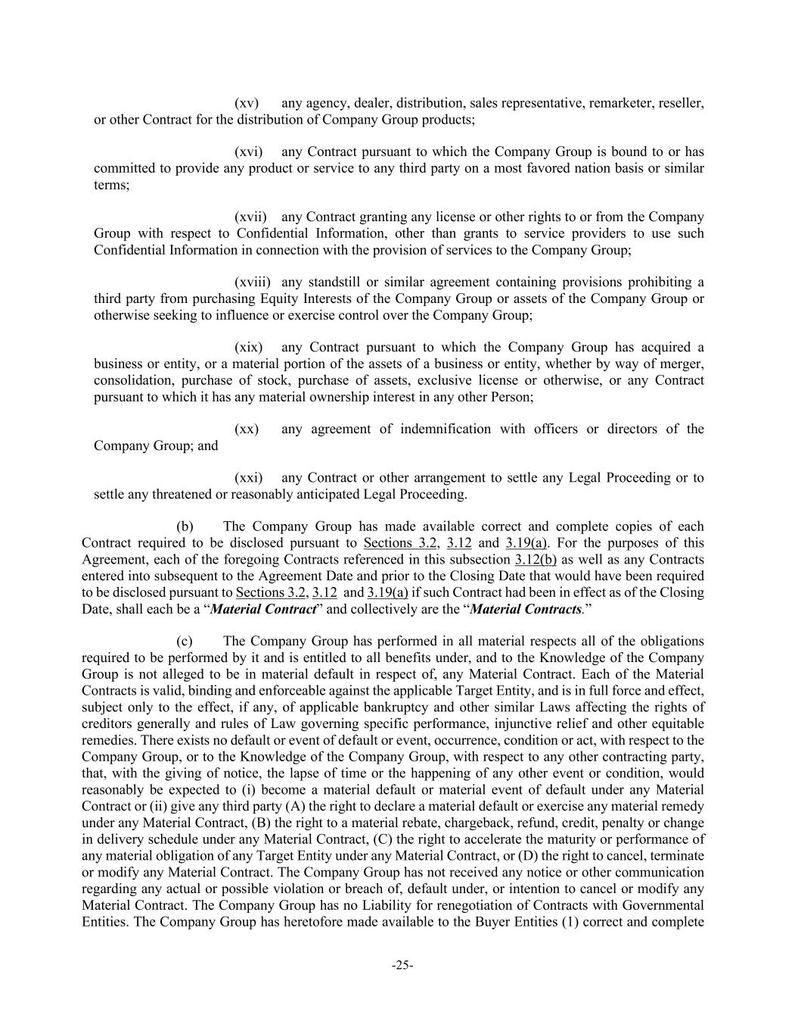
-25- (xv) any agency, dealer, distribution, sales representative, remarketer, reseller, or other Contract for the distribution of Company Group products; (xvi) any Contract pursuant to which the Company Group is bound to or has committed to provide any product or service to any third party on a most favored nation basis or similar terms; (xvii) any Contract granting any license or other rights to or from the Company Group with respect to Confidential Information, other than grants to service providers to use such Confidential Information in connection with the provision of services to the Company Group; (xviii) any standstill or similar agreement containing provisions prohibiting a third party from purchasing Equity Interests of the Company Group or assets of the Company Group or otherwise seeking to influence or exercise control over the Company Group; (xix) any Contract pursuant to which the Company Group has acquired a business or entity, or a material portion of the assets of a business or entity, whether by way of merger, consolidation, purchase of stock, purchase of assets, exclusive license or otherwise, or any Contract pursuant to which it has any material ownership interest in any other Person; (xx) any agreement of indemnification with officers or directors of the Company Group; and (xxi) any Contract or other arrangement to settle any Legal Proceeding or to settle any threatened or reasonably anticipated Legal Proceeding. (b) The Company Group has made available correct and complete copies of each Contract required to be disclosed pursuant to Sections 3.2, 3.12 and 3.19(a). For the purposes of this Agreement, each of the foregoing Contracts referenced in this subsection 3.12(b) as well as any Contracts entered into subsequent to the Agreement Date and prior to the Closing Date that would have been required to be disclosed pursuant to Sections 3.2, 3.12 and 3.19(a) if such Contract had been in effect as of the Closing Date, shall each be a “Material Contract” and collectively are the “Material Contracts.” (c) The Company Group has performed in all material respects all of the obligations required to be performed by it and is entitled to all benefits under, and to the Knowledge of the Company Group is not alleged to be in material default in respect of, any Material Contract. Each of the Material Contracts is valid, binding and enforceable against the applicable Target Entity, and is in full force and effect, subject only to the effect, if any, of applicable bankruptcy and other similar Laws affecting the rights of creditors generally and rules of Law governing specific performance, injunctive relief and other equitable remedies. There exists no default or event of default or event, occurrence, condition or act, with respect to the Company Group, or to the Knowledge of the Company Group, with respect to any other contracting party, that, with the giving of notice, the lapse of time or the happening of any other event or condition, would reasonably be expected to (i) become a material default or material event of default under any Material Contract or (ii) give any third party (A) the right to declare a material default or exercise any material remedy under any Material Contract, (B) the right to a material rebate, chargeback, refund, credit, penalty or change in delivery schedule under any Material Contract, (C) the right to accelerate the maturity or performance of any material obligation of any Target Entity under any Material Contract, or (D) the right to cancel, terminate or modify any Material Contract. The Company Group has not received any notice or other communication regarding any actual or possible violation or breach of, default under, or intention to cancel or modify any Material Contract. The Company Group has no Liability for renegotiation of Contracts with Governmental Entities. The Company Group has heretofore made available to the Buyer Entities (1) correct and complete

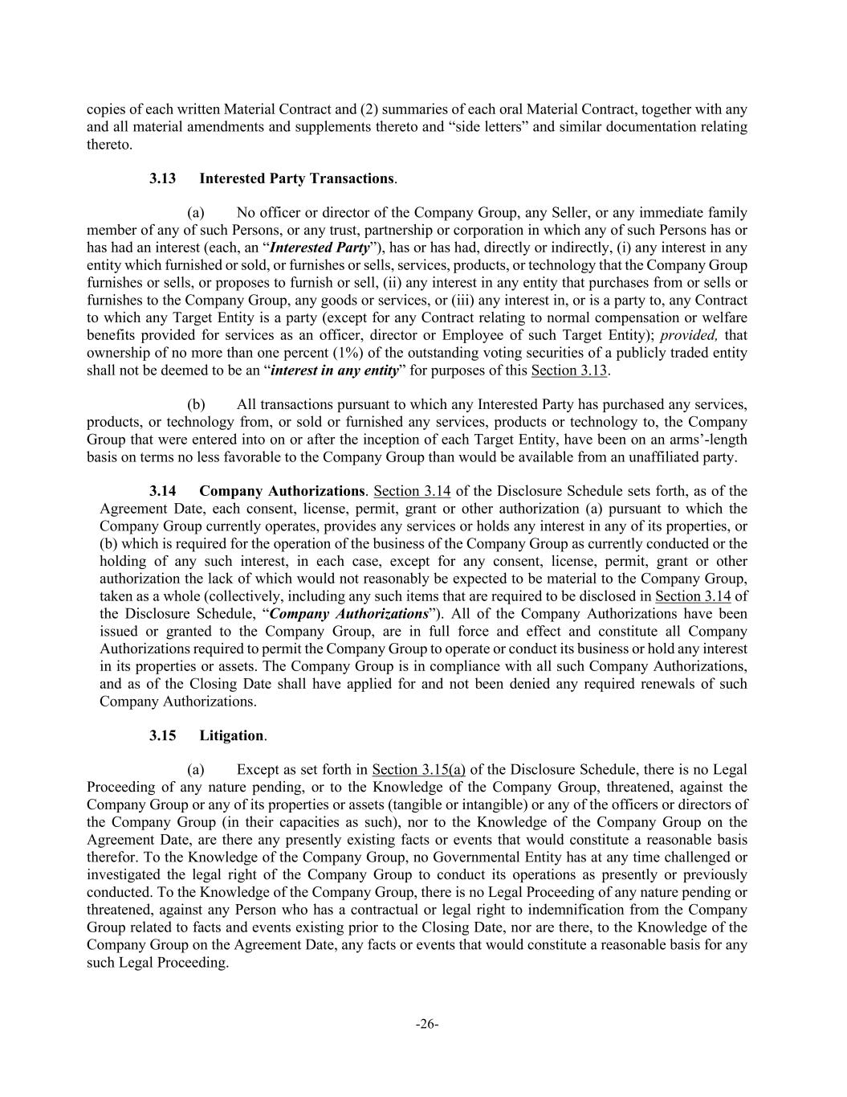
-26- copies of each written Material Contract and (2) summaries of each oral Material Contract, together with any and all material amendments and supplements thereto and “side letters” and similar documentation relating thereto. 3.13 Interested Party Transactions. (a) No officer or director of the Company Group, any Seller, or any immediate family member of any of such Persons, or any trust, partnership or corporation in which any of such Persons has or has had an interest (each, an “Interested Party”), has or has had, directly or indirectly, (i) any interest in any entity which furnished or sold, or furnishes or sells, services, products, or technology that the Company Group furnishes or sells, or proposes to furnish or sell, (ii) any interest in any entity that purchases from or sells or furnishes to the Company Group, any goods or services, or (iii) any interest in, or is a party to, any Contract to which any Target Entity is a party (except for any Contract relating to normal compensation or welfare benefits provided for services as an officer, director or Employee of such Target Entity); provided, that ownership of no more than one percent (1%) of the outstanding voting securities of a publicly traded entity shall not be deemed to be an “interest in any entity” for purposes of this Section 3.13. (b) All transactions pursuant to which any Interested Party has purchased any services, products, or technology from, or sold or furnished any services, products or technology to, the Company Group that were entered into on or after the inception of each Target Entity, have been on an arms’-length basis on terms no less favorable to the Company Group than would be available from an unaffiliated party. 3.14 Company Authorizations. Section 3.14 of the Disclosure Schedule sets forth, as of the Agreement Date, each consent, license, permit, grant or other authorization (a) pursuant to which the Company Group currently operates, provides any services or holds any interest in any of its properties, or (b) which is required for the operation of the business of the Company Group as currently conducted or the holding of any such interest, in each case, except for any consent, license, permit, grant or other authorization the lack of which would not reasonably be expected to be material to the Company Group, taken as a whole (collectively, including any such items that are required to be disclosed in Section 3.14 of the Disclosure Schedule, “Company Authorizations”). All of the Company Authorizations have been issued or granted to the Company Group, are in full force and effect and constitute all Company Authorizations required to permit the Company Group to operate or conduct its business or hold any interest in its properties or assets. The Company Group is in compliance with all such Company Authorizations, and as of the Closing Date shall have applied for and not been denied any required renewals of such Company Authorizations. 3.15 Litigation. (a) Except as set forth in Section 3.15(a) of the Disclosure Schedule, there is no Legal Proceeding of any nature pending, or to the Knowledge of the Company Group, threatened, against the Company Group or any of its properties or assets (tangible or intangible) or any of the officers or directors of the Company Group (in their capacities as such), nor to the Knowledge of the Company Group on the Agreement Date, are there any presently existing facts or events that would constitute a reasonable basis therefor. To the Knowledge of the Company Group, no Governmental Entity has at any time challenged or investigated the legal right of the Company Group to conduct its operations as presently or previously conducted. To the Knowledge of the Company Group, there is no Legal Proceeding of any nature pending or threatened, against any Person who has a contractual or legal right to indemnification from the Company Group related to facts and events existing prior to the Closing Date, nor are there, to the Knowledge of the Company Group on the Agreement Date, any facts or events that would constitute a reasonable basis for any such Legal Proceeding.

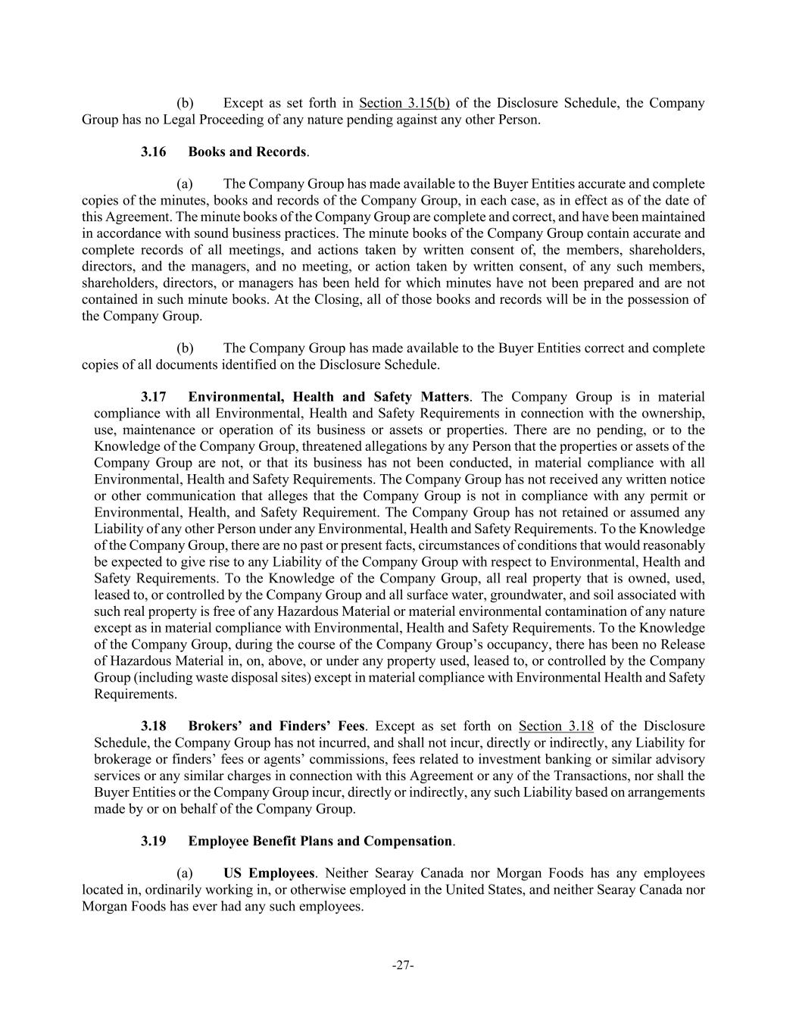
-27- (b) Except as set forth in Section 3.15(b) of the Disclosure Schedule, the Company Group has no Legal Proceeding of any nature pending against any other Person. 3.16 Books and Records. (a) The Company Group has made available to the Buyer Entities accurate and complete copies of the minutes, books and records of the Company Group, in each case, as in effect as of the date of this Agreement. The minute books of the Company Group are complete and correct, and have been maintained in accordance with sound business practices. The minute books of the Company Group contain accurate and complete records of all meetings, and actions taken by written consent of, the members, shareholders, directors, and the managers, and no meeting, or action taken by written consent, of any such members, shareholders, directors, or managers has been held for which minutes have not been prepared and are not contained in such minute books. At the Closing, all of those books and records will be in the possession of the Company Group. (b) The Company Group has made available to the Buyer Entities correct and complete copies of all documents identified on the Disclosure Schedule. 3.17 Environmental, Health and Safety Matters. The Company Group is in material compliance with all Environmental, Health and Safety Requirements in connection with the ownership, use, maintenance or operation of its business or assets or properties. There are no pending, or to the Knowledge of the Company Group, threatened allegations by any Person that the properties or assets of the Company Group are not, or that its business has not been conducted, in material compliance with all Environmental, Health and Safety Requirements. The Company Group has not received any written notice or other communication that alleges that the Company Group is not in compliance with any permit or Environmental, Health, and Safety Requirement. The Company Group has not retained or assumed any Liability of any other Person under any Environmental, Health and Safety Requirements. To the Knowledge of the Company Group, there are no past or present facts, circumstances of conditions that would reasonably be expected to give rise to any Liability of the Company Group with respect to Environmental, Health and Safety Requirements. To the Knowledge of the Company Group, all real property that is owned, used, leased to, or controlled by the Company Group and all surface water, groundwater, and soil associated with such real property is free of any Hazardous Material or material environmental contamination of any nature except as in material compliance with Environmental, Health and Safety Requirements. To the Knowledge of the Company Group, during the course of the Company Group’s occupancy, there has been no Release of Hazardous Material in, on, above, or under any property used, leased to, or controlled by the Company Group (including waste disposal sites) except in material compliance with Environmental Health and Safety Requirements. 3.18 Brokers’ and Finders’ Fees. Except as set forth on Section 3.18 of the Disclosure Schedule, the Company Group has not incurred, and shall not incur, directly or indirectly, any Liability for brokerage or finders’ fees or agents’ commissions, fees related to investment banking or similar advisory services or any similar charges in connection with this Agreement or any of the Transactions, nor shall the Buyer Entities or the Company Group incur, directly or indirectly, any such Liability based on arrangements made by or on behalf of the Company Group. 3.19 Employee Benefit Plans and Compensation. (a) US Employees. Neither Searay Canada nor Morgan Foods has any employees located in, ordinarily working in, or otherwise employed in the United States, and neither Searay Canada nor Morgan Foods has ever had any such employees.

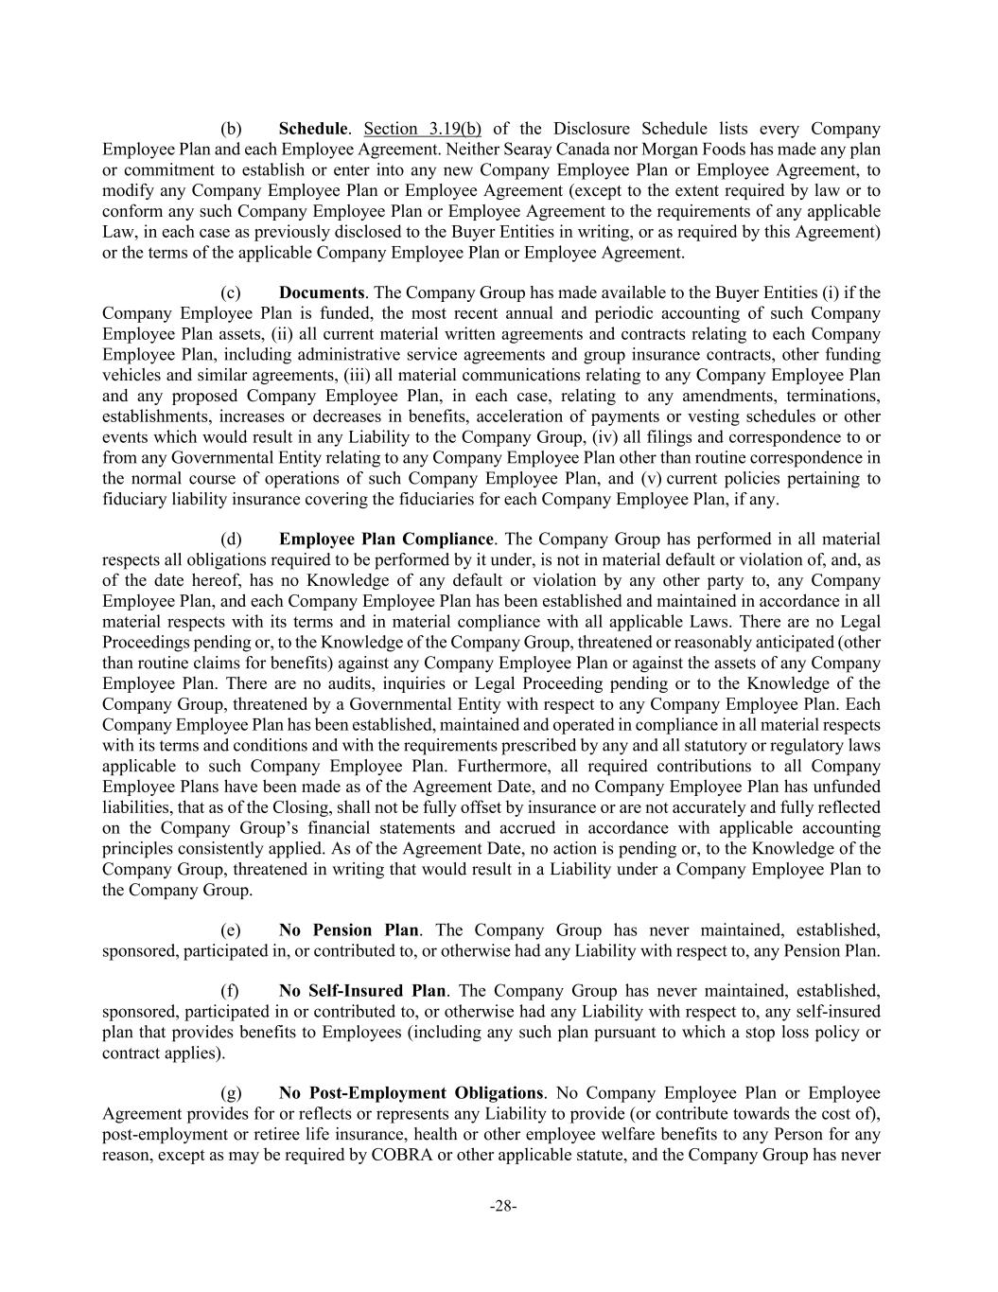
-28- (b) Schedule. Section 3.19(b) of the Disclosure Schedule lists every Company Employee Plan and each Employee Agreement. Neither Searay Canada nor Morgan Foods has made any plan or commitment to establish or enter into any new Company Employee Plan or Employee Agreement, to modify any Company Employee Plan or Employee Agreement (except to the extent required by law or to conform any such Company Employee Plan or Employee Agreement to the requirements of any applicable Law, in each case as previously disclosed to the Buyer Entities in writing, or as required by this Agreement) or the terms of the applicable Company Employee Plan or Employee Agreement. (c) Documents. The Company Group has made available to the Buyer Entities (i) if the Company Employee Plan is funded, the most recent annual and periodic accounting of such Company Employee Plan assets, (ii) all current material written agreements and contracts relating to each Company Employee Plan, including administrative service agreements and group insurance contracts, other funding vehicles and similar agreements, (iii) all material communications relating to any Company Employee Plan and any proposed Company Employee Plan, in each case, relating to any amendments, terminations, establishments, increases or decreases in benefits, acceleration of payments or vesting schedules or other events which would result in any Liability to the Company Group, (iv) all filings and correspondence to or from any Governmental Entity relating to any Company Employee Plan other than routine correspondence in the normal course of operations of such Company Employee Plan, and (v) current policies pertaining to fiduciary liability insurance covering the fiduciaries for each Company Employee Plan, if any. (d) Employee Plan Compliance. The Company Group has performed in all material respects all obligations required to be performed by it under, is not in material default or violation of, and, as of the date hereof, has no Knowledge of any default or violation by any other party to, any Company Employee Plan, and each Company Employee Plan has been established and maintained in accordance in all material respects with its terms and in material compliance with all applicable Laws. There are no Legal Proceedings pending or, to the Knowledge of the Company Group, threatened or reasonably anticipated (other than routine claims for benefits) against any Company Employee Plan or against the assets of any Company Employee Plan. There are no audits, inquiries or Legal Proceeding pending or to the Knowledge of the Company Group, threatened by a Governmental Entity with respect to any Company Employee Plan. Each Company Employee Plan has been established, maintained and operated in compliance in all material respects with its terms and conditions and with the requirements prescribed by any and all statutory or regulatory laws applicable to such Company Employee Plan. Furthermore, all required contributions to all Company Employee Plans have been made as of the Agreement Date, and no Company Employee Plan has unfunded liabilities, that as of the Closing, shall not be fully offset by insurance or are not accurately and fully reflected on the Company Group’s financial statements and accrued in accordance with applicable accounting principles consistently applied. As of the Agreement Date, no action is pending or, to the Knowledge of the Company Group, threatened in writing that would result in a Liability under a Company Employee Plan to the Company Group. (e) No Pension Plan. The Company Group has never maintained, established, sponsored, participated in, or contributed to, or otherwise had any Liability with respect to, any Pension Plan. (f) No Self-Insured Plan. The Company Group has never maintained, established, sponsored, participated in or contributed to, or otherwise had any Liability with respect to, any self-insured plan that provides benefits to Employees (including any such plan pursuant to which a stop loss policy or contract applies). (g) No Post-Employment Obligations. No Company Employee Plan or Employee Agreement provides for or reflects or represents any Liability to provide (or contribute towards the cost of), post-employment or retiree life insurance, health or other employee welfare benefits to any Person for any reason, except as may be required by COBRA or other applicable statute, and the Company Group has never

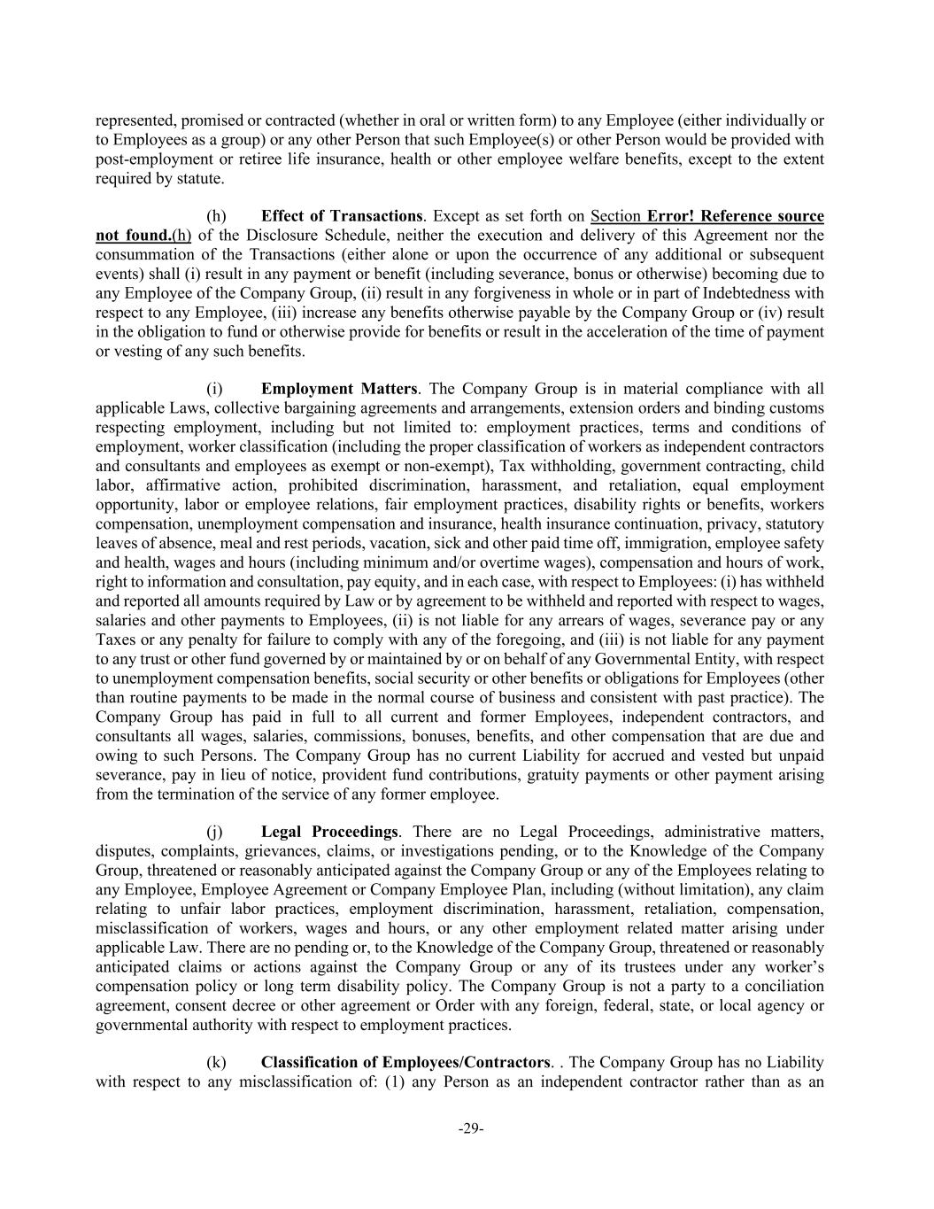
-29- represented, promised or contracted (whether in oral or written form) to any Employee (either individually or to Employees as a group) or any other Person that such Employee(s) or other Person would be provided with post-employment or retiree life insurance, health or other employee welfare benefits, except to the extent required by statute. (h) Effect of Transactions. Except as set forth on Section Error! Reference source not found.(h) of the Disclosure Schedule, neither the execution and delivery of this Agreement nor the consummation of the Transactions (either alone or upon the occurrence of any additional or subsequent events) shall (i) result in any payment or benefit (including severance, bonus or otherwise) becoming due to any Employee of the Company Group, (ii) result in any forgiveness in whole or in part of Indebtedness with respect to any Employee, (iii) increase any benefits otherwise payable by the Company Group or (iv) result in the obligation to fund or otherwise provide for benefits or result in the acceleration of the time of payment or vesting of any such benefits. (i) Employment Matters. The Company Group is in material compliance with all applicable Laws, collective bargaining agreements and arrangements, extension orders and binding customs respecting employment, including but not limited to: employment practices, terms and conditions of employment, worker classification (including the proper classification of workers as independent contractors and consultants and employees as exempt or non-exempt), Tax withholding, government contracting, child labor, affirmative action, prohibited discrimination, harassment, and retaliation, equal employment opportunity, labor or employee relations, fair employment practices, disability rights or benefits, workers compensation, unemployment compensation and insurance, health insurance continuation, privacy, statutory leaves of absence, meal and rest periods, vacation, sick and other paid time off, immigration, employee safety and health, wages and hours (including minimum and/or overtime wages), compensation and hours of work, right to information and consultation, pay equity, and in each case, with respect to Employees: (i) has withheld and reported all amounts required by Law or by agreement to be withheld and reported with respect to wages, salaries and other payments to Employees, (ii) is not liable for any arrears of wages, severance pay or any Taxes or any penalty for failure to comply with any of the foregoing, and (iii) is not liable for any payment to any trust or other fund governed by or maintained by or on behalf of any Governmental Entity, with respect to unemployment compensation benefits, social security or other benefits or obligations for Employees (other than routine payments to be made in the normal course of business and consistent with past practice). The Company Group has paid in full to all current and former Employees, independent contractors, and consultants all wages, salaries, commissions, bonuses, benefits, and other compensation that are due and owing to such Persons. The Company Group has no current Liability for accrued and vested but unpaid severance, pay in lieu of notice, provident fund contributions, gratuity payments or other payment arising from the termination of the service of any former employee. (j) Legal Proceedings. There are no Legal Proceedings, administrative matters, disputes, complaints, grievances, claims, or investigations pending, or to the Knowledge of the Company Group, threatened or reasonably anticipated against the Company Group or any of the Employees relating to any Employee, Employee Agreement or Company Employee Plan, including (without limitation), any claim relating to unfair labor practices, employment discrimination, harassment, retaliation, compensation, misclassification of workers, wages and hours, or any other employment related matter arising under applicable Law. There are no pending or, to the Knowledge of the Company Group, threatened or reasonably anticipated claims or actions against the Company Group or any of its trustees under any worker’s compensation policy or long term disability policy. The Company Group is not a party to a conciliation agreement, consent decree or other agreement or Order with any foreign, federal, state, or local agency or governmental authority with respect to employment practices. (k) Classification of Employees/Contractors. . The Company Group has no Liability with respect to any misclassification of: (1) any Person as an independent contractor rather than as an

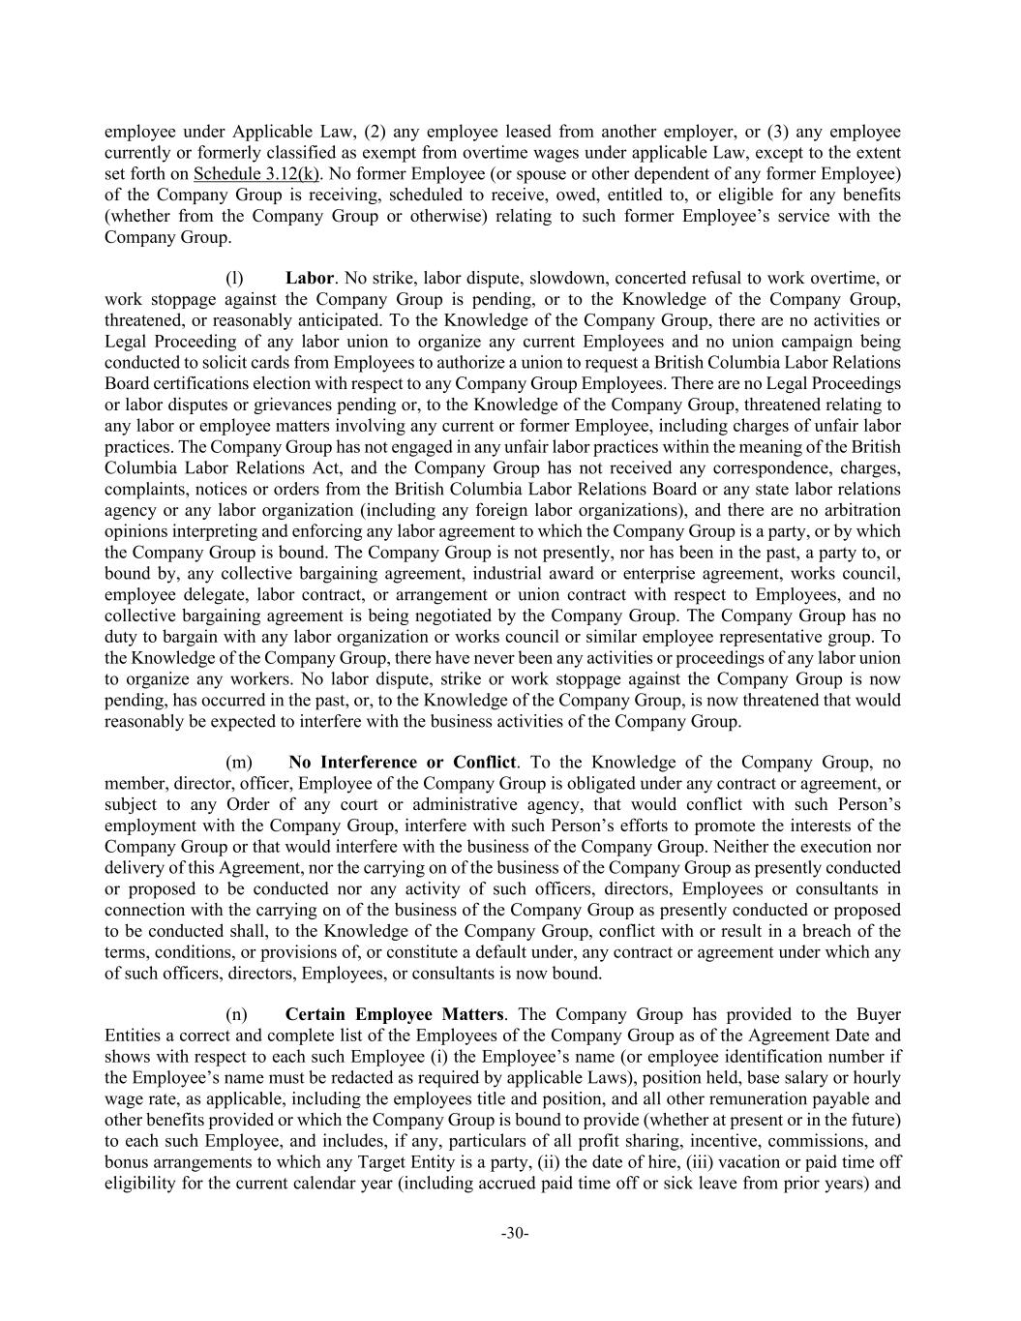
-30- employee under Applicable Law, (2) any employee leased from another employer, or (3) any employee currently or formerly classified as exempt from overtime wages under applicable Law, except to the extent set forth on Schedule 3.12(k). No former Employee (or spouse or other dependent of any former Employee) of the Company Group is receiving, scheduled to receive, owed, entitled to, or eligible for any benefits (whether from the Company Group or otherwise) relating to such former Employee’s service with the Company Group. (l) Labor. No strike, labor dispute, slowdown, concerted refusal to work overtime, or work stoppage against the Company Group is pending, or to the Knowledge of the Company Group, threatened, or reasonably anticipated. To the Knowledge of the Company Group, there are no activities or Legal Proceeding of any labor union to organize any current Employees and no union campaign being conducted to solicit cards from Employees to authorize a union to request a British Columbia Labor Relations Board certifications election with respect to any Company Group Employees. There are no Legal Proceedings or labor disputes or grievances pending or, to the Knowledge of the Company Group, threatened relating to any labor or employee matters involving any current or former Employee, including charges of unfair labor practices. The Company Group has not engaged in any unfair labor practices within the meaning of the British Columbia Labor Relations Act, and the Company Group has not received any correspondence, charges, complaints, notices or orders from the British Columbia Labor Relations Board or any state labor relations agency or any labor organization (including any foreign labor organizations), and there are no arbitration opinions interpreting and enforcing any labor agreement to which the Company Group is a party, or by which the Company Group is bound. The Company Group is not presently, nor has been in the past, a party to, or bound by, any collective bargaining agreement, industrial award or enterprise agreement, works council, employee delegate, labor contract, or arrangement or union contract with respect to Employees, and no collective bargaining agreement is being negotiated by the Company Group. The Company Group has no duty to bargain with any labor organization or works council or similar employee representative group. To the Knowledge of the Company Group, there have never been any activities or proceedings of any labor union to organize any workers. No labor dispute, strike or work stoppage against the Company Group is now pending, has occurred in the past, or, to the Knowledge of the Company Group, is now threatened that would reasonably be expected to interfere with the business activities of the Company Group. (m) No Interference or Conflict. To the Knowledge of the Company Group, no member, director, officer, Employee of the Company Group is obligated under any contract or agreement, or subject to any Order of any court or administrative agency, that would conflict with such Person’s employment with the Company Group, interfere with such Person’s efforts to promote the interests of the Company Group or that would interfere with the business of the Company Group. Neither the execution nor delivery of this Agreement, nor the carrying on of the business of the Company Group as presently conducted or proposed to be conducted nor any activity of such officers, directors, Employees or consultants in connection with the carrying on of the business of the Company Group as presently conducted or proposed to be conducted shall, to the Knowledge of the Company Group, conflict with or result in a breach of the terms, conditions, or provisions of, or constitute a default under, any contract or agreement under which any of such officers, directors, Employees, or consultants is now bound. (n) Certain Employee Matters. The Company Group has provided to the Buyer Entities a correct and complete list of the Employees of the Company Group as of the Agreement Date and shows with respect to each such Employee (i) the Employee’s name (or employee identification number if the Employee’s name must be redacted as required by applicable Laws), position held, base salary or hourly wage rate, as applicable, including the employees title and position, and all other remuneration payable and other benefits provided or which the Company Group is bound to provide (whether at present or in the future) to each such Employee, and includes, if any, particulars of all profit sharing, incentive, commissions, and bonus arrangements to which any Target Entity is a party, (ii) the date of hire, (iii) vacation or paid time off eligibility for the current calendar year (including accrued paid time off or sick leave from prior years) and

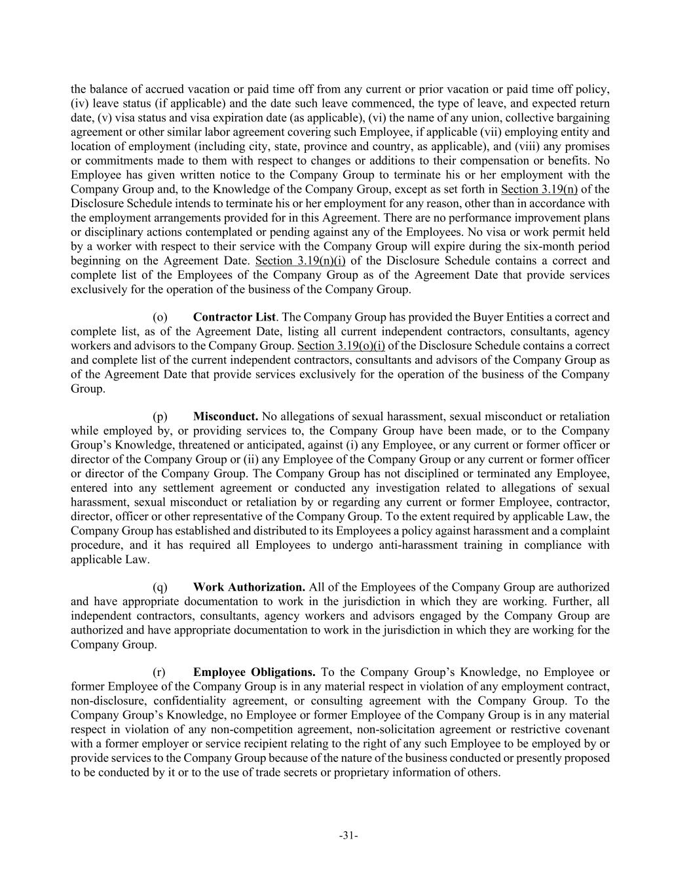
-31- the balance of accrued vacation or paid time off from any current or prior vacation or paid time off policy, (iv) leave status (if applicable) and the date such leave commenced, the type of leave, and expected return date, (v) visa status and visa expiration date (as applicable), (vi) the name of any union, collective bargaining agreement or other similar labor agreement covering such Employee, if applicable (vii) employing entity and location of employment (including city, state, province and country, as applicable), and (viii) any promises or commitments made to them with respect to changes or additions to their compensation or benefits. No Employee has given written notice to the Company Group to terminate his or her employment with the Company Group and, to the Knowledge of the Company Group, except as set forth in Section 3.19(n) of the Disclosure Schedule intends to terminate his or her employment for any reason, other than in accordance with the employment arrangements provided for in this Agreement. There are no performance improvement plans or disciplinary actions contemplated or pending against any of the Employees. No visa or work permit held by a worker with respect to their service with the Company Group will expire during the six-month period beginning on the Agreement Date. Section 3.19(n)(i) of the Disclosure Schedule contains a correct and complete list of the Employees of the Company Group as of the Agreement Date that provide services exclusively for the operation of the business of the Company Group. (o) Contractor List. The Company Group has provided the Buyer Entities a correct and complete list, as of the Agreement Date, listing all current independent contractors, consultants, agency workers and advisors to the Company Group. Section 3.19(o)(i) of the Disclosure Schedule contains a correct and complete list of the current independent contractors, consultants and advisors of the Company Group as of the Agreement Date that provide services exclusively for the operation of the business of the Company Group. (p) Misconduct. No allegations of sexual harassment, sexual misconduct or retaliation while employed by, or providing services to, the Company Group have been made, or to the Company Group’s Knowledge, threatened or anticipated, against (i) any Employee, or any current or former officer or director of the Company Group or (ii) any Employee of the Company Group or any current or former officer or director of the Company Group. The Company Group has not disciplined or terminated any Employee, entered into any settlement agreement or conducted any investigation related to allegations of sexual harassment, sexual misconduct or retaliation by or regarding any current or former Employee, contractor, director, officer or other representative of the Company Group. To the extent required by applicable Law, the Company Group has established and distributed to its Employees a policy against harassment and a complaint procedure, and it has required all Employees to undergo anti-harassment training in compliance with applicable Law. (q) Work Authorization. All of the Employees of the Company Group are authorized and have appropriate documentation to work in the jurisdiction in which they are working. Further, all independent contractors, consultants, agency workers and advisors engaged by the Company Group are authorized and have appropriate documentation to work in the jurisdiction in which they are working for the Company Group. (r) Employee Obligations. To the Company Group’s Knowledge, no Employee or former Employee of the Company Group is in any material respect in violation of any employment contract, non-disclosure, confidentiality agreement, or consulting agreement with the Company Group. To the Company Group’s Knowledge, no Employee or former Employee of the Company Group is in any material respect in violation of any non-competition agreement, non-solicitation agreement or restrictive covenant with a former employer or service recipient relating to the right of any such Employee to be employed by or provide services to the Company Group because of the nature of the business conducted or presently proposed to be conducted by it or to the use of trade secrets or proprietary information of others.

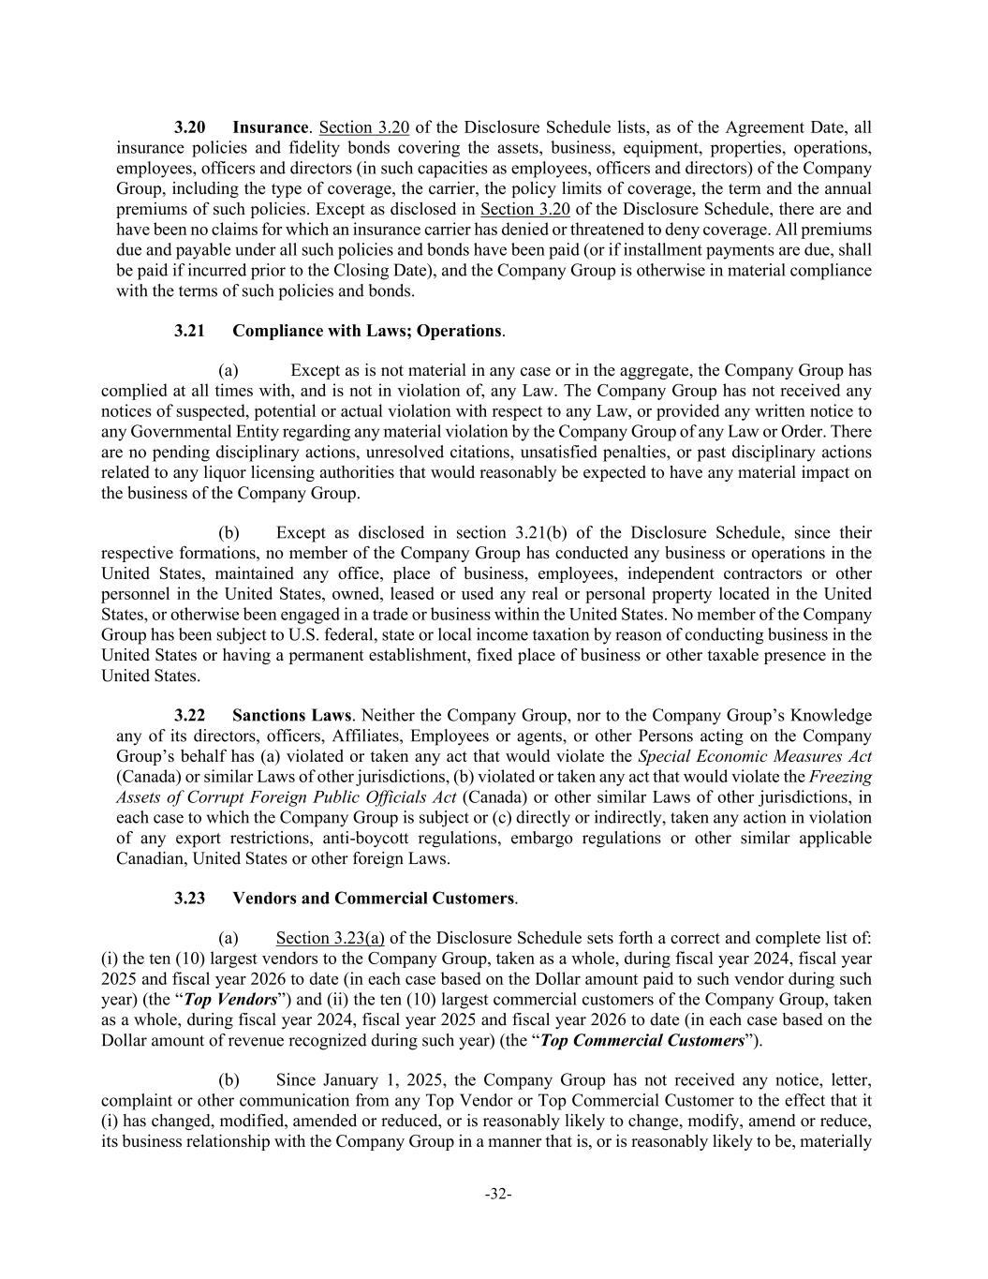
-32- 3.20 Insurance. Section 3.20 of the Disclosure Schedule lists, as of the Agreement Date, all insurance policies and fidelity bonds covering the assets, business, equipment, properties, operations, employees, officers and directors (in such capacities as employees, officers and directors) of the Company Group, including the type of coverage, the carrier, the policy limits of coverage, the term and the annual premiums of such policies. Except as disclosed in Section 3.20 of the Disclosure Schedule, there are and have been no claims for which an insurance carrier has denied or threatened to deny coverage. All premiums due and payable under all such policies and bonds have been paid (or if installment payments are due, shall be paid if incurred prior to the Closing Date), and the Company Group is otherwise in material compliance with the terms of such policies and bonds. 3.21 Compliance with Laws; Operations. (a) Except as is not material in any case or in the aggregate, the Company Group has complied at all times with, and is not in violation of, any Law. The Company Group has not received any notices of suspected, potential or actual violation with respect to any Law, or provided any written notice to any Governmental Entity regarding any material violation by the Company Group of any Law or Order. There are no pending disciplinary actions, unresolved citations, unsatisfied penalties, or past disciplinary actions related to any liquor licensing authorities that would reasonably be expected to have any material impact on the business of the Company Group. (b) Except as disclosed in section 3.21(b) of the Disclosure Schedule, since their respective formations, no member of the Company Group has conducted any business or operations in the United States, maintained any office, place of business, employees, independent contractors or other personnel in the United States, owned, leased or used any real or personal property located in the United States, or otherwise been engaged in a trade or business within the United States. No member of the Company Group has been subject to U.S. federal, state or local income taxation by reason of conducting business in the United States or having a permanent establishment, fixed place of business or other taxable presence in the United States. 3.22 Sanctions Laws. Neither the Company Group, nor to the Company Group’s Knowledge any of its directors, officers, Affiliates, Employees or agents, or other Persons acting on the Company Group’s behalf has (a) violated or taken any act that would violate the Special Economic Measures Act (Canada) or similar Laws of other jurisdictions, (b) violated or taken any act that would violate the Freezing Assets of Corrupt Foreign Public Officials Act (Canada) or other similar Laws of other jurisdictions, in each case to which the Company Group is subject or (c) directly or indirectly, taken any action in violation of any export restrictions, anti-boycott regulations, embargo regulations or other similar applicable Canadian, United States or other foreign Laws. 3.23 Vendors and Commercial Customers. (a) Section 3.23(a) of the Disclosure Schedule sets forth a correct and complete list of: (i) the ten (10) largest vendors to the Company Group, taken as a whole, during fiscal year 2024, fiscal year 2025 and fiscal year 2026 to date (in each case based on the Dollar amount paid to such vendor during such year) (the “Top Vendors”) and (ii) the ten (10) largest commercial customers of the Company Group, taken as a whole, during fiscal year 2024, fiscal year 2025 and fiscal year 2026 to date (in each case based on the Dollar amount of revenue recognized during such year) (the “Top Commercial Customers”). (b) Since January 1, 2025, the Company Group has not received any notice, letter, complaint or other communication from any Top Vendor or Top Commercial Customer to the effect that it (i) has changed, modified, amended or reduced, or is reasonably likely to change, modify, amend or reduce, its business relationship with the Company Group in a manner that is, or is reasonably likely to be, materially

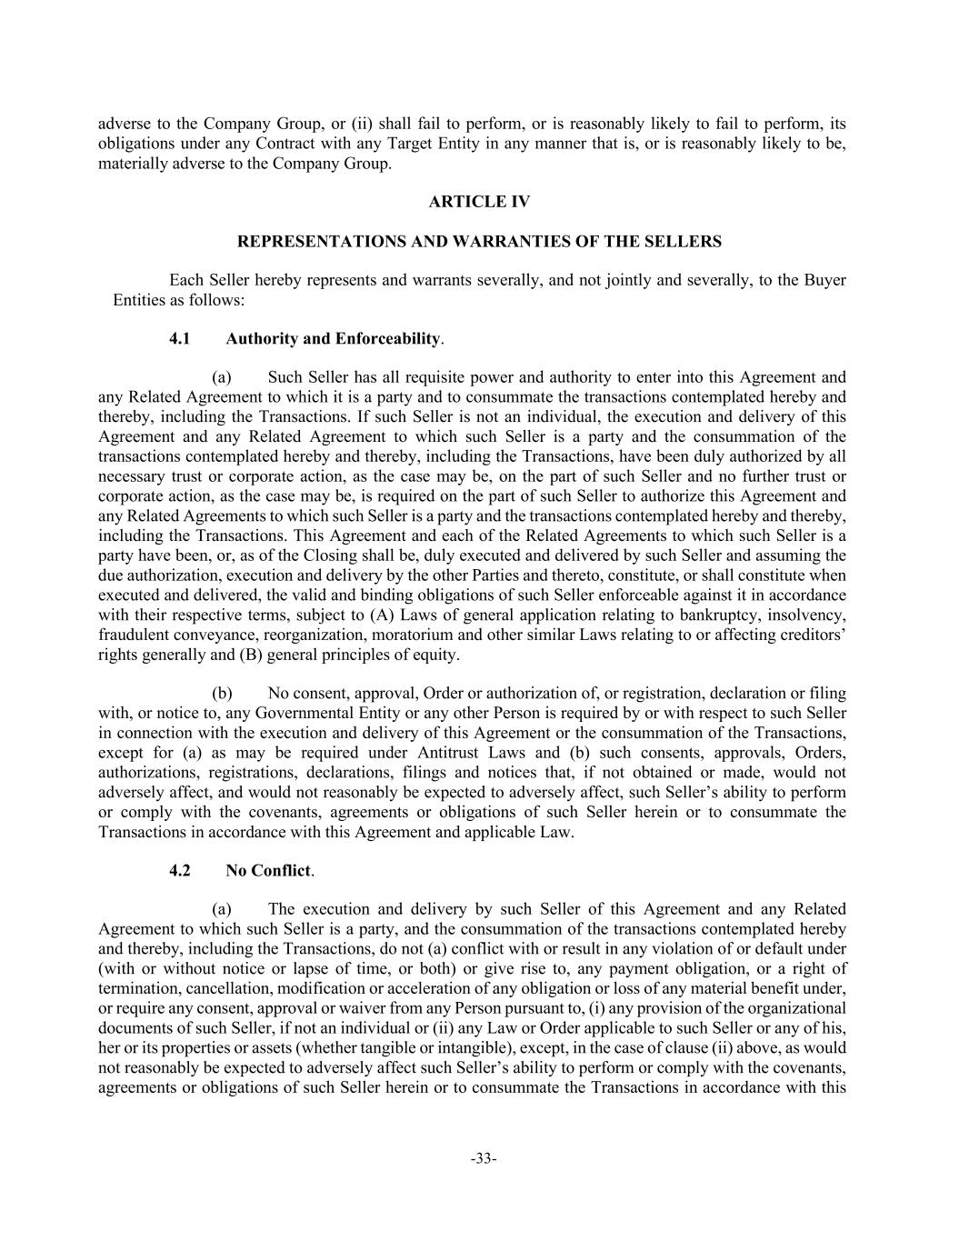
-33- adverse to the Company Group, or (ii) shall fail to perform, or is reasonably likely to fail to perform, its obligations under any Contract with any Target Entity in any manner that is, or is reasonably likely to be, materially adverse to the Company Group. ARTICLE IV REPRESENTATIONS AND WARRANTIES OF THE SELLERS Each Seller hereby represents and warrants severally, and not jointly and severally, to the Buyer Entities as follows: 4.1 Authority and Enforceability. (a) Such Seller has all requisite power and authority to enter into this Agreement and any Related Agreement to which it is a party and to consummate the transactions contemplated hereby and thereby, including the Transactions. If such Seller is not an individual, the execution and delivery of this Agreement and any Related Agreement to which such Seller is a party and the consummation of the transactions contemplated hereby and thereby, including the Transactions, have been duly authorized by all necessary trust or corporate action, as the case may be, on the part of such Seller and no further trust or corporate action, as the case may be, is required on the part of such Seller to authorize this Agreement and any Related Agreements to which such Seller is a party and the transactions contemplated hereby and thereby, including the Transactions. This Agreement and each of the Related Agreements to which such Seller is a party have been, or, as of the Closing shall be, duly executed and delivered by such Seller and assuming the due authorization, execution and delivery by the other Parties and thereto, constitute, or shall constitute when executed and delivered, the valid and binding obligations of such Seller enforceable against it in accordance with their respective terms, subject to (A) Laws of general application relating to bankruptcy, insolvency, fraudulent conveyance, reorganization, moratorium and other similar Laws relating to or affecting creditors’ rights generally and (B) general principles of equity. (b) No consent, approval, Order or authorization of, or registration, declaration or filing with, or notice to, any Governmental Entity or any other Person is required by or with respect to such Seller in connection with the execution and delivery of this Agreement or the consummation of the Transactions, except for (a) as may be required under Antitrust Laws and (b) such consents, approvals, Orders, authorizations, registrations, declarations, filings and notices that, if not obtained or made, would not adversely affect, and would not reasonably be expected to adversely affect, such Seller’s ability to perform or comply with the covenants, agreements or obligations of such Seller herein or to consummate the Transactions in accordance with this Agreement and applicable Law. 4.2 No Conflict. (a) The execution and delivery by such Seller of this Agreement and any Related Agreement to which such Seller is a party, and the consummation of the transactions contemplated hereby and thereby, including the Transactions, do not (a) conflict with or result in any violation of or default under (with or without notice or lapse of time, or both) or give rise to, any payment obligation, or a right of termination, cancellation, modification or acceleration of any obligation or loss of any material benefit under, or require any consent, approval or waiver from any Person pursuant to, (i) any provision of the organizational documents of such Seller, if not an individual or (ii) any Law or Order applicable to such Seller or any of his, her or its properties or assets (whether tangible or intangible), except, in the case of clause (ii) above, as would not reasonably be expected to adversely affect such Seller’s ability to perform or comply with the covenants, agreements or obligations of such Seller herein or to consummate the Transactions in accordance with this

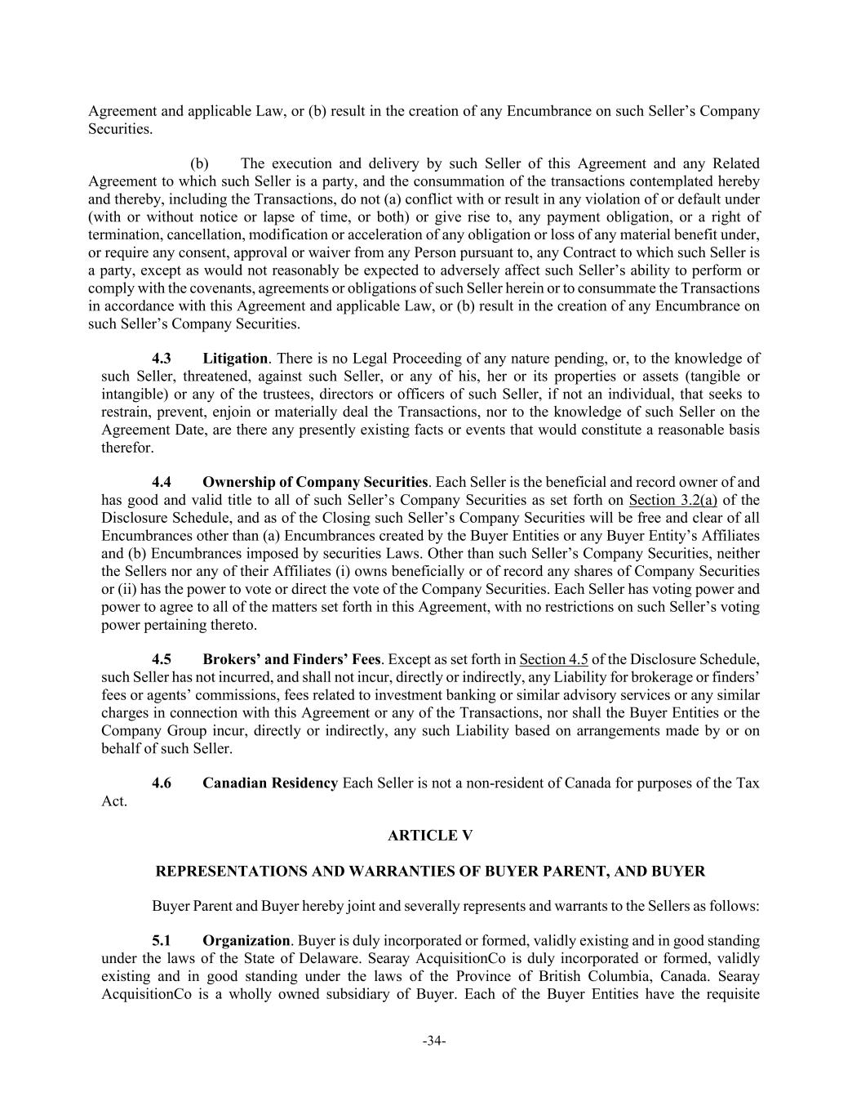
-34- Agreement and applicable Law, or (b) result in the creation of any Encumbrance on such Seller’s Company Securities. (b) The execution and delivery by such Seller of this Agreement and any Related Agreement to which such Seller is a party, and the consummation of the transactions contemplated hereby and thereby, including the Transactions, do not (a) conflict with or result in any violation of or default under (with or without notice or lapse of time, or both) or give rise to, any payment obligation, or a right of termination, cancellation, modification or acceleration of any obligation or loss of any material benefit under, or require any consent, approval or waiver from any Person pursuant to, any Contract to which such Seller is a party, except as would not reasonably be expected to adversely affect such Seller’s ability to perform or comply with the covenants, agreements or obligations of such Seller herein or to consummate the Transactions in accordance with this Agreement and applicable Law, or (b) result in the creation of any Encumbrance on such Seller’s Company Securities. 4.3 Litigation. There is no Legal Proceeding of any nature pending, or, to the knowledge of such Seller, threatened, against such Seller, or any of his, her or its properties or assets (tangible or intangible) or any of the trustees, directors or officers of such Seller, if not an individual, that seeks to restrain, prevent, enjoin or materially deal the Transactions, nor to the knowledge of such Seller on the Agreement Date, are there any presently existing facts or events that would constitute a reasonable basis therefor. 4.4 Ownership of Company Securities. Each Seller is the beneficial and record owner of and has good and valid title to all of such Seller’s Company Securities as set forth on Section 3.2(a) of the Disclosure Schedule, and as of the Closing such Seller’s Company Securities will be free and clear of all Encumbrances other than (a) Encumbrances created by the Buyer Entities or any Buyer Entity’s Affiliates and (b) Encumbrances imposed by securities Laws. Other than such Seller’s Company Securities, neither the Sellers nor any of their Affiliates (i) owns beneficially or of record any shares of Company Securities or (ii) has the power to vote or direct the vote of the Company Securities. Each Seller has voting power and power to agree to all of the matters set forth in this Agreement, with no restrictions on such Seller’s voting power pertaining thereto. 4.5 Brokers’ and Finders’ Fees. Except as set forth in Section 4.5 of the Disclosure Schedule, such Seller has not incurred, and shall not incur, directly or indirectly, any Liability for brokerage or finders’ fees or agents’ commissions, fees related to investment banking or similar advisory services or any similar charges in connection with this Agreement or any of the Transactions, nor shall the Buyer Entities or the Company Group incur, directly or indirectly, any such Liability based on arrangements made by or on behalf of such Seller. 4.6 Canadian Residency Each Seller is not a non-resident of Canada for purposes of the Tax Act. ARTICLE V REPRESENTATIONS AND WARRANTIES OF BUYER PARENT, AND BUYER Buyer Parent and Buyer hereby joint and severally represents and warrants to the Sellers as follows: 5.1 Organization. Buyer is duly incorporated or formed, validly existing and in good standing under the laws of the State of Delaware. Searay AcquisitionCo is duly incorporated or formed, validly existing and in good standing under the laws of the Province of British Columbia, Canada. Searay AcquisitionCo is a wholly owned subsidiary of Buyer. Each of the Buyer Entities have the requisite

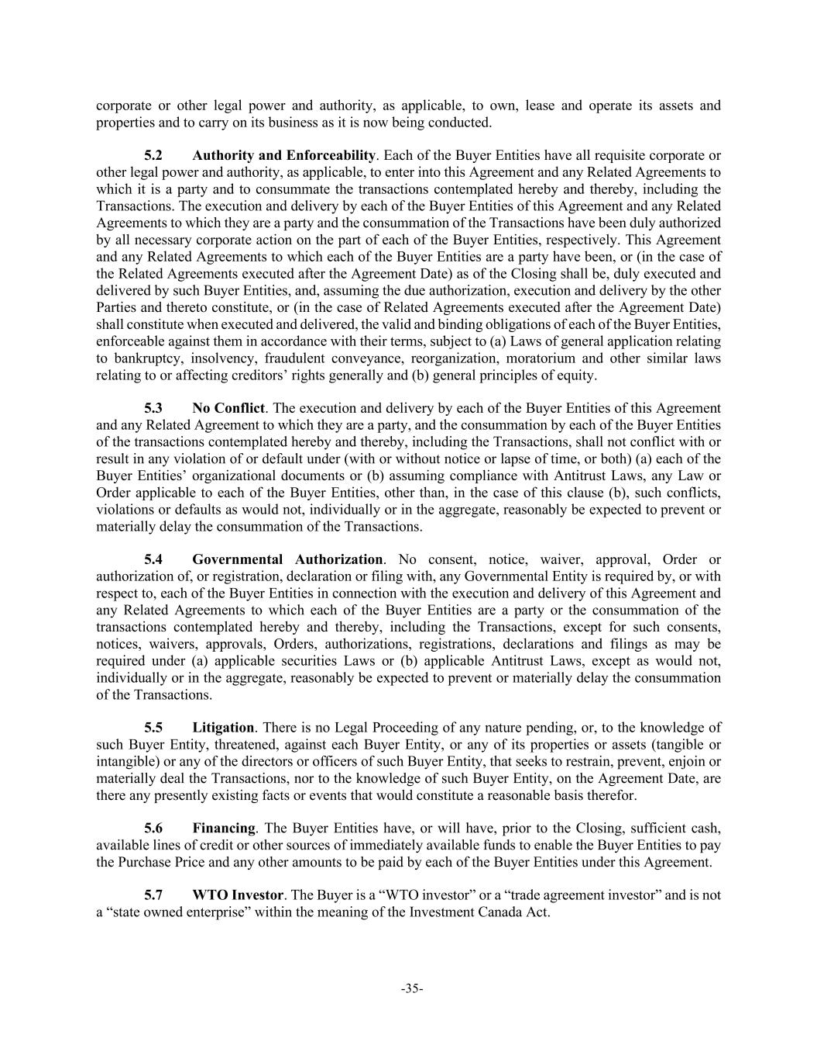
-35- corporate or other legal power and authority, as applicable, to own, lease and operate its assets and properties and to carry on its business as it is now being conducted. 5.2 Authority and Enforceability. Each of the Buyer Entities have all requisite corporate or other legal power and authority, as applicable, to enter into this Agreement and any Related Agreements to which it is a party and to consummate the transactions contemplated hereby and thereby, including the Transactions. The execution and delivery by each of the Buyer Entities of this Agreement and any Related Agreements to which they are a party and the consummation of the Transactions have been duly authorized by all necessary corporate action on the part of each of the Buyer Entities, respectively. This Agreement and any Related Agreements to which each of the Buyer Entities are a party have been, or (in the case of the Related Agreements executed after the Agreement Date) as of the Closing shall be, duly executed and delivered by such Buyer Entities, and, assuming the due authorization, execution and delivery by the other Parties and thereto constitute, or (in the case of Related Agreements executed after the Agreement Date) shall constitute when executed and delivered, the valid and binding obligations of each of the Buyer Entities, enforceable against them in accordance with their terms, subject to (a) Laws of general application relating to bankruptcy, insolvency, fraudulent conveyance, reorganization, moratorium and other similar laws relating to or affecting creditors’ rights generally and (b) general principles of equity. 5.3 No Conflict. The execution and delivery by each of the Buyer Entities of this Agreement and any Related Agreement to which they are a party, and the consummation by each of the Buyer Entities of the transactions contemplated hereby and thereby, including the Transactions, shall not conflict with or result in any violation of or default under (with or without notice or lapse of time, or both) (a) each of the Buyer Entities’ organizational documents or (b) assuming compliance with Antitrust Laws, any Law or Order applicable to each of the Buyer Entities, other than, in the case of this clause (b), such conflicts, violations or defaults as would not, individually or in the aggregate, reasonably be expected to prevent or materially delay the consummation of the Transactions. 5.4 Governmental Authorization. No consent, notice, waiver, approval, Order or authorization of, or registration, declaration or filing with, any Governmental Entity is required by, or with respect to, each of the Buyer Entities in connection with the execution and delivery of this Agreement and any Related Agreements to which each of the Buyer Entities are a party or the consummation of the transactions contemplated hereby and thereby, including the Transactions, except for such consents, notices, waivers, approvals, Orders, authorizations, registrations, declarations and filings as may be required under (a) applicable securities Laws or (b) applicable Antitrust Laws, except as would not, individually or in the aggregate, reasonably be expected to prevent or materially delay the consummation of the Transactions. 5.5 Litigation. There is no Legal Proceeding of any nature pending, or, to the knowledge of such Buyer Entity, threatened, against each Buyer Entity, or any of its properties or assets (tangible or intangible) or any of the directors or officers of such Buyer Entity, that seeks to restrain, prevent, enjoin or materially deal the Transactions, nor to the knowledge of such Buyer Entity, on the Agreement Date, are there any presently existing facts or events that would constitute a reasonable basis therefor. 5.6 Financing. The Buyer Entities have, or will have, prior to the Closing, sufficient cash, available lines of credit or other sources of immediately available funds to enable the Buyer Entities to pay the Purchase Price and any other amounts to be paid by each of the Buyer Entities under this Agreement. 5.7 WTO Investor. The Buyer is a “WTO investor” or a “trade agreement investor” and is not a “state owned enterprise” within the meaning of the Investment Canada Act.

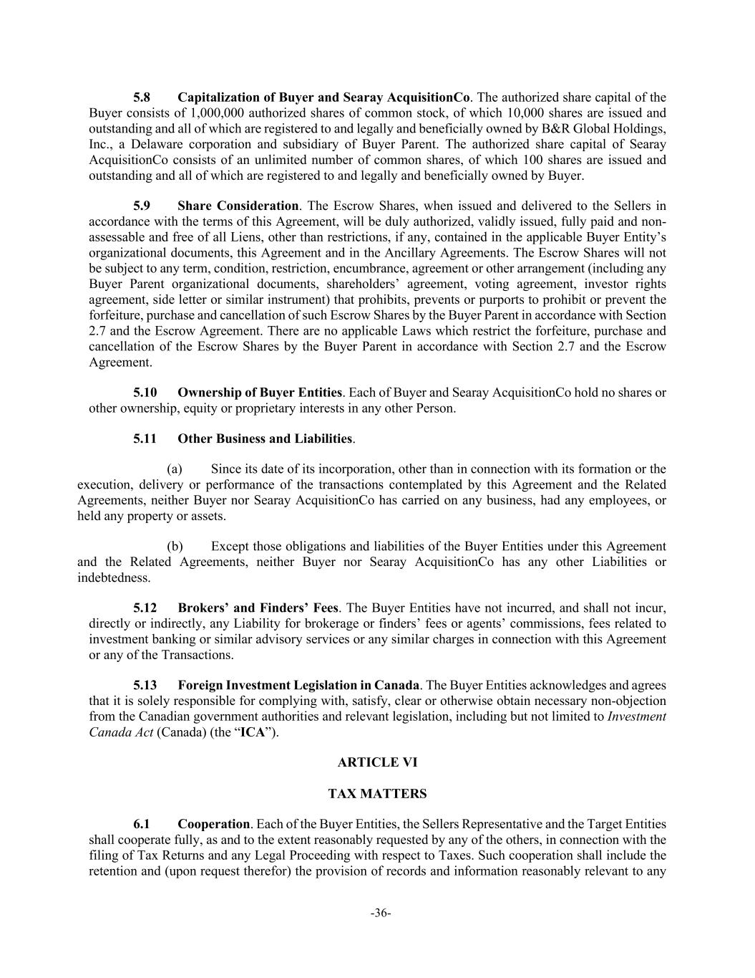
-36- 5.8 Capitalization of Buyer and Searay AcquisitionCo. The authorized share capital of the Buyer consists of 1,000,000 authorized shares of common stock, of which 10,000 shares are issued and outstanding and all of which are registered to and legally and beneficially owned by B&R Global Holdings, Inc., a Delaware corporation and subsidiary of Buyer Parent. The authorized share capital of Searay AcquisitionCo consists of an unlimited number of common shares, of which 100 shares are issued and outstanding and all of which are registered to and legally and beneficially owned by Buyer. 5.9 Share Consideration. The Escrow Shares, when issued and delivered to the Sellers in accordance with the terms of this Agreement, will be duly authorized, validly issued, fully paid and non- assessable and free of all Liens, other than restrictions, if any, contained in the applicable Buyer Entity’s organizational documents, this Agreement and in the Ancillary Agreements. The Escrow Shares will not be subject to any term, condition, restriction, encumbrance, agreement or other arrangement (including any Buyer Parent organizational documents, shareholders’ agreement, voting agreement, investor rights agreement, side letter or similar instrument) that prohibits, prevents or purports to prohibit or prevent the forfeiture, purchase and cancellation of such Escrow Shares by the Buyer Parent in accordance with Section 2.7 and the Escrow Agreement. There are no applicable Laws which restrict the forfeiture, purchase and cancellation of the Escrow Shares by the Buyer Parent in accordance with Section 2.7 and the Escrow Agreement. 5.10 Ownership of Buyer Entities. Each of Buyer and Searay AcquisitionCo hold no shares or other ownership, equity or proprietary interests in any other Person. 5.11 Other Business and Liabilities. (a) Since its date of its incorporation, other than in connection with its formation or the execution, delivery or performance of the transactions contemplated by this Agreement and the Related Agreements, neither Buyer nor Searay AcquisitionCo has carried on any business, had any employees, or held any property or assets. (b) Except those obligations and liabilities of the Buyer Entities under this Agreement and the Related Agreements, neither Buyer nor Searay AcquisitionCo has any other Liabilities or indebtedness. 5.12 Brokers’ and Finders’ Fees. The Buyer Entities have not incurred, and shall not incur, directly or indirectly, any Liability for brokerage or finders’ fees or agents’ commissions, fees related to investment banking or similar advisory services or any similar charges in connection with this Agreement or any of the Transactions. 5.13 Foreign Investment Legislation in Canada. The Buyer Entities acknowledges and agrees that it is solely responsible for complying with, satisfy, clear or otherwise obtain necessary non-objection from the Canadian government authorities and relevant legislation, including but not limited to Investment Canada Act (Canada) (the “ICA”). ARTICLE VI TAX MATTERS 6.1 Cooperation. Each of the Buyer Entities, the Sellers Representative and the Target Entities shall cooperate fully, as and to the extent reasonably requested by any of the others, in connection with the filing of Tax Returns and any Legal Proceeding with respect to Taxes. Such cooperation shall include the retention and (upon request therefor) the provision of records and information reasonably relevant to any

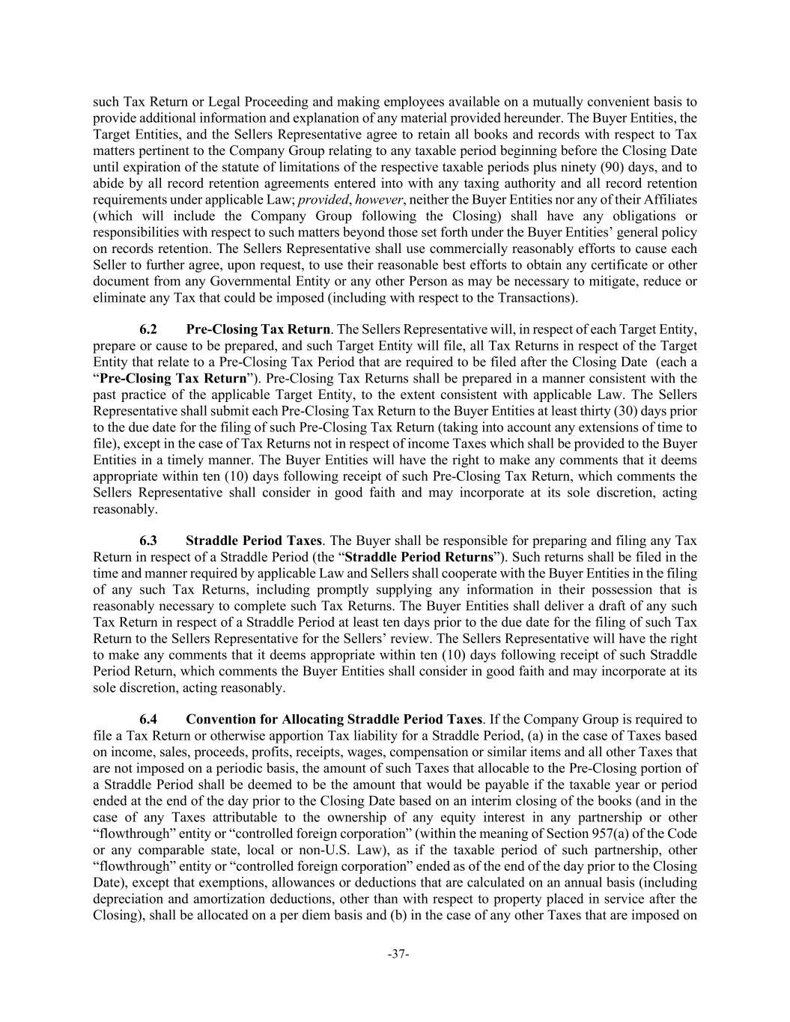
-37- such Tax Return or Legal Proceeding and making employees available on a mutually convenient basis to provide additional information and explanation of any material provided hereunder. The Buyer Entities, the Target Entities, and the Sellers Representative agree to retain all books and records with respect to Tax matters pertinent to the Company Group relating to any taxable period beginning before the Closing Date until expiration of the statute of limitations of the respective taxable periods plus ninety (90) days, and to abide by all record retention agreements entered into with any taxing authority and all record retention requirements under applicable Law; provided, however, neither the Buyer Entities nor any of their Affiliates (which will include the Company Group following the Closing) shall have any obligations or responsibilities with respect to such matters beyond those set forth under the Buyer Entities’ general policy on records retention. The Sellers Representative shall use commercially reasonably efforts to cause each Seller to further agree, upon request, to use their reasonable best efforts to obtain any certificate or other document from any Governmental Entity or any other Person as may be necessary to mitigate, reduce or eliminate any Tax that could be imposed (including with respect to the Transactions). 6.2 Pre-Closing Tax Return. The Sellers Representative will, in respect of each Target Entity, prepare or cause to be prepared, and such Target Entity will file, all Tax Returns in respect of the Target Entity that relate to a Pre-Closing Tax Period that are required to be filed after the Closing Date (each a “Pre-Closing Tax Return”). Pre-Closing Tax Returns shall be prepared in a manner consistent with the past practice of the applicable Target Entity, to the extent consistent with applicable Law. The Sellers Representative shall submit each Pre-Closing Tax Return to the Buyer Entities at least thirty (30) days prior to the due date for the filing of such Pre-Closing Tax Return (taking into account any extensions of time to file), except in the case of Tax Returns not in respect of income Taxes which shall be provided to the Buyer Entities in a timely manner. The Buyer Entities will have the right to make any comments that it deems appropriate within ten (10) days following receipt of such Pre-Closing Tax Return, which comments the Sellers Representative shall consider in good faith and may incorporate at its sole discretion, acting reasonably. 6.3 Straddle Period Taxes. The Buyer shall be responsible for preparing and filing any Tax Return in respect of a Straddle Period (the “Straddle Period Returns”). Such returns shall be filed in the time and manner required by applicable Law and Sellers shall cooperate with the Buyer Entities in the filing of any such Tax Returns, including promptly supplying any information in their possession that is reasonably necessary to complete such Tax Returns. The Buyer Entities shall deliver a draft of any such Tax Return in respect of a Straddle Period at least ten days prior to the due date for the filing of such Tax Return to the Sellers Representative for the Sellers’ review. The Sellers Representative will have the right to make any comments that it deems appropriate within ten (10) days following receipt of such Straddle Period Return, which comments the Buyer Entities shall consider in good faith and may incorporate at its sole discretion, acting reasonably. 6.4 Convention for Allocating Straddle Period Taxes. If the Company Group is required to file a Tax Return or otherwise apportion Tax liability for a Straddle Period, (a) in the case of Taxes based on income, sales, proceeds, profits, receipts, wages, compensation or similar items and all other Taxes that are not imposed on a periodic basis, the amount of such Taxes that allocable to the Pre-Closing portion of a Straddle Period shall be deemed to be the amount that would be payable if the taxable year or period ended at the end of the day prior to the Closing Date based on an interim closing of the books (and in the case of any Taxes attributable to the ownership of any equity interest in any partnership or other “flowthrough” entity or “controlled foreign corporation” (within the meaning of Section 957(a) of the Code or any comparable state, local or non-U.S. Law), as if the taxable period of such partnership, other “flowthrough” entity or “controlled foreign corporation” ended as of the end of the day prior to the Closing Date), except that exemptions, allowances or deductions that are calculated on an annual basis (including depreciation and amortization deductions, other than with respect to property placed in service after the Closing), shall be allocated on a per diem basis and (b) in the case of any other Taxes that are imposed on

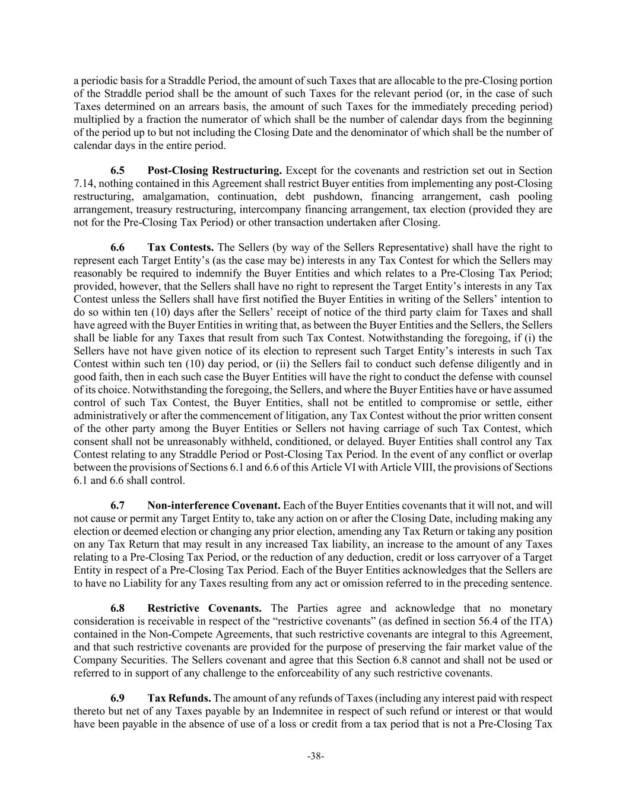
-38- a periodic basis for a Straddle Period, the amount of such Taxes that are allocable to the pre-Closing portion of the Straddle period shall be the amount of such Taxes for the relevant period (or, in the case of such Taxes determined on an arrears basis, the amount of such Taxes for the immediately preceding period) multiplied by a fraction the numerator of which shall be the number of calendar days from the beginning of the period up to but not including the Closing Date and the denominator of which shall be the number of calendar days in the entire period. 6.5 Post-Closing Restructuring. Except for the covenants and restriction set out in Section 7.14, nothing contained in this Agreement shall restrict Buyer entities from implementing any post-Closing restructuring, amalgamation, continuation, debt pushdown, financing arrangement, cash pooling arrangement, treasury restructuring, intercompany financing arrangement, tax election (provided they are not for the Pre-Closing Tax Period) or other transaction undertaken after Closing. 6.6 Tax Contests. The Sellers (by way of the Sellers Representative) shall have the right to represent each Target Entity’s (as the case may be) interests in any Tax Contest for which the Sellers may reasonably be required to indemnify the Buyer Entities and which relates to a Pre-Closing Tax Period; provided, however, that the Sellers shall have no right to represent the Target Entity’s interests in any Tax Contest unless the Sellers shall have first notified the Buyer Entities in writing of the Sellers’ intention to do so within ten (10) days after the Sellers’ receipt of notice of the third party claim for Taxes and shall have agreed with the Buyer Entities in writing that, as between the Buyer Entities and the Sellers, the Sellers shall be liable for any Taxes that result from such Tax Contest. Notwithstanding the foregoing, if (i) the Sellers have not have given notice of its election to represent such Target Entity’s interests in such Tax Contest within such ten (10) day period, or (ii) the Sellers fail to conduct such defense diligently and in good faith, then in each such case the Buyer Entities will have the right to conduct the defense with counsel of its choice. Notwithstanding the foregoing, the Sellers, and where the Buyer Entities have or have assumed control of such Tax Contest, the Buyer Entities, shall not be entitled to compromise or settle, either administratively or after the commencement of litigation, any Tax Contest without the prior written consent of the other party among the Buyer Entities or Sellers not having carriage of such Tax Contest, which consent shall not be unreasonably withheld, conditioned, or delayed. Buyer Entities shall control any Tax Contest relating to any Straddle Period or Post-Closing Tax Period. In the event of any conflict or overlap between the provisions of Sections 6.1 and 6.6 of this Article VI with Article VIII, the provisions of Sections 6.1 and 6.6 shall control. 6.7 Non-interference Covenant. Each of the Buyer Entities covenants that it will not, and will not cause or permit any Target Entity to, take any action on or after the Closing Date, including making any election or deemed election or changing any prior election, amending any Tax Return or taking any position on any Tax Return that may result in any increased Tax liability, an increase to the amount of any Taxes relating to a Pre-Closing Tax Period, or the reduction of any deduction, credit or loss carryover of a Target Entity in respect of a Pre-Closing Tax Period. Each of the Buyer Entities acknowledges that the Sellers are to have no Liability for any Taxes resulting from any act or omission referred to in the preceding sentence. 6.8 Restrictive Covenants. The Parties agree and acknowledge that no monetary consideration is receivable in respect of the “restrictive covenants” (as defined in section 56.4 of the ITA) contained in the Non-Compete Agreements, that such restrictive covenants are integral to this Agreement, and that such restrictive covenants are provided for the purpose of preserving the fair market value of the Company Securities. The Sellers covenant and agree that this Section 6.8 cannot and shall not be used or referred to in support of any challenge to the enforceability of any such restrictive covenants. 6.9 Tax Refunds. The amount of any refunds of Taxes (including any interest paid with respect thereto but net of any Taxes payable by an Indemnitee in respect of such refund or interest or that would have been payable in the absence of use of a loss or credit from a tax period that is not a Pre-Closing Tax

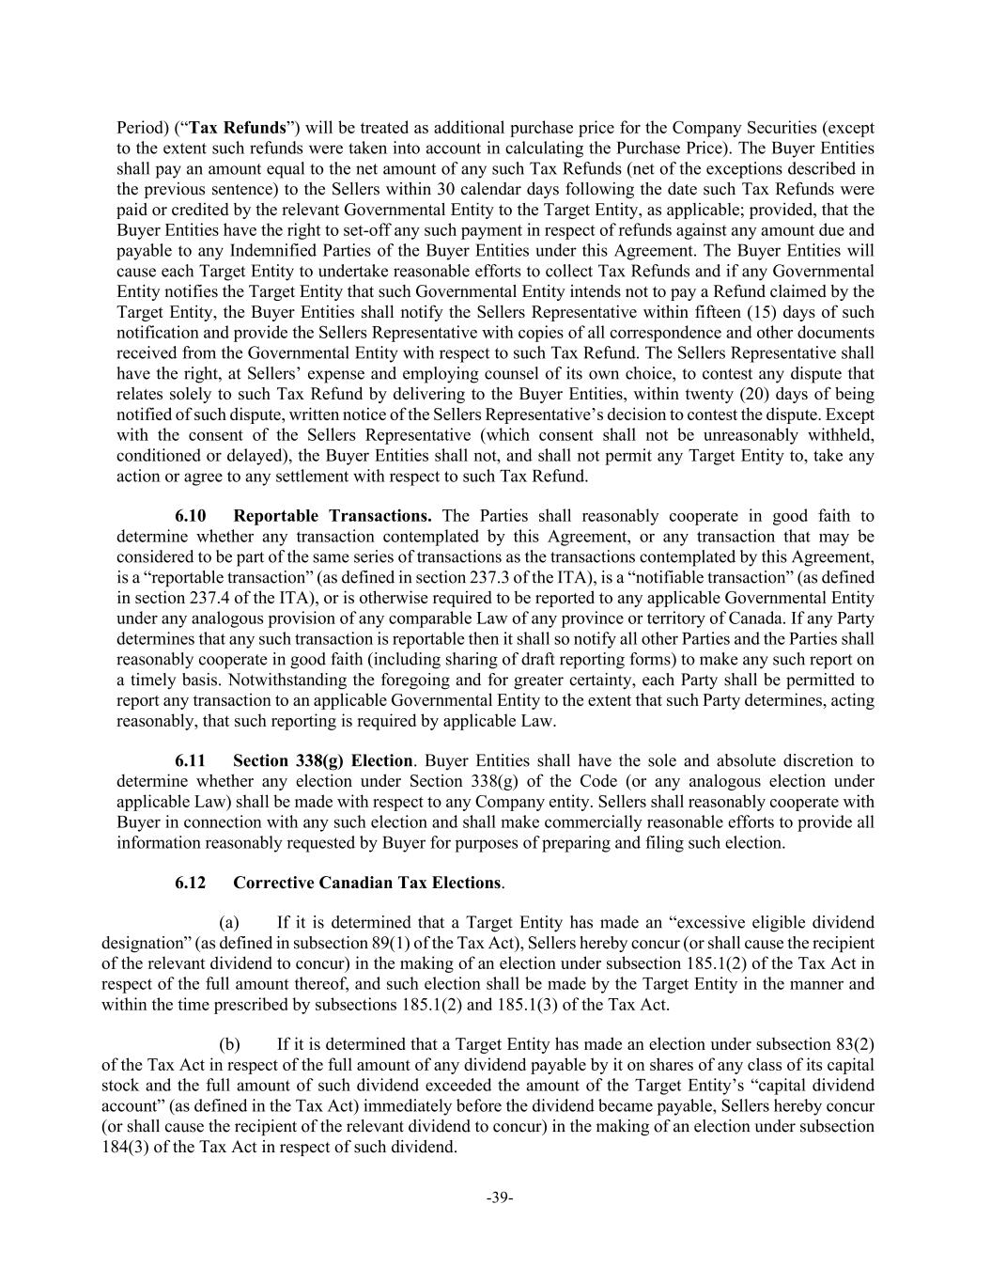
-39- Period) (“Tax Refunds”) will be treated as additional purchase price for the Company Securities (except to the extent such refunds were taken into account in calculating the Purchase Price). The Buyer Entities shall pay an amount equal to the net amount of any such Tax Refunds (net of the exceptions described in the previous sentence) to the Sellers within 30 calendar days following the date such Tax Refunds were paid or credited by the relevant Governmental Entity to the Target Entity, as applicable; provided, that the Buyer Entities have the right to set-off any such payment in respect of refunds against any amount due and payable to any Indemnified Parties of the Buyer Entities under this Agreement. The Buyer Entities will cause each Target Entity to undertake reasonable efforts to collect Tax Refunds and if any Governmental Entity notifies the Target Entity that such Governmental Entity intends not to pay a Refund claimed by the Target Entity, the Buyer Entities shall notify the Sellers Representative within fifteen (15) days of such notification and provide the Sellers Representative with copies of all correspondence and other documents received from the Governmental Entity with respect to such Tax Refund. The Sellers Representative shall have the right, at Sellers’ expense and employing counsel of its own choice, to contest any dispute that relates solely to such Tax Refund by delivering to the Buyer Entities, within twenty (20) days of being notified of such dispute, written notice of the Sellers Representative’s decision to contest the dispute. Except with the consent of the Sellers Representative (which consent shall not be unreasonably withheld, conditioned or delayed), the Buyer Entities shall not, and shall not permit any Target Entity to, take any action or agree to any settlement with respect to such Tax Refund. 6.10 Reportable Transactions. The Parties shall reasonably cooperate in good faith to determine whether any transaction contemplated by this Agreement, or any transaction that may be considered to be part of the same series of transactions as the transactions contemplated by this Agreement, is a “reportable transaction” (as defined in section 237.3 of the ITA), is a “notifiable transaction” (as defined in section 237.4 of the ITA), or is otherwise required to be reported to any applicable Governmental Entity under any analogous provision of any comparable Law of any province or territory of Canada. If any Party determines that any such transaction is reportable then it shall so notify all other Parties and the Parties shall reasonably cooperate in good faith (including sharing of draft reporting forms) to make any such report on a timely basis. Notwithstanding the foregoing and for greater certainty, each Party shall be permitted to report any transaction to an applicable Governmental Entity to the extent that such Party determines, acting reasonably, that such reporting is required by applicable Law. 6.11 Section 338(g) Election. Buyer Entities shall have the sole and absolute discretion to determine whether any election under Section 338(g) of the Code (or any analogous election under applicable Law) shall be made with respect to any Company entity. Sellers shall reasonably cooperate with Buyer in connection with any such election and shall make commercially reasonable efforts to provide all information reasonably requested by Buyer for purposes of preparing and filing such election. 6.12 Corrective Canadian Tax Elections. (a) If it is determined that a Target Entity has made an “excessive eligible dividend designation” (as defined in subsection 89(1) of the Tax Act), Sellers hereby concur (or shall cause the recipient of the relevant dividend to concur) in the making of an election under subsection 185.1(2) of the Tax Act in respect of the full amount thereof, and such election shall be made by the Target Entity in the manner and within the time prescribed by subsections 185.1(2) and 185.1(3) of the Tax Act. (b) If it is determined that a Target Entity has made an election under subsection 83(2) of the Tax Act in respect of the full amount of any dividend payable by it on shares of any class of its capital stock and the full amount of such dividend exceeded the amount of the Target Entity’s “capital dividend account” (as defined in the Tax Act) immediately before the dividend became payable, Sellers hereby concur (or shall cause the recipient of the relevant dividend to concur) in the making of an election under subsection 184(3) of the Tax Act in respect of such dividend.

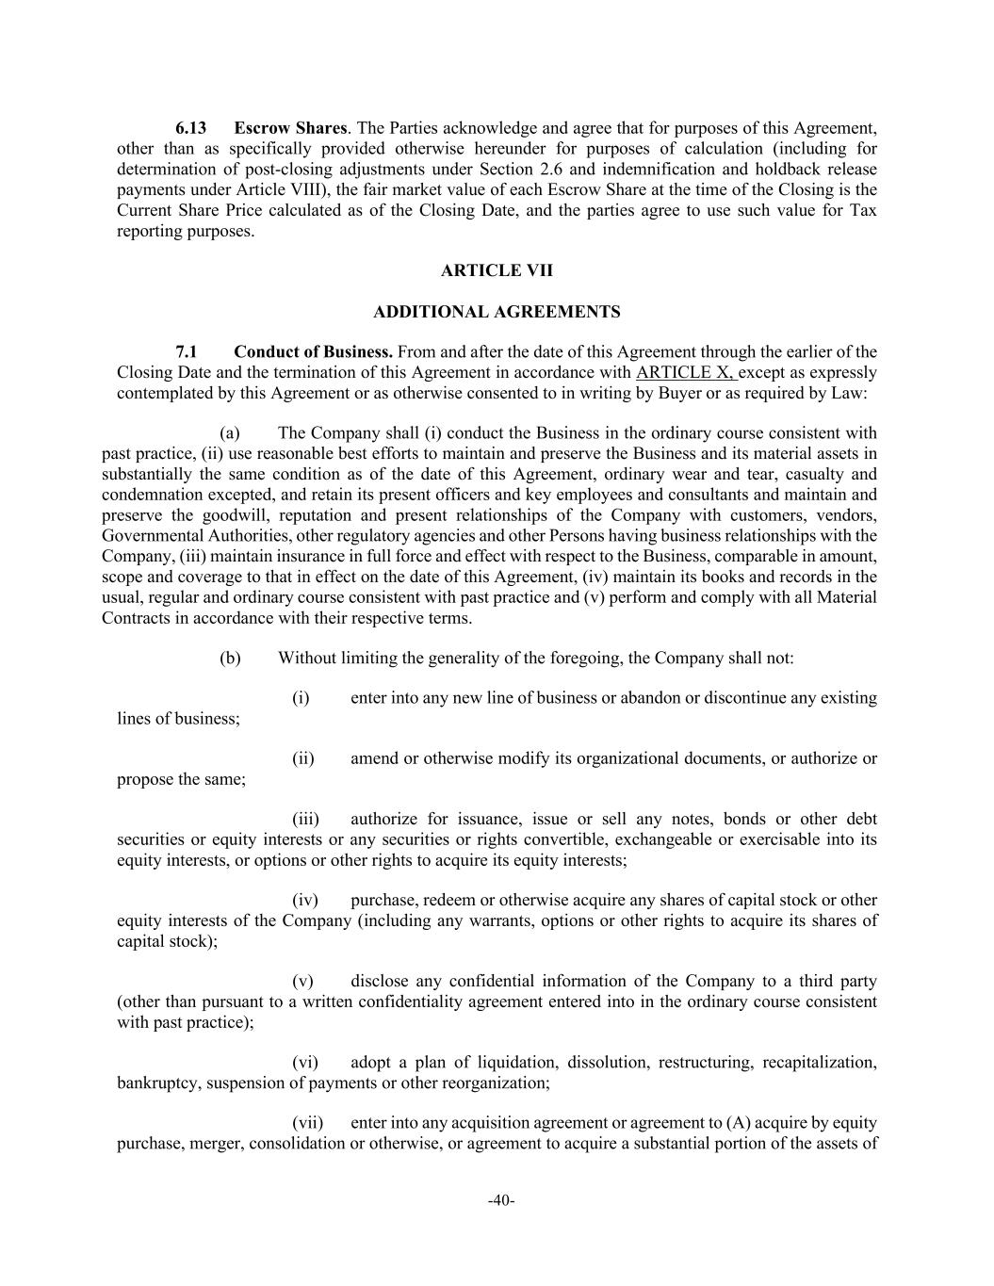
-40- 6.13 Escrow Shares. The Parties acknowledge and agree that for purposes of this Agreement, other than as specifically provided otherwise hereunder for purposes of calculation (including for determination of post-closing adjustments under Section 2.6 and indemnification and holdback release payments under Article VIII), the fair market value of each Escrow Share at the time of the Closing is the Current Share Price calculated as of the Closing Date, and the parties agree to use such value for Tax reporting purposes. ARTICLE VII ADDITIONAL AGREEMENTS 7.1 Conduct of Business. From and after the date of this Agreement through the earlier of the Closing Date and the termination of this Agreement in accordance with ARTICLE X, except as expressly contemplated by this Agreement or as otherwise consented to in writing by Buyer or as required by Law: (a) The Company shall (i) conduct the Business in the ordinary course consistent with past practice, (ii) use reasonable best efforts to maintain and preserve the Business and its material assets in substantially the same condition as of the date of this Agreement, ordinary wear and tear, casualty and condemnation excepted, and retain its present officers and key employees and consultants and maintain and preserve the goodwill, reputation and present relationships of the Company with customers, vendors, Governmental Authorities, other regulatory agencies and other Persons having business relationships with the Company, (iii) maintain insurance in full force and effect with respect to the Business, comparable in amount, scope and coverage to that in effect on the date of this Agreement, (iv) maintain its books and records in the usual, regular and ordinary course consistent with past practice and (v) perform and comply with all Material Contracts in accordance with their respective terms. (b) Without limiting the generality of the foregoing, the Company shall not: (i) enter into any new line of business or abandon or discontinue any existing lines of business; (ii) amend or otherwise modify its organizational documents, or authorize or propose the same; (iii) authorize for issuance, issue or sell any notes, bonds or other debt securities or equity interests or any securities or rights convertible, exchangeable or exercisable into its equity interests, or options or other rights to acquire its equity interests; (iv) purchase, redeem or otherwise acquire any shares of capital stock or other equity interests of the Company (including any warrants, options or other rights to acquire its shares of capital stock); (v) disclose any confidential information of the Company to a third party (other than pursuant to a written confidentiality agreement entered into in the ordinary course consistent with past practice); (vi) adopt a plan of liquidation, dissolution, restructuring, recapitalization, bankruptcy, suspension of payments or other reorganization; (vii) enter into any acquisition agreement or agreement to (A) acquire by equity purchase, merger, consolidation or otherwise, or agreement to acquire a substantial portion of the assets of

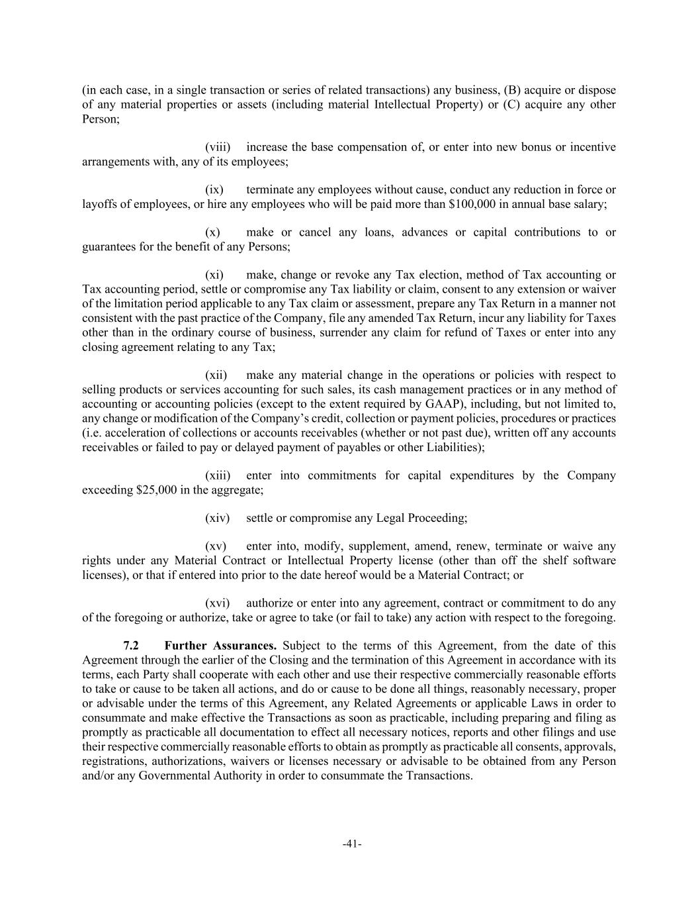
-41- (in each case, in a single transaction or series of related transactions) any business, (B) acquire or dispose of any material properties or assets (including material Intellectual Property) or (C) acquire any other Person; (viii) increase the base compensation of, or enter into new bonus or incentive arrangements with, any of its employees; (ix) terminate any employees without cause, conduct any reduction in force or layoffs of employees, or hire any employees who will be paid more than $100,000 in annual base salary; (x) make or cancel any loans, advances or capital contributions to or guarantees for the benefit of any Persons; (xi) make, change or revoke any Tax election, method of Tax accounting or Tax accounting period, settle or compromise any Tax liability or claim, consent to any extension or waiver of the limitation period applicable to any Tax claim or assessment, prepare any Tax Return in a manner not consistent with the past practice of the Company, file any amended Tax Return, incur any liability for Taxes other than in the ordinary course of business, surrender any claim for refund of Taxes or enter into any closing agreement relating to any Tax; (xii) make any material change in the operations or policies with respect to selling products or services accounting for such sales, its cash management practices or in any method of accounting or accounting policies (except to the extent required by GAAP), including, but not limited to, any change or modification of the Company’s credit, collection or payment policies, procedures or practices (i.e. acceleration of collections or accounts receivables (whether or not past due), written off any accounts receivables or failed to pay or delayed payment of payables or other Liabilities); (xiii) enter into commitments for capital expenditures by the Company exceeding $25,000 in the aggregate; (xiv) settle or compromise any Legal Proceeding; (xv) enter into, modify, supplement, amend, renew, terminate or waive any rights under any Material Contract or Intellectual Property license (other than off the shelf software licenses), or that if entered into prior to the date hereof would be a Material Contract; or (xvi) authorize or enter into any agreement, contract or commitment to do any of the foregoing or authorize, take or agree to take (or fail to take) any action with respect to the foregoing. 7.2 Further Assurances. Subject to the terms of this Agreement, from the date of this Agreement through the earlier of the Closing and the termination of this Agreement in accordance with its terms, each Party shall cooperate with each other and use their respective commercially reasonable efforts to take or cause to be taken all actions, and do or cause to be done all things, reasonably necessary, proper or advisable under the terms of this Agreement, any Related Agreements or applicable Laws in order to consummate and make effective the Transactions as soon as practicable, including preparing and filing as promptly as practicable all documentation to effect all necessary notices, reports and other filings and use their respective commercially reasonable efforts to obtain as promptly as practicable all consents, approvals, registrations, authorizations, waivers or licenses necessary or advisable to be obtained from any Person and/or any Governmental Authority in order to consummate the Transactions.

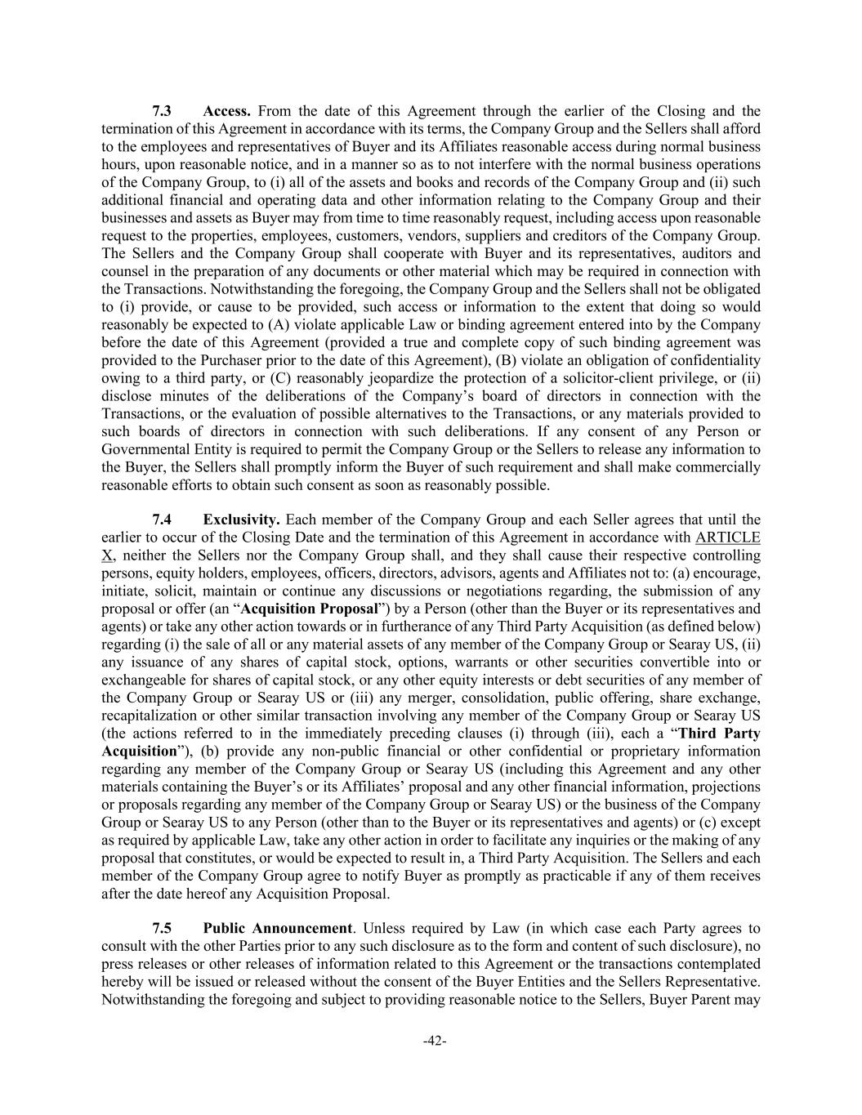
-42- 7.3 Access. From the date of this Agreement through the earlier of the Closing and the termination of this Agreement in accordance with its terms, the Company Group and the Sellers shall afford to the employees and representatives of Buyer and its Affiliates reasonable access during normal business hours, upon reasonable notice, and in a manner so as to not interfere with the normal business operations of the Company Group, to (i) all of the assets and books and records of the Company Group and (ii) such additional financial and operating data and other information relating to the Company Group and their businesses and assets as Buyer may from time to time reasonably request, including access upon reasonable request to the properties, employees, customers, vendors, suppliers and creditors of the Company Group. The Sellers and the Company Group shall cooperate with Buyer and its representatives, auditors and counsel in the preparation of any documents or other material which may be required in connection with the Transactions. Notwithstanding the foregoing, the Company Group and the Sellers shall not be obligated to (i) provide, or cause to be provided, such access or information to the extent that doing so would reasonably be expected to (A) violate applicable Law or binding agreement entered into by the Company before the date of this Agreement (provided a true and complete copy of such binding agreement was provided to the Purchaser prior to the date of this Agreement), (B) violate an obligation of confidentiality owing to a third party, or (C) reasonably jeopardize the protection of a solicitor-client privilege, or (ii) disclose minutes of the deliberations of the Company’s board of directors in connection with the Transactions, or the evaluation of possible alternatives to the Transactions, or any materials provided to such boards of directors in connection with such deliberations. If any consent of any Person or Governmental Entity is required to permit the Company Group or the Sellers to release any information to the Buyer, the Sellers shall promptly inform the Buyer of such requirement and shall make commercially reasonable efforts to obtain such consent as soon as reasonably possible. 7.4 Exclusivity. Each member of the Company Group and each Seller agrees that until the earlier to occur of the Closing Date and the termination of this Agreement in accordance with ARTICLE X, neither the Sellers nor the Company Group shall, and they shall cause their respective controlling persons, equity holders, employees, officers, directors, advisors, agents and Affiliates not to: (a) encourage, initiate, solicit, maintain or continue any discussions or negotiations regarding, the submission of any proposal or offer (an “Acquisition Proposal”) by a Person (other than the Buyer or its representatives and agents) or take any other action towards or in furtherance of any Third Party Acquisition (as defined below) regarding (i) the sale of all or any material assets of any member of the Company Group or Searay US, (ii) any issuance of any shares of capital stock, options, warrants or other securities convertible into or exchangeable for shares of capital stock, or any other equity interests or debt securities of any member of the Company Group or Searay US or (iii) any merger, consolidation, public offering, share exchange, recapitalization or other similar transaction involving any member of the Company Group or Searay US (the actions referred to in the immediately preceding clauses (i) through (iii), each a “Third Party Acquisition”), (b) provide any non-public financial or other confidential or proprietary information regarding any member of the Company Group or Searay US (including this Agreement and any other materials containing the Buyer’s or its Affiliates’ proposal and any other financial information, projections or proposals regarding any member of the Company Group or Searay US) or the business of the Company Group or Searay US to any Person (other than to the Buyer or its representatives and agents) or (c) except as required by applicable Law, take any other action in order to facilitate any inquiries or the making of any proposal that constitutes, or would be expected to result in, a Third Party Acquisition. The Sellers and each member of the Company Group agree to notify Buyer as promptly as practicable if any of them receives after the date hereof any Acquisition Proposal. 7.5 Public Announcement. Unless required by Law (in which case each Party agrees to consult with the other Parties prior to any such disclosure as to the form and content of such disclosure), no press releases or other releases of information related to this Agreement or the transactions contemplated hereby will be issued or released without the consent of the Buyer Entities and the Sellers Representative. Notwithstanding the foregoing and subject to providing reasonable notice to the Sellers, Buyer Parent may

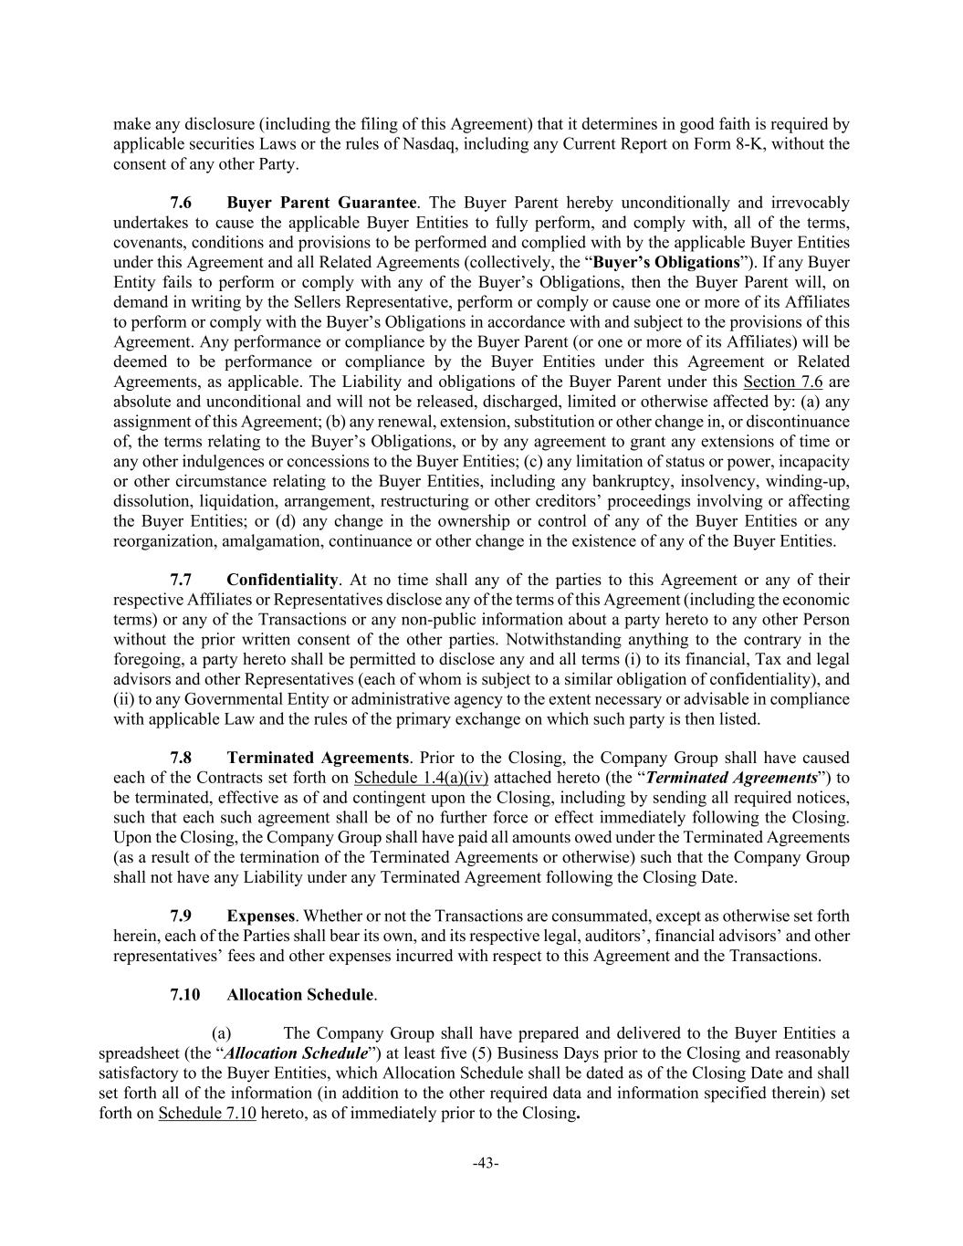
-43- make any disclosure (including the filing of this Agreement) that it determines in good faith is required by applicable securities Laws or the rules of Nasdaq, including any Current Report on Form 8-K, without the consent of any other Party. 7.6 Buyer Parent Guarantee. The Buyer Parent hereby unconditionally and irrevocably undertakes to cause the applicable Buyer Entities to fully perform, and comply with, all of the terms, covenants, conditions and provisions to be performed and complied with by the applicable Buyer Entities under this Agreement and all Related Agreements (collectively, the “Buyer’s Obligations”). If any Buyer Entity fails to perform or comply with any of the Buyer’s Obligations, then the Buyer Parent will, on demand in writing by the Sellers Representative, perform or comply or cause one or more of its Affiliates to perform or comply with the Buyer’s Obligations in accordance with and subject to the provisions of this Agreement. Any performance or compliance by the Buyer Parent (or one or more of its Affiliates) will be deemed to be performance or compliance by the Buyer Entities under this Agreement or Related Agreements, as applicable. The Liability and obligations of the Buyer Parent under this Section 7.6 are absolute and unconditional and will not be released, discharged, limited or otherwise affected by: (a) any assignment of this Agreement; (b) any renewal, extension, substitution or other change in, or discontinuance of, the terms relating to the Buyer’s Obligations, or by any agreement to grant any extensions of time or any other indulgences or concessions to the Buyer Entities; (c) any limitation of status or power, incapacity or other circumstance relating to the Buyer Entities, including any bankruptcy, insolvency, winding-up, dissolution, liquidation, arrangement, restructuring or other creditors’ proceedings involving or affecting the Buyer Entities; or (d) any change in the ownership or control of any of the Buyer Entities or any reorganization, amalgamation, continuance or other change in the existence of any of the Buyer Entities. 7.7 Confidentiality. At no time shall any of the parties to this Agreement or any of their respective Affiliates or Representatives disclose any of the terms of this Agreement (including the economic terms) or any of the Transactions or any non-public information about a party hereto to any other Person without the prior written consent of the other parties. Notwithstanding anything to the contrary in the foregoing, a party hereto shall be permitted to disclose any and all terms (i) to its financial, Tax and legal advisors and other Representatives (each of whom is subject to a similar obligation of confidentiality), and (ii) to any Governmental Entity or administrative agency to the extent necessary or advisable in compliance with applicable Law and the rules of the primary exchange on which such party is then listed. 7.8 Terminated Agreements. Prior to the Closing, the Company Group shall have caused each of the Contracts set forth on Schedule 1.4(a)(iv) attached hereto (the “Terminated Agreements”) to be terminated, effective as of and contingent upon the Closing, including by sending all required notices, such that each such agreement shall be of no further force or effect immediately following the Closing. Upon the Closing, the Company Group shall have paid all amounts owed under the Terminated Agreements (as a result of the termination of the Terminated Agreements or otherwise) such that the Company Group shall not have any Liability under any Terminated Agreement following the Closing Date. 7.9 Expenses. Whether or not the Transactions are consummated, except as otherwise set forth herein, each of the Parties shall bear its own, and its respective legal, auditors’, financial advisors’ and other representatives’ fees and other expenses incurred with respect to this Agreement and the Transactions. 7.10 Allocation Schedule. (a) The Company Group shall have prepared and delivered to the Buyer Entities a spreadsheet (the “Allocation Schedule”) at least five (5) Business Days prior to the Closing and reasonably satisfactory to the Buyer Entities, which Allocation Schedule shall be dated as of the Closing Date and shall set forth all of the information (in addition to the other required data and information specified therein) set forth on Schedule 7.10 hereto, as of immediately prior to the Closing.

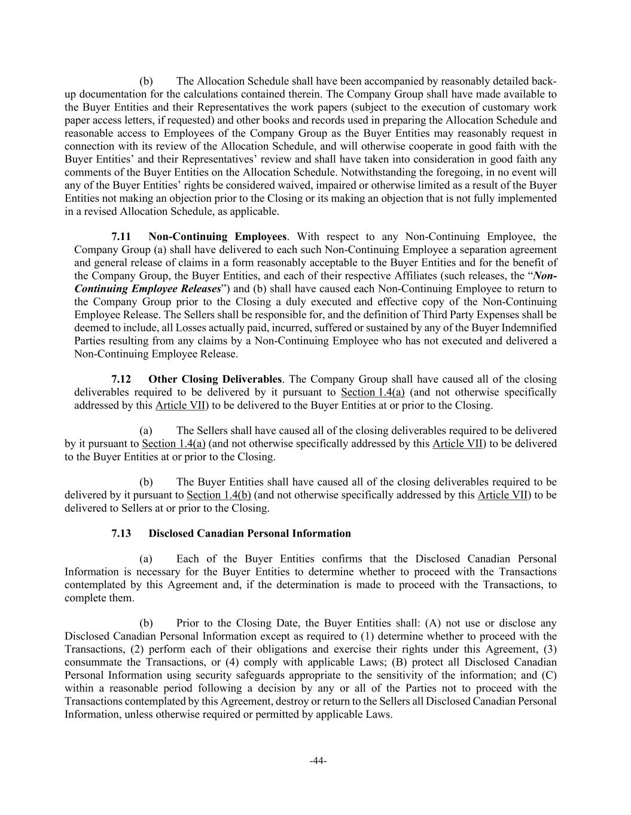
-44- (b) The Allocation Schedule shall have been accompanied by reasonably detailed back- up documentation for the calculations contained therein. The Company Group shall have made available to the Buyer Entities and their Representatives the work papers (subject to the execution of customary work paper access letters, if requested) and other books and records used in preparing the Allocation Schedule and reasonable access to Employees of the Company Group as the Buyer Entities may reasonably request in connection with its review of the Allocation Schedule, and will otherwise cooperate in good faith with the Buyer Entities’ and their Representatives’ review and shall have taken into consideration in good faith any comments of the Buyer Entities on the Allocation Schedule. Notwithstanding the foregoing, in no event will any of the Buyer Entities’ rights be considered waived, impaired or otherwise limited as a result of the Buyer Entities not making an objection prior to the Closing or its making an objection that is not fully implemented in a revised Allocation Schedule, as applicable. 7.11 Non-Continuing Employees. With respect to any Non-Continuing Employee, the Company Group (a) shall have delivered to each such Non-Continuing Employee a separation agreement and general release of claims in a form reasonably acceptable to the Buyer Entities and for the benefit of the Company Group, the Buyer Entities, and each of their respective Affiliates (such releases, the “Non- Continuing Employee Releases”) and (b) shall have caused each Non-Continuing Employee to return to the Company Group prior to the Closing a duly executed and effective copy of the Non-Continuing Employee Release. The Sellers shall be responsible for, and the definition of Third Party Expenses shall be deemed to include, all Losses actually paid, incurred, suffered or sustained by any of the Buyer Indemnified Parties resulting from any claims by a Non-Continuing Employee who has not executed and delivered a Non-Continuing Employee Release. 7.12 Other Closing Deliverables. The Company Group shall have caused all of the closing deliverables required to be delivered by it pursuant to Section 1.4(a) (and not otherwise specifically addressed by this Article VII) to be delivered to the Buyer Entities at or prior to the Closing. (a) The Sellers shall have caused all of the closing deliverables required to be delivered by it pursuant to Section 1.4(a) (and not otherwise specifically addressed by this Article VII) to be delivered to the Buyer Entities at or prior to the Closing. (b) The Buyer Entities shall have caused all of the closing deliverables required to be delivered by it pursuant to Section 1.4(b) (and not otherwise specifically addressed by this Article VII) to be delivered to Sellers at or prior to the Closing. 7.13 Disclosed Canadian Personal Information (a) Each of the Buyer Entities confirms that the Disclosed Canadian Personal Information is necessary for the Buyer Entities to determine whether to proceed with the Transactions contemplated by this Agreement and, if the determination is made to proceed with the Transactions, to complete them. (b) Prior to the Closing Date, the Buyer Entities shall: (A) not use or disclose any Disclosed Canadian Personal Information except as required to (1) determine whether to proceed with the Transactions, (2) perform each of their obligations and exercise their rights under this Agreement, (3) consummate the Transactions, or (4) comply with applicable Laws; (B) protect all Disclosed Canadian Personal Information using security safeguards appropriate to the sensitivity of the information; and (C) within a reasonable period following a decision by any or all of the Parties not to proceed with the Transactions contemplated by this Agreement, destroy or return to the Sellers all Disclosed Canadian Personal Information, unless otherwise required or permitted by applicable Laws.

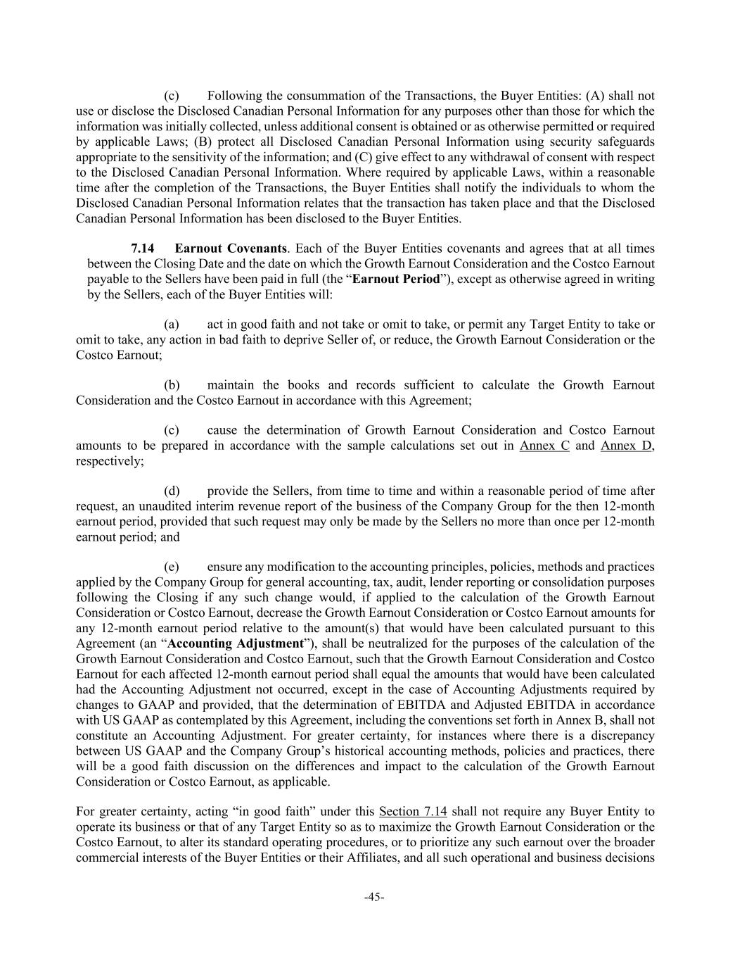
-45- (c) Following the consummation of the Transactions, the Buyer Entities: (A) shall not use or disclose the Disclosed Canadian Personal Information for any purposes other than those for which the information was initially collected, unless additional consent is obtained or as otherwise permitted or required by applicable Laws; (B) protect all Disclosed Canadian Personal Information using security safeguards appropriate to the sensitivity of the information; and (C) give effect to any withdrawal of consent with respect to the Disclosed Canadian Personal Information. Where required by applicable Laws, within a reasonable time after the completion of the Transactions, the Buyer Entities shall notify the individuals to whom the Disclosed Canadian Personal Information relates that the transaction has taken place and that the Disclosed Canadian Personal Information has been disclosed to the Buyer Entities. 7.14 Earnout Covenants. Each of the Buyer Entities covenants and agrees that at all times between the Closing Date and the date on which the Growth Earnout Consideration and the Costco Earnout payable to the Sellers have been paid in full (the “Earnout Period”), except as otherwise agreed in writing by the Sellers, each of the Buyer Entities will: (a) act in good faith and not take or omit to take, or permit any Target Entity to take or omit to take, any action in bad faith to deprive Seller of, or reduce, the Growth Earnout Consideration or the Costco Earnout; (b) maintain the books and records sufficient to calculate the Growth Earnout Consideration and the Costco Earnout in accordance with this Agreement; (c) cause the determination of Growth Earnout Consideration and Costco Earnout amounts to be prepared in accordance with the sample calculations set out in Annex C and Annex D, respectively; (d) provide the Sellers, from time to time and within a reasonable period of time after request, an unaudited interim revenue report of the business of the Company Group for the then 12-month earnout period, provided that such request may only be made by the Sellers no more than once per 12-month earnout period; and (e) ensure any modification to the accounting principles, policies, methods and practices applied by the Company Group for general accounting, tax, audit, lender reporting or consolidation purposes following the Closing if any such change would, if applied to the calculation of the Growth Earnout Consideration or Costco Earnout, decrease the Growth Earnout Consideration or Costco Earnout amounts for any 12-month earnout period relative to the amount(s) that would have been calculated pursuant to this Agreement (an “Accounting Adjustment”), shall be neutralized for the purposes of the calculation of the Growth Earnout Consideration and Costco Earnout, such that the Growth Earnout Consideration and Costco Earnout for each affected 12-month earnout period shall equal the amounts that would have been calculated had the Accounting Adjustment not occurred, except in the case of Accounting Adjustments required by changes to GAAP and provided, that the determination of EBITDA and Adjusted EBITDA in accordance with US GAAP as contemplated by this Agreement, including the conventions set forth in Annex B, shall not constitute an Accounting Adjustment. For greater certainty, for instances where there is a discrepancy between US GAAP and the Company Group’s historical accounting methods, policies and practices, there will be a good faith discussion on the differences and impact to the calculation of the Growth Earnout Consideration or Costco Earnout, as applicable. For greater certainty, acting “in good faith” under this Section 7.14 shall not require any Buyer Entity to operate its business or that of any Target Entity so as to maximize the Growth Earnout Consideration or the Costco Earnout, to alter its standard operating procedures, or to prioritize any such earnout over the broader commercial interests of the Buyer Entities or their Affiliates, and all such operational and business decisions

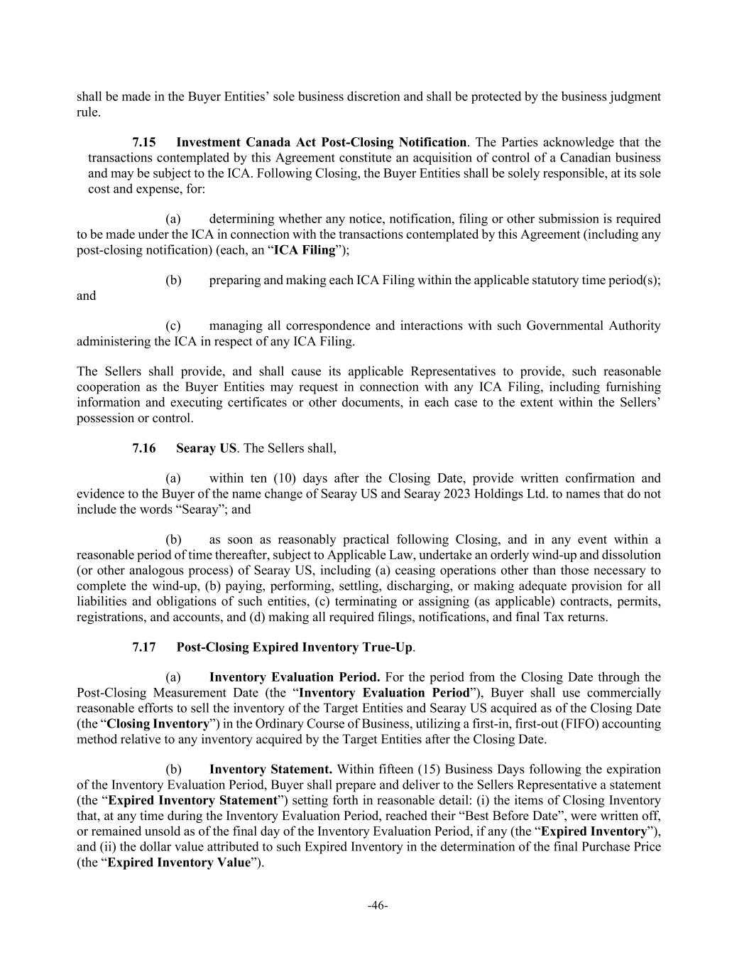
-46- shall be made in the Buyer Entities’ sole business discretion and shall be protected by the business judgment rule. 7.15 Investment Canada Act Post-Closing Notification. The Parties acknowledge that the transactions contemplated by this Agreement constitute an acquisition of control of a Canadian business and may be subject to the ICA. Following Closing, the Buyer Entities shall be solely responsible, at its sole cost and expense, for: (a) determining whether any notice, notification, filing or other submission is required to be made under the ICA in connection with the transactions contemplated by this Agreement (including any post-closing notification) (each, an “ICA Filing”); (b) preparing and making each ICA Filing within the applicable statutory time period(s); and (c) managing all correspondence and interactions with such Governmental Authority administering the ICA in respect of any ICA Filing. The Sellers shall provide, and shall cause its applicable Representatives to provide, such reasonable cooperation as the Buyer Entities may request in connection with any ICA Filing, including furnishing information and executing certificates or other documents, in each case to the extent within the Sellers’ possession or control. 7.16 Searay US. The Sellers shall, (a) within ten (10) days after the Closing Date, provide written confirmation and evidence to the Buyer of the name change of Searay US and Searay 2023 Holdings Ltd. to names that do not include the words “Searay”; and (b) as soon as reasonably practical following Closing, and in any event within a reasonable period of time thereafter, subject to Applicable Law, undertake an orderly wind-up and dissolution (or other analogous process) of Searay US, including (a) ceasing operations other than those necessary to complete the wind-up, (b) paying, performing, settling, discharging, or making adequate provision for all liabilities and obligations of such entities, (c) terminating or assigning (as applicable) contracts, permits, registrations, and accounts, and (d) making all required filings, notifications, and final Tax returns. 7.17 Post-Closing Expired Inventory True-Up. (a) Inventory Evaluation Period. For the period from the Closing Date through the Post-Closing Measurement Date (the “Inventory Evaluation Period”), Buyer shall use commercially reasonable efforts to sell the inventory of the Target Entities and Searay US acquired as of the Closing Date (the “Closing Inventory”) in the Ordinary Course of Business, utilizing a first-in, first-out (FIFO) accounting method relative to any inventory acquired by the Target Entities after the Closing Date. (b) Inventory Statement. Within fifteen (15) Business Days following the expiration of the Inventory Evaluation Period, Buyer shall prepare and deliver to the Sellers Representative a statement (the “Expired Inventory Statement”) setting forth in reasonable detail: (i) the items of Closing Inventory that, at any time during the Inventory Evaluation Period, reached their “Best Before Date”, were written off, or remained unsold as of the final day of the Inventory Evaluation Period, if any (the “Expired Inventory”), and (ii) the dollar value attributed to such Expired Inventory in the determination of the final Purchase Price (the “Expired Inventory Value”).

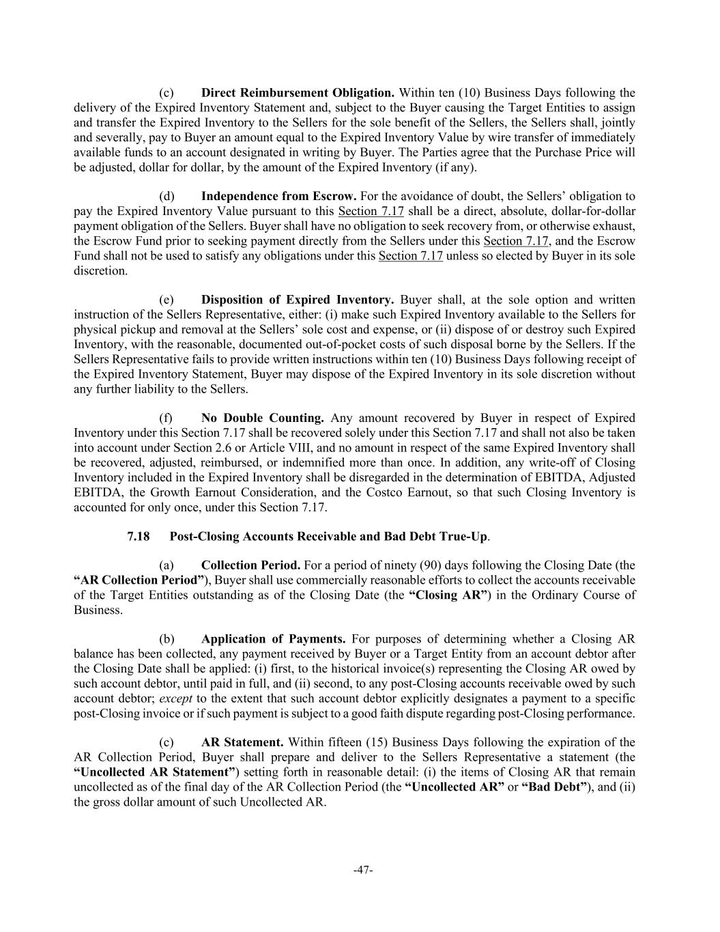
-47- (c) Direct Reimbursement Obligation. Within ten (10) Business Days following the delivery of the Expired Inventory Statement and, subject to the Buyer causing the Target Entities to assign and transfer the Expired Inventory to the Sellers for the sole benefit of the Sellers, the Sellers shall, jointly and severally, pay to Buyer an amount equal to the Expired Inventory Value by wire transfer of immediately available funds to an account designated in writing by Buyer. The Parties agree that the Purchase Price will be adjusted, dollar for dollar, by the amount of the Expired Inventory (if any). (d) Independence from Escrow. For the avoidance of doubt, the Sellers’ obligation to pay the Expired Inventory Value pursuant to this Section 7.17 shall be a direct, absolute, dollar-for-dollar payment obligation of the Sellers. Buyer shall have no obligation to seek recovery from, or otherwise exhaust, the Escrow Fund prior to seeking payment directly from the Sellers under this Section 7.17, and the Escrow Fund shall not be used to satisfy any obligations under this Section 7.17 unless so elected by Buyer in its sole discretion. (e) Disposition of Expired Inventory. Buyer shall, at the sole option and written instruction of the Sellers Representative, either: (i) make such Expired Inventory available to the Sellers for physical pickup and removal at the Sellers’ sole cost and expense, or (ii) dispose of or destroy such Expired Inventory, with the reasonable, documented out-of-pocket costs of such disposal borne by the Sellers. If the Sellers Representative fails to provide written instructions within ten (10) Business Days following receipt of the Expired Inventory Statement, Buyer may dispose of the Expired Inventory in its sole discretion without any further liability to the Sellers. (f) No Double Counting. Any amount recovered by Buyer in respect of Expired Inventory under this Section 7.17 shall be recovered solely under this Section 7.17 and shall not also be taken into account under Section 2.6 or Article VIII, and no amount in respect of the same Expired Inventory shall be recovered, adjusted, reimbursed, or indemnified more than once. In addition, any write-off of Closing Inventory included in the Expired Inventory shall be disregarded in the determination of EBITDA, Adjusted EBITDA, the Growth Earnout Consideration, and the Costco Earnout, so that such Closing Inventory is accounted for only once, under this Section 7.17. 7.18 Post-Closing Accounts Receivable and Bad Debt True-Up. (a) Collection Period. For a period of ninety (90) days following the Closing Date (the “AR Collection Period”), Buyer shall use commercially reasonable efforts to collect the accounts receivable of the Target Entities outstanding as of the Closing Date (the “Closing AR”) in the Ordinary Course of Business. (b) Application of Payments. For purposes of determining whether a Closing AR balance has been collected, any payment received by Buyer or a Target Entity from an account debtor after the Closing Date shall be applied: (i) first, to the historical invoice(s) representing the Closing AR owed by such account debtor, until paid in full, and (ii) second, to any post-Closing accounts receivable owed by such account debtor; except to the extent that such account debtor explicitly designates a payment to a specific post-Closing invoice or if such payment is subject to a good faith dispute regarding post-Closing performance. (c) AR Statement. Within fifteen (15) Business Days following the expiration of the AR Collection Period, Buyer shall prepare and deliver to the Sellers Representative a statement (the “Uncollected AR Statement”) setting forth in reasonable detail: (i) the items of Closing AR that remain uncollected as of the final day of the AR Collection Period (the “Uncollected AR” or “Bad Debt”), and (ii) the gross dollar amount of such Uncollected AR.

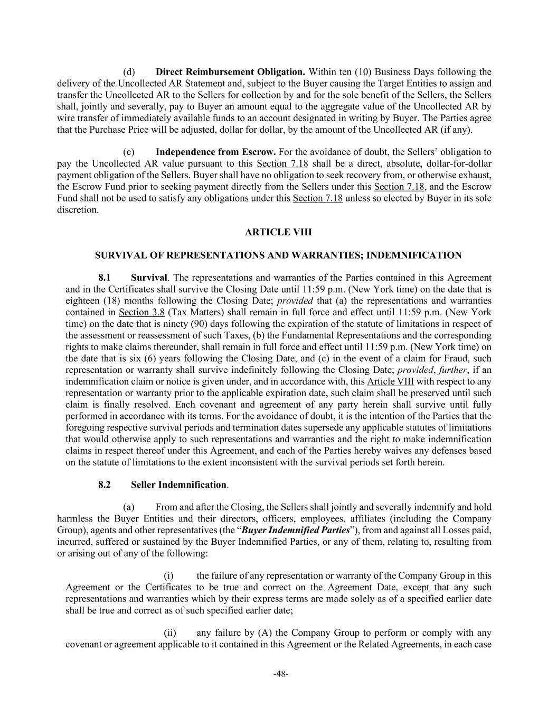
-48- (d) Direct Reimbursement Obligation. Within ten (10) Business Days following the delivery of the Uncollected AR Statement and, subject to the Buyer causing the Target Entities to assign and transfer the Uncollected AR to the Sellers for collection by and for the sole benefit of the Sellers, the Sellers shall, jointly and severally, pay to Buyer an amount equal to the aggregate value of the Uncollected AR by wire transfer of immediately available funds to an account designated in writing by Buyer. The Parties agree that the Purchase Price will be adjusted, dollar for dollar, by the amount of the Uncollected AR (if any). (e) Independence from Escrow. For the avoidance of doubt, the Sellers’ obligation to pay the Uncollected AR value pursuant to this Section 7.18 shall be a direct, absolute, dollar-for-dollar payment obligation of the Sellers. Buyer shall have no obligation to seek recovery from, or otherwise exhaust, the Escrow Fund prior to seeking payment directly from the Sellers under this Section 7.18, and the Escrow Fund shall not be used to satisfy any obligations under this Section 7.18 unless so elected by Buyer in its sole discretion. ARTICLE VIII SURVIVAL OF REPRESENTATIONS AND WARRANTIES; INDEMNIFICATION 8.1 Survival. The representations and warranties of the Parties contained in this Agreement and in the Certificates shall survive the Closing Date until 11:59 p.m. (New York time) on the date that is eighteen (18) months following the Closing Date; provided that (a) the representations and warranties contained in Section 3.8 (Tax Matters) shall remain in full force and effect until 11:59 p.m. (New York time) on the date that is ninety (90) days following the expiration of the statute of limitations in respect of the assessment or reassessment of such Taxes, (b) the Fundamental Representations and the corresponding rights to make claims thereunder, shall remain in full force and effect until 11:59 p.m. (New York time) on the date that is six (6) years following the Closing Date, and (c) in the event of a claim for Fraud, such representation or warranty shall survive indefinitely following the Closing Date; provided, further, if an indemnification claim or notice is given under, and in accordance with, this Article VIII with respect to any representation or warranty prior to the applicable expiration date, such claim shall be preserved until such claim is finally resolved. Each covenant and agreement of any party herein shall survive until fully performed in accordance with its terms. For the avoidance of doubt, it is the intention of the Parties that the foregoing respective survival periods and termination dates supersede any applicable statutes of limitations that would otherwise apply to such representations and warranties and the right to make indemnification claims in respect thereof under this Agreement, and each of the Parties hereby waives any defenses based on the statute of limitations to the extent inconsistent with the survival periods set forth herein. 8.2 Seller Indemnification. (a) From and after the Closing, the Sellers shall jointly and severally indemnify and hold harmless the Buyer Entities and their directors, officers, employees, affiliates (including the Company Group), agents and other representatives (the “Buyer Indemnified Parties”), from and against all Losses paid, incurred, suffered or sustained by the Buyer Indemnified Parties, or any of them, relating to, resulting from or arising out of any of the following: (i) the failure of any representation or warranty of the Company Group in this Agreement or the Certificates to be true and correct on the Agreement Date, except that any such representations and warranties which by their express terms are made solely as of a specified earlier date shall be true and correct as of such specified earlier date; (ii) any failure by (A) the Company Group to perform or comply with any covenant or agreement applicable to it contained in this Agreement or the Related Agreements, in each case

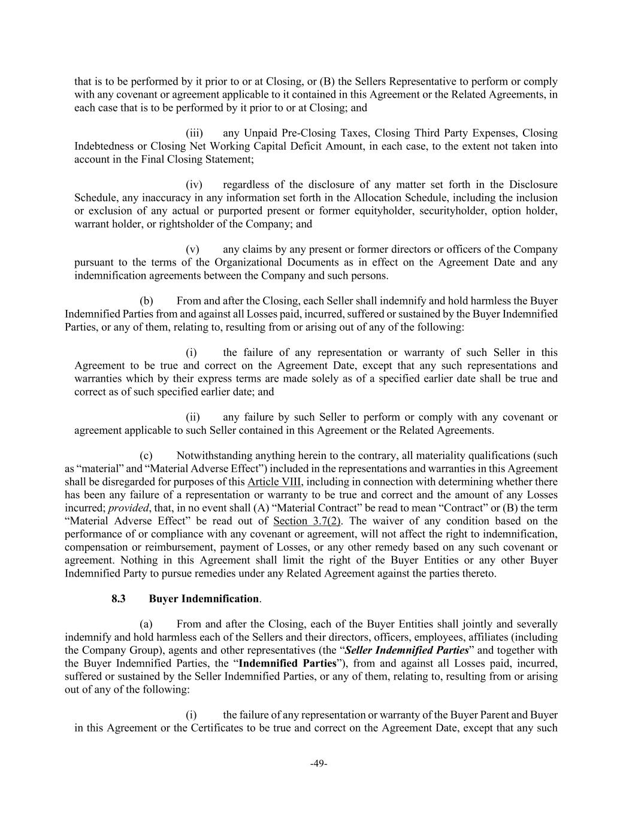
-49- that is to be performed by it prior to or at Closing, or (B) the Sellers Representative to perform or comply with any covenant or agreement applicable to it contained in this Agreement or the Related Agreements, in each case that is to be performed by it prior to or at Closing; and (iii) any Unpaid Pre-Closing Taxes, Closing Third Party Expenses, Closing Indebtedness or Closing Net Working Capital Deficit Amount, in each case, to the extent not taken into account in the Final Closing Statement; (iv) regardless of the disclosure of any matter set forth in the Disclosure Schedule, any inaccuracy in any information set forth in the Allocation Schedule, including the inclusion or exclusion of any actual or purported present or former equityholder, securityholder, option holder, warrant holder, or rightsholder of the Company; and (v) any claims by any present or former directors or officers of the Company pursuant to the terms of the Organizational Documents as in effect on the Agreement Date and any indemnification agreements between the Company and such persons. (b) From and after the Closing, each Seller shall indemnify and hold harmless the Buyer Indemnified Parties from and against all Losses paid, incurred, suffered or sustained by the Buyer Indemnified Parties, or any of them, relating to, resulting from or arising out of any of the following: (i) the failure of any representation or warranty of such Seller in this Agreement to be true and correct on the Agreement Date, except that any such representations and warranties which by their express terms are made solely as of a specified earlier date shall be true and correct as of such specified earlier date; and (ii) any failure by such Seller to perform or comply with any covenant or agreement applicable to such Seller contained in this Agreement or the Related Agreements. (c) Notwithstanding anything herein to the contrary, all materiality qualifications (such as “material” and “Material Adverse Effect”) included in the representations and warranties in this Agreement shall be disregarded for purposes of this Article VIII, including in connection with determining whether there has been any failure of a representation or warranty to be true and correct and the amount of any Losses incurred; provided, that, in no event shall (A) “Material Contract” be read to mean “Contract” or (B) the term “Material Adverse Effect” be read out of Section 3.7(2). The waiver of any condition based on the performance of or compliance with any covenant or agreement, will not affect the right to indemnification, compensation or reimbursement, payment of Losses, or any other remedy based on any such covenant or agreement. Nothing in this Agreement shall limit the right of the Buyer Entities or any other Buyer Indemnified Party to pursue remedies under any Related Agreement against the parties thereto. 8.3 Buyer Indemnification. (a) From and after the Closing, each of the Buyer Entities shall jointly and severally indemnify and hold harmless each of the Sellers and their directors, officers, employees, affiliates (including the Company Group), agents and other representatives (the “Seller Indemnified Parties” and together with the Buyer Indemnified Parties, the “Indemnified Parties”), from and against all Losses paid, incurred, suffered or sustained by the Seller Indemnified Parties, or any of them, relating to, resulting from or arising out of any of the following: (i) the failure of any representation or warranty of the Buyer Parent and Buyer in this Agreement or the Certificates to be true and correct on the Agreement Date, except that any such

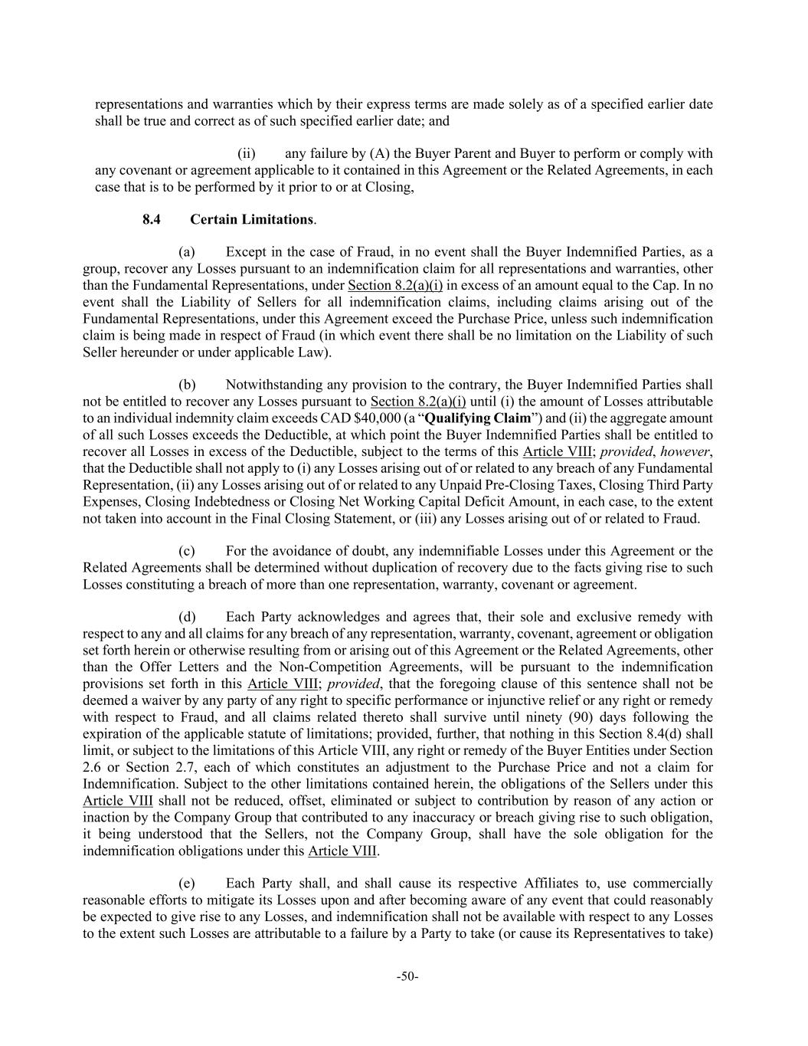
-50- representations and warranties which by their express terms are made solely as of a specified earlier date shall be true and correct as of such specified earlier date; and (ii) any failure by (A) the Buyer Parent and Buyer to perform or comply with any covenant or agreement applicable to it contained in this Agreement or the Related Agreements, in each case that is to be performed by it prior to or at Closing, 8.4 Certain Limitations. (a) Except in the case of Fraud, in no event shall the Buyer Indemnified Parties, as a group, recover any Losses pursuant to an indemnification claim for all representations and warranties, other than the Fundamental Representations, under Section 8.2(a)(i) in excess of an amount equal to the Cap. In no event shall the Liability of Sellers for all indemnification claims, including claims arising out of the Fundamental Representations, under this Agreement exceed the Purchase Price, unless such indemnification claim is being made in respect of Fraud (in which event there shall be no limitation on the Liability of such Seller hereunder or under applicable Law). (b) Notwithstanding any provision to the contrary, the Buyer Indemnified Parties shall not be entitled to recover any Losses pursuant to Section 8.2(a)(i) until (i) the amount of Losses attributable to an individual indemnity claim exceeds CAD $40,000 (a “Qualifying Claim”) and (ii) the aggregate amount of all such Losses exceeds the Deductible, at which point the Buyer Indemnified Parties shall be entitled to recover all Losses in excess of the Deductible, subject to the terms of this Article VIII; provided, however, that the Deductible shall not apply to (i) any Losses arising out of or related to any breach of any Fundamental Representation, (ii) any Losses arising out of or related to any Unpaid Pre-Closing Taxes, Closing Third Party Expenses, Closing Indebtedness or Closing Net Working Capital Deficit Amount, in each case, to the extent not taken into account in the Final Closing Statement, or (iii) any Losses arising out of or related to Fraud. (c) For the avoidance of doubt, any indemnifiable Losses under this Agreement or the Related Agreements shall be determined without duplication of recovery due to the facts giving rise to such Losses constituting a breach of more than one representation, warranty, covenant or agreement. (d) Each Party acknowledges and agrees that, their sole and exclusive remedy with respect to any and all claims for any breach of any representation, warranty, covenant, agreement or obligation set forth herein or otherwise resulting from or arising out of this Agreement or the Related Agreements, other than the Offer Letters and the Non-Competition Agreements, will be pursuant to the indemnification provisions set forth in this Article VIII; provided, that the foregoing clause of this sentence shall not be deemed a waiver by any party of any right to specific performance or injunctive relief or any right or remedy with respect to Fraud, and all claims related thereto shall survive until ninety (90) days following the expiration of the applicable statute of limitations; provided, further, that nothing in this Section 8.4(d) shall limit, or subject to the limitations of this Article VIII, any right or remedy of the Buyer Entities under Section 2.6 or Section 2.7, each of which constitutes an adjustment to the Purchase Price and not a claim for Indemnification. Subject to the other limitations contained herein, the obligations of the Sellers under this Article VIII shall not be reduced, offset, eliminated or subject to contribution by reason of any action or inaction by the Company Group that contributed to any inaccuracy or breach giving rise to such obligation, it being understood that the Sellers, not the Company Group, shall have the sole obligation for the indemnification obligations under this Article VIII. (e) Each Party shall, and shall cause its respective Affiliates to, use commercially reasonable efforts to mitigate its Losses upon and after becoming aware of any event that could reasonably be expected to give rise to any Losses, and indemnification shall not be available with respect to any Losses to the extent such Losses are attributable to a failure by a Party to take (or cause its Representatives to take)

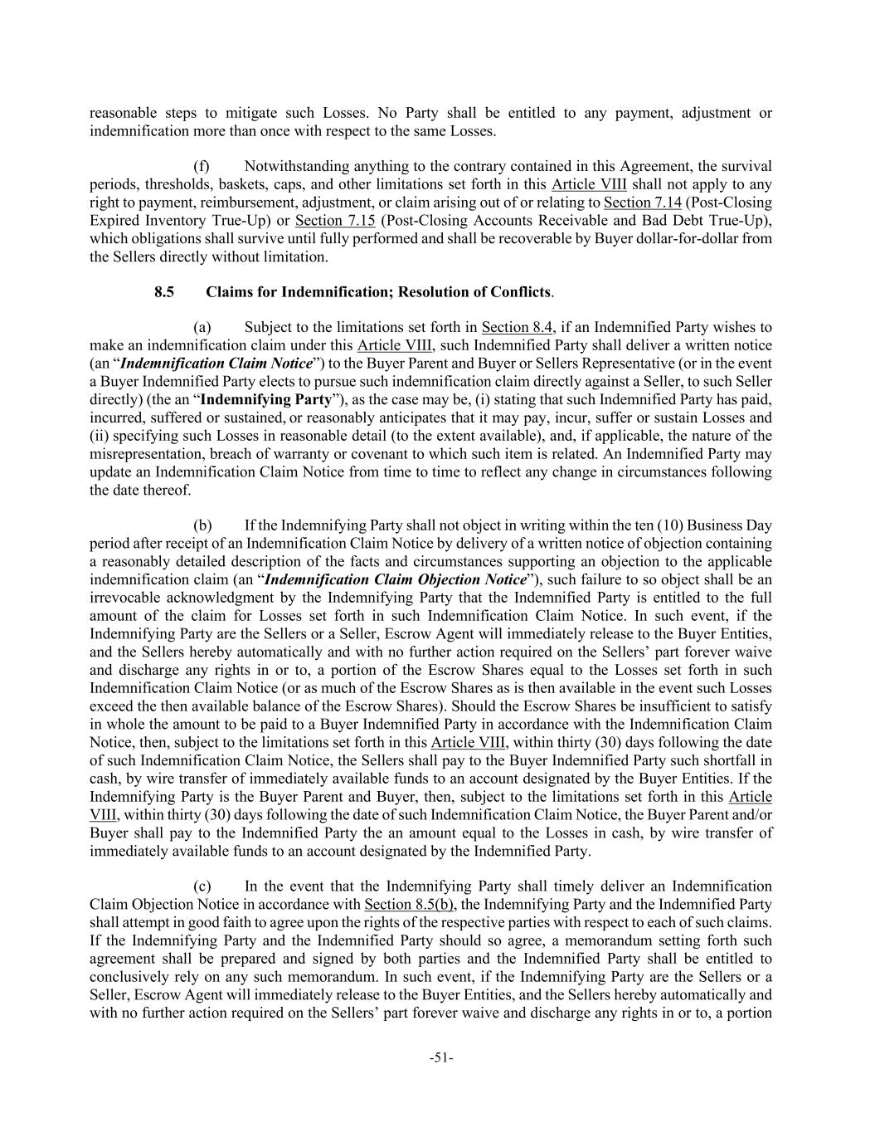
-51- reasonable steps to mitigate such Losses. No Party shall be entitled to any payment, adjustment or indemnification more than once with respect to the same Losses. (f) Notwithstanding anything to the contrary contained in this Agreement, the survival periods, thresholds, baskets, caps, and other limitations set forth in this Article VIII shall not apply to any right to payment, reimbursement, adjustment, or claim arising out of or relating to Section 7.14 (Post-Closing Expired Inventory True-Up) or Section 7.15 (Post-Closing Accounts Receivable and Bad Debt True-Up), which obligations shall survive until fully performed and shall be recoverable by Buyer dollar-for-dollar from the Sellers directly without limitation. 8.5 Claims for Indemnification; Resolution of Conflicts. (a) Subject to the limitations set forth in Section 8.4, if an Indemnified Party wishes to make an indemnification claim under this Article VIII, such Indemnified Party shall deliver a written notice (an “Indemnification Claim Notice”) to the Buyer Parent and Buyer or Sellers Representative (or in the event a Buyer Indemnified Party elects to pursue such indemnification claim directly against a Seller, to such Seller directly) (the an “Indemnifying Party”), as the case may be, (i) stating that such Indemnified Party has paid, incurred, suffered or sustained, or reasonably anticipates that it may pay, incur, suffer or sustain Losses and (ii) specifying such Losses in reasonable detail (to the extent available), and, if applicable, the nature of the misrepresentation, breach of warranty or covenant to which such item is related. An Indemnified Party may update an Indemnification Claim Notice from time to time to reflect any change in circumstances following the date thereof. (b) If the Indemnifying Party shall not object in writing within the ten (10) Business Day period after receipt of an Indemnification Claim Notice by delivery of a written notice of objection containing a reasonably detailed description of the facts and circumstances supporting an objection to the applicable indemnification claim (an “Indemnification Claim Objection Notice”), such failure to so object shall be an irrevocable acknowledgment by the Indemnifying Party that the Indemnified Party is entitled to the full amount of the claim for Losses set forth in such Indemnification Claim Notice. In such event, if the Indemnifying Party are the Sellers or a Seller, Escrow Agent will immediately release to the Buyer Entities, and the Sellers hereby automatically and with no further action required on the Sellers’ part forever waive and discharge any rights in or to, a portion of the Escrow Shares equal to the Losses set forth in such Indemnification Claim Notice (or as much of the Escrow Shares as is then available in the event such Losses exceed the then available balance of the Escrow Shares). Should the Escrow Shares be insufficient to satisfy in whole the amount to be paid to a Buyer Indemnified Party in accordance with the Indemnification Claim Notice, then, subject to the limitations set forth in this Article VIII, within thirty (30) days following the date of such Indemnification Claim Notice, the Sellers shall pay to the Buyer Indemnified Party such shortfall in cash, by wire transfer of immediately available funds to an account designated by the Buyer Entities. If the Indemnifying Party is the Buyer Parent and Buyer, then, subject to the limitations set forth in this Article VIII, within thirty (30) days following the date of such Indemnification Claim Notice, the Buyer Parent and/or Buyer shall pay to the Indemnified Party the an amount equal to the Losses in cash, by wire transfer of immediately available funds to an account designated by the Indemnified Party. (c) In the event that the Indemnifying Party shall timely deliver an Indemnification Claim Objection Notice in accordance with Section 8.5(b), the Indemnifying Party and the Indemnified Party shall attempt in good faith to agree upon the rights of the respective parties with respect to each of such claims. If the Indemnifying Party and the Indemnified Party should so agree, a memorandum setting forth such agreement shall be prepared and signed by both parties and the Indemnified Party shall be entitled to conclusively rely on any such memorandum. In such event, if the Indemnifying Party are the Sellers or a Seller, Escrow Agent will immediately release to the Buyer Entities, and the Sellers hereby automatically and with no further action required on the Sellers’ part forever waive and discharge any rights in or to, a portion

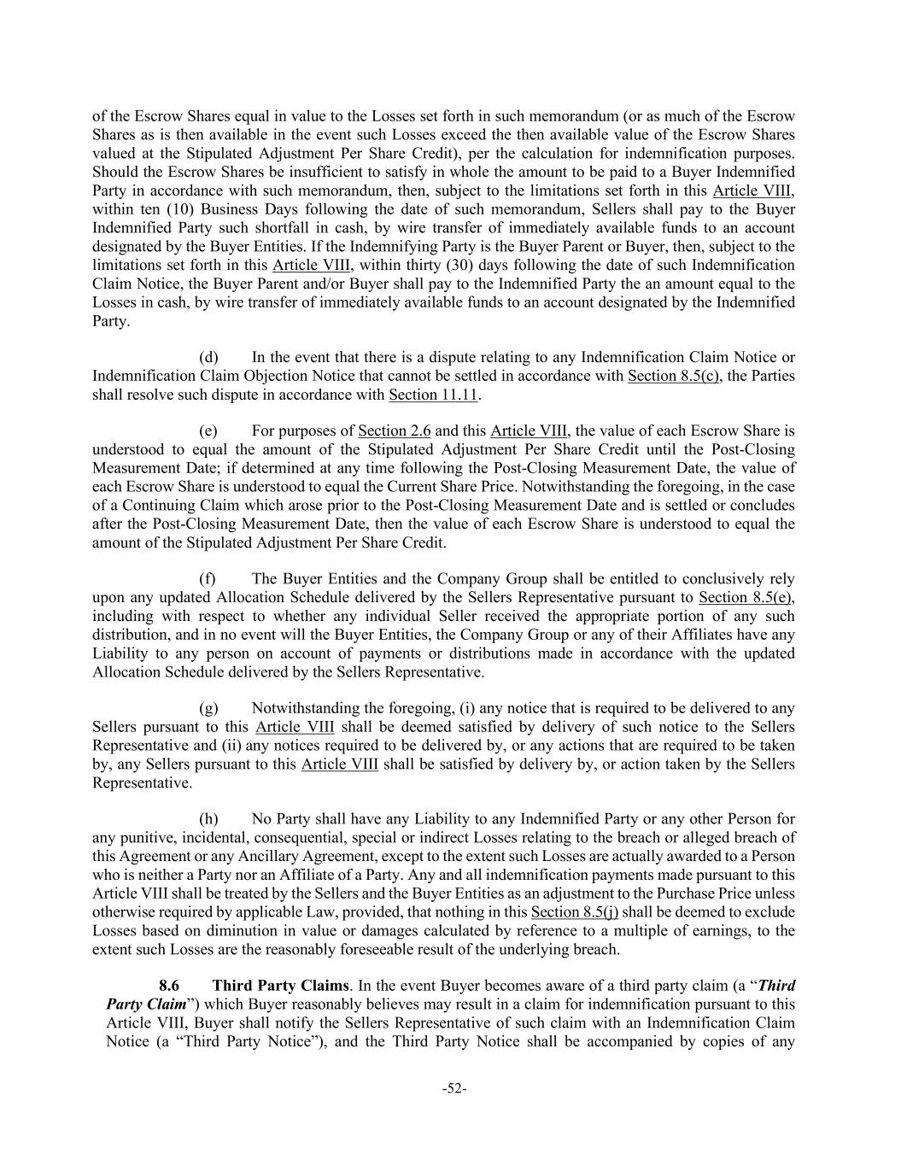
-52- of the Escrow Shares equal in value to the Losses set forth in such memorandum (or as much of the Escrow Shares as is then available in the event such Losses exceed the then available value of the Escrow Shares valued at the Stipulated Adjustment Per Share Credit), per the calculation for indemnification purposes. Should the Escrow Shares be insufficient to satisfy in whole the amount to be paid to a Buyer Indemnified Party in accordance with such memorandum, then, subject to the limitations set forth in this Article VIII, within ten (10) Business Days following the date of such memorandum, Sellers shall pay to the Buyer Indemnified Party such shortfall in cash, by wire transfer of immediately available funds to an account designated by the Buyer Entities. If the Indemnifying Party is the Buyer Parent or Buyer, then, subject to the limitations set forth in this Article VIII, within thirty (30) days following the date of such Indemnification Claim Notice, the Buyer Parent and/or Buyer shall pay to the Indemnified Party the an amount equal to the Losses in cash, by wire transfer of immediately available funds to an account designated by the Indemnified Party. (d) In the event that there is a dispute relating to any Indemnification Claim Notice or Indemnification Claim Objection Notice that cannot be settled in accordance with Section 8.5(c), the Parties shall resolve such dispute in accordance with Section 11.11. (e) For purposes of Section 2.6 and this Article VIII, the value of each Escrow Share is understood to equal the amount of the Stipulated Adjustment Per Share Credit until the Post-Closing Measurement Date; if determined at any time following the Post-Closing Measurement Date, the value of each Escrow Share is understood to equal the Current Share Price. Notwithstanding the foregoing, in the case of a Continuing Claim which arose prior to the Post-Closing Measurement Date and is settled or concludes after the Post-Closing Measurement Date, then the value of each Escrow Share is understood to equal the amount of the Stipulated Adjustment Per Share Credit. (f) The Buyer Entities and the Company Group shall be entitled to conclusively rely upon any updated Allocation Schedule delivered by the Sellers Representative pursuant to Section 8.5(e), including with respect to whether any individual Seller received the appropriate portion of any such distribution, and in no event will the Buyer Entities, the Company Group or any of their Affiliates have any Liability to any person on account of payments or distributions made in accordance with the updated Allocation Schedule delivered by the Sellers Representative. (g) Notwithstanding the foregoing, (i) any notice that is required to be delivered to any Sellers pursuant to this Article VIII shall be deemed satisfied by delivery of such notice to the Sellers Representative and (ii) any notices required to be delivered by, or any actions that are required to be taken by, any Sellers pursuant to this Article VIII shall be satisfied by delivery by, or action taken by the Sellers Representative. (h) No Party shall have any Liability to any Indemnified Party or any other Person for any punitive, incidental, consequential, special or indirect Losses relating to the breach or alleged breach of this Agreement or any Ancillary Agreement, except to the extent such Losses are actually awarded to a Person who is neither a Party nor an Affiliate of a Party. Any and all indemnification payments made pursuant to this Article VIII shall be treated by the Sellers and the Buyer Entities as an adjustment to the Purchase Price unless otherwise required by applicable Law, provided, that nothing in this Section 8.5(j) shall be deemed to exclude Losses based on diminution in value or damages calculated by reference to a multiple of earnings, to the extent such Losses are the reasonably foreseeable result of the underlying breach. 8.6 Third Party Claims. In the event Buyer becomes aware of a third party claim (a “Third Party Claim”) which Buyer reasonably believes may result in a claim for indemnification pursuant to this Article VIII, Buyer shall notify the Sellers Representative of such claim with an Indemnification Claim Notice (a “Third Party Notice”), and the Third Party Notice shall be accompanied by copies of any

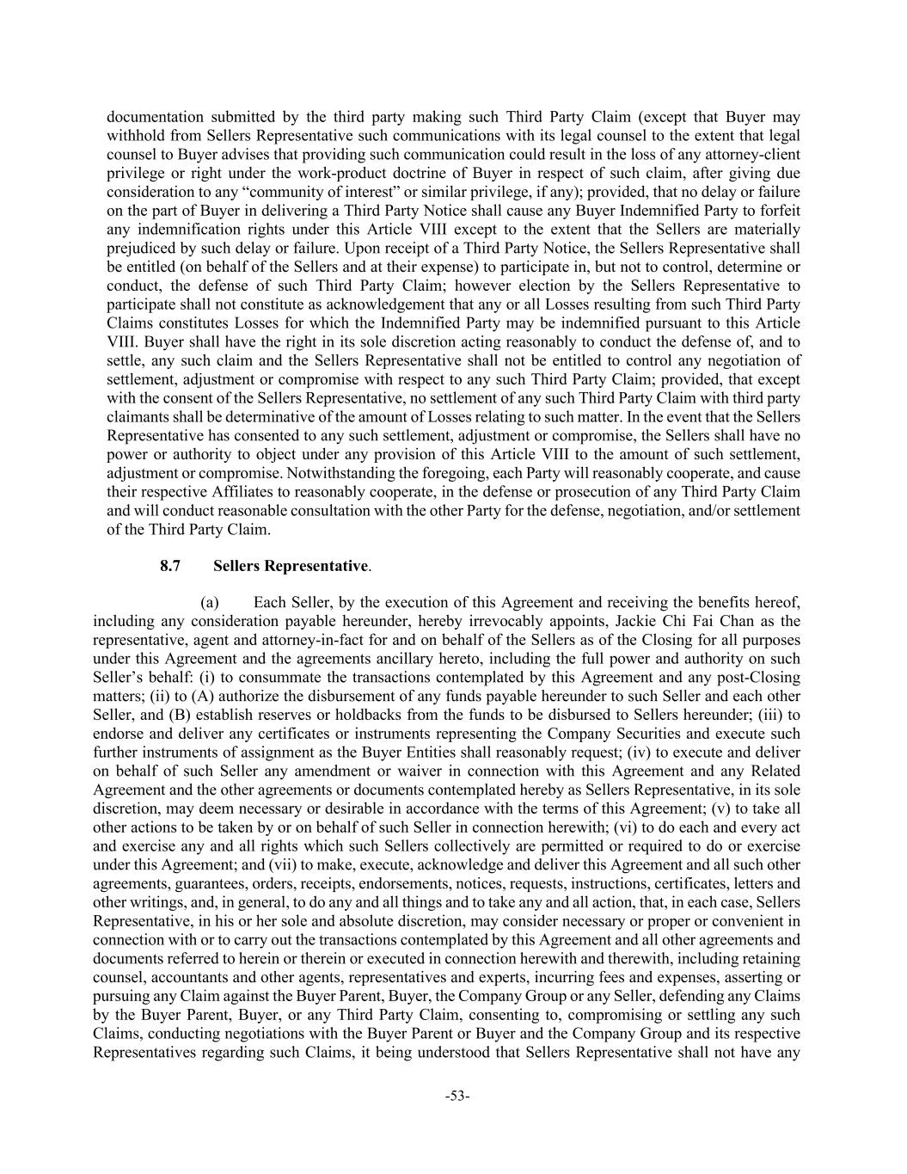
-53- documentation submitted by the third party making such Third Party Claim (except that Buyer may withhold from Sellers Representative such communications with its legal counsel to the extent that legal counsel to Buyer advises that providing such communication could result in the loss of any attorney-client privilege or right under the work-product doctrine of Buyer in respect of such claim, after giving due consideration to any “community of interest” or similar privilege, if any); provided, that no delay or failure on the part of Buyer in delivering a Third Party Notice shall cause any Buyer Indemnified Party to forfeit any indemnification rights under this Article VIII except to the extent that the Sellers are materially prejudiced by such delay or failure. Upon receipt of a Third Party Notice, the Sellers Representative shall be entitled (on behalf of the Sellers and at their expense) to participate in, but not to control, determine or conduct, the defense of such Third Party Claim; however election by the Sellers Representative to participate shall not constitute as acknowledgement that any or all Losses resulting from such Third Party Claims constitutes Losses for which the Indemnified Party may be indemnified pursuant to this Article VIII. Buyer shall have the right in its sole discretion acting reasonably to conduct the defense of, and to settle, any such claim and the Sellers Representative shall not be entitled to control any negotiation of settlement, adjustment or compromise with respect to any such Third Party Claim; provided, that except with the consent of the Sellers Representative, no settlement of any such Third Party Claim with third party claimants shall be determinative of the amount of Losses relating to such matter. In the event that the Sellers Representative has consented to any such settlement, adjustment or compromise, the Sellers shall have no power or authority to object under any provision of this Article VIII to the amount of such settlement, adjustment or compromise. Notwithstanding the foregoing, each Party will reasonably cooperate, and cause their respective Affiliates to reasonably cooperate, in the defense or prosecution of any Third Party Claim and will conduct reasonable consultation with the other Party for the defense, negotiation, and/or settlement of the Third Party Claim. 8.7 Sellers Representative. (a) Each Seller, by the execution of this Agreement and receiving the benefits hereof, including any consideration payable hereunder, hereby irrevocably appoints, Jackie Chi Fai Chan as the representative, agent and attorney-in-fact for and on behalf of the Sellers as of the Closing for all purposes under this Agreement and the agreements ancillary hereto, including the full power and authority on such Seller’s behalf: (i) to consummate the transactions contemplated by this Agreement and any post-Closing matters; (ii) to (A) authorize the disbursement of any funds payable hereunder to such Seller and each other Seller, and (B) establish reserves or holdbacks from the funds to be disbursed to Sellers hereunder; (iii) to endorse and deliver any certificates or instruments representing the Company Securities and execute such further instruments of assignment as the Buyer Entities shall reasonably request; (iv) to execute and deliver on behalf of such Seller any amendment or waiver in connection with this Agreement and any Related Agreement and the other agreements or documents contemplated hereby as Sellers Representative, in its sole discretion, may deem necessary or desirable in accordance with the terms of this Agreement; (v) to take all other actions to be taken by or on behalf of such Seller in connection herewith; (vi) to do each and every act and exercise any and all rights which such Sellers collectively are permitted or required to do or exercise under this Agreement; and (vii) to make, execute, acknowledge and deliver this Agreement and all such other agreements, guarantees, orders, receipts, endorsements, notices, requests, instructions, certificates, letters and other writings, and, in general, to do any and all things and to take any and all action, that, in each case, Sellers Representative, in his or her sole and absolute discretion, may consider necessary or proper or convenient in connection with or to carry out the transactions contemplated by this Agreement and all other agreements and documents referred to herein or therein or executed in connection herewith and therewith, including retaining counsel, accountants and other agents, representatives and experts, incurring fees and expenses, asserting or pursuing any Claim against the Buyer Parent, Buyer, the Company Group or any Seller, defending any Claims by the Buyer Parent, Buyer, or any Third Party Claim, consenting to, compromising or settling any such Claims, conducting negotiations with the Buyer Parent or Buyer and the Company Group and its respective Representatives regarding such Claims, it being understood that Sellers Representative shall not have any

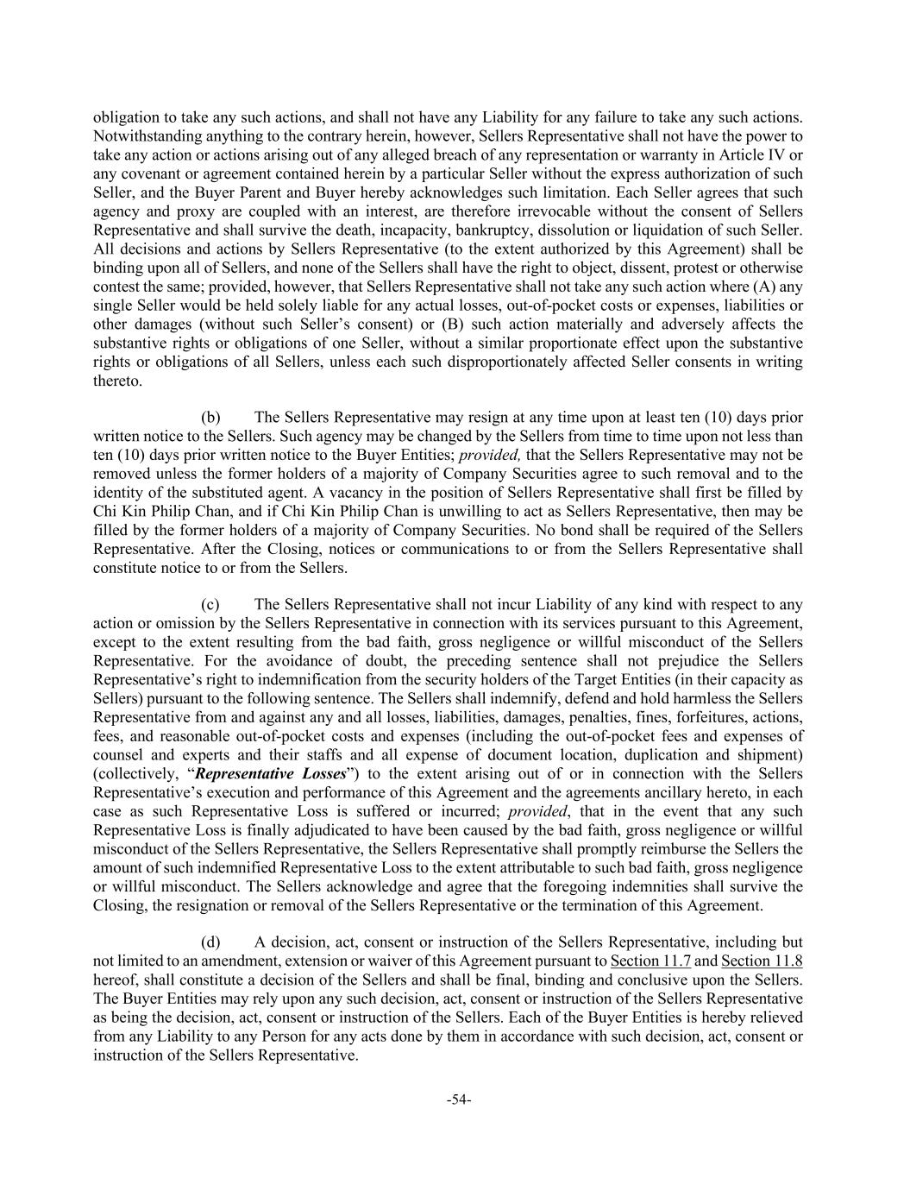
-54- obligation to take any such actions, and shall not have any Liability for any failure to take any such actions. Notwithstanding anything to the contrary herein, however, Sellers Representative shall not have the power to take any action or actions arising out of any alleged breach of any representation or warranty in Article IV or any covenant or agreement contained herein by a particular Seller without the express authorization of such Seller, and the Buyer Parent and Buyer hereby acknowledges such limitation. Each Seller agrees that such agency and proxy are coupled with an interest, are therefore irrevocable without the consent of Sellers Representative and shall survive the death, incapacity, bankruptcy, dissolution or liquidation of such Seller. All decisions and actions by Sellers Representative (to the extent authorized by this Agreement) shall be binding upon all of Sellers, and none of the Sellers shall have the right to object, dissent, protest or otherwise contest the same; provided, however, that Sellers Representative shall not take any such action where (A) any single Seller would be held solely liable for any actual losses, out-of-pocket costs or expenses, liabilities or other damages (without such Seller’s consent) or (B) such action materially and adversely affects the substantive rights or obligations of one Seller, without a similar proportionate effect upon the substantive rights or obligations of all Sellers, unless each such disproportionately affected Seller consents in writing thereto. (b) The Sellers Representative may resign at any time upon at least ten (10) days prior written notice to the Sellers. Such agency may be changed by the Sellers from time to time upon not less than ten (10) days prior written notice to the Buyer Entities; provided, that the Sellers Representative may not be removed unless the former holders of a majority of Company Securities agree to such removal and to the identity of the substituted agent. A vacancy in the position of Sellers Representative shall first be filled by Chi Kin Philip Chan, and if Chi Kin Philip Chan is unwilling to act as Sellers Representative, then may be filled by the former holders of a majority of Company Securities. No bond shall be required of the Sellers Representative. After the Closing, notices or communications to or from the Sellers Representative shall constitute notice to or from the Sellers. (c) The Sellers Representative shall not incur Liability of any kind with respect to any action or omission by the Sellers Representative in connection with its services pursuant to this Agreement, except to the extent resulting from the bad faith, gross negligence or willful misconduct of the Sellers Representative. For the avoidance of doubt, the preceding sentence shall not prejudice the Sellers Representative’s right to indemnification from the security holders of the Target Entities (in their capacity as Sellers) pursuant to the following sentence. The Sellers shall indemnify, defend and hold harmless the Sellers Representative from and against any and all losses, liabilities, damages, penalties, fines, forfeitures, actions, fees, and reasonable out-of-pocket costs and expenses (including the out-of-pocket fees and expenses of counsel and experts and their staffs and all expense of document location, duplication and shipment) (collectively, “Representative Losses”) to the extent arising out of or in connection with the Sellers Representative’s execution and performance of this Agreement and the agreements ancillary hereto, in each case as such Representative Loss is suffered or incurred; provided, that in the event that any such Representative Loss is finally adjudicated to have been caused by the bad faith, gross negligence or willful misconduct of the Sellers Representative, the Sellers Representative shall promptly reimburse the Sellers the amount of such indemnified Representative Loss to the extent attributable to such bad faith, gross negligence or willful misconduct. The Sellers acknowledge and agree that the foregoing indemnities shall survive the Closing, the resignation or removal of the Sellers Representative or the termination of this Agreement. (d) A decision, act, consent or instruction of the Sellers Representative, including but not limited to an amendment, extension or waiver of this Agreement pursuant to Section 11.7 and Section 11.8 hereof, shall constitute a decision of the Sellers and shall be final, binding and conclusive upon the Sellers. The Buyer Entities may rely upon any such decision, act, consent or instruction of the Sellers Representative as being the decision, act, consent or instruction of the Sellers. Each of the Buyer Entities is hereby relieved from any Liability to any Person for any acts done by them in accordance with such decision, act, consent or instruction of the Sellers Representative.

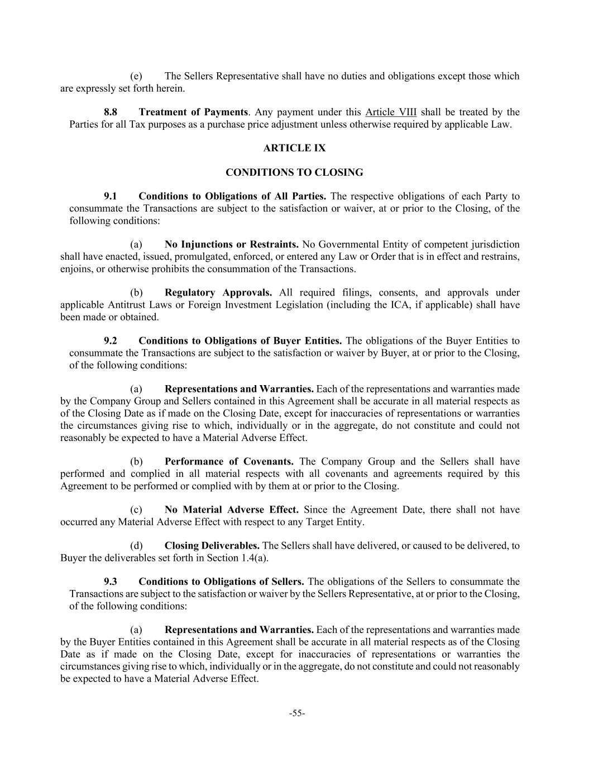
-55- (e) The Sellers Representative shall have no duties and obligations except those which are expressly set forth herein. 8.8 Treatment of Payments. Any payment under this Article VIII shall be treated by the Parties for all Tax purposes as a purchase price adjustment unless otherwise required by applicable Law. ARTICLE IX CONDITIONS TO CLOSING 9.1 Conditions to Obligations of All Parties. The respective obligations of each Party to consummate the Transactions are subject to the satisfaction or waiver, at or prior to the Closing, of the following conditions: (a) No Injunctions or Restraints. No Governmental Entity of competent jurisdiction shall have enacted, issued, promulgated, enforced, or entered any Law or Order that is in effect and restrains, enjoins, or otherwise prohibits the consummation of the Transactions. (b) Regulatory Approvals. All required filings, consents, and approvals under applicable Antitrust Laws or Foreign Investment Legislation (including the ICA, if applicable) shall have been made or obtained. 9.2 Conditions to Obligations of Buyer Entities. The obligations of the Buyer Entities to consummate the Transactions are subject to the satisfaction or waiver by Buyer, at or prior to the Closing, of the following conditions: (a) Representations and Warranties. Each of the representations and warranties made by the Company Group and Sellers contained in this Agreement shall be accurate in all material respects as of the Closing Date as if made on the Closing Date, except for inaccuracies of representations or warranties the circumstances giving rise to which, individually or in the aggregate, do not constitute and could not reasonably be expected to have a Material Adverse Effect. (b) Performance of Covenants. The Company Group and the Sellers shall have performed and complied in all material respects with all covenants and agreements required by this Agreement to be performed or complied with by them at or prior to the Closing. (c) No Material Adverse Effect. Since the Agreement Date, there shall not have occurred any Material Adverse Effect with respect to any Target Entity. (d) Closing Deliverables. The Sellers shall have delivered, or caused to be delivered, to Buyer the deliverables set forth in Section 1.4(a). 9.3 Conditions to Obligations of Sellers. The obligations of the Sellers to consummate the Transactions are subject to the satisfaction or waiver by the Sellers Representative, at or prior to the Closing, of the following conditions: (a) Representations and Warranties. Each of the representations and warranties made by the Buyer Entities contained in this Agreement shall be accurate in all material respects as of the Closing Date as if made on the Closing Date, except for inaccuracies of representations or warranties the circumstances giving rise to which, individually or in the aggregate, do not constitute and could not reasonably be expected to have a Material Adverse Effect.

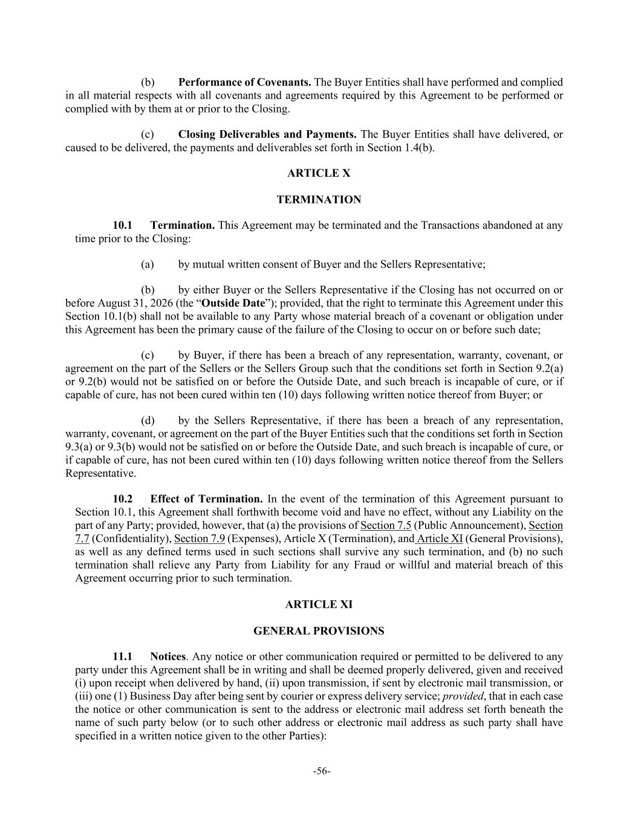
-56- (b) Performance of Covenants. The Buyer Entities shall have performed and complied in all material respects with all covenants and agreements required by this Agreement to be performed or complied with by them at or prior to the Closing. (c) Closing Deliverables and Payments. The Buyer Entities shall have delivered, or caused to be delivered, the payments and deliverables set forth in Section 1.4(b). ARTICLE X TERMINATION 10.1 Termination. This Agreement may be terminated and the Transactions abandoned at any time prior to the Closing: (a) by mutual written consent of Buyer and the Sellers Representative; (b) by either Buyer or the Sellers Representative if the Closing has not occurred on or before August 31, 2026 (the “Outside Date”); provided, that the right to terminate this Agreement under this Section 10.1(b) shall not be available to any Party whose material breach of a covenant or obligation under this Agreement has been the primary cause of the failure of the Closing to occur on or before such date; (c) by Buyer, if there has been a breach of any representation, warranty, covenant, or agreement on the part of the Sellers or the Sellers Group such that the conditions set forth in Section 9.2(a) or 9.2(b) would not be satisfied on or before the Outside Date, and such breach is incapable of cure, or if capable of cure, has not been cured within ten (10) days following written notice thereof from Buyer; or (d) by the Sellers Representative, if there has been a breach of any representation, warranty, covenant, or agreement on the part of the Buyer Entities such that the conditions set forth in Section 9.3(a) or 9.3(b) would not be satisfied on or before the Outside Date, and such breach is incapable of cure, or if capable of cure, has not been cured within ten (10) days following written notice thereof from the Sellers Representative. 10.2 Effect of Termination. In the event of the termination of this Agreement pursuant to Section 10.1, this Agreement shall forthwith become void and have no effect, without any Liability on the part of any Party; provided, however, that (a) the provisions of Section 7.5 (Public Announcement), Section 7.7 (Confidentiality), Section 7.9 (Expenses), Article X (Termination), and Article XI (General Provisions), as well as any defined terms used in such sections shall survive any such termination, and (b) no such termination shall relieve any Party from Liability for any Fraud or willful and material breach of this Agreement occurring prior to such termination. ARTICLE XI GENERAL PROVISIONS 11.1 Notices. Any notice or other communication required or permitted to be delivered to any party under this Agreement shall be in writing and shall be deemed properly delivered, given and received (i) upon receipt when delivered by hand, (ii) upon transmission, if sent by electronic mail transmission, or (iii) one (1) Business Day after being sent by courier or express delivery service; provided, that in each case the notice or other communication is sent to the address or electronic mail address set forth beneath the name of such party below (or to such other address or electronic mail address as such party shall have specified in a written notice given to the other Parties):

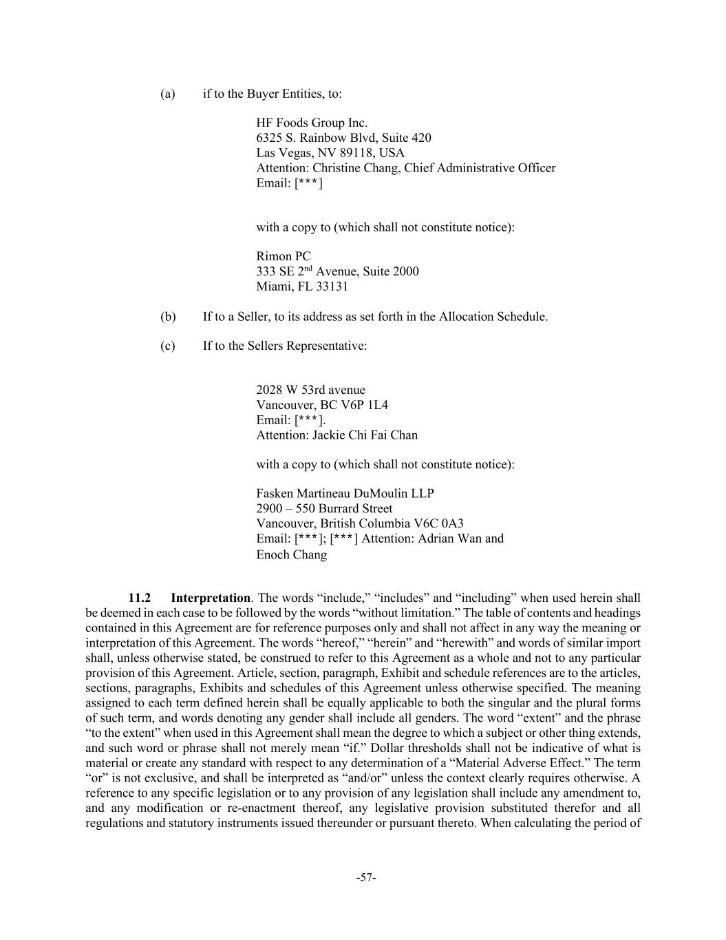
-57- (a) if to the Buyer Entities, to: HF Foods Group Inc. 6325 S. Rainbow Blvd, Suite 420 Las Vegas, NV 89118, USA Attention: Christine Chang, Chief Administrative Officer Email: [***] with a copy to (which shall not constitute notice): Rimon PC 333 SE 2nd Avenue, Suite 2000 Miami, FL 33131 (b) If to a Seller, to its address as set forth in the Allocation Schedule. (c) If to the Sellers Representative: 2028 W 53rd avenue Vancouver, BC V6P 1L4 Email: [***]. Attention: Jackie Chi Fai Chan with a copy to (which shall not constitute notice): Fasken Martineau DuMoulin LLP 2900 – 550 Burrard Street Vancouver, British Columbia V6C 0A3 Email: [***]; [***] Attention: Adrian Wan and Enoch Chang 11.2 Interpretation. The words “include,” “includes” and “including” when used herein shall be deemed in each case to be followed by the words “without limitation.” The table of contents and headings contained in this Agreement are for reference purposes only and shall not affect in any way the meaning or interpretation of this Agreement. The words “hereof,” “herein” and “herewith” and words of similar import shall, unless otherwise stated, be construed to refer to this Agreement as a whole and not to any particular provision of this Agreement. Article, section, paragraph, Exhibit and schedule references are to the articles, sections, paragraphs, Exhibits and schedules of this Agreement unless otherwise specified. The meaning assigned to each term defined herein shall be equally applicable to both the singular and the plural forms of such term, and words denoting any gender shall include all genders. The word “extent” and the phrase “to the extent” when used in this Agreement shall mean the degree to which a subject or other thing extends, and such word or phrase shall not merely mean “if.” Dollar thresholds shall not be indicative of what is material or create any standard with respect to any determination of a “Material Adverse Effect.” The term “or” is not exclusive, and shall be interpreted as “and/or” unless the context clearly requires otherwise. A reference to any specific legislation or to any provision of any legislation shall include any amendment to, and any modification or re-enactment thereof, any legislative provision substituted therefor and all regulations and statutory instruments issued thereunder or pursuant thereto. When calculating the period of

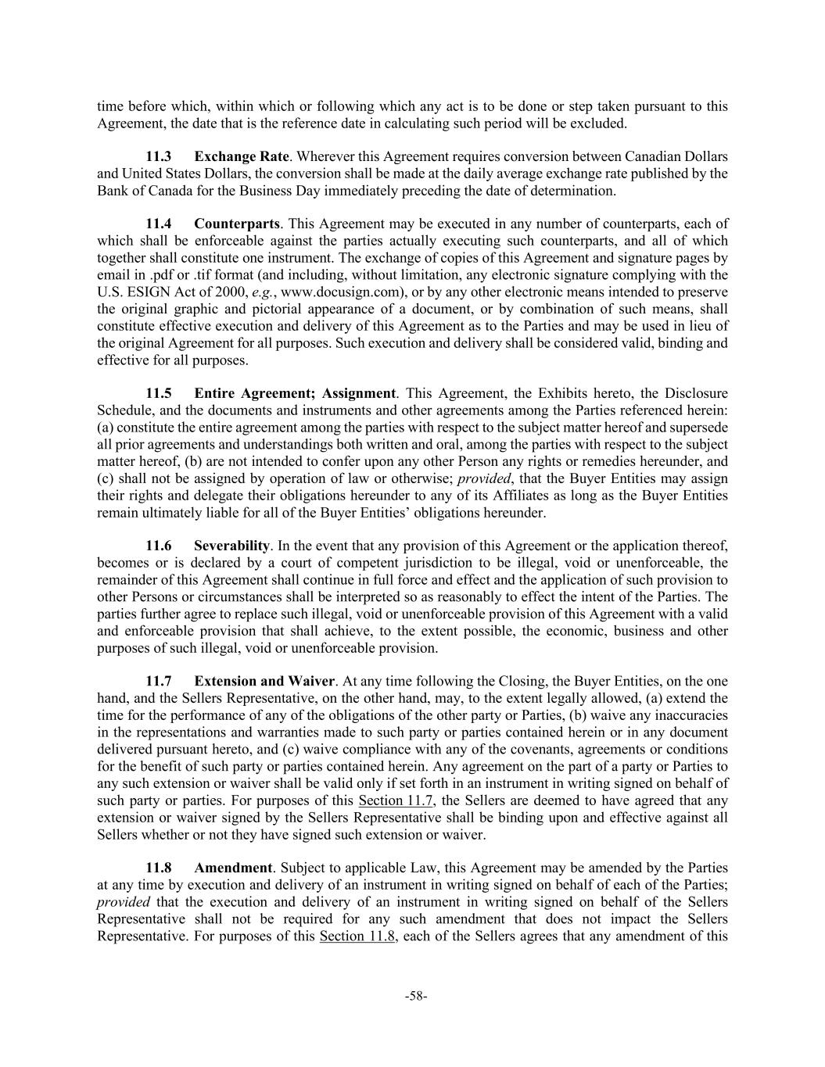
-58- time before which, within which or following which any act is to be done or step taken pursuant to this Agreement, the date that is the reference date in calculating such period will be excluded. 11.3 Exchange Rate. Wherever this Agreement requires conversion between Canadian Dollars and United States Dollars, the conversion shall be made at the daily average exchange rate published by the Bank of Canada for the Business Day immediately preceding the date of determination. 11.4 Counterparts. This Agreement may be executed in any number of counterparts, each of which shall be enforceable against the parties actually executing such counterparts, and all of which together shall constitute one instrument. The exchange of copies of this Agreement and signature pages by email in .pdf or .tif format (and including, without limitation, any electronic signature complying with the U.S. ESIGN Act of 2000, e.g., www.docusign.com), or by any other electronic means intended to preserve the original graphic and pictorial appearance of a document, or by combination of such means, shall constitute effective execution and delivery of this Agreement as to the Parties and may be used in lieu of the original Agreement for all purposes. Such execution and delivery shall be considered valid, binding and effective for all purposes. 11.5 Entire Agreement; Assignment. This Agreement, the Exhibits hereto, the Disclosure Schedule, and the documents and instruments and other agreements among the Parties referenced herein: (a) constitute the entire agreement among the parties with respect to the subject matter hereof and supersede all prior agreements and understandings both written and oral, among the parties with respect to the subject matter hereof, (b) are not intended to confer upon any other Person any rights or remedies hereunder, and (c) shall not be assigned by operation of law or otherwise; provided, that the Buyer Entities may assign their rights and delegate their obligations hereunder to any of its Affiliates as long as the Buyer Entities remain ultimately liable for all of the Buyer Entities’ obligations hereunder. 11.6 Severability. In the event that any provision of this Agreement or the application thereof, becomes or is declared by a court of competent jurisdiction to be illegal, void or unenforceable, the remainder of this Agreement shall continue in full force and effect and the application of such provision to other Persons or circumstances shall be interpreted so as reasonably to effect the intent of the Parties. The parties further agree to replace such illegal, void or unenforceable provision of this Agreement with a valid and enforceable provision that shall achieve, to the extent possible, the economic, business and other purposes of such illegal, void or unenforceable provision. 11.7 Extension and Waiver. At any time following the Closing, the Buyer Entities, on the one hand, and the Sellers Representative, on the other hand, may, to the extent legally allowed, (a) extend the time for the performance of any of the obligations of the other party or Parties, (b) waive any inaccuracies in the representations and warranties made to such party or parties contained herein or in any document delivered pursuant hereto, and (c) waive compliance with any of the covenants, agreements or conditions for the benefit of such party or parties contained herein. Any agreement on the part of a party or Parties to any such extension or waiver shall be valid only if set forth in an instrument in writing signed on behalf of such party or parties. For purposes of this Section 11.7, the Sellers are deemed to have agreed that any extension or waiver signed by the Sellers Representative shall be binding upon and effective against all Sellers whether or not they have signed such extension or waiver. 11.8 Amendment. Subject to applicable Law, this Agreement may be amended by the Parties at any time by execution and delivery of an instrument in writing signed on behalf of each of the Parties; provided that the execution and delivery of an instrument in writing signed on behalf of the Sellers Representative shall not be required for any such amendment that does not impact the Sellers Representative. For purposes of this Section 11.8, each of the Sellers agrees that any amendment of this

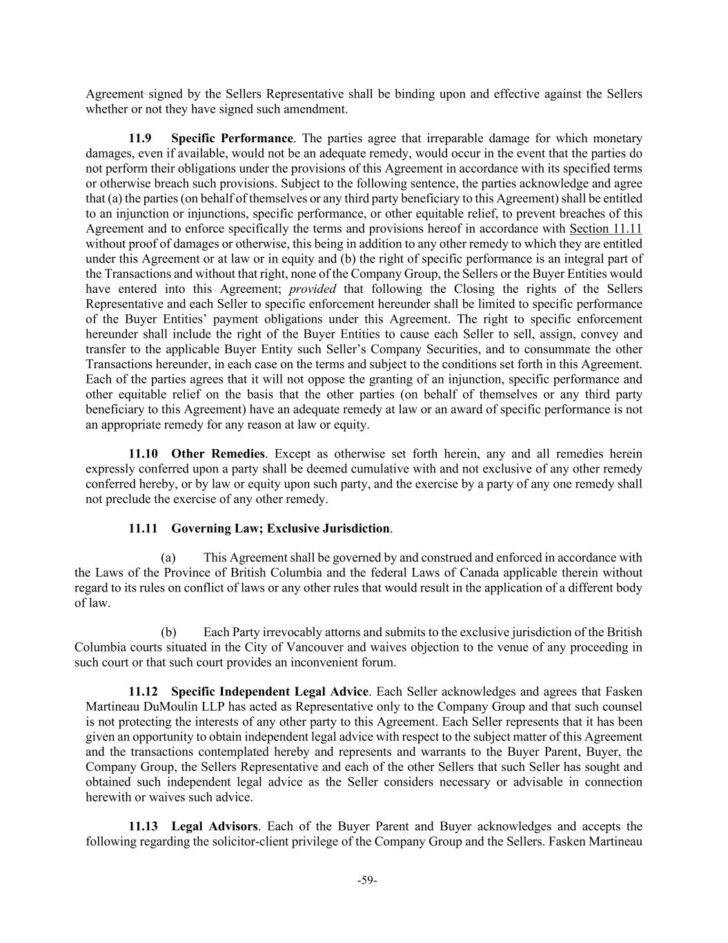
-59- Agreement signed by the Sellers Representative shall be binding upon and effective against the Sellers whether or not they have signed such amendment. 11.9 Specific Performance. The parties agree that irreparable damage for which monetary damages, even if available, would not be an adequate remedy, would occur in the event that the parties do not perform their obligations under the provisions of this Agreement in accordance with its specified terms or otherwise breach such provisions. Subject to the following sentence, the parties acknowledge and agree that (a) the parties (on behalf of themselves or any third party beneficiary to this Agreement) shall be entitled to an injunction or injunctions, specific performance, or other equitable relief, to prevent breaches of this Agreement and to enforce specifically the terms and provisions hereof in accordance with Section 11.11 without proof of damages or otherwise, this being in addition to any other remedy to which they are entitled under this Agreement or at law or in equity and (b) the right of specific performance is an integral part of the Transactions and without that right, none of the Company Group, the Sellers or the Buyer Entities would have entered into this Agreement; provided that following the Closing the rights of the Sellers Representative and each Seller to specific enforcement hereunder shall be limited to specific performance of the Buyer Entities’ payment obligations under this Agreement. The right to specific enforcement hereunder shall include the right of the Buyer Entities to cause each Seller to sell, assign, convey and transfer to the applicable Buyer Entity such Seller’s Company Securities, and to consummate the other Transactions hereunder, in each case on the terms and subject to the conditions set forth in this Agreement. Each of the parties agrees that it will not oppose the granting of an injunction, specific performance and other equitable relief on the basis that the other parties (on behalf of themselves or any third party beneficiary to this Agreement) have an adequate remedy at law or an award of specific performance is not an appropriate remedy for any reason at law or equity. 11.10 Other Remedies. Except as otherwise set forth herein, any and all remedies herein expressly conferred upon a party shall be deemed cumulative with and not exclusive of any other remedy conferred hereby, or by law or equity upon such party, and the exercise by a party of any one remedy shall not preclude the exercise of any other remedy. 11.11 Governing Law; Exclusive Jurisdiction. (a) This Agreement shall be governed by and construed and enforced in accordance with the Laws of the Province of British Columbia and the federal Laws of Canada applicable therein without regard to its rules on conflict of laws or any other rules that would result in the application of a different body of law. (b) Each Party irrevocably attorns and submits to the exclusive jurisdiction of the British Columbia courts situated in the City of Vancouver and waives objection to the venue of any proceeding in such court or that such court provides an inconvenient forum. 11.12 Specific Independent Legal Advice. Each Seller acknowledges and agrees that Fasken Martineau DuMoulin LLP has acted as Representative only to the Company Group and that such counsel is not protecting the interests of any other party to this Agreement. Each Seller represents that it has been given an opportunity to obtain independent legal advice with respect to the subject matter of this Agreement and the transactions contemplated hereby and represents and warrants to the Buyer Parent, Buyer, the Company Group, the Sellers Representative and each of the other Sellers that such Seller has sought and obtained such independent legal advice as the Seller considers necessary or advisable in connection herewith or waives such advice. 11.13 Legal Advisors. Each of the Buyer Parent and Buyer acknowledges and accepts the following regarding the solicitor-client privilege of the Company Group and the Sellers. Fasken Martineau

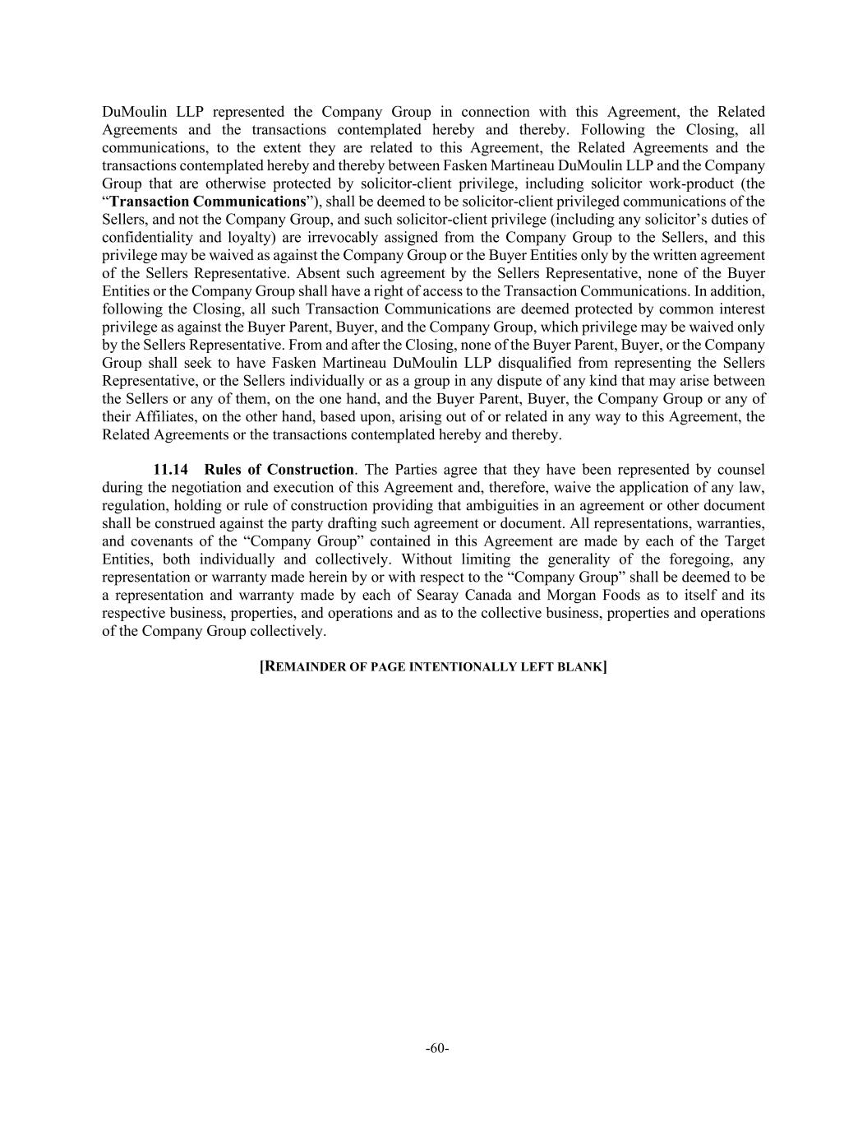
-60- DuMoulin LLP represented the Company Group in connection with this Agreement, the Related Agreements and the transactions contemplated hereby and thereby. Following the Closing, all communications, to the extent they are related to this Agreement, the Related Agreements and the transactions contemplated hereby and thereby between Fasken Martineau DuMoulin LLP and the Company Group that are otherwise protected by solicitor-client privilege, including solicitor work-product (the “Transaction Communications”), shall be deemed to be solicitor-client privileged communications of the Sellers, and not the Company Group, and such solicitor-client privilege (including any solicitor’s duties of confidentiality and loyalty) are irrevocably assigned from the Company Group to the Sellers, and this privilege may be waived as against the Company Group or the Buyer Entities only by the written agreement of the Sellers Representative. Absent such agreement by the Sellers Representative, none of the Buyer Entities or the Company Group shall have a right of access to the Transaction Communications. In addition, following the Closing, all such Transaction Communications are deemed protected by common interest privilege as against the Buyer Parent, Buyer, and the Company Group, which privilege may be waived only by the Sellers Representative. From and after the Closing, none of the Buyer Parent, Buyer, or the Company Group shall seek to have Fasken Martineau DuMoulin LLP disqualified from representing the Sellers Representative, or the Sellers individually or as a group in any dispute of any kind that may arise between the Sellers or any of them, on the one hand, and the Buyer Parent, Buyer, the Company Group or any of their Affiliates, on the other hand, based upon, arising out of or related in any way to this Agreement, the Related Agreements or the transactions contemplated hereby and thereby. 11.14 Rules of Construction. The Parties agree that they have been represented by counsel during the negotiation and execution of this Agreement and, therefore, waive the application of any law, regulation, holding or rule of construction providing that ambiguities in an agreement or other document shall be construed against the party drafting such agreement or document. All representations, warranties, and covenants of the “Company Group” contained in this Agreement are made by each of the Target Entities, both individually and collectively. Without limiting the generality of the foregoing, any representation or warranty made herein by or with respect to the “Company Group” shall be deemed to be a representation and warranty made by each of Searay Canada and Morgan Foods as to itself and its respective business, properties, and operations and as to the collective business, properties and operations of the Company Group collectively. [REMAINDER OF PAGE INTENTIONALLY LEFT BLANK]

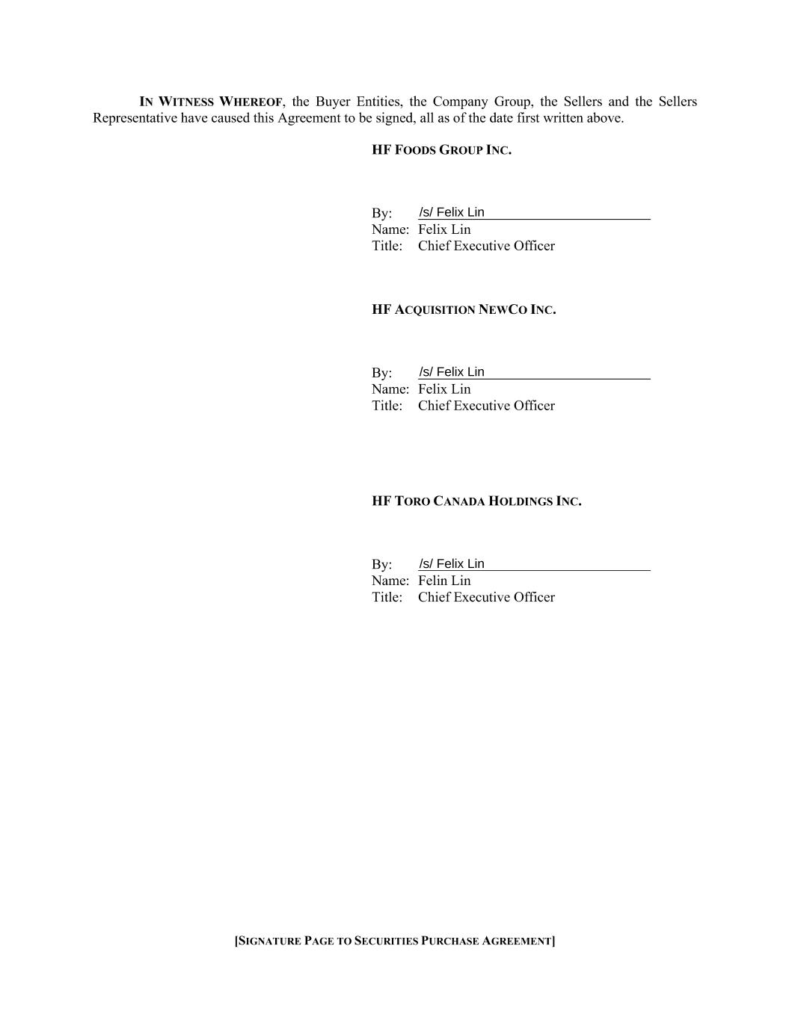

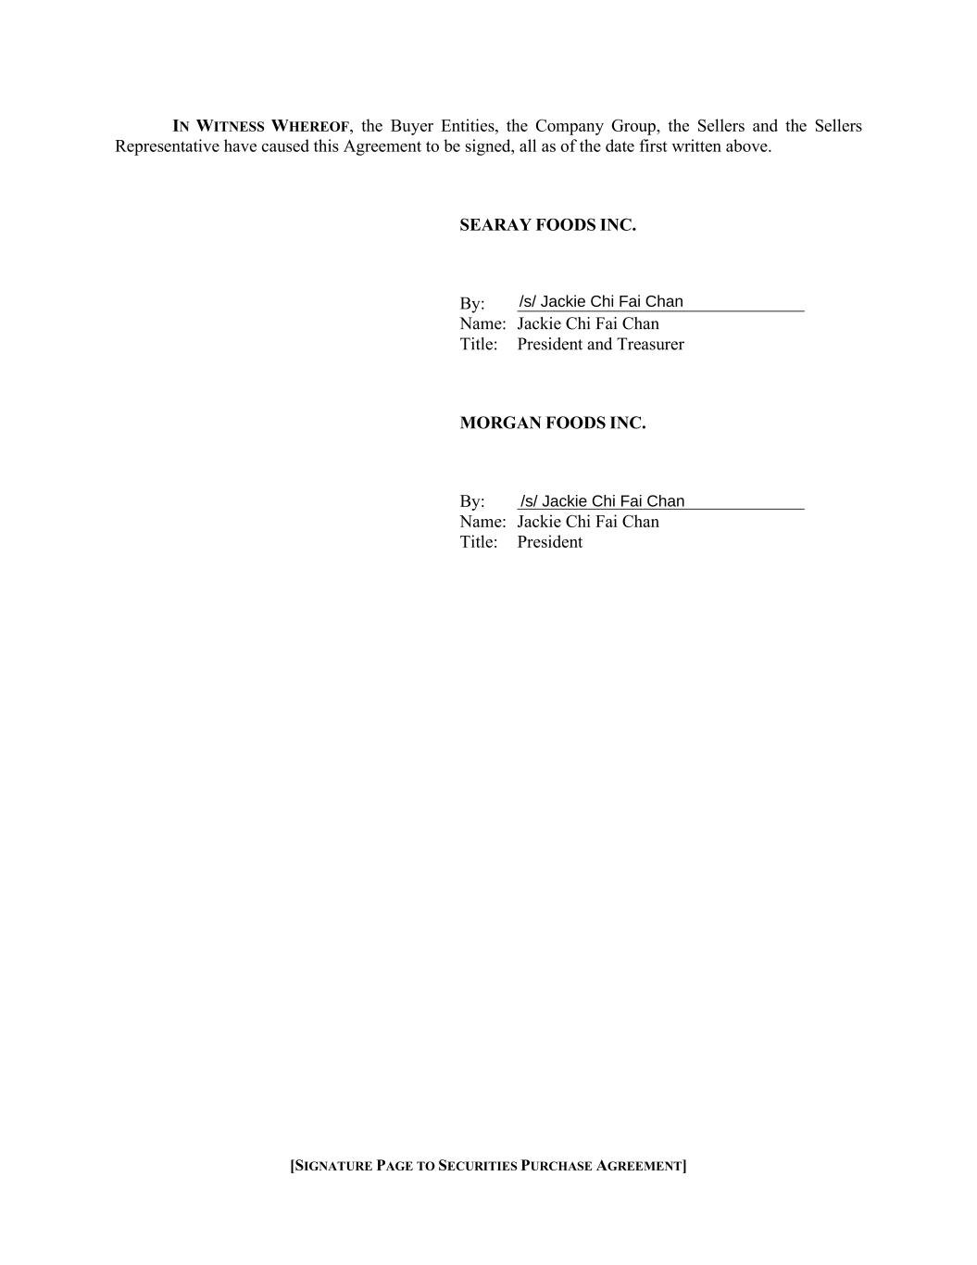
[SIGNATURE PAGE TO SECURITIES PURCHASE AGREEMENT] IN WITNESS WHEREOF, the Buyer Entities, the Company Group, the Sellers and the Sellers Representative have caused this Agreement to be signed, all as of the date first written above. SEARAY FOODS INC. By: Name: Jackie Chi Fai Chan Title: President and Treasurer MORGAN FOODS INC. By: Name: Jackie Chi Fai Chan Title: President

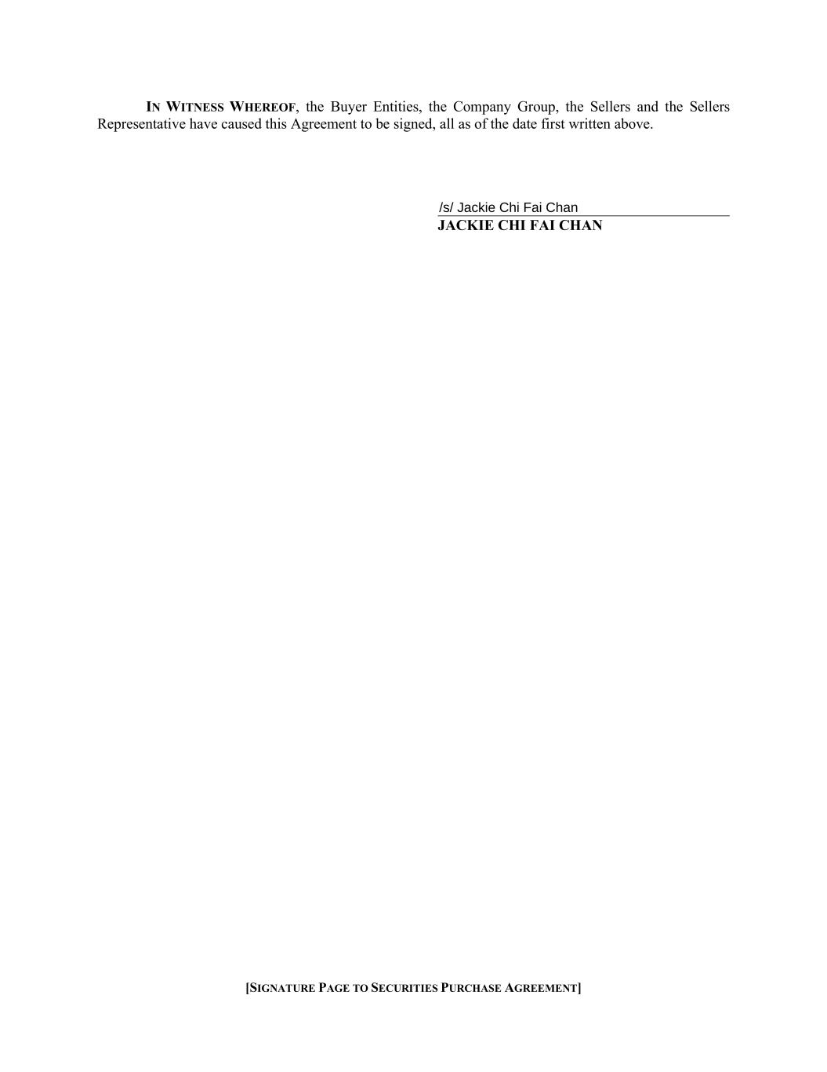
[SIGNATURE PAGE TO SECURITIES PURCHASE AGREEMENT] IN WITNESS WHEREOF, the Buyer Entities, the Company Group, the Sellers and the Sellers Representative have caused this Agreement to be signed, all as of the date first written above. JACKIE CHI FAI CHAN

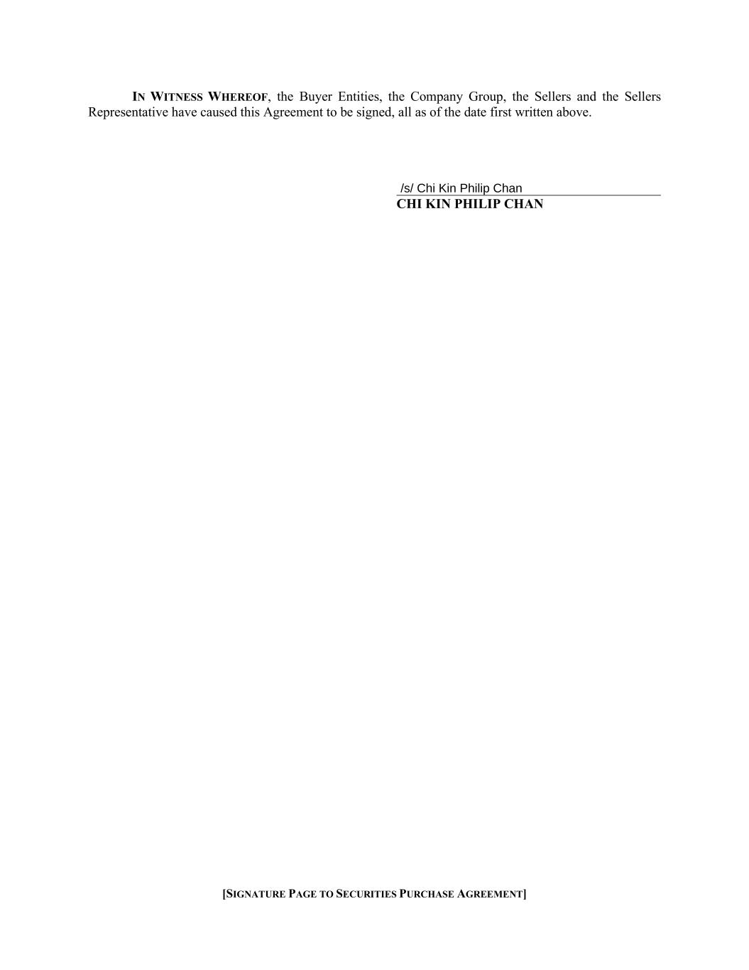
[SIGNATURE PAGE TO SECURITIES PURCHASE AGREEMENT] IN WITNESS WHEREOF, the Buyer Entities, the Company Group, the Sellers and the Sellers Representative have caused this Agreement to be signed, all as of the date first written above. CHI KIN PHILIP CHAN

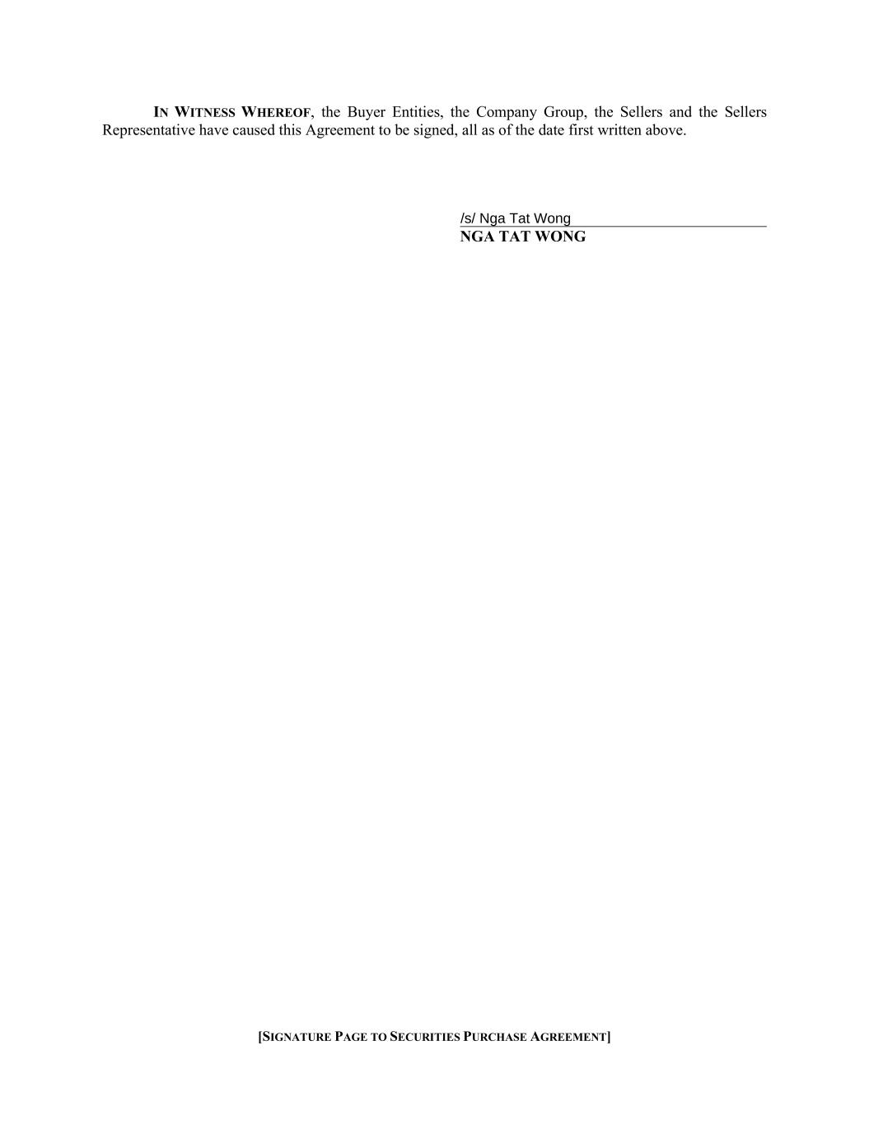
[SIGNATURE PAGE TO SECURITIES PURCHASE AGREEMENT] IN WITNESS WHEREOF, the Buyer Entities, the Company Group, the Sellers and the Sellers Representative have caused this Agreement to be signed, all as of the date first written above. NGA TAT WONG

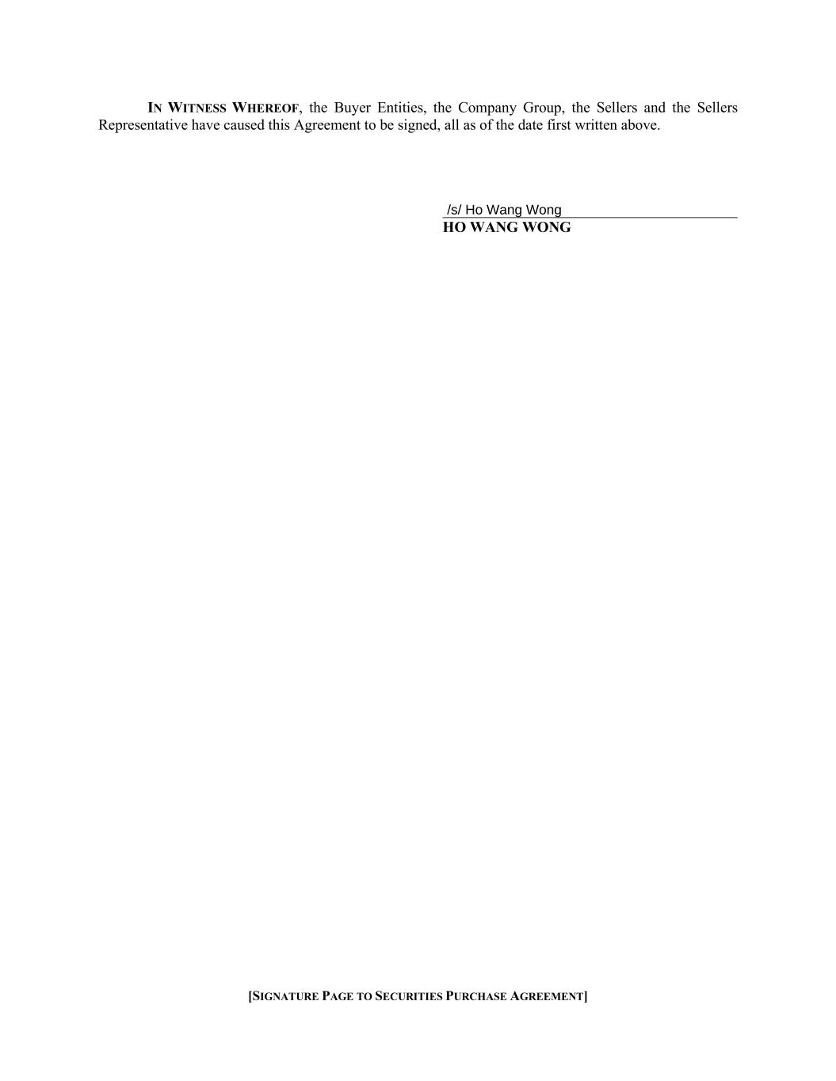
[SIGNATURE PAGE TO SECURITIES PURCHASE AGREEMENT] IN WITNESS WHEREOF, the Buyer Entities, the Company Group, the Sellers and the Sellers Representative have caused this Agreement to be signed, all as of the date first written above. HO WANG WONG

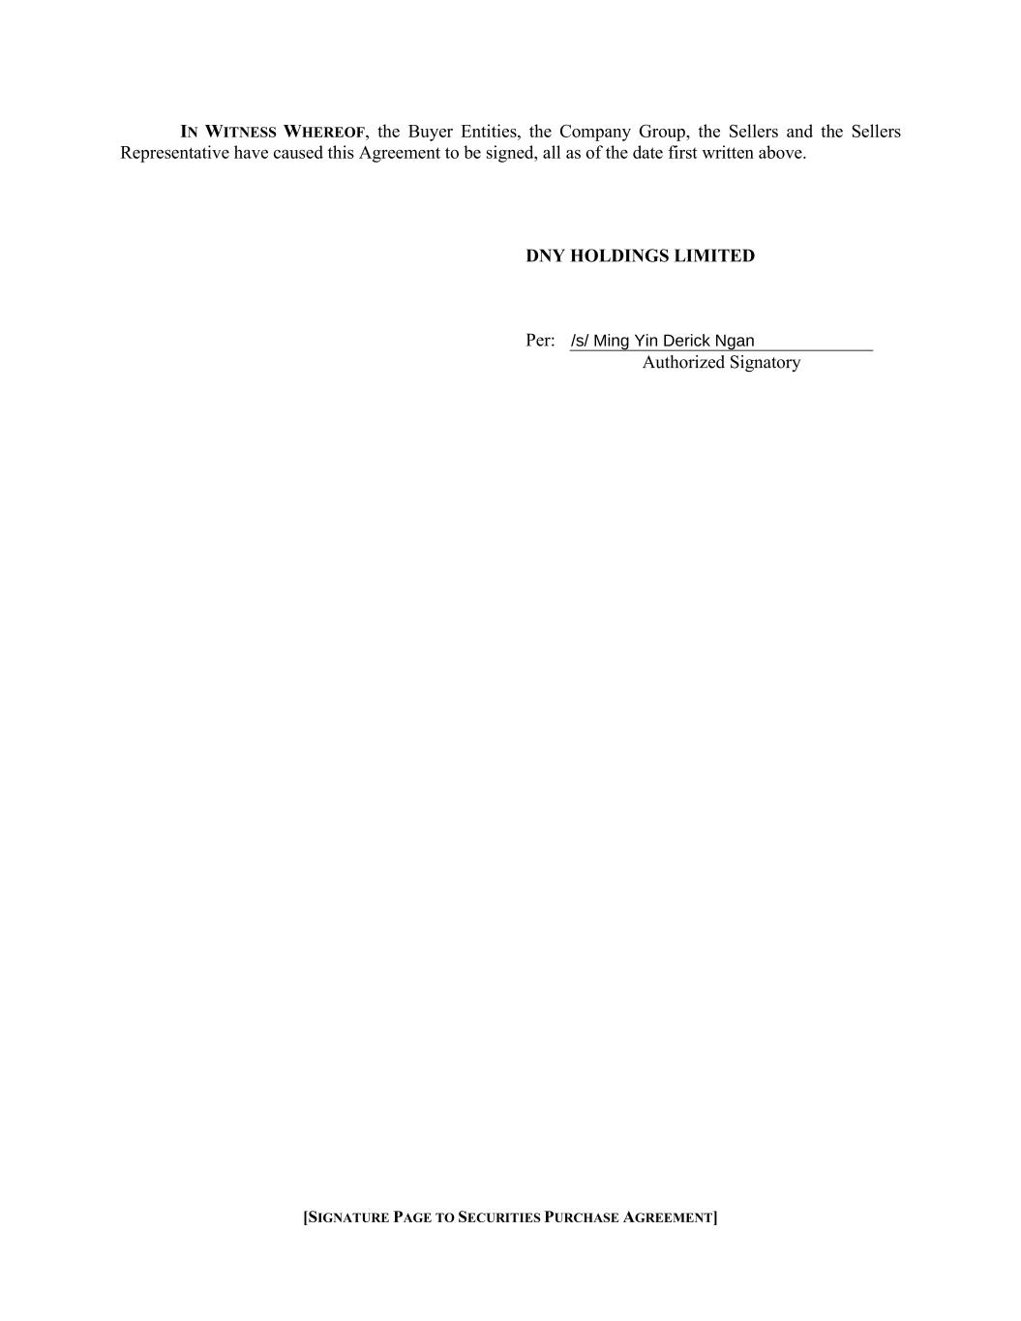
[SIGNATURE PAGE TO SECURITIES PURCHASE AGREEMENT] IN WITNESS WHEREOF, the Buyer Entities, the Company Group, the Sellers and the Sellers Representative have caused this Agreement to be signed, all as of the date first written above. DNY HOLDINGS LIMITED Per: Authorized Signatory

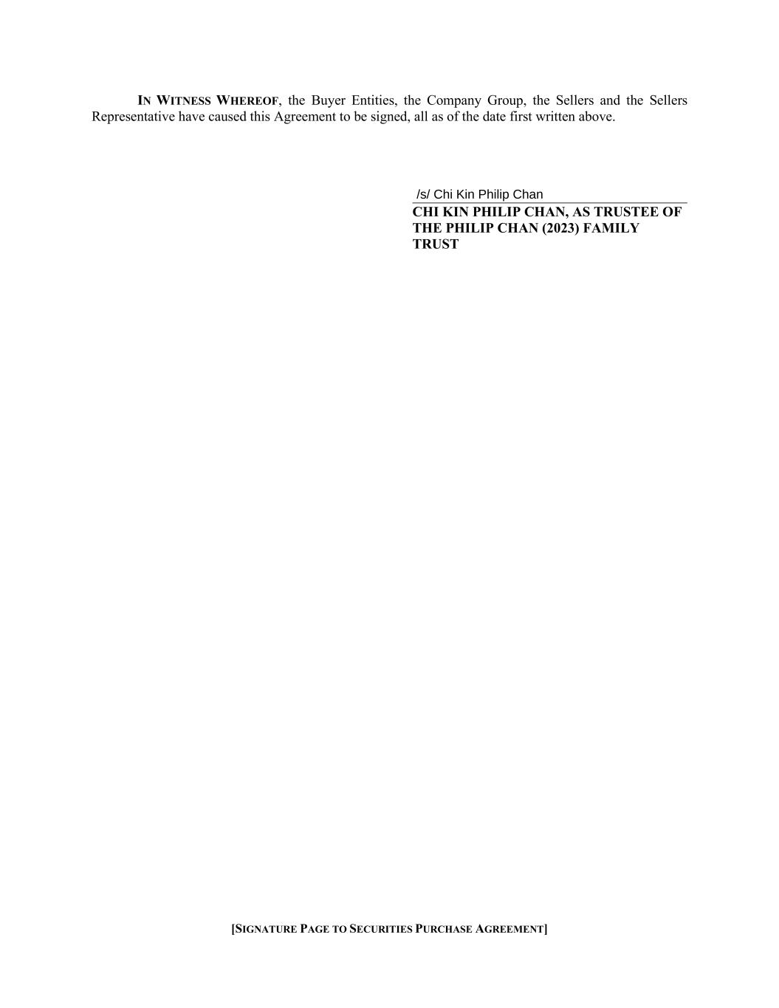
[SIGNATURE PAGE TO SECURITIES PURCHASE AGREEMENT] IN WITNESS WHEREOF, the Buyer Entities, the Company Group, the Sellers and the Sellers Representative have caused this Agreement to be signed, all as of the date first written above. CHI KIN PHILIP CHAN, AS TRUSTEE OF THE PHILIP CHAN (2023) FAMILY TRUST

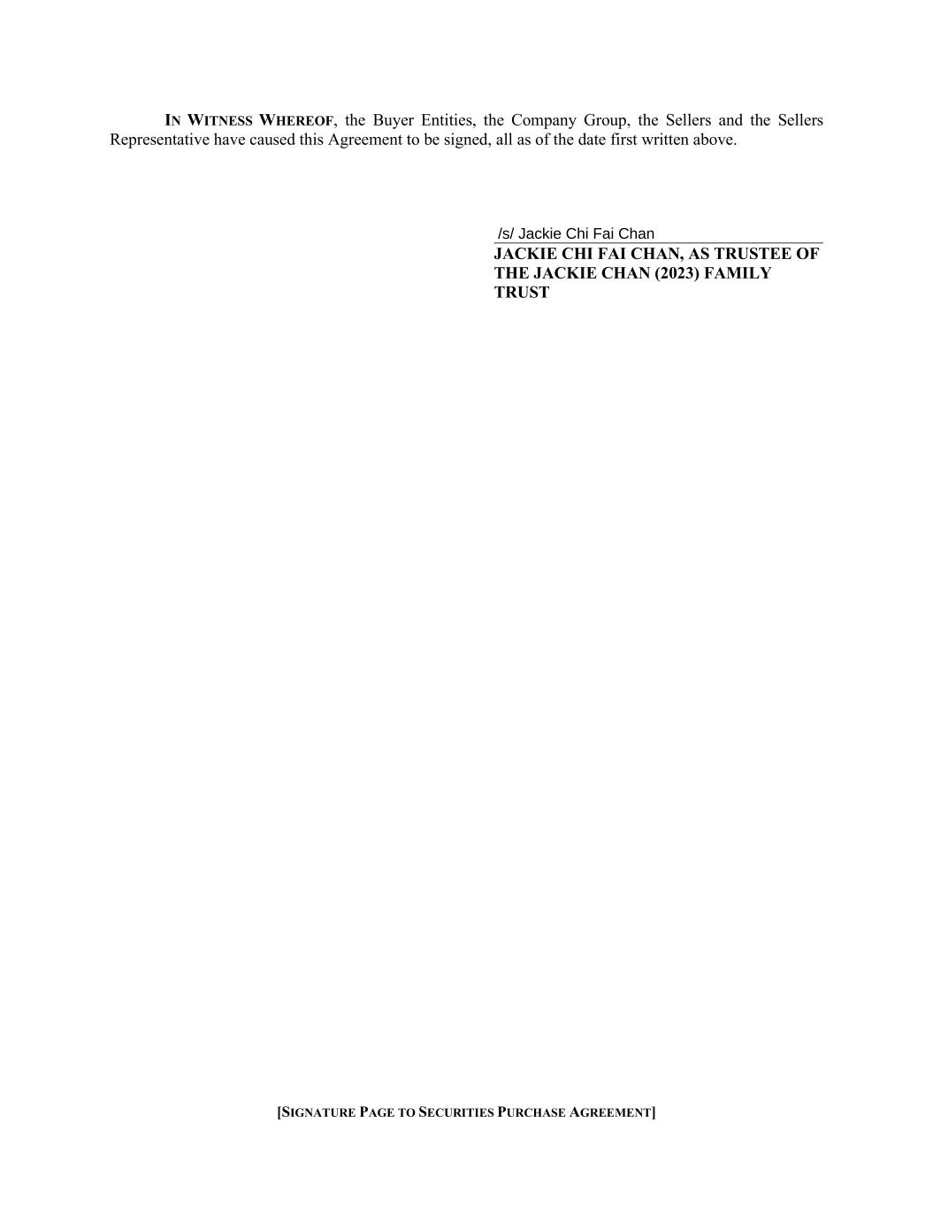
[SIGNATURE PAGE TO SECURITIES PURCHASE AGREEMENT] IN WITNESS WHEREOF, the Buyer Entities, the Company Group, the Sellers and the Sellers Representative have caused this Agreement to be signed, all as of the date first written above. JACKIE CHI FAI CHAN, AS TRUSTEE OF THE JACKIE CHAN (2023) FAMILY TRUST

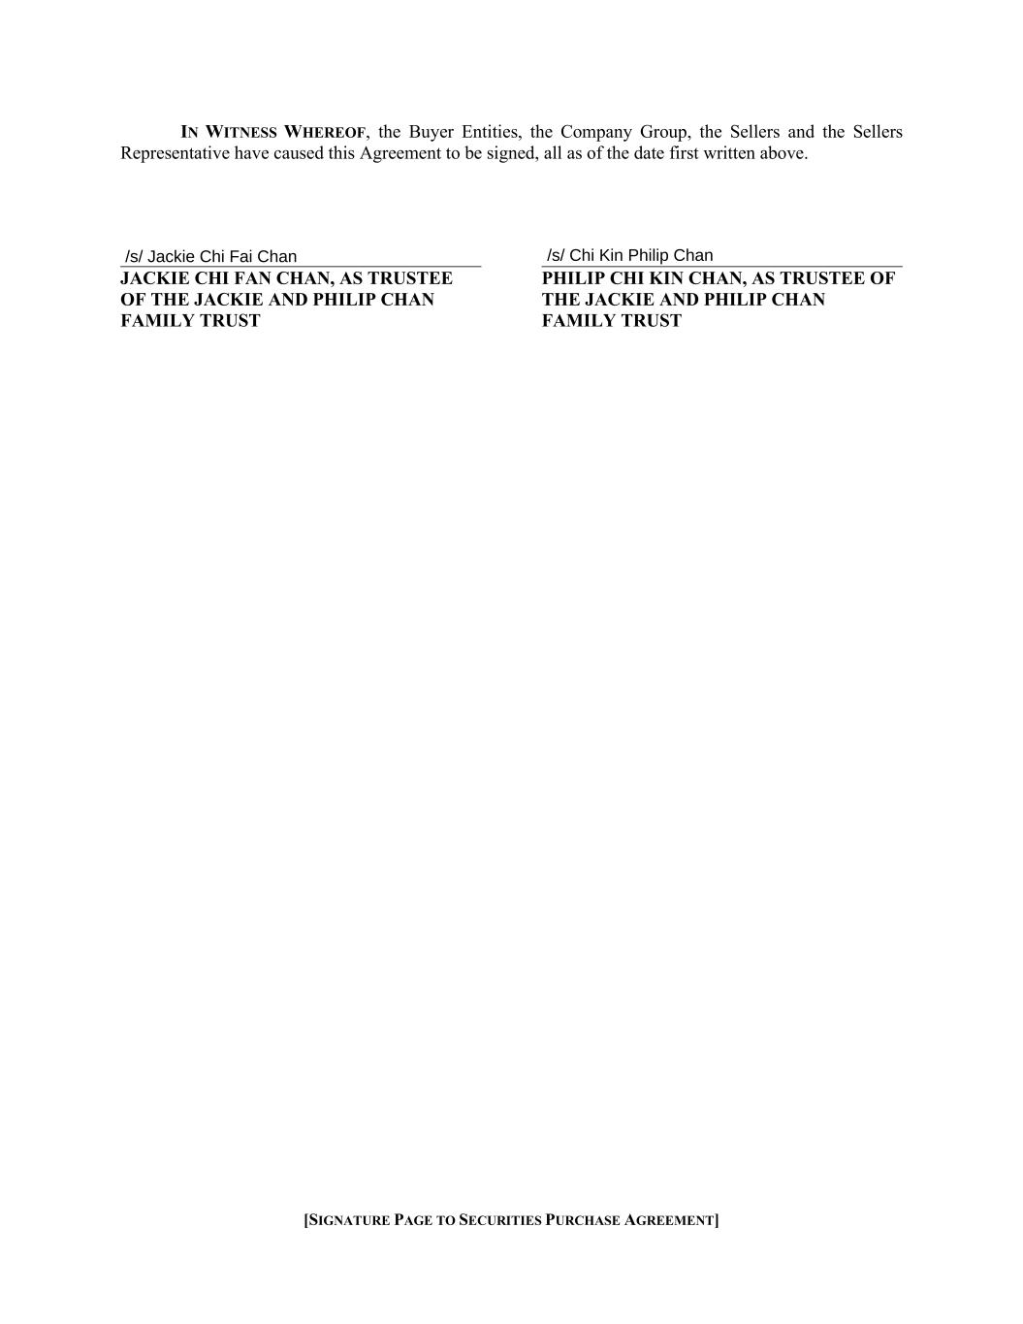
[SIGNATURE PAGE TO SECURITIES PURCHASE AGREEMENT] IN WITNESS WHEREOF, the Buyer Entities, the Company Group, the Sellers and the Sellers Representative have caused this Agreement to be signed, all as of the date first written above. JACKIE CHI FAN CHAN, AS TRUSTEE OF THE JACKIE AND PHILIP CHAN FAMILY TRUST PHILIP CHI KIN CHAN, AS TRUSTEE OF THE JACKIE AND PHILIP CHAN FAMILY TRUST

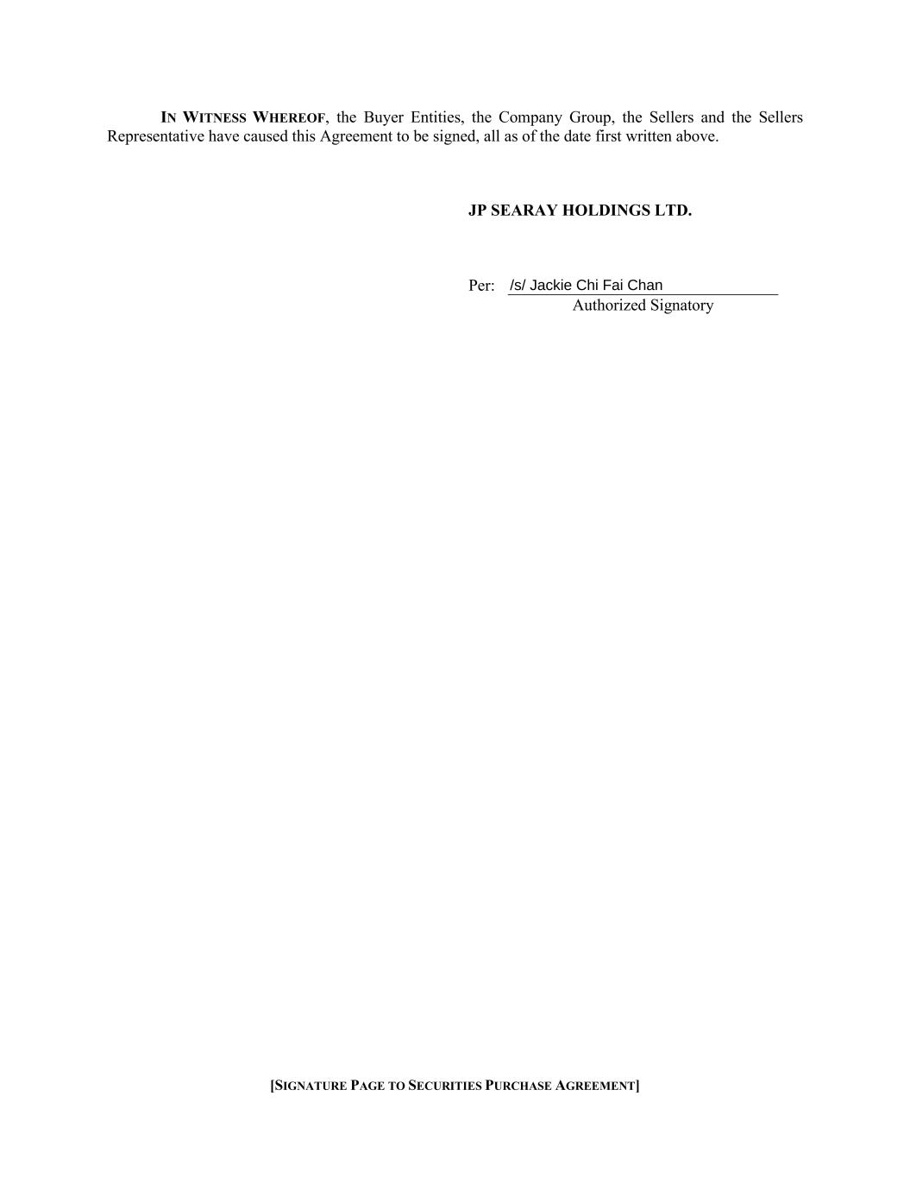
[SIGNATURE PAGE TO SECURITIES PURCHASE AGREEMENT] IN WITNESS WHEREOF, the Buyer Entities, the Company Group, the Sellers and the Sellers Representative have caused this Agreement to be signed, all as of the date first written above. JP SEARAY HOLDINGS LTD. Per: Authorized Signatory

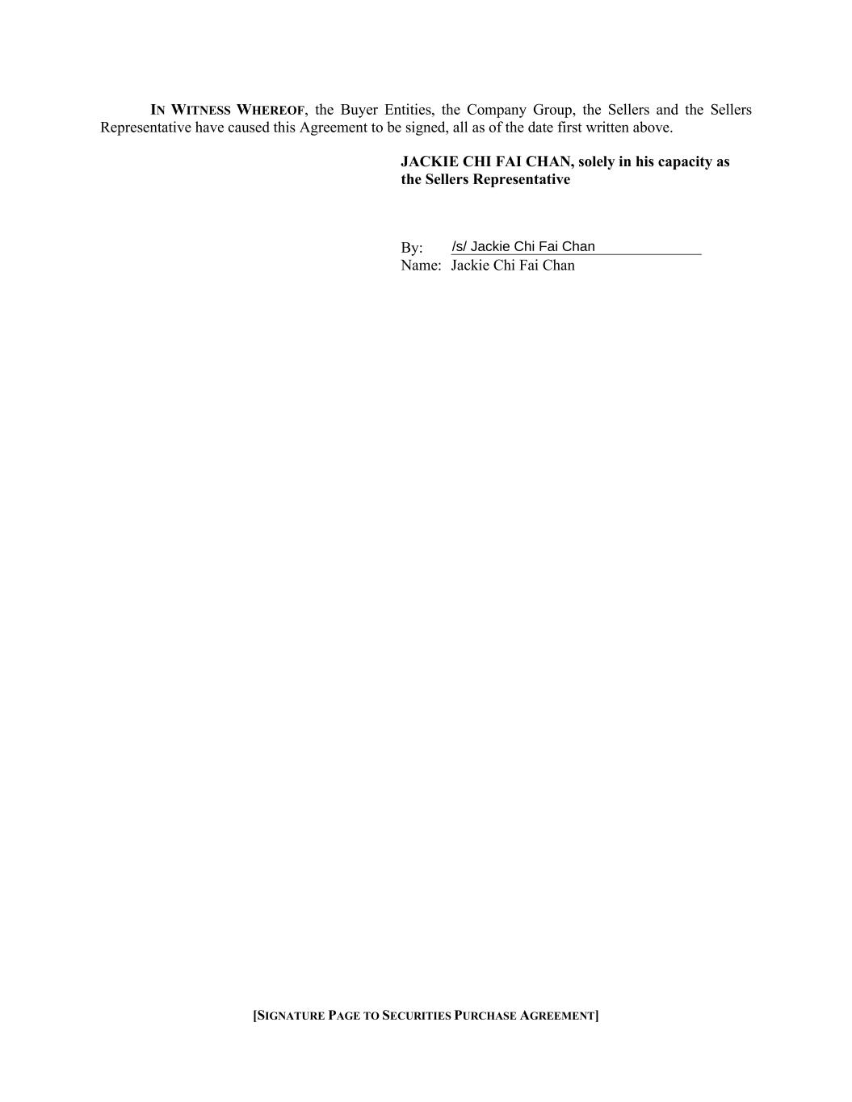
[SIGNATURE PAGE TO SECURITIES PURCHASE AGREEMENT] IN WITNESS WHEREOF, the Buyer Entities, the Company Group, the Sellers and the Sellers Representative have caused this Agreement to be signed, all as of the date first written above. JACKIE CHI FAI CHAN, solely in his capacity as the Sellers Representative By: Name: Jackie Chi Fai Chan

Exhibit 99.1

HF Foods Group to Acquire Searay Foods, a Highly Attractive Canadian Importer and Distributor of Ethnic and Specialty Seafood Products, Marking the Company's First International Expansion

Strategic entry into Canada through the Vancouver metro market, one of North America's premier specialty Asian foods markets with deep multicultural ties

Reinforces HF Foods' positioning as the acquiror of choice, extending its proven M&A playbook into new geographies

Transaction valued at approximately 5.0x Searay's 2025P Adjusted EBITDA and is expected to be immediately accretive to Margins and EPS

Consideration to be funded through a combination of cash and HF Foods common stock

HF Foods' reaffirms previously communicated target of expanding consolidated Adjusted EBITDA margin to 4.5%-5.0%+ over the next three to five years

LAS VEGAS, July 23, 2026 (GLOBE NEWSWIRE) — HF Foods Group Inc. (NASDAQ: HFFG) (“HF Foods” or the “Company”), a leading distributor of international foodservice solutions to Asian restaurants and other businesses across the United States, today announced that it has entered into a definitive agreement to acquire Searay Foods Inc. and its related entities (“Searay”), a leading Canadian importer and distributor of ethnic and specialty frozen seafood, headquartered in Richmond, British Columbia. The transaction represents HF Foods’ first expansion outside the United States and is expected to close in Q3 2026, subject to customary closing conditions and regulatory approvals.

Under the terms of the agreement, HF Foods will acquire up to 100% of the outstanding equity interests of Searay for total consideration of approximately CAD$47.9 million (approximately US$35 million), representing approximately 5.0x Searay's 2025 Adjusted EBITDA of approximately CAD$9.6 million. Consideration will be funded through a combination of cash on hand and shares of HF Foods common stock, with final terms to be disclosed upon closing.

Management Commentary

“The acquisition of Searay is a pivotal milestone in HF Foods’ growth journey and the first step in our long-stated strategy to expand our platform beyond the United States,” said Felix Lin, President and Chief Executive Officer of HF Foods. “Searay has built an exceptional reputation over 25 years as a leading Canadian distributor of ethnic frozen seafood, with deep supplier relationships, a trusted multi-brand portfolio, and industry-leading margins. This transaction is consistent with the disciplined, accretive M&A strategy we have communicated to investors, and we are excited to combine Searay’s expertise in frozen seafood with HF Foods’ national distribution infrastructure to unlock meaningful cross-selling and supply chain synergies across both businesses.”

“We are proud of what we have built at Searay over the past 25 years, and we believe HF Foods is the right partner to carry that legacy forward,” said Jack and Philip Chan, Co-Presidents and founders of Searay. “HF Foods’ scale, distribution network, and shared commitment to quality and customer service make this a natural combination. We look forward to working alongside the HF Foods team to accelerate Searay’s growth, including our ongoing expansion into the U.S. market.”

Strategic Rationale

•First International Expansion: The transaction marks HF Foods’ entry into Canada and establishes a platform to pursue further growth across North America, consistent with the Company’s previously disclosed proven M&A playbook of geographic expansion, increased distribution capabilities, and new product categories.

•Complementary Product Portfolio: Searay’s ethnic frozen seafood offering, including its Searay Foods, Thai Best, Pinoy’s Best, Smart Fish, Diamond Shrimp, and Gold Label brands, broadens HF Foods’ specialty product assortment and deepens its presence in the seafood category, which represents approximately 36% of HF Foods’ existing net revenue.

•Cross-Border Synergies: Searay’s recently established U.S. operations, including its planned Los Angeles direct import operations, are expected to benefit from HF Foods’ existing distribution network, sourcing scale, and West Coast infrastructure.

•Attractive Financial Profile: Searay has demonstrated a revenue compound annual growth rate of approximately 15% from FY2019 to FY2024 and strong Normalized EBITDA margins of approximately 14-15%, supported by disciplined inventory management and long-tenured supplier and customer relationships.

•Accretive Transaction: The acquisition is expected to be accretive to HF Foods’ Adjusted EBITDA and margins, consistent with the Company’s previously communicated target of expanding consolidated Adjusted EBITDA margin to 4.5%-5.0%+ over the next three to five years.

Transaction Details

HF Foods will acquire up to 100% of Searay Foods Inc., Morgan Foods Inc., and Searay Foods USA Inc. for total consideration of approximately CAD$47.9 million (approximately US$35 million based on current exchange rates), representing approximately 5.0x Searay's 2025 Adjusted EBITDA of approximately CAD$9.6 million. The consideration is expected to be funded through a combination of cash on hand and newly issued shares of HF Foods common stock; the final split between cash and stock consideration will be disclosed at closing. Following the closing of the transaction, Searay's existing management team, led by incoming Chief Executive Officer Derick Ngan, is expected to continue to lead Searay's day-to-day operations as a subsidiary of HF Foods.

The transaction is expected to close in Q3 2026, subject to customary closing conditions, including regulatory approvals.

About HF Foods Group Inc.

HF Foods Group Inc. is a leading marketer and distributor of fresh produce, frozen and dry food, and non-food products to primarily Asian restaurants and other foodservice customers throughout the United States. HF Foods aims to supply the increasing demand for Asian American restaurant cuisine, leveraging its nationwide network of distribution centers and its strong relations with growers and suppliers of fresh, high-quality specialty restaurant food products and supplies in the US and Asia. Headquartered in Las Vegas, Nevada, HF Foods trades on Nasdaq under the symbol “HFFG”. For more information, please visit www.hffoodsgroup.com.

About Searay Foods Inc.

Founded in 2000 and headquartered in Richmond, British Columbia, Searay Foods Inc. is a leading Canadian importer and distributor of branded ethnic and specialty frozen seafood, serving retail, wholesale, and restaurant customers across North America. Searay sources premium frozen seafood from more than 80 suppliers worldwide and distributes its products through six proprietary brands, including Searay Foods, Thai Best, Pinoy’s Best, Smart Fish, Diamond Shrimp, and Gold Label.

Forward-Looking Statements

All statements in this news release other than statements of historical facts are, or may be deemed to be, “forward-looking statements” within the meaning of the Private Securities Litigation Reform Act of 1995 and contain our current expectations about our future results, including statements regarding the expected timing, benefits, and effects of the proposed acquisition of Searay. We have attempted to identify any forward-looking statements by using words such

as “expects,” “believes,” “anticipates,” “plans,” “will,” “target” and other similar expressions. Although we believe that the expectations reflected in all of our forward-looking statements are reasonable, we can give no assurance that such expectations will prove to be correct. Such statements are not guarantees of future performance or events and are subject to known and unknown risks and uncertainties that could cause the Company’s actual results, events, or financial positions to differ materially from those included within or implied by such forward-looking statements, including risks relating to the Company’s ability to satisfy closing conditions and consummate the proposed acquisition on the anticipated terms or timing, or at all, risks relating to the Company’s ability to successfully integrate Searay’s operations and realize anticipated synergies, risks relating to the impact of foreign currency fluctuations, and other factors disclosed under the caption “Risk Factors” in our Annual Report on Form 10-K for the year ended December 31, 2025 and other filings with the Securities and Exchange Commission (the “SEC”). Readers are cautioned not to place undue reliance on these forward-looking statements, which speak only as of the date made. Except as required by law, we undertake no obligation to disclose any revision to these forward-looking statements.

Contacts:

ICR
Anna Kate Heller
hffoodsgroup@icrinc.com

