UNITED STATES
SECURITIES AND EXCHANGE COMMISSION
Washington, D.C. 20549

FORM 8-K

CURRENT REPORT
Pursuant to Section 13 or 15(d) of the Securities Exchange Act of 1934

Date of Report (Date of earliest event reported): June 11, 2026

HF FOODS GROUP INC.
(Exact name of registrant as specified in its charter)
Delaware  State or other Jurisdiction of  incorporation ) |  |  | 001-38180  (Commission  File No.) |  |  | 81-2717873  (IRS Employer  Identification No)
6325 South Rainbow Boulevard, Suite 420  Las Vegas, Nevada  (Address of principal executive offices) |  |  | 89118  (Zip Code)

Registrant’s telephone number, including area code: (888)-905-0998

Not Applicable
(Former name or former address, if changed since last report)

Check the appropriate box below if the Form 8-K filing is intended to simultaneously satisfy the filing obligation of the registrant under any of the following provisions:

☐ Written communications pursuant to Rule 425 under the Securities Act (17 CFR 230.425)

☐ Soliciting material pursuant to Rule 14a-12 under the Exchange Act (17 CFR 240.14a-12)

☐ Pre-commencement communications pursuant to Rule 14d-2(b) under the Exchange Act (17 CFR 240.14d-2(b))

☐ Pre-commencement communications pursuant to Rule 13e-4(c) under the Exchange Act (17 CFR 240.13e-4(c))

Securities registered pursuant to Section 12(b) of the Act:
Title of each class |  |  | Trading Symbol |  |  | Name of each exchange on which registered
Common Stock, $0.0001 par value |  |  | HFFG |  |  | Nasdaq Capital Market

Indicate by check mark whether the registrant is an emerging growth company as defined in Rule 405 of the Securities Act of 1933 (§230.405 of this chapter) or Rule 12b-2 of the Securities Exchange Act of 1934 (§240.12b-2 of this chapter).

Emerging growth company ☐

If an emerging growth company, indicate by check mark if the registrant has elected not to use the extended transition period for complying with any new or revised financial accounting standards provided pursuant to Section 13(a) of the Exchange Act. ☐

Item 1.01. Entry into a Material Definitieve Agreement.

On June 11, 2026, the Board of Directors (the “Board”) of HF Foods Group Inc., a Delaware corporation (the “Company”), authorized and declared a dividend distribution of one right (each, a “Right”) for each outstanding share of common stock, par value $0.0001 per share (the “Common Stock”), of the Company to stockholders of record as of the close of business on June 22, 2026 (the “Record Date”). Each Right entitles the registered holder to purchase from the Company one one-thousandth of a share of Series AA Participating Preferred Stock, par value $0.0001 per share (the “Preferred Stock”), of the Company at an exercise price of $9.55 (the “Exercise Price”), subject to adjustment. The complete terms of the Rights are set forth in a Preferred Stock Rights Agreement (the “Rights Agreement”), dated as of June 12, 2026, between the Company and Equiniti Trust Company, LLC, as rights agent.

The Board adopted the Rights Agreement to protect stockholders from, among other things, unreported stockholder group formation activity and attempted unsolicited, nonpublic takeover efforts by certain stockholders that the Company believes to be in violation of applicable law and not aligned with the best interests of the Company and its stockholders. In general terms, it works by imposing a significant penalty upon any person or group that acquires 15 percent (15%) or more of the shares of Common Stock without the approval of the Board. As a result, the overall effect of the Rights Agreement and the issuance of the Rights may be to render more difficult or discourage a merger, tender or exchange offer or other business combination involving the Company that is not approved by the Board.

The following is a summary of the terms of the Rights Agreement. The summary does not purport to be complete and is qualified in its entirety by reference to the Rights Agreement, a copy of which is attached as Exhibit 4.1 and is incorporated herein by reference. Capitalized terms used in the summary below have the meanings set forth in the Rights Agreement.

Distribution and Transfer of Rights; Rights Certificates: |  |  |  |  |  | The Board has declared a dividend of one Right for each outstanding share of Common Stock. Prior to the Distribution Date referred to below:  • the Rights will be evidenced by and trade with the certificates for the Common Stock (or, with respect to any uncertificated Common Stock registered in book entry form, by notation in book entry), and no separate rights certificates will be distributed;  • new Common Stock certificates issued after the Record Date will contain a legend incorporating the Rights Agreement by reference (for uncertificated Common Stock registered in book entry form, this legend will be contained in a notation in book entry); and  • the surrender for transfer of any certificates for Common Stock (or the surrender for transfer of any uncertificated Common Stock registered in book entry form) will also constitute the transfer of the Rights associated with such Common Stock.  Rights will accompany any new shares of Common Stock that are issued after the Record Date.
Distribution Date: |  |  |  |  |  | Subject to certain exceptions specified in the Rights Agreement, the Rights will separate from the Common Stock and become exercisable following (1) the 10th business day (or such later date as may be determined by the Board) after the public announcement that a person or group of affiliated or associated persons (such person or group, an “Acquiring Person”) has acquired beneficial ownership of fifteen percent (15%) or more of the Common Stock or (2) the 10th business day (or such later date as may be determined by the Board) after a person or group announces a tender or exchange offer that would result in ownership by a person or group of fifteen percent (15%) or more of the Common Stock. For purposes of the Rights Agreement, beneficial ownership is defined to include the ownership of derivative securities.  A person or group who beneficially owned fifteen percent (15%) or more of the Company’s outstanding Common Stock prior to the first public announcement by the Company of the adoption of the Rights Agreement will not trigger the Rights Agreement so long as they do not acquire beneficial ownership of any additional shares of Common Stock at a time when they still beneficially own fifteen percent (15%) or more of such Common Stock, subject to certain exceptions as set forth in the Rights Agreement.  The date on which the Rights separate from the Common Stock and become exercisable is referred to as the “Distribution Date.”  After the Distribution Date, the Company will mail Rights certificates to the Company’s stockholders as of the close of business on the Distribution Date and the Rights will become transferable apart from the Common Stock. Thereafter, such Rights certificates alone will represent the Rights.

Preferred Stock Purchasable Upon Exercise of Rights: |  |  |  |  |  | After the Distribution Date, each Right will entitle the holder to purchase, for the Exercise Price, one one-thousandth of a share of Preferred Stock having economic and other terms similar to that of one share of Common Stock. This portion of a share of Preferred Stock is intended to give the stockholder approximately the same dividend, voting and liquidation rights as would one share of Common Stock, and should approximate the value of one share of Common Stock.  More specifically, each one one-thousandth of a share of Preferred Stock, if issued, will:  • not be redeemable;  • entitle holders to quarterly dividend payments of $0.001 per one one-thousandth of a share of Preferred Stock, or an amount equal to the dividend paid on one share of Common Stock, whichever is greater;  • entitle holders upon liquidation either to receive $1 per one one-thousandth of a share of Preferred Stock or an amount equal to the payment made on one share of Common Stock, whichever is greater;  • have the same voting power as one share of Common Stock; and  • entitle holders to a payment per one one-thousandth of a share of Preferred Stock equal to the payment made on one share of Common Stock if the Common Stock is exchanged via merger, consolidation or a similar transaction.
Flip-In Trigger: |  |  |  |  |  | If an Acquiring Person obtains beneficial ownership of fifteen percent (15%) or more of the Common Stock, then each Right will entitle the holder thereof to purchase, for the Exercise Price, a number of shares of Common Stock (or, in certain circumstances, cash, property or other securities of the Company) having a then-current market value of twice the Exercise Price. However, the Rights are not exercisable following the occurrence of the foregoing event until such time as the Rights are no longer redeemable by the Company, as further described below.  Following the occurrence of an event set forth in preceding paragraph, all Rights that are or, under certain circumstances specified in the Rights Agreement, were beneficially owned by an Acquiring Person or certain of its transferees will be void.
Flip-Over Trigger: |  |  |  |  |  | If, after an Acquiring Person obtains fifteen percent (15%) or more of the Common Stock, (1) the Company merges into another entity, (2) an acquiring entity merges into the Company or (3) the Company sells or transfers more than 50 percent of its assets, cash flow or earning power, then each Right (except for Rights that have previously been voided as set forth above) will entitle the holder thereof to purchase, for the Exercise Price, a number of shares of common stock of the person engaging in the transaction having a then-current market value of twice the Exercise Price.
Redemption of the Rights: |  |  |  |  |  | The Rights will be redeemable at the Company’s option for $0.001 per Right (payable in cash, Common Stock or other consideration deemed appropriate by the Board) at any time on or prior to the 10th business day (or such later date as may be determined by the Board) after the public announcement that an Acquiring Person has acquired beneficial ownership of fifteen percent (15%) or more of the Common Stock. Immediately upon the action of the Board ordering redemption, the Rights will terminate and the only right of the holders of the Rights will be to receive the $0.001 redemption price. The redemption price will be adjusted if the Company undertakes a stock dividend or a stock split.

Exchange Provision: |  |  |  |  |  | At any time after the date on which an Acquiring Person beneficially owns fifteen percent (15%) or more of the Common Stock and prior to the acquisition by the Acquiring Person of 50 percent of the Common Stock, the Board may exchange the Rights (except for Rights that have previously been voided as set forth above), in whole or in part, for Common Stock at an exchange ratio of one share of Common Stock per Right (subject to adjustment). In certain circumstances, the Company may elect to exchange the Rights for cash or other securities of the Company having a value approximately equal to one share of Common Stock.
Expiration of the Rights: |  |  |  |  |  | The Rights expire on the earliest of (1) 5:00 p.m., New York City time, on June 10, 2027 or (2) upon the redemption or exchange of the Rights as described above.
Amendment of Terms of the Rights Agreement and Rights: |  |  |  |  |  | The terms of the Rights and the Rights Agreement may be amended in any respect without the consent of the holders of the Rights on or prior to the Distribution Date. Thereafter, the terms of the Rights and the Rights Agreement may be amended without the consent of the holders of Rights in order to (1) cure any ambiguities, (2) shorten or lengthen any time period pursuant to the Rights Agreement or (3) make changes that do not adversely affect the interests of holders of the Rights.
Voting Rights; Other Stockholder Rights: |  |  |  |  |  | The Rights will not have any voting rights. Until a Right is exercised, the holder thereof, as such, will have no separate rights as stockholder of the Company.
Anti-Dilution Provisions: |  |  |  |  |  | The Board may adjust the Exercise Price, the number of shares of Preferred Stock issuable and the number of outstanding Rights to prevent dilution that may occur from a stock dividend, a stock split or a reclassification of the Preferred Stock or Common Stock.  With certain exceptions, no adjustments to the Exercise Price will be made until the cumulative adjustments amount to at least one percent of the Exercise Price. No fractional shares of Preferred Stock will be issued and, in lieu thereof, an adjustment in cash will be made based on the current market price of the Preferred Stock.
Taxes: |  |  |  |  |  | The distribution of Rights should not be taxable for federal income tax purposes. However, following an event that renders the Rights exercisable or upon redemption of the Rights, stockholders may recognize taxable income.

Item 3.03. Material Modification to Rights of Security Holders.

The information included in Item 1.01 and Item 5.03 of this Current Report on Form 8-K is incorporated herein by reference into this Item 3.03.

Item 5.03. Amendments to Articles of Incorporation or Bylaws; Change in Fiscal Year.

The information included in Item 1.01 is incorporated herein by reference.
In connection with the adoption of the Rights Agreement, on June 11, 2026 the Board approved a Certificate of Designation of Rights, Preferences and Privileges of Series AA Participating Preferred Stock (the “Certificate of Designation”) setting forth the rights, powers and preferences of the Preferred Stock. The Certificate of Designation was filed with the Secretary of State of the State of Delaware on June 12, 2026. A copy of the Certificate of Designation is attached as Exhibit 3.1 and is incorporated herein by reference.

Item 9.01. Financial Statements and Exhibits.

Exhibit No. |  |  |  |  |  | Description
3.1 |  |  |  |  |  | Certificate of Designation of Rights, Preferences Privileges of Series AA Participating Preferred Stock
4.1 |  |  |  |  |  | Preferred Stock Rights Agreement, dated as of June 12, 2026, by and between HF Foods Group Inc. and Equiniti Trust Company, LLC, as rights agent.*
104 |  |  |  |  |  | Cover Page Interactive Data File - the cover page XBRL tags are embedded within the Inline Instance XBRL document

*Certain portions of this exhibit have been omitted in accordance with Regulation S-K Item 601(b)(10)(iv) because they are both (i) not material to investors and (ii) the type of information that the Company customarily and actually treats as private or confidential, and have been marked with ‘‘[***]’’ to indicate where omissions have been made. The Company agrees to furnish supplementally an unredacted copy of the exhibit to the SEC upon its request.

SIGNATURES

Pursuant to the requirements of the Securities Exchange Act of 1934, the registrant has duly caused this report to be signed on its behalf by the undersigned hereunto duly authorized.

 |  |  | HF FOODS GROUP INC.
Date: June 12, 2026 |  |  | /s/ Paul McGarry
 |  |  | Paul McGarry
 |  |  | Chief Financial Officer
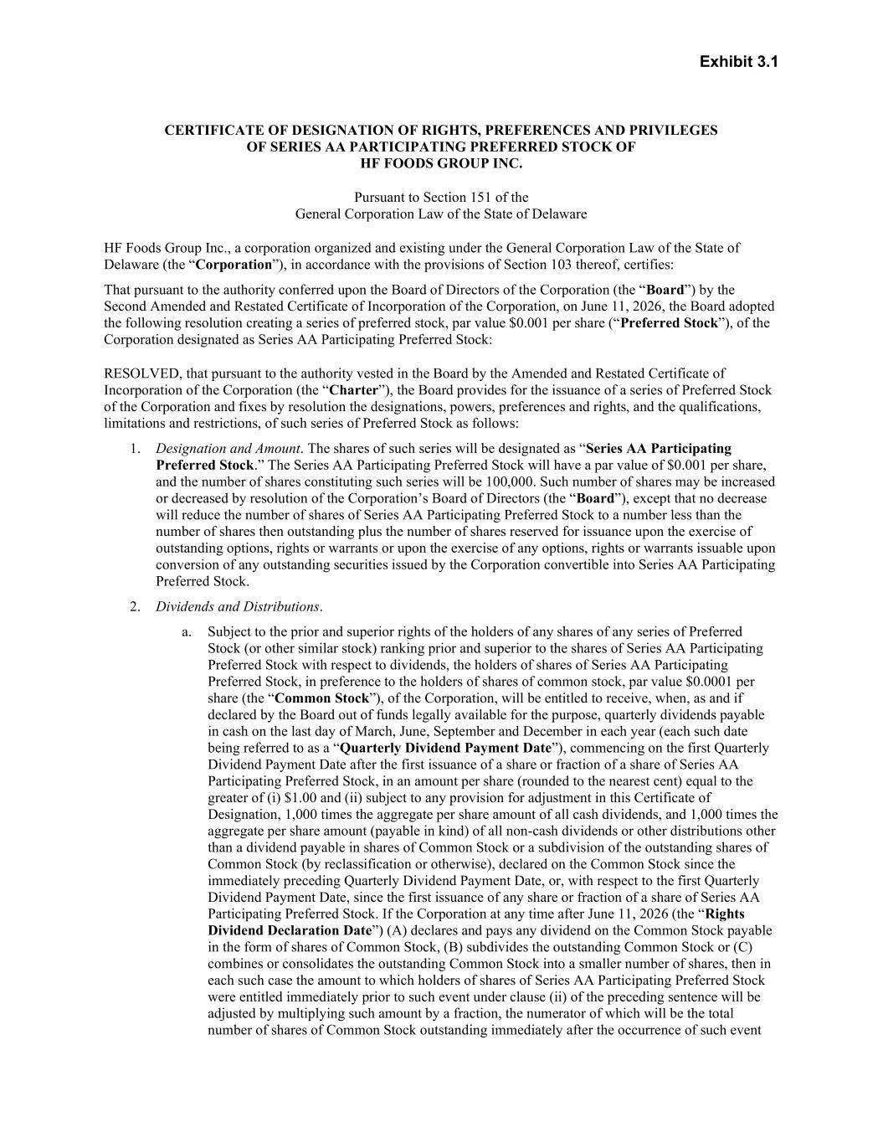

Exhibit 3.1 CERTIFICATE OF DESIGNATION OF RIGHTS, PREFERENCES AND PRIVILEGES OF SERIES AA PARTICIPATING PREFERRED STOCK OF HF FOODS GROUP INC. Pursuant to Section 151 of the General Corporation Law of the State of Delaware HF Foods Group Inc., a corporation organized and existing under the General Corporation Law of the State of Delaware (the “Corporation”), in accordance with the provisions of Section 103 thereof, certifies: That pursuant to the authority conferred upon the Board of Directors of the Corporation (the “Board”) by the Second Amended and Restated Certificate of Incorporation of the Corporation, on June 11, 2026, the Board adopted the following resolution creating a series of preferred stock, par value $0.001 per share (“Preferred Stock”), of the Corporation designated as Series AA Participating Preferred Stock: RESOLVED, that pursuant to the authority vested in the Board by the Amended and Restated Certificate of Incorporation of the Corporation (the “Charter”), the Board provides for the issuance of a series of Preferred Stock of the Corporation and fixes by resolution the designations, powers, preferences and rights, and the qualifications, limitations and restrictions, of such series of Preferred Stock as follows: 1. Designation and Amount. The shares of such series will be designated as “Series AA Participating Preferred Stock.” The Series AA Participating Preferred Stock will have a par value of $0.001 per share, and the number of shares constituting such series will be 100,000. Such number of shares may be increased or decreased by resolution of the Corporation’s Board of Directors (the “Board”), except that no decrease will reduce the number of shares of Series AA Participating Preferred Stock to a number less than the number of shares then outstanding plus the number of shares reserved for issuance upon the exercise of outstanding options, rights or warrants or upon the exercise of any options, rights or warrants issuable upon conversion of any outstanding securities issued by the Corporation convertible into Series AA Participating Preferred Stock. 2. Dividends and Distributions. a. Subject to the prior and superior rights of the holders of any shares of any series of Preferred Stock (or other similar stock) ranking prior and superior to the shares of Series AA Participating Preferred Stock with respect to dividends, the holders of shares of Series AA Participating Preferred Stock, in preference to the holders of shares of common stock, par value $0.0001 per share (the “Common Stock”), of the Corporation, will be entitled to receive, when, as and if declared by the Board out of funds legally available for the purpose, quarterly dividends payable in cash on the last day of March, June, September and December in each year (each such date being referred to as a “Quarterly Dividend Payment Date”), commencing on the first Quarterly Dividend Payment Date after the first issuance of a share or fraction of a share of Series AA Participating Preferred Stock, in an amount per share (rounded to the nearest cent) equal to the greater of (i) $1.00 and (ii) subject to any provision for adjustment in this Certificate of Designation, 1,000 times the aggregate per share amount of all cash dividends, and 1,000 times the aggregate per share amount (payable in kind) of all non-cash dividends or other distributions other than a dividend payable in shares of Common Stock or a subdivision of the outstanding shares of Common Stock (by reclassification or otherwise), declared on the Common Stock since the immediately preceding Quarterly Dividend Payment Date, or, with respect to the first Quarterly Dividend Payment Date, since the first issuance of any share or fraction of a share of Series AA Participating Preferred Stock. If the Corporation at any time after June 11, 2026 (the “Rights Dividend Declaration Date”) (A) declares and pays any dividend on the Common Stock payable in the form of shares of Common Stock, (B) subdivides the outstanding Common Stock or (C) combines or consolidates the outstanding Common Stock into a smaller number of shares, then in each such case the amount to which holders of shares of Series AA Participating Preferred Stock were entitled immediately prior to such event under clause (ii) of the preceding sentence will be adjusted by multiplying such amount by a fraction, the numerator of which will be the total number of shares of Common Stock outstanding immediately after the occurrence of such event

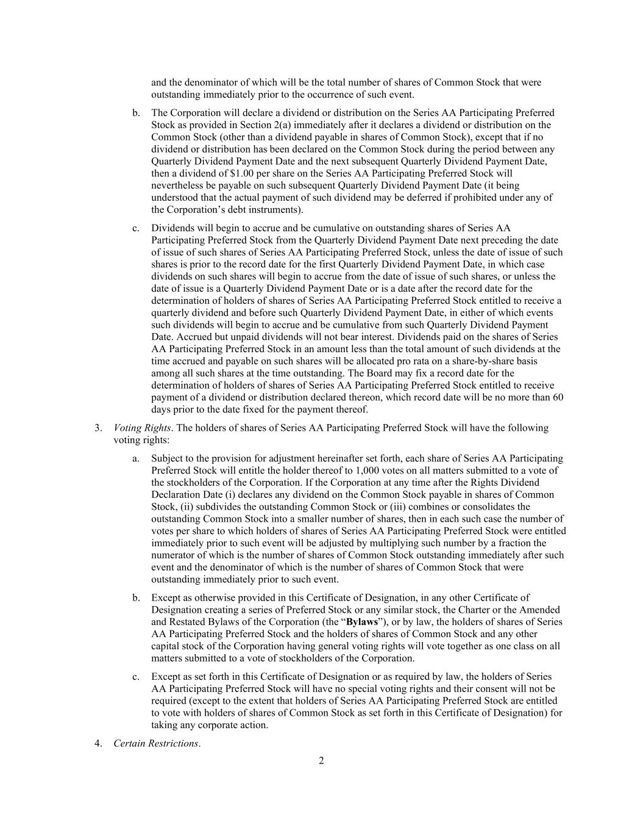
2 and the denominator of which will be the total number of shares of Common Stock that were outstanding immediately prior to the occurrence of such event. b. The Corporation will declare a dividend or distribution on the Series AA Participating Preferred Stock as provided in Section 2(a) immediately after it declares a dividend or distribution on the Common Stock (other than a dividend payable in shares of Common Stock), except that if no dividend or distribution has been declared on the Common Stock during the period between any Quarterly Dividend Payment Date and the next subsequent Quarterly Dividend Payment Date, then a dividend of $1.00 per share on the Series AA Participating Preferred Stock will nevertheless be payable on such subsequent Quarterly Dividend Payment Date (it being understood that the actual payment of such dividend may be deferred if prohibited under any of the Corporation’s debt instruments). c. Dividends will begin to accrue and be cumulative on outstanding shares of Series AA Participating Preferred Stock from the Quarterly Dividend Payment Date next preceding the date of issue of such shares of Series AA Participating Preferred Stock, unless the date of issue of such shares is prior to the record date for the first Quarterly Dividend Payment Date, in which case dividends on such shares will begin to accrue from the date of issue of such shares, or unless the date of issue is a Quarterly Dividend Payment Date or is a date after the record date for the determination of holders of shares of Series AA Participating Preferred Stock entitled to receive a quarterly dividend and before such Quarterly Dividend Payment Date, in either of which events such dividends will begin to accrue and be cumulative from such Quarterly Dividend Payment Date. Accrued but unpaid dividends will not bear interest. Dividends paid on the shares of Series AA Participating Preferred Stock in an amount less than the total amount of such dividends at the time accrued and payable on such shares will be allocated pro rata on a share-by-share basis among all such shares at the time outstanding. The Board may fix a record date for the determination of holders of shares of Series AA Participating Preferred Stock entitled to receive payment of a dividend or distribution declared thereon, which record date will be no more than 60 days prior to the date fixed for the payment thereof. 3. Voting Rights. The holders of shares of Series AA Participating Preferred Stock will have the following voting rights: a. Subject to the provision for adjustment hereinafter set forth, each share of Series AA Participating Preferred Stock will entitle the holder thereof to 1,000 votes on all matters submitted to a vote of the stockholders of the Corporation. If the Corporation at any time after the Rights Dividend Declaration Date (i) declares any dividend on the Common Stock payable in shares of Common Stock, (ii) subdivides the outstanding Common Stock or (iii) combines or consolidates the outstanding Common Stock into a smaller number of shares, then in each such case the number of votes per share to which holders of shares of Series AA Participating Preferred Stock were entitled immediately prior to such event will be adjusted by multiplying such number by a fraction the numerator of which is the number of shares of Common Stock outstanding immediately after such event and the denominator of which is the number of shares of Common Stock that were outstanding immediately prior to such event. b. Except as otherwise provided in this Certificate of Designation, in any other Certificate of Designation creating a series of Preferred Stock or any similar stock, the Charter or the Amended and Restated Bylaws of the Corporation (the “Bylaws”), or by law, the holders of shares of Series AA Participating Preferred Stock and the holders of shares of Common Stock and any other capital stock of the Corporation having general voting rights will vote together as one class on all matters submitted to a vote of stockholders of the Corporation. c. Except as set forth in this Certificate of Designation or as required by law, the holders of Series AA Participating Preferred Stock will have no special voting rights and their consent will not be required (except to the extent that holders of Series AA Participating Preferred Stock are entitled to vote with holders of shares of Common Stock as set forth in this Certificate of Designation) for taking any corporate action. 4. Certain Restrictions.

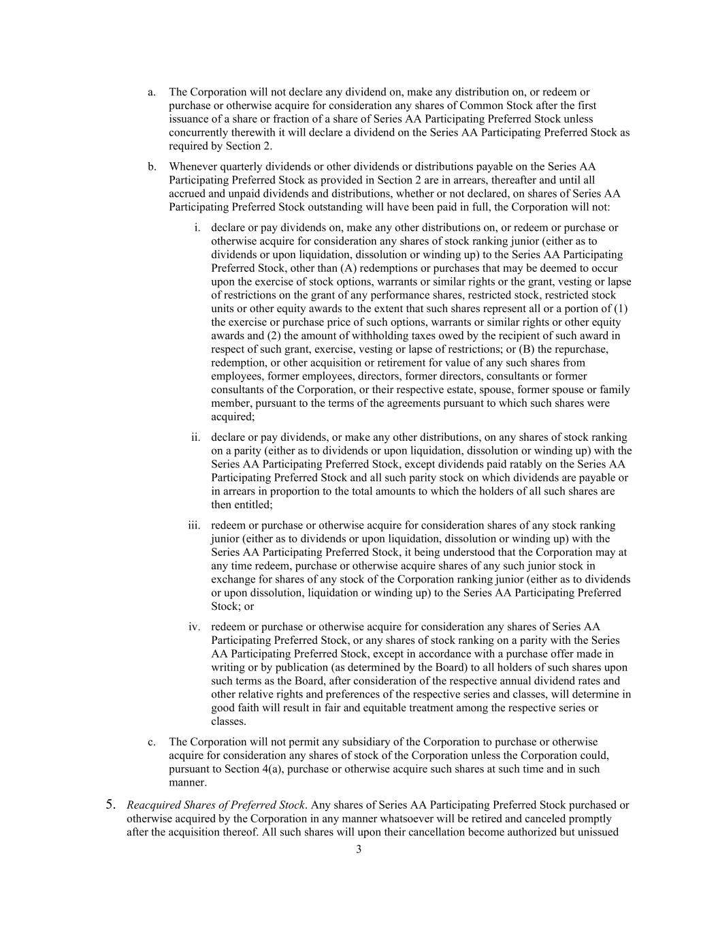
3 a. The Corporation will not declare any dividend on, make any distribution on, or redeem or purchase or otherwise acquire for consideration any shares of Common Stock after the first issuance of a share or fraction of a share of Series AA Participating Preferred Stock unless concurrently therewith it will declare a dividend on the Series AA Participating Preferred Stock as required by Section 2. b. Whenever quarterly dividends or other dividends or distributions payable on the Series AA Participating Preferred Stock as provided in Section 2 are in arrears, thereafter and until all accrued and unpaid dividends and distributions, whether or not declared, on shares of Series AA Participating Preferred Stock outstanding will have been paid in full, the Corporation will not: i. declare or pay dividends on, make any other distributions on, or redeem or purchase or otherwise acquire for consideration any shares of stock ranking junior (either as to dividends or upon liquidation, dissolution or winding up) to the Series AA Participating Preferred Stock, other than (A) redemptions or purchases that may be deemed to occur upon the exercise of stock options, warrants or similar rights or the grant, vesting or lapse of restrictions on the grant of any performance shares, restricted stock, restricted stock units or other equity awards to the extent that such shares represent all or a portion of (1) the exercise or purchase price of such options, warrants or similar rights or other equity awards and (2) the amount of withholding taxes owed by the recipient of such award in respect of such grant, exercise, vesting or lapse of restrictions; or (B) the repurchase, redemption, or other acquisition or retirement for value of any such shares from employees, former employees, directors, former directors, consultants or former consultants of the Corporation, or their respective estate, spouse, former spouse or family member, pursuant to the terms of the agreements pursuant to which such shares were acquired; ii. declare or pay dividends, or make any other distributions, on any shares of stock ranking on a parity (either as to dividends or upon liquidation, dissolution or winding up) with the Series AA Participating Preferred Stock, except dividends paid ratably on the Series AA Participating Preferred Stock and all such parity stock on which dividends are payable or in arrears in proportion to the total amounts to which the holders of all such shares are then entitled; iii. redeem or purchase or otherwise acquire for consideration shares of any stock ranking junior (either as to dividends or upon liquidation, dissolution or winding up) with the Series AA Participating Preferred Stock, it being understood that the Corporation may at any time redeem, purchase or otherwise acquire shares of any such junior stock in exchange for shares of any stock of the Corporation ranking junior (either as to dividends or upon dissolution, liquidation or winding up) to the Series AA Participating Preferred Stock; or iv. redeem or purchase or otherwise acquire for consideration any shares of Series AA Participating Preferred Stock, or any shares of stock ranking on a parity with the Series AA Participating Preferred Stock, except in accordance with a purchase offer made in writing or by publication (as determined by the Board) to all holders of such shares upon such terms as the Board, after consideration of the respective annual dividend rates and other relative rights and preferences of the respective series and classes, will determine in good faith will result in fair and equitable treatment among the respective series or classes. c. The Corporation will not permit any subsidiary of the Corporation to purchase or otherwise acquire for consideration any shares of stock of the Corporation unless the Corporation could, pursuant to Section 4(a), purchase or otherwise acquire such shares at such time and in such manner. 5. Reacquired Shares of Preferred Stock. Any shares of Series AA Participating Preferred Stock purchased or otherwise acquired by the Corporation in any manner whatsoever will be retired and canceled promptly after the acquisition thereof. All such shares will upon their cancellation become authorized but unissued

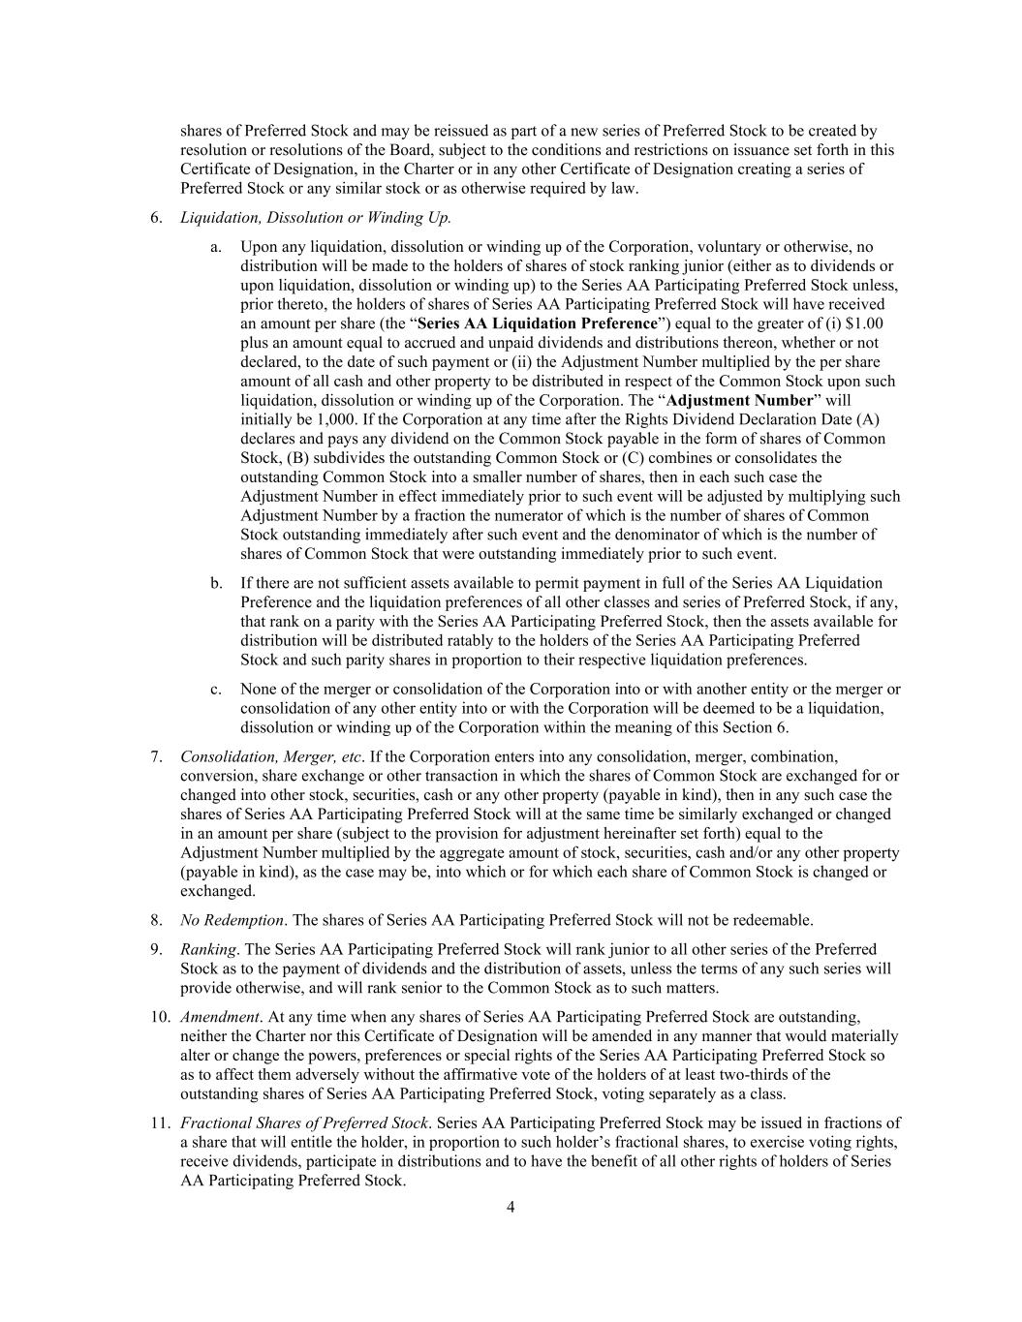
4 shares of Preferred Stock and may be reissued as part of a new series of Preferred Stock to be created by resolution or resolutions of the Board, subject to the conditions and restrictions on issuance set forth in this Certificate of Designation, in the Charter or in any other Certificate of Designation creating a series of Preferred Stock or any similar stock or as otherwise required by law. 6. Liquidation, Dissolution or Winding Up. a. Upon any liquidation, dissolution or winding up of the Corporation, voluntary or otherwise, no distribution will be made to the holders of shares of stock ranking junior (either as to dividends or upon liquidation, dissolution or winding up) to the Series AA Participating Preferred Stock unless, prior thereto, the holders of shares of Series AA Participating Preferred Stock will have received an amount per share (the “Series AA Liquidation Preference”) equal to the greater of (i) $1.00 plus an amount equal to accrued and unpaid dividends and distributions thereon, whether or not declared, to the date of such payment or (ii) the Adjustment Number multiplied by the per share amount of all cash and other property to be distributed in respect of the Common Stock upon such liquidation, dissolution or winding up of the Corporation. The “Adjustment Number” will initially be 1,000. If the Corporation at any time after the Rights Dividend Declaration Date (A) declares and pays any dividend on the Common Stock payable in the form of shares of Common Stock, (B) subdivides the outstanding Common Stock or (C) combines or consolidates the outstanding Common Stock into a smaller number of shares, then in each such case the Adjustment Number in effect immediately prior to such event will be adjusted by multiplying such Adjustment Number by a fraction the numerator of which is the number of shares of Common Stock outstanding immediately after such event and the denominator of which is the number of shares of Common Stock that were outstanding immediately prior to such event. b. If there are not sufficient assets available to permit payment in full of the Series AA Liquidation Preference and the liquidation preferences of all other classes and series of Preferred Stock, if any, that rank on a parity with the Series AA Participating Preferred Stock, then the assets available for distribution will be distributed ratably to the holders of the Series AA Participating Preferred Stock and such parity shares in proportion to their respective liquidation preferences. c. None of the merger or consolidation of the Corporation into or with another entity or the merger or consolidation of any other entity into or with the Corporation will be deemed to be a liquidation, dissolution or winding up of the Corporation within the meaning of this Section 6. 7. Consolidation, Merger, etc. If the Corporation enters into any consolidation, merger, combination, conversion, share exchange or other transaction in which the shares of Common Stock are exchanged for or changed into other stock, securities, cash or any other property (payable in kind), then in any such case the shares of Series AA Participating Preferred Stock will at the same time be similarly exchanged or changed in an amount per share (subject to the provision for adjustment hereinafter set forth) equal to the Adjustment Number multiplied by the aggregate amount of stock, securities, cash and/or any other property (payable in kind), as the case may be, into which or for which each share of Common Stock is changed or exchanged. 8. No Redemption. The shares of Series AA Participating Preferred Stock will not be redeemable. 9. Ranking. The Series AA Participating Preferred Stock will rank junior to all other series of the Preferred Stock as to the payment of dividends and the distribution of assets, unless the terms of any such series will provide otherwise, and will rank senior to the Common Stock as to such matters. 10. Amendment. At any time when any shares of Series AA Participating Preferred Stock are outstanding, neither the Charter nor this Certificate of Designation will be amended in any manner that would materially alter or change the powers, preferences or special rights of the Series AA Participating Preferred Stock so as to affect them adversely without the affirmative vote of the holders of at least two-thirds of the outstanding shares of Series AA Participating Preferred Stock, voting separately as a class. 11. Fractional Shares of Preferred Stock. Series AA Participating Preferred Stock may be issued in fractions of a share that will entitle the holder, in proportion to such holder’s fractional shares, to exercise voting rights, receive dividends, participate in distributions and to have the benefit of all other rights of holders of Series AA Participating Preferred Stock.


5 * * *


IN WITNESS WHEREOF, the undersigned has executed this Certificate as of the 12th day of June, 2026. HF FOODS GROUP INC. By: /s/Felix Lin Name: Felix Lin Title: President and Chief Executive Officer

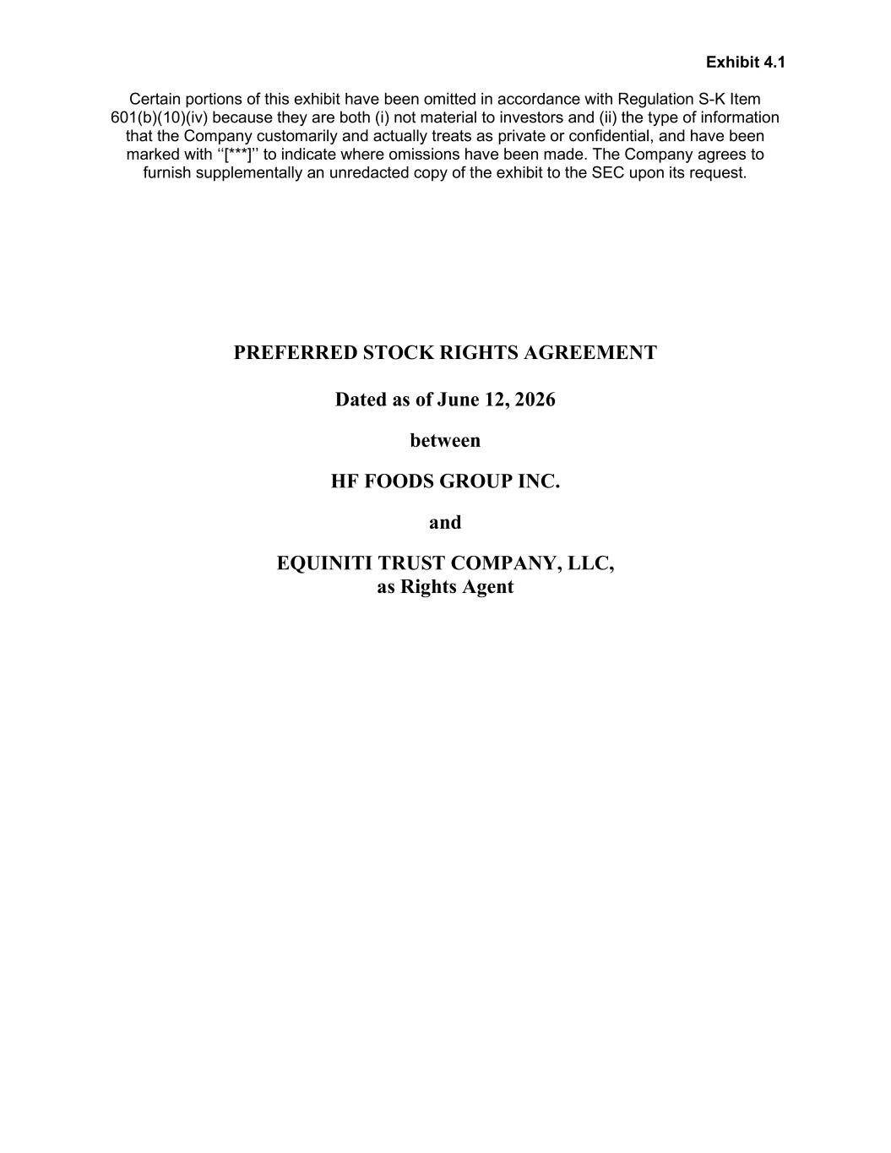
Exhibit 4.1 Certain portions of this exhibit have been omitted in accordance with Regulation S-K Item 601(b)(10)(iv) because they are both (i) not material to investors and (ii) the type of information that the Company customarily and actually treats as private or confidential, and have been marked with ‘‘[***]’’ to indicate where omissions have been made. The Company agrees to furnish supplementally an unredacted copy of the exhibit to the SEC upon its request. PREFERRED STOCK RIGHTS AGREEMENT Dated as of June 12, 2026 between HF FOODS GROUP INC. and EQUINITI TRUST COMPANY, LLC, as Rights Agent

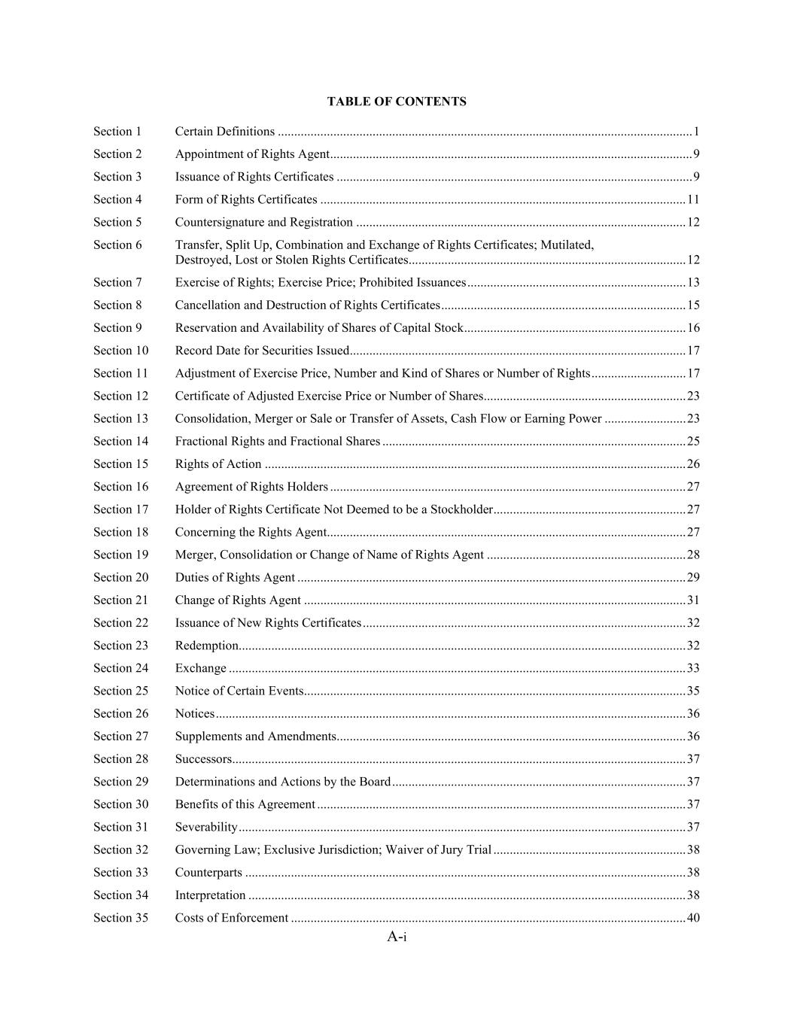
A-i TABLE OF CONTENTS Section 1 Certain Definitions ............................................................................................................................... 1 Section 2 Appointment of Rights Agent ............................................................................................................... 9 Section 3 Issuance of Rights Certificates ............................................................................................................. 9 Section 4 Form of Rights Certificates ................................................................................................................ 11 Section 5 Countersignature and Registration ..................................................................................................... 12 Section 6 Transfer, Split Up, Combination and Exchange of Rights Certificates; Mutilated, Destroyed, Lost or Stolen Rights Certificates..................................................................................... 12 Section 7 Exercise of Rights; Exercise Price; Prohibited Issuances ................................................................... 13 Section 8 Cancellation and Destruction of Rights Certificates ........................................................................... 15 Section 9 Reservation and Availability of Shares of Capital Stock .................................................................... 16 Section 10 Record Date for Securities Issued ....................................................................................................... 17 Section 11 Adjustment of Exercise Price, Number and Kind of Shares or Number of Rights ............................. 17 Section 12 Certificate of Adjusted Exercise Price or Number of Shares .............................................................. 23 Section 13 Consolidation, Merger or Sale or Transfer of Assets, Cash Flow or Earning Power ......................... 23 Section 14 Fractional Rights and Fractional Shares ............................................................................................. 25 Section 15 Rights of Action ................................................................................................................................. 26 Section 16 Agreement of Rights Holders ............................................................................................................. 27 Section 17 Holder of Rights Certificate Not Deemed to be a Stockholder ........................................................... 27 Section 18 Concerning the Rights Agent .............................................................................................................. 27 Section 19 Merger, Consolidation or Change of Name of Rights Agent ............................................................. 28 Section 20 Duties of Rights Agent ....................................................................................................................... 29 Section 21 Change of Rights Agent ..................................................................................................................... 31 Section 22 Issuance of New Rights Certificates ................................................................................................... 32 Section 23 Redemption ......................................................................................................................................... 32 Section 24 Exchange ............................................................................................................................................ 33 Section 25 Notice of Certain Events ..................................................................................................................... 35 Section 26 Notices ................................................................................................................................................ 36 Section 27 Supplements and Amendments ........................................................................................................... 36 Section 28 Successors........................................................................................................................................... 37 Section 29 Determinations and Actions by the Board .......................................................................................... 37 Section 30 Benefits of this Agreement ................................................................................................................. 37 Section 31 Severability ......................................................................................................................................... 37 Section 32 Governing Law; Exclusive Jurisdiction; Waiver of Jury Trial ........................................................... 38 Section 33 Counterparts ....................................................................................................................................... 38 Section 34 Interpretation ...................................................................................................................................... 38 Section 35 Costs of Enforcement ......................................................................................................................... 40


A-ii Section 36 Force Majeure ..................................................................................................................................... 40 Section 37 USA PATRIOT Act............................................................................................................................ 40 EXHIBITS Exhibit A Form of Certificate of Designation of Rights, Preferences and Privileges of Series AA Participating Preferred Stock Exhibit B Form of Rights Certificate Exhibit C Form of Summary of Rights

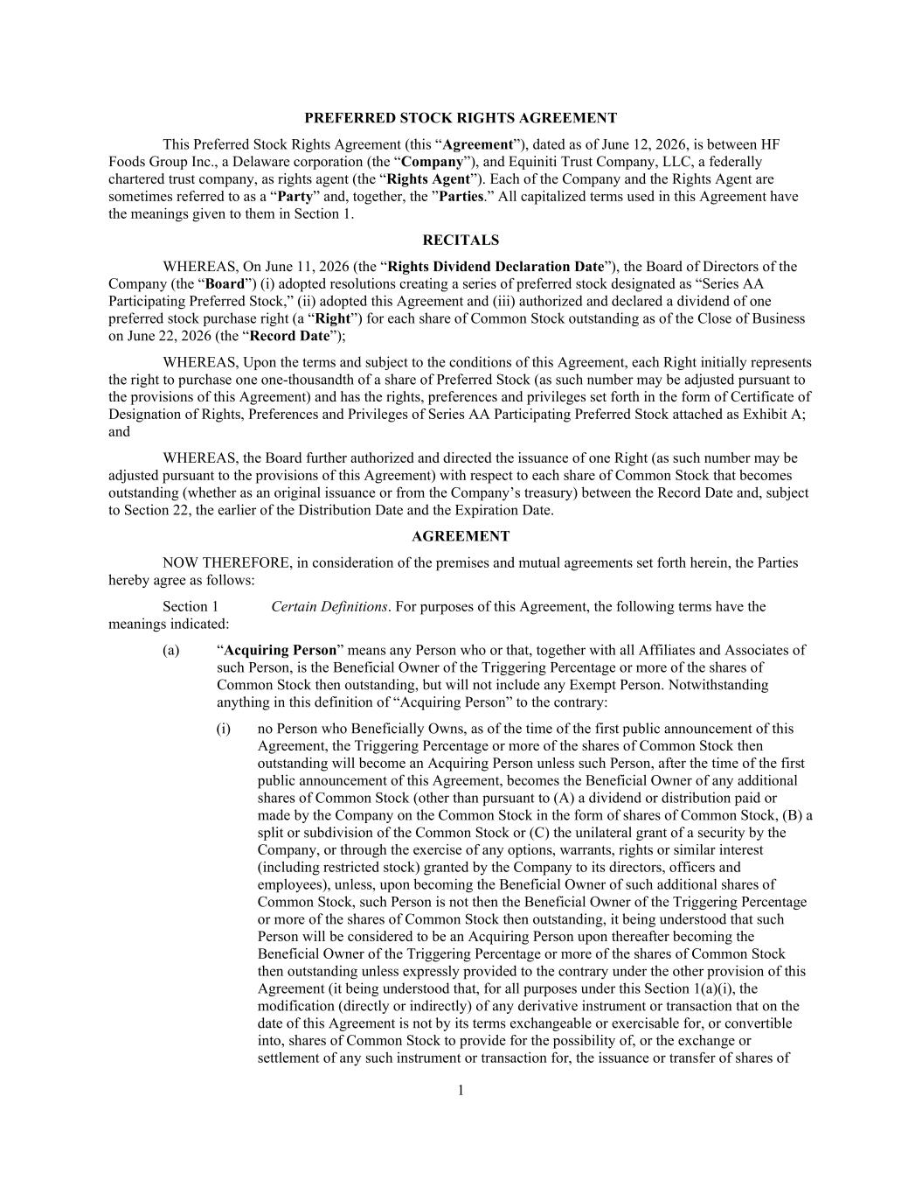
1 PREFERRED STOCK RIGHTS AGREEMENT This Preferred Stock Rights Agreement (this “Agreement”), dated as of June 12, 2026, is between HF Foods Group Inc., a Delaware corporation (the “Company”), and Equiniti Trust Company, LLC, a federally chartered trust company, as rights agent (the “Rights Agent”). Each of the Company and the Rights Agent are sometimes referred to as a “Party” and, together, the ”Parties.” All capitalized terms used in this Agreement have the meanings given to them in Section 1. RECITALS WHEREAS, On June 11, 2026 (the “Rights Dividend Declaration Date”), the Board of Directors of the Company (the “Board”) (i) adopted resolutions creating a series of preferred stock designated as “Series AA Participating Preferred Stock,” (ii) adopted this Agreement and (iii) authorized and declared a dividend of one preferred stock purchase right (a “Right”) for each share of Common Stock outstanding as of the Close of Business on June 22, 2026 (the “Record Date”); WHEREAS, Upon the terms and subject to the conditions of this Agreement, each Right initially represents the right to purchase one one-thousandth of a share of Preferred Stock (as such number may be adjusted pursuant to the provisions of this Agreement) and has the rights, preferences and privileges set forth in the form of Certificate of Designation of Rights, Preferences and Privileges of Series AA Participating Preferred Stock attached as Exhibit A; and WHEREAS, the Board further authorized and directed the issuance of one Right (as such number may be adjusted pursuant to the provisions of this Agreement) with respect to each share of Common Stock that becomes outstanding (whether as an original issuance or from the Company’s treasury) between the Record Date and, subject to Section 22, the earlier of the Distribution Date and the Expiration Date. AGREEMENT NOW THEREFORE, in consideration of the premises and mutual agreements set forth herein, the Parties hereby agree as follows: Section 1 Certain Definitions. For purposes of this Agreement, the following terms have the meanings indicated: (a) “Acquiring Person” means any Person who or that, together with all Affiliates and Associates of such Person, is the Beneficial Owner of the Triggering Percentage or more of the shares of Common Stock then outstanding, but will not include any Exempt Person. Notwithstanding anything in this definition of “Acquiring Person” to the contrary: (i) no Person who Beneficially Owns, as of the time of the first public announcement of this Agreement, the Triggering Percentage or more of the shares of Common Stock then outstanding will become an Acquiring Person unless such Person, after the time of the first public announcement of this Agreement, becomes the Beneficial Owner of any additional shares of Common Stock (other than pursuant to (A) a dividend or distribution paid or made by the Company on the Common Stock in the form of shares of Common Stock, (B) a split or subdivision of the Common Stock or (C) the unilateral grant of a security by the Company, or through the exercise of any options, warrants, rights or similar interest (including restricted stock) granted by the Company to its directors, officers and employees), unless, upon becoming the Beneficial Owner of such additional shares of Common Stock, such Person is not then the Beneficial Owner of the Triggering Percentage or more of the shares of Common Stock then outstanding, it being understood that such Person will be considered to be an Acquiring Person upon thereafter becoming the Beneficial Owner of the Triggering Percentage or more of the shares of Common Stock then outstanding unless expressly provided to the contrary under the other provision of this Agreement (it being understood that, for all purposes under this Section 1(a)(i), the modification (directly or indirectly) of any derivative instrument or transaction that on the date of this Agreement is not by its terms exchangeable or exercisable for, or convertible into, shares of Common Stock to provide for the possibility of, or the exchange or settlement of any such instrument or transaction for, the issuance or transfer of shares of

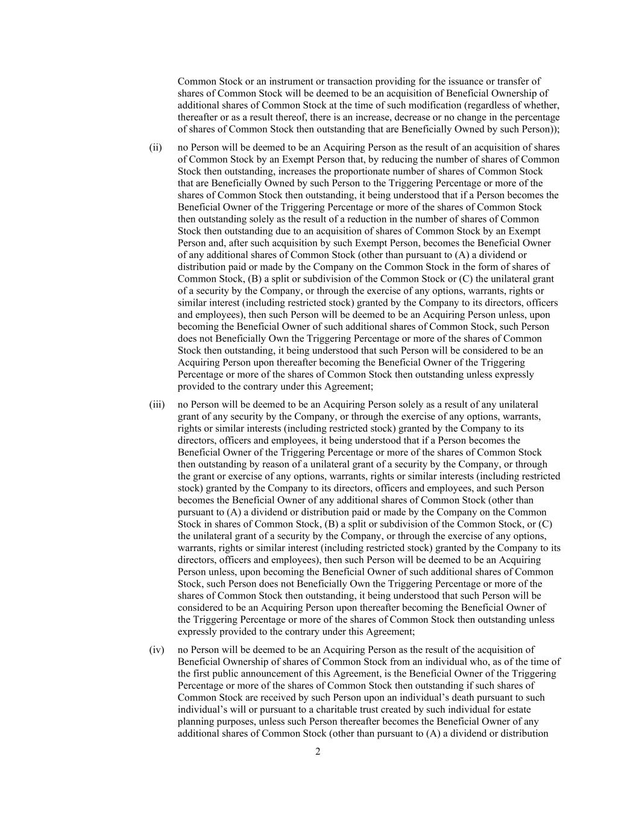
2 Common Stock or an instrument or transaction providing for the issuance or transfer of shares of Common Stock will be deemed to be an acquisition of Beneficial Ownership of additional shares of Common Stock at the time of such modification (regardless of whether, thereafter or as a result thereof, there is an increase, decrease or no change in the percentage of shares of Common Stock then outstanding that are Beneficially Owned by such Person)); (ii) no Person will be deemed to be an Acquiring Person as the result of an acquisition of shares of Common Stock by an Exempt Person that, by reducing the number of shares of Common Stock then outstanding, increases the proportionate number of shares of Common Stock that are Beneficially Owned by such Person to the Triggering Percentage or more of the shares of Common Stock then outstanding, it being understood that if a Person becomes the Beneficial Owner of the Triggering Percentage or more of the shares of Common Stock then outstanding solely as the result of a reduction in the number of shares of Common Stock then outstanding due to an acquisition of shares of Common Stock by an Exempt Person and, after such acquisition by such Exempt Person, becomes the Beneficial Owner of any additional shares of Common Stock (other than pursuant to (A) a dividend or distribution paid or made by the Company on the Common Stock in the form of shares of Common Stock, (B) a split or subdivision of the Common Stock or (C) the unilateral grant of a security by the Company, or through the exercise of any options, warrants, rights or similar interest (including restricted stock) granted by the Company to its directors, officers and employees), then such Person will be deemed to be an Acquiring Person unless, upon becoming the Beneficial Owner of such additional shares of Common Stock, such Person does not Beneficially Own the Triggering Percentage or more of the shares of Common Stock then outstanding, it being understood that such Person will be considered to be an Acquiring Person upon thereafter becoming the Beneficial Owner of the Triggering Percentage or more of the shares of Common Stock then outstanding unless expressly provided to the contrary under this Agreement; (iii) no Person will be deemed to be an Acquiring Person solely as a result of any unilateral grant of any security by the Company, or through the exercise of any options, warrants, rights or similar interests (including restricted stock) granted by the Company to its directors, officers and employees, it being understood that if a Person becomes the Beneficial Owner of the Triggering Percentage or more of the shares of Common Stock then outstanding by reason of a unilateral grant of a security by the Company, or through the grant or exercise of any options, warrants, rights or similar interests (including restricted stock) granted by the Company to its directors, officers and employees, and such Person becomes the Beneficial Owner of any additional shares of Common Stock (other than pursuant to (A) a dividend or distribution paid or made by the Company on the Common Stock in shares of Common Stock, (B) a split or subdivision of the Common Stock, or (C) the unilateral grant of a security by the Company, or through the exercise of any options, warrants, rights or similar interest (including restricted stock) granted by the Company to its directors, officers and employees), then such Person will be deemed to be an Acquiring Person unless, upon becoming the Beneficial Owner of such additional shares of Common Stock, such Person does not Beneficially Own the Triggering Percentage or more of the shares of Common Stock then outstanding, it being understood that such Person will be considered to be an Acquiring Person upon thereafter becoming the Beneficial Owner of the Triggering Percentage or more of the shares of Common Stock then outstanding unless expressly provided to the contrary under this Agreement; (iv) no Person will be deemed to be an Acquiring Person as the result of the acquisition of Beneficial Ownership of shares of Common Stock from an individual who, as of the time of the first public announcement of this Agreement, is the Beneficial Owner of the Triggering Percentage or more of the shares of Common Stock then outstanding if such shares of Common Stock are received by such Person upon an individual’s death pursuant to such individual’s will or pursuant to a charitable trust created by such individual for estate planning purposes, unless such Person thereafter becomes the Beneficial Owner of any additional shares of Common Stock (other than pursuant to (A) a dividend or distribution

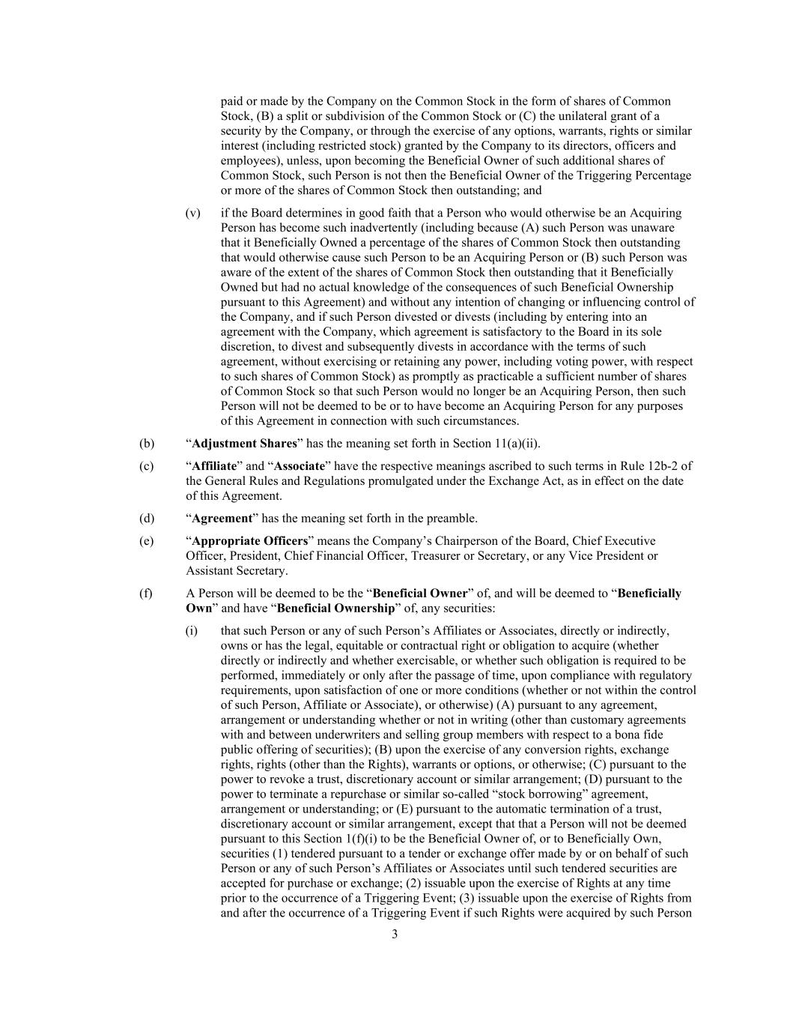
3 paid or made by the Company on the Common Stock in the form of shares of Common Stock, (B) a split or subdivision of the Common Stock or (C) the unilateral grant of a security by the Company, or through the exercise of any options, warrants, rights or similar interest (including restricted stock) granted by the Company to its directors, officers and employees), unless, upon becoming the Beneficial Owner of such additional shares of Common Stock, such Person is not then the Beneficial Owner of the Triggering Percentage or more of the shares of Common Stock then outstanding; and (v) if the Board determines in good faith that a Person who would otherwise be an Acquiring Person has become such inadvertently (including because (A) such Person was unaware that it Beneficially Owned a percentage of the shares of Common Stock then outstanding that would otherwise cause such Person to be an Acquiring Person or (B) such Person was aware of the extent of the shares of Common Stock then outstanding that it Beneficially Owned but had no actual knowledge of the consequences of such Beneficial Ownership pursuant to this Agreement) and without any intention of changing or influencing control of the Company, and if such Person divested or divests (including by entering into an agreement with the Company, which agreement is satisfactory to the Board in its sole discretion, to divest and subsequently divests in accordance with the terms of such agreement, without exercising or retaining any power, including voting power, with respect to such shares of Common Stock) as promptly as practicable a sufficient number of shares of Common Stock so that such Person would no longer be an Acquiring Person, then such Person will not be deemed to be or to have become an Acquiring Person for any purposes of this Agreement in connection with such circumstances. (b) “Adjustment Shares” has the meaning set forth in Section 11(a)(ii). (c) “Affiliate” and “Associate” have the respective meanings ascribed to such terms in Rule 12b-2 of the General Rules and Regulations promulgated under the Exchange Act, as in effect on the date of this Agreement. (d) “Agreement” has the meaning set forth in the preamble. (e) “Appropriate Officers” means the Company’s Chairperson of the Board, Chief Executive Officer, President, Chief Financial Officer, Treasurer or Secretary, or any Vice President or Assistant Secretary. (f) A Person will be deemed to be the “Beneficial Owner” of, and will be deemed to “Beneficially Own” and have “Beneficial Ownership” of, any securities: (i) that such Person or any of such Person’s Affiliates or Associates, directly or indirectly, owns or has the legal, equitable or contractual right or obligation to acquire (whether directly or indirectly and whether exercisable, or whether such obligation is required to be performed, immediately or only after the passage of time, upon compliance with regulatory requirements, upon satisfaction of one or more conditions (whether or not within the control of such Person, Affiliate or Associate), or otherwise) (A) pursuant to any agreement, arrangement or understanding whether or not in writing (other than customary agreements with and between underwriters and selling group members with respect to a bona fide public offering of securities); (B) upon the exercise of any conversion rights, exchange rights, rights (other than the Rights), warrants or options, or otherwise; (C) pursuant to the power to revoke a trust, discretionary account or similar arrangement; (D) pursuant to the power to terminate a repurchase or similar so-called “stock borrowing” agreement, arrangement or understanding; or (E) pursuant to the automatic termination of a trust, discretionary account or similar arrangement, except that that a Person will not be deemed pursuant to this Section 1(f)(i) to be the Beneficial Owner of, or to Beneficially Own, securities (1) tendered pursuant to a tender or exchange offer made by or on behalf of such Person or any of such Person’s Affiliates or Associates until such tendered securities are accepted for purchase or exchange; (2) issuable upon the exercise of Rights at any time prior to the occurrence of a Triggering Event; (3) issuable upon the exercise of Rights from and after the occurrence of a Triggering Event if such Rights were acquired by such Person

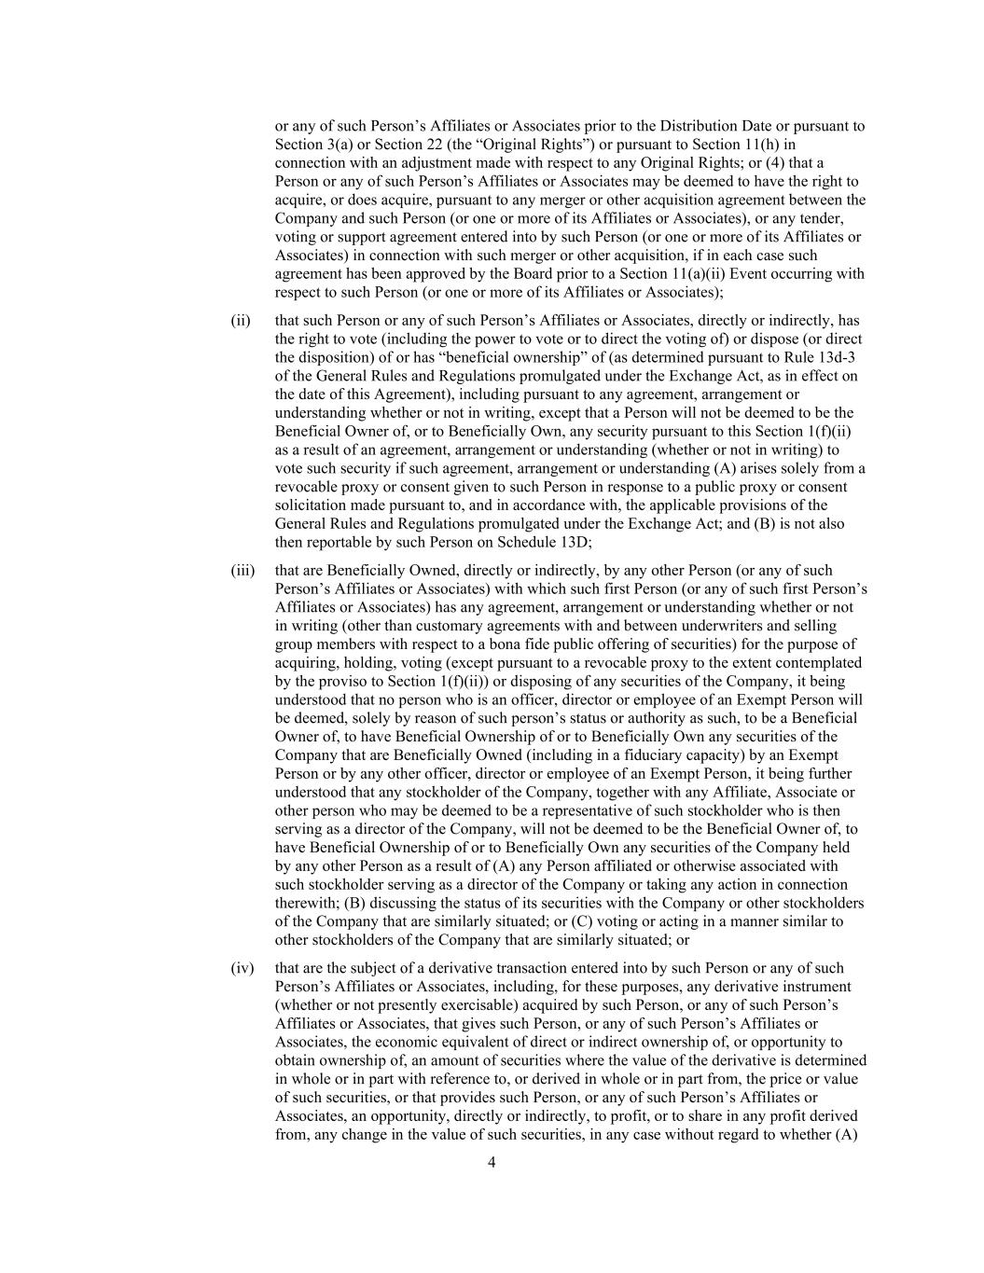
4 or any of such Person’s Affiliates or Associates prior to the Distribution Date or pursuant to Section 3(a) or Section 22 (the “Original Rights”) or pursuant to Section 11(h) in connection with an adjustment made with respect to any Original Rights; or (4) that a Person or any of such Person’s Affiliates or Associates may be deemed to have the right to acquire, or does acquire, pursuant to any merger or other acquisition agreement between the Company and such Person (or one or more of its Affiliates or Associates), or any tender, voting or support agreement entered into by such Person (or one or more of its Affiliates or Associates) in connection with such merger or other acquisition, if in each case such agreement has been approved by the Board prior to a Section 11(a)(ii) Event occurring with respect to such Person (or one or more of its Affiliates or Associates); (ii) that such Person or any of such Person’s Affiliates or Associates, directly or indirectly, has the right to vote (including the power to vote or to direct the voting of) or dispose (or direct the disposition) of or has “beneficial ownership” of (as determined pursuant to Rule 13d-3 of the General Rules and Regulations promulgated under the Exchange Act, as in effect on the date of this Agreement), including pursuant to any agreement, arrangement or understanding whether or not in writing, except that a Person will not be deemed to be the Beneficial Owner of, or to Beneficially Own, any security pursuant to this Section 1(f)(ii) as a result of an agreement, arrangement or understanding (whether or not in writing) to vote such security if such agreement, arrangement or understanding (A) arises solely from a revocable proxy or consent given to such Person in response to a public proxy or consent solicitation made pursuant to, and in accordance with, the applicable provisions of the General Rules and Regulations promulgated under the Exchange Act; and (B) is not also then reportable by such Person on Schedule 13D; (iii) that are Beneficially Owned, directly or indirectly, by any other Person (or any of such Person’s Affiliates or Associates) with which such first Person (or any of such first Person’s Affiliates or Associates) has any agreement, arrangement or understanding whether or not in writing (other than customary agreements with and between underwriters and selling group members with respect to a bona fide public offering of securities) for the purpose of acquiring, holding, voting (except pursuant to a revocable proxy to the extent contemplated by the proviso to Section 1(f)(ii)) or disposing of any securities of the Company, it being understood that no person who is an officer, director or employee of an Exempt Person will be deemed, solely by reason of such person’s status or authority as such, to be a Beneficial Owner of, to have Beneficial Ownership of or to Beneficially Own any securities of the Company that are Beneficially Owned (including in a fiduciary capacity) by an Exempt Person or by any other officer, director or employee of an Exempt Person, it being further understood that any stockholder of the Company, together with any Affiliate, Associate or other person who may be deemed to be a representative of such stockholder who is then serving as a director of the Company, will not be deemed to be the Beneficial Owner of, to have Beneficial Ownership of or to Beneficially Own any securities of the Company held by any other Person as a result of (A) any Person affiliated or otherwise associated with such stockholder serving as a director of the Company or taking any action in connection therewith; (B) discussing the status of its securities with the Company or other stockholders of the Company that are similarly situated; or (C) voting or acting in a manner similar to other stockholders of the Company that are similarly situated; or (iv) that are the subject of a derivative transaction entered into by such Person or any of such Person’s Affiliates or Associates, including, for these purposes, any derivative instrument (whether or not presently exercisable) acquired by such Person, or any of such Person’s Affiliates or Associates, that gives such Person, or any of such Person’s Affiliates or Associates, the economic equivalent of direct or indirect ownership of, or opportunity to obtain ownership of, an amount of securities where the value of the derivative is determined in whole or in part with reference to, or derived in whole or in part from, the price or value of such securities, or that provides such Person, or any of such Person’s Affiliates or Associates, an opportunity, directly or indirectly, to profit, or to share in any profit derived from, any change in the value of such securities, in any case without regard to whether (A)

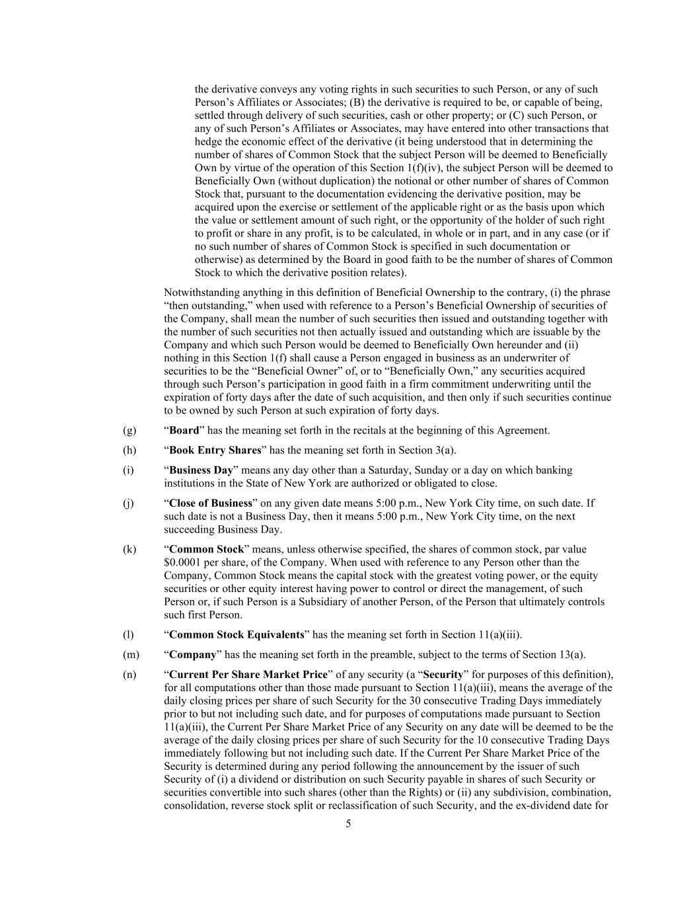
5 the derivative conveys any voting rights in such securities to such Person, or any of such Person’s Affiliates or Associates; (B) the derivative is required to be, or capable of being, settled through delivery of such securities, cash or other property; or (C) such Person, or any of such Person’s Affiliates or Associates, may have entered into other transactions that hedge the economic effect of the derivative (it being understood that in determining the number of shares of Common Stock that the subject Person will be deemed to Beneficially Own by virtue of the operation of this Section 1(f)(iv), the subject Person will be deemed to Beneficially Own (without duplication) the notional or other number of shares of Common Stock that, pursuant to the documentation evidencing the derivative position, may be acquired upon the exercise or settlement of the applicable right or as the basis upon which the value or settlement amount of such right, or the opportunity of the holder of such right to profit or share in any profit, is to be calculated, in whole or in part, and in any case (or if no such number of shares of Common Stock is specified in such documentation or otherwise) as determined by the Board in good faith to be the number of shares of Common Stock to which the derivative position relates). Notwithstanding anything in this definition of Beneficial Ownership to the contrary, (i) the phrase “then outstanding,” when used with reference to a Person’s Beneficial Ownership of securities of the Company, shall mean the number of such securities then issued and outstanding together with the number of such securities not then actually issued and outstanding which are issuable by the Company and which such Person would be deemed to Beneficially Own hereunder and (ii) nothing in this Section 1(f) shall cause a Person engaged in business as an underwriter of securities to be the “Beneficial Owner” of, or to “Beneficially Own,” any securities acquired through such Person’s participation in good faith in a firm commitment underwriting until the expiration of forty days after the date of such acquisition, and then only if such securities continue to be owned by such Person at such expiration of forty days. (g) “Board” has the meaning set forth in the recitals at the beginning of this Agreement. (h) “Book Entry Shares” has the meaning set forth in Section 3(a). (i) “Business Day” means any day other than a Saturday, Sunday or a day on which banking institutions in the State of New York are authorized or obligated to close. (j) “Close of Business” on any given date means 5:00 p.m., New York City time, on such date. If such date is not a Business Day, then it means 5:00 p.m., New York City time, on the next succeeding Business Day. (k) “Common Stock” means, unless otherwise specified, the shares of common stock, par value $0.0001 per share, of the Company. When used with reference to any Person other than the Company, Common Stock means the capital stock with the greatest voting power, or the equity securities or other equity interest having power to control or direct the management, of such Person or, if such Person is a Subsidiary of another Person, of the Person that ultimately controls such first Person. (l) “Common Stock Equivalents” has the meaning set forth in Section 11(a)(iii). (m) “Company” has the meaning set forth in the preamble, subject to the terms of Section 13(a). (n) “Current Per Share Market Price” of any security (a “Security” for purposes of this definition), for all computations other than those made pursuant to Section 11(a)(iii), means the average of the daily closing prices per share of such Security for the 30 consecutive Trading Days immediately prior to but not including such date, and for purposes of computations made pursuant to Section 11(a)(iii), the Current Per Share Market Price of any Security on any date will be deemed to be the average of the daily closing prices per share of such Security for the 10 consecutive Trading Days immediately following but not including such date. If the Current Per Share Market Price of the Security is determined during any period following the announcement by the issuer of such Security of (i) a dividend or distribution on such Security payable in shares of such Security or securities convertible into such shares (other than the Rights) or (ii) any subdivision, combination, consolidation, reverse stock split or reclassification of such Security, and the ex-dividend date for

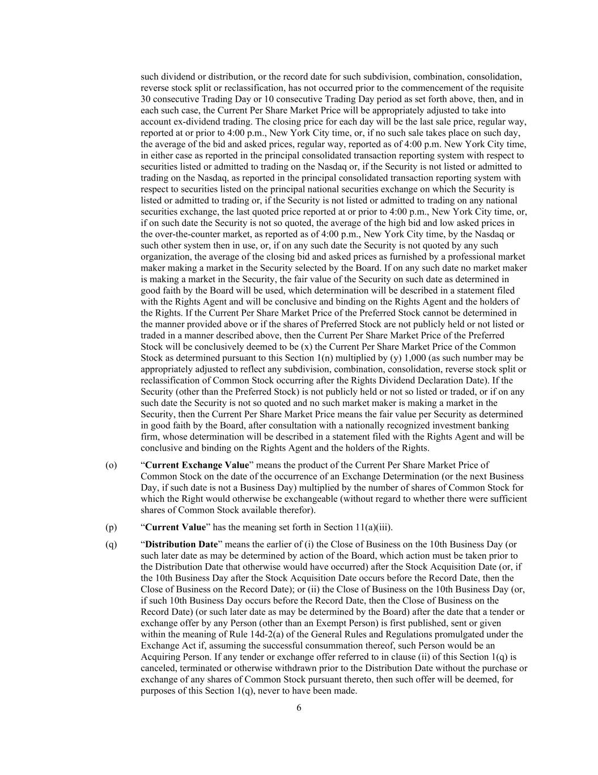
6 such dividend or distribution, or the record date for such subdivision, combination, consolidation, reverse stock split or reclassification, has not occurred prior to the commencement of the requisite 30 consecutive Trading Day or 10 consecutive Trading Day period as set forth above, then, and in each such case, the Current Per Share Market Price will be appropriately adjusted to take into account ex-dividend trading. The closing price for each day will be the last sale price, regular way, reported at or prior to 4:00 p.m., New York City time, or, if no such sale takes place on such day, the average of the bid and asked prices, regular way, reported as of 4:00 p.m. New York City time, in either case as reported in the principal consolidated transaction reporting system with respect to securities listed or admitted to trading on the Nasdaq or, if the Security is not listed or admitted to trading on the Nasdaq, as reported in the principal consolidated transaction reporting system with respect to securities listed on the principal national securities exchange on which the Security is listed or admitted to trading or, if the Security is not listed or admitted to trading on any national securities exchange, the last quoted price reported at or prior to 4:00 p.m., New York City time, or, if on such date the Security is not so quoted, the average of the high bid and low asked prices in the over-the-counter market, as reported as of 4:00 p.m., New York City time, by the Nasdaq or such other system then in use, or, if on any such date the Security is not quoted by any such organization, the average of the closing bid and asked prices as furnished by a professional market maker making a market in the Security selected by the Board. If on any such date no market maker is making a market in the Security, the fair value of the Security on such date as determined in good faith by the Board will be used, which determination will be described in a statement filed with the Rights Agent and will be conclusive and binding on the Rights Agent and the holders of the Rights. If the Current Per Share Market Price of the Preferred Stock cannot be determined in the manner provided above or if the shares of Preferred Stock are not publicly held or not listed or traded in a manner described above, then the Current Per Share Market Price of the Preferred Stock will be conclusively deemed to be (x) the Current Per Share Market Price of the Common Stock as determined pursuant to this Section 1(n) multiplied by (y) 1,000 (as such number may be appropriately adjusted to reflect any subdivision, combination, consolidation, reverse stock split or reclassification of Common Stock occurring after the Rights Dividend Declaration Date). If the Security (other than the Preferred Stock) is not publicly held or not so listed or traded, or if on any such date the Security is not so quoted and no such market maker is making a market in the Security, then the Current Per Share Market Price means the fair value per Security as determined in good faith by the Board, after consultation with a nationally recognized investment banking firm, whose determination will be described in a statement filed with the Rights Agent and will be conclusive and binding on the Rights Agent and the holders of the Rights. (o) “Current Exchange Value” means the product of the Current Per Share Market Price of Common Stock on the date of the occurrence of an Exchange Determination (or the next Business Day, if such date is not a Business Day) multiplied by the number of shares of Common Stock for which the Right would otherwise be exchangeable (without regard to whether there were sufficient shares of Common Stock available therefor). (p) “Current Value” has the meaning set forth in Section 11(a)(iii). (q) “Distribution Date” means the earlier of (i) the Close of Business on the 10th Business Day (or such later date as may be determined by action of the Board, which action must be taken prior to the Distribution Date that otherwise would have occurred) after the Stock Acquisition Date (or, if the 10th Business Day after the Stock Acquisition Date occurs before the Record Date, then the Close of Business on the Record Date); or (ii) the Close of Business on the 10th Business Day (or, if such 10th Business Day occurs before the Record Date, then the Close of Business on the Record Date) (or such later date as may be determined by the Board) after the date that a tender or exchange offer by any Person (other than an Exempt Person) is first published, sent or given within the meaning of Rule 14d-2(a) of the General Rules and Regulations promulgated under the Exchange Act if, assuming the successful consummation thereof, such Person would be an Acquiring Person. If any tender or exchange offer referred to in clause (ii) of this Section 1(q) is canceled, terminated or otherwise withdrawn prior to the Distribution Date without the purchase or exchange of any shares of Common Stock pursuant thereto, then such offer will be deemed, for purposes of this Section 1(q), never to have been made.

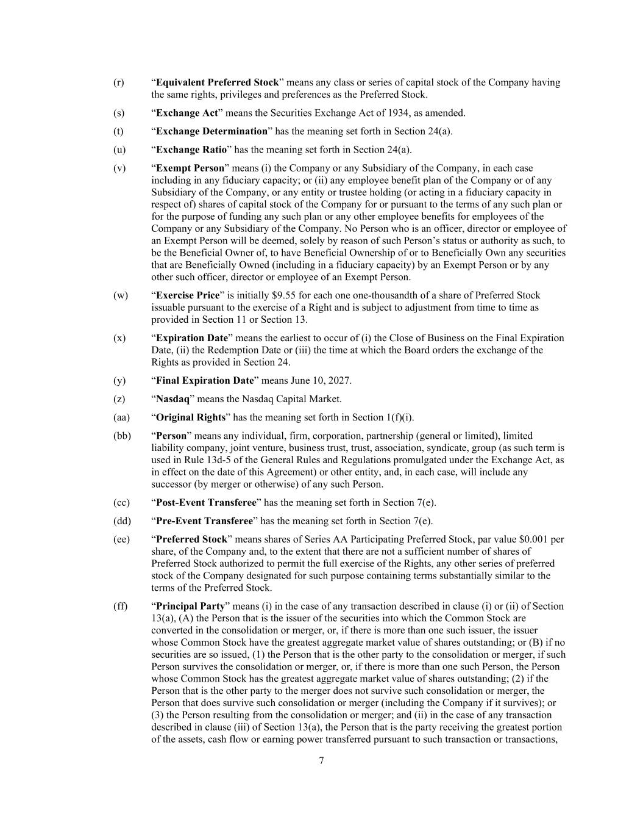
7 (r) “Equivalent Preferred Stock” means any class or series of capital stock of the Company having the same rights, privileges and preferences as the Preferred Stock. (s) “Exchange Act” means the Securities Exchange Act of 1934, as amended. (t) “Exchange Determination” has the meaning set forth in Section 24(a). (u) “Exchange Ratio” has the meaning set forth in Section 24(a). (v) “Exempt Person” means (i) the Company or any Subsidiary of the Company, in each case including in any fiduciary capacity; or (ii) any employee benefit plan of the Company or of any Subsidiary of the Company, or any entity or trustee holding (or acting in a fiduciary capacity in respect of) shares of capital stock of the Company for or pursuant to the terms of any such plan or for the purpose of funding any such plan or any other employee benefits for employees of the Company or any Subsidiary of the Company. No Person who is an officer, director or employee of an Exempt Person will be deemed, solely by reason of such Person’s status or authority as such, to be the Beneficial Owner of, to have Beneficial Ownership of or to Beneficially Own any securities that are Beneficially Owned (including in a fiduciary capacity) by an Exempt Person or by any other such officer, director or employee of an Exempt Person. (w) “Exercise Price” is initially $9.55 for each one one-thousandth of a share of Preferred Stock issuable pursuant to the exercise of a Right and is subject to adjustment from time to time as provided in Section 11 or Section 13. (x) “Expiration Date” means the earliest to occur of (i) the Close of Business on the Final Expiration Date, (ii) the Redemption Date or (iii) the time at which the Board orders the exchange of the Rights as provided in Section 24. (y) “Final Expiration Date” means June 10, 2027. (z) “Nasdaq” means the Nasdaq Capital Market. (aa) “Original Rights” has the meaning set forth in Section 1(f)(i). (bb) “Person” means any individual, firm, corporation, partnership (general or limited), limited liability company, joint venture, business trust, trust, association, syndicate, group (as such term is used in Rule 13d-5 of the General Rules and Regulations promulgated under the Exchange Act, as in effect on the date of this Agreement) or other entity, and, in each case, will include any successor (by merger or otherwise) of any such Person. (cc) “Post-Event Transferee” has the meaning set forth in Section 7(e). (dd) “Pre-Event Transferee” has the meaning set forth in Section 7(e). (ee) “Preferred Stock” means shares of Series AA Participating Preferred Stock, par value $0.001 per share, of the Company and, to the extent that there are not a sufficient number of shares of Preferred Stock authorized to permit the full exercise of the Rights, any other series of preferred stock of the Company designated for such purpose containing terms substantially similar to the terms of the Preferred Stock. (ff) “Principal Party” means (i) in the case of any transaction described in clause (i) or (ii) of Section 13(a), (A) the Person that is the issuer of the securities into which the Common Stock are converted in the consolidation or merger, or, if there is more than one such issuer, the issuer whose Common Stock have the greatest aggregate market value of shares outstanding; or (B) if no securities are so issued, (1) the Person that is the other party to the consolidation or merger, if such Person survives the consolidation or merger, or, if there is more than one such Person, the Person whose Common Stock has the greatest aggregate market value of shares outstanding; (2) if the Person that is the other party to the merger does not survive such consolidation or merger, the Person that does survive such consolidation or merger (including the Company if it survives); or (3) the Person resulting from the consolidation or merger; and (ii) in the case of any transaction described in clause (iii) of Section 13(a), the Person that is the party receiving the greatest portion of the assets, cash flow or earning power transferred pursuant to such transaction or transactions,

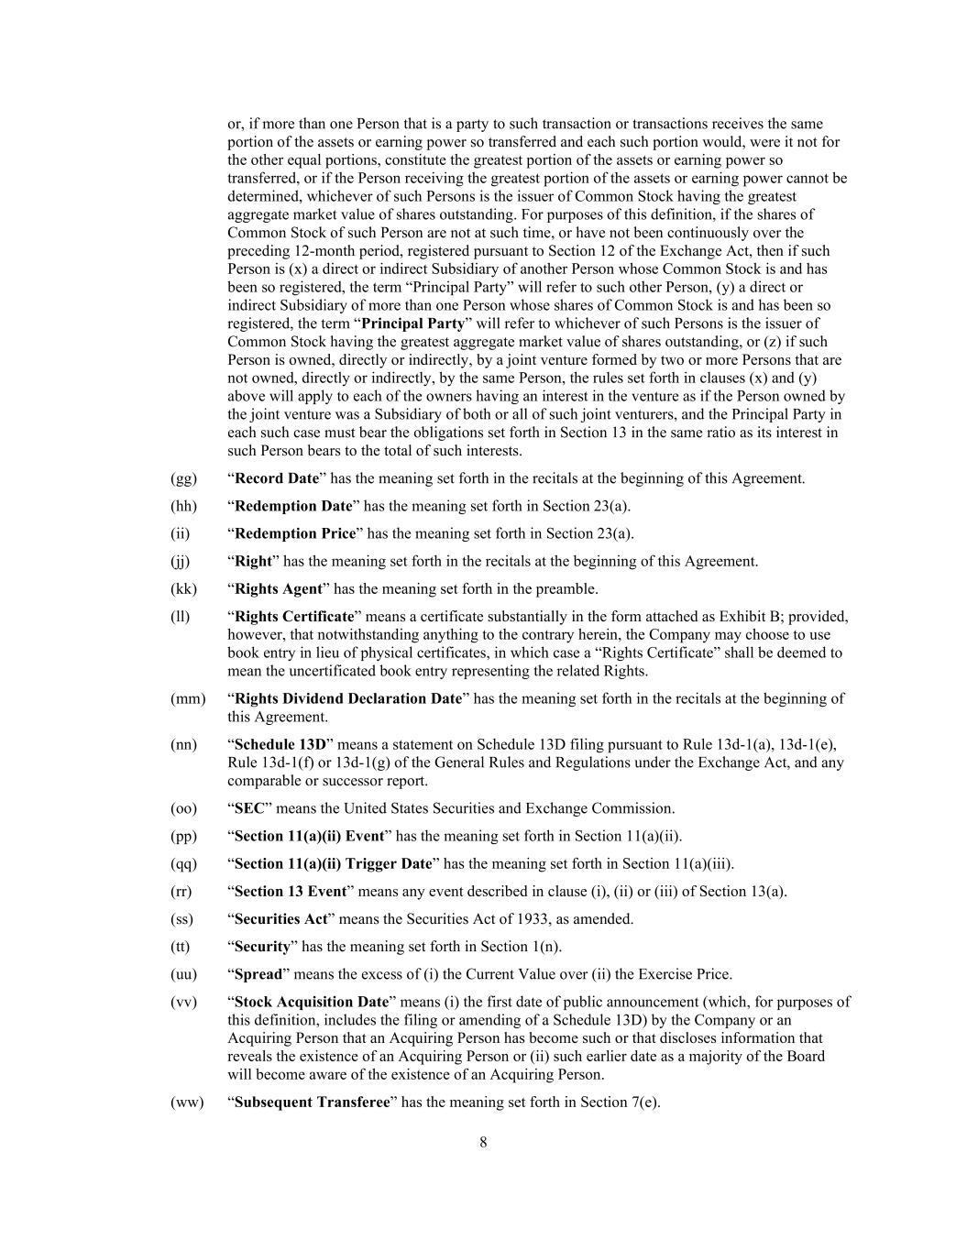
8 or, if more than one Person that is a party to such transaction or transactions receives the same portion of the assets or earning power so transferred and each such portion would, were it not for the other equal portions, constitute the greatest portion of the assets or earning power so transferred, or if the Person receiving the greatest portion of the assets or earning power cannot be determined, whichever of such Persons is the issuer of Common Stock having the greatest aggregate market value of shares outstanding. For purposes of this definition, if the shares of Common Stock of such Person are not at such time, or have not been continuously over the preceding 12-month period, registered pursuant to Section 12 of the Exchange Act, then if such Person is (x) a direct or indirect Subsidiary of another Person whose Common Stock is and has been so registered, the term “Principal Party” will refer to such other Person, (y) a direct or indirect Subsidiary of more than one Person whose shares of Common Stock is and has been so registered, the term “Principal Party” will refer to whichever of such Persons is the issuer of Common Stock having the greatest aggregate market value of shares outstanding, or (z) if such Person is owned, directly or indirectly, by a joint venture formed by two or more Persons that are not owned, directly or indirectly, by the same Person, the rules set forth in clauses (x) and (y) above will apply to each of the owners having an interest in the venture as if the Person owned by the joint venture was a Subsidiary of both or all of such joint venturers, and the Principal Party in each such case must bear the obligations set forth in Section 13 in the same ratio as its interest in such Person bears to the total of such interests. (gg) “Record Date” has the meaning set forth in the recitals at the beginning of this Agreement. (hh) “Redemption Date” has the meaning set forth in Section 23(a). (ii) “Redemption Price” has the meaning set forth in Section 23(a). (jj) “Right” has the meaning set forth in the recitals at the beginning of this Agreement. (kk) “Rights Agent” has the meaning set forth in the preamble. (ll) “Rights Certificate” means a certificate substantially in the form attached as Exhibit B; provided, however, that notwithstanding anything to the contrary herein, the Company may choose to use book entry in lieu of physical certificates, in which case a “Rights Certificate” shall be deemed to mean the uncertificated book entry representing the related Rights. (mm) “Rights Dividend Declaration Date” has the meaning set forth in the recitals at the beginning of this Agreement. (nn) “Schedule 13D” means a statement on Schedule 13D filing pursuant to Rule 13d-1(a), 13d-1(e), Rule 13d-1(f) or 13d-1(g) of the General Rules and Regulations under the Exchange Act, and any comparable or successor report. (oo) “SEC” means the United States Securities and Exchange Commission. (pp) “Section 11(a)(ii) Event” has the meaning set forth in Section 11(a)(ii). (qq) “Section 11(a)(ii) Trigger Date” has the meaning set forth in Section 11(a)(iii). (rr) “Section 13 Event” means any event described in clause (i), (ii) or (iii) of Section 13(a). (ss) “Securities Act” means the Securities Act of 1933, as amended. (tt) “Security” has the meaning set forth in Section 1(n). (uu) “Spread” means the excess of (i) the Current Value over (ii) the Exercise Price. (vv) “Stock Acquisition Date” means (i) the first date of public announcement (which, for purposes of this definition, includes the filing or amending of a Schedule 13D) by the Company or an Acquiring Person that an Acquiring Person has become such or that discloses information that reveals the existence of an Acquiring Person or (ii) such earlier date as a majority of the Board will become aware of the existence of an Acquiring Person. (ww) “Subsequent Transferee” has the meaning set forth in Section 7(e).

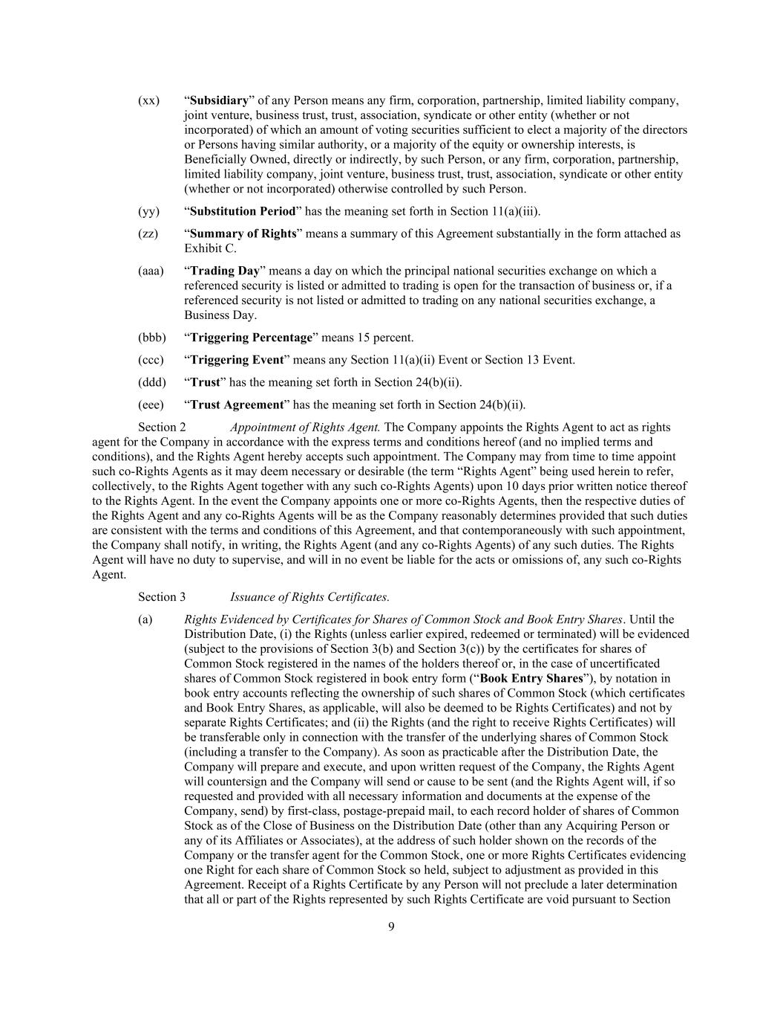
9 (xx) “Subsidiary” of any Person means any firm, corporation, partnership, limited liability company, joint venture, business trust, trust, association, syndicate or other entity (whether or not incorporated) of which an amount of voting securities sufficient to elect a majority of the directors or Persons having similar authority, or a majority of the equity or ownership interests, is Beneficially Owned, directly or indirectly, by such Person, or any firm, corporation, partnership, limited liability company, joint venture, business trust, trust, association, syndicate or other entity (whether or not incorporated) otherwise controlled by such Person. (yy) “Substitution Period” has the meaning set forth in Section 11(a)(iii). (zz) “Summary of Rights” means a summary of this Agreement substantially in the form attached as Exhibit C. (aaa) “Trading Day” means a day on which the principal national securities exchange on which a referenced security is listed or admitted to trading is open for the transaction of business or, if a referenced security is not listed or admitted to trading on any national securities exchange, a Business Day. (bbb) “Triggering Percentage” means 15 percent. (ccc) “Triggering Event” means any Section 11(a)(ii) Event or Section 13 Event. (ddd) “Trust” has the meaning set forth in Section 24(b)(ii). (eee) “Trust Agreement” has the meaning set forth in Section 24(b)(ii). Section 2 Appointment of Rights Agent. The Company appoints the Rights Agent to act as rights agent for the Company in accordance with the express terms and conditions hereof (and no implied terms and conditions), and the Rights Agent hereby accepts such appointment. The Company may from time to time appoint such co-Rights Agents as it may deem necessary or desirable (the term “Rights Agent” being used herein to refer, collectively, to the Rights Agent together with any such co-Rights Agents) upon 10 days prior written notice thereof to the Rights Agent. In the event the Company appoints one or more co-Rights Agents, then the respective duties of the Rights Agent and any co-Rights Agents will be as the Company reasonably determines provided that such duties are consistent with the terms and conditions of this Agreement, and that contemporaneously with such appointment, the Company shall notify, in writing, the Rights Agent (and any co-Rights Agents) of any such duties. The Rights Agent will have no duty to supervise, and will in no event be liable for the acts or omissions of, any such co-Rights Agent. Section 3 Issuance of Rights Certificates. (a) Rights Evidenced by Certificates for Shares of Common Stock and Book Entry Shares. Until the Distribution Date, (i) the Rights (unless earlier expired, redeemed or terminated) will be evidenced (subject to the provisions of Section 3(b) and Section 3(c)) by the certificates for shares of Common Stock registered in the names of the holders thereof or, in the case of uncertificated shares of Common Stock registered in book entry form (“Book Entry Shares”), by notation in book entry accounts reflecting the ownership of such shares of Common Stock (which certificates and Book Entry Shares, as applicable, will also be deemed to be Rights Certificates) and not by separate Rights Certificates; and (ii) the Rights (and the right to receive Rights Certificates) will be transferable only in connection with the transfer of the underlying shares of Common Stock (including a transfer to the Company). As soon as practicable after the Distribution Date, the Company will prepare and execute, and upon written request of the Company, the Rights Agent will countersign and the Company will send or cause to be sent (and the Rights Agent will, if so requested and provided with all necessary information and documents at the expense of the Company, send) by first-class, postage-prepaid mail, to each record holder of shares of Common Stock as of the Close of Business on the Distribution Date (other than any Acquiring Person or any of its Affiliates or Associates), at the address of such holder shown on the records of the Company or the transfer agent for the Common Stock, one or more Rights Certificates evidencing one Right for each share of Common Stock so held, subject to adjustment as provided in this Agreement. Receipt of a Rights Certificate by any Person will not preclude a later determination that all or part of the Rights represented by such Rights Certificate are void pursuant to Section

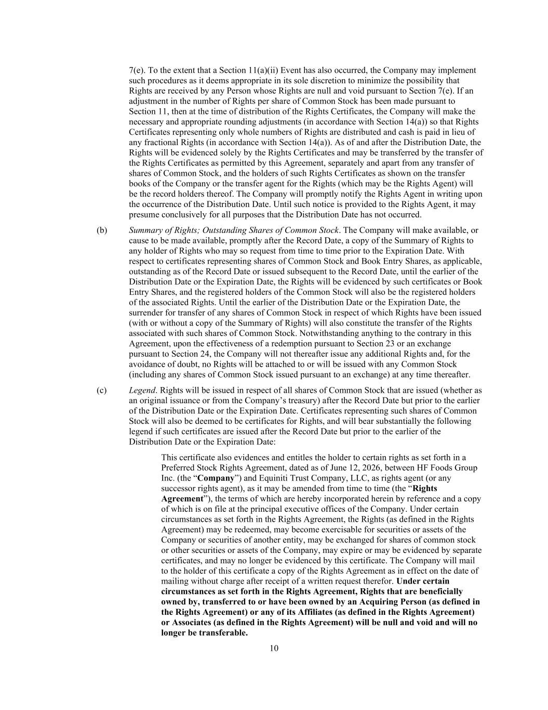
10 7(e). To the extent that a Section 11(a)(ii) Event has also occurred, the Company may implement such procedures as it deems appropriate in its sole discretion to minimize the possibility that Rights are received by any Person whose Rights are null and void pursuant to Section 7(e). If an adjustment in the number of Rights per share of Common Stock has been made pursuant to Section 11, then at the time of distribution of the Rights Certificates, the Company will make the necessary and appropriate rounding adjustments (in accordance with Section 14(a)) so that Rights Certificates representing only whole numbers of Rights are distributed and cash is paid in lieu of any fractional Rights (in accordance with Section 14(a)). As of and after the Distribution Date, the Rights will be evidenced solely by the Rights Certificates and may be transferred by the transfer of the Rights Certificates as permitted by this Agreement, separately and apart from any transfer of shares of Common Stock, and the holders of such Rights Certificates as shown on the transfer books of the Company or the transfer agent for the Rights (which may be the Rights Agent) will be the record holders thereof. The Company will promptly notify the Rights Agent in writing upon the occurrence of the Distribution Date. Until such notice is provided to the Rights Agent, it may presume conclusively for all purposes that the Distribution Date has not occurred. (b) Summary of Rights; Outstanding Shares of Common Stock. The Company will make available, or cause to be made available, promptly after the Record Date, a copy of the Summary of Rights to any holder of Rights who may so request from time to time prior to the Expiration Date. With respect to certificates representing shares of Common Stock and Book Entry Shares, as applicable, outstanding as of the Record Date or issued subsequent to the Record Date, until the earlier of the Distribution Date or the Expiration Date, the Rights will be evidenced by such certificates or Book Entry Shares, and the registered holders of the Common Stock will also be the registered holders of the associated Rights. Until the earlier of the Distribution Date or the Expiration Date, the surrender for transfer of any shares of Common Stock in respect of which Rights have been issued (with or without a copy of the Summary of Rights) will also constitute the transfer of the Rights associated with such shares of Common Stock. Notwithstanding anything to the contrary in this Agreement, upon the effectiveness of a redemption pursuant to Section 23 or an exchange pursuant to Section 24, the Company will not thereafter issue any additional Rights and, for the avoidance of doubt, no Rights will be attached to or will be issued with any Common Stock (including any shares of Common Stock issued pursuant to an exchange) at any time thereafter. (c) Legend. Rights will be issued in respect of all shares of Common Stock that are issued (whether as an original issuance or from the Company’s treasury) after the Record Date but prior to the earlier of the Distribution Date or the Expiration Date. Certificates representing such shares of Common Stock will also be deemed to be certificates for Rights, and will bear substantially the following legend if such certificates are issued after the Record Date but prior to the earlier of the Distribution Date or the Expiration Date: This certificate also evidences and entitles the holder to certain rights as set forth in a Preferred Stock Rights Agreement, dated as of June 12, 2026, between HF Foods Group Inc. (the “Company”) and Equiniti Trust Company, LLC, as rights agent (or any successor rights agent), as it may be amended from time to time (the “Rights Agreement”), the terms of which are hereby incorporated herein by reference and a copy of which is on file at the principal executive offices of the Company. Under certain circumstances as set forth in the Rights Agreement, the Rights (as defined in the Rights Agreement) may be redeemed, may become exercisable for securities or assets of the Company or securities of another entity, may be exchanged for shares of common stock or other securities or assets of the Company, may expire or may be evidenced by separate certificates, and may no longer be evidenced by this certificate. The Company will mail to the holder of this certificate a copy of the Rights Agreement as in effect on the date of mailing without charge after receipt of a written request therefor. Under certain circumstances as set forth in the Rights Agreement, Rights that are beneficially owned by, transferred to or have been owned by an Acquiring Person (as defined in the Rights Agreement) or any of its Affiliates (as defined in the Rights Agreement) or Associates (as defined in the Rights Agreement) will be null and void and will no longer be transferable.

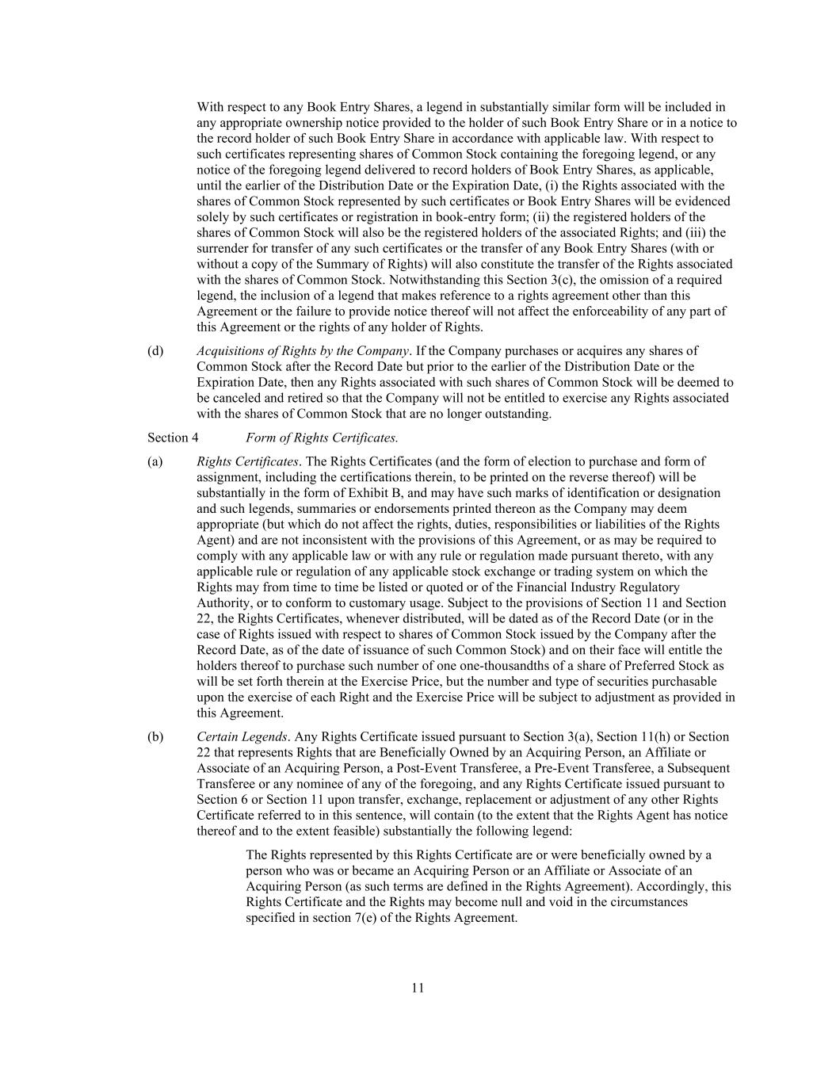
11 With respect to any Book Entry Shares, a legend in substantially similar form will be included in any appropriate ownership notice provided to the holder of such Book Entry Share or in a notice to the record holder of such Book Entry Share in accordance with applicable law. With respect to such certificates representing shares of Common Stock containing the foregoing legend, or any notice of the foregoing legend delivered to record holders of Book Entry Shares, as applicable, until the earlier of the Distribution Date or the Expiration Date, (i) the Rights associated with the shares of Common Stock represented by such certificates or Book Entry Shares will be evidenced solely by such certificates or registration in book-entry form; (ii) the registered holders of the shares of Common Stock will also be the registered holders of the associated Rights; and (iii) the surrender for transfer of any such certificates or the transfer of any Book Entry Shares (with or without a copy of the Summary of Rights) will also constitute the transfer of the Rights associated with the shares of Common Stock. Notwithstanding this Section 3(c), the omission of a required legend, the inclusion of a legend that makes reference to a rights agreement other than this Agreement or the failure to provide notice thereof will not affect the enforceability of any part of this Agreement or the rights of any holder of Rights. (d) Acquisitions of Rights by the Company. If the Company purchases or acquires any shares of Common Stock after the Record Date but prior to the earlier of the Distribution Date or the Expiration Date, then any Rights associated with such shares of Common Stock will be deemed to be canceled and retired so that the Company will not be entitled to exercise any Rights associated with the shares of Common Stock that are no longer outstanding. Section 4 Form of Rights Certificates. (a) Rights Certificates. The Rights Certificates (and the form of election to purchase and form of assignment, including the certifications therein, to be printed on the reverse thereof) will be substantially in the form of Exhibit B, and may have such marks of identification or designation and such legends, summaries or endorsements printed thereon as the Company may deem appropriate (but which do not affect the rights, duties, responsibilities or liabilities of the Rights Agent) and are not inconsistent with the provisions of this Agreement, or as may be required to comply with any applicable law or with any rule or regulation made pursuant thereto, with any applicable rule or regulation of any applicable stock exchange or trading system on which the Rights may from time to time be listed or quoted or of the Financial Industry Regulatory Authority, or to conform to customary usage. Subject to the provisions of Section 11 and Section 22, the Rights Certificates, whenever distributed, will be dated as of the Record Date (or in the case of Rights issued with respect to shares of Common Stock issued by the Company after the Record Date, as of the date of issuance of such Common Stock) and on their face will entitle the holders thereof to purchase such number of one one-thousandths of a share of Preferred Stock as will be set forth therein at the Exercise Price, but the number and type of securities purchasable upon the exercise of each Right and the Exercise Price will be subject to adjustment as provided in this Agreement. (b) Certain Legends. Any Rights Certificate issued pursuant to Section 3(a), Section 11(h) or Section 22 that represents Rights that are Beneficially Owned by an Acquiring Person, an Affiliate or Associate of an Acquiring Person, a Post-Event Transferee, a Pre-Event Transferee, a Subsequent Transferee or any nominee of any of the foregoing, and any Rights Certificate issued pursuant to Section 6 or Section 11 upon transfer, exchange, replacement or adjustment of any other Rights Certificate referred to in this sentence, will contain (to the extent that the Rights Agent has notice thereof and to the extent feasible) substantially the following legend: The Rights represented by this Rights Certificate are or were beneficially owned by a person who was or became an Acquiring Person or an Affiliate or Associate of an Acquiring Person (as such terms are defined in the Rights Agreement). Accordingly, this Rights Certificate and the Rights may become null and void in the circumstances specified in section 7(e) of the Rights Agreement.

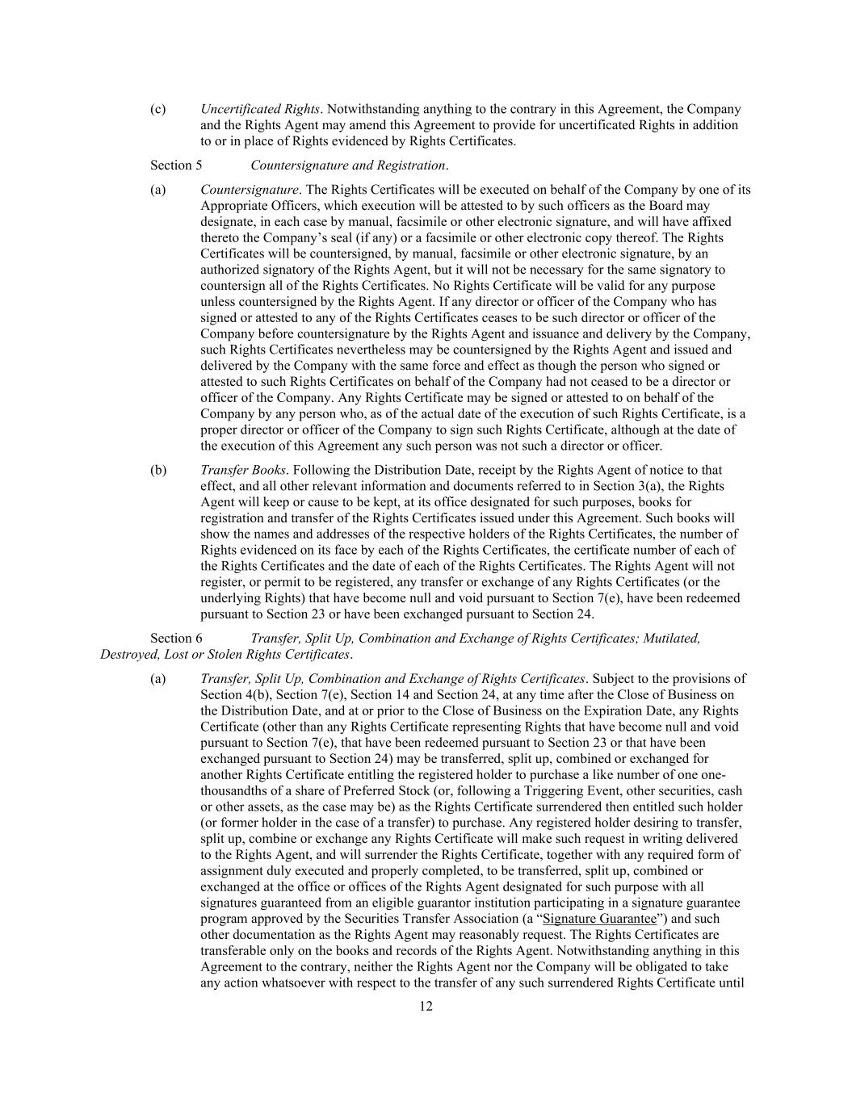
12 (c) Uncertificated Rights. Notwithstanding anything to the contrary in this Agreement, the Company and the Rights Agent may amend this Agreement to provide for uncertificated Rights in addition to or in place of Rights evidenced by Rights Certificates. Section 5 Countersignature and Registration. (a) Countersignature. The Rights Certificates will be executed on behalf of the Company by one of its Appropriate Officers, which execution will be attested to by such officers as the Board may designate, in each case by manual, facsimile or other electronic signature, and will have affixed thereto the Company’s seal (if any) or a facsimile or other electronic copy thereof. The Rights Certificates will be countersigned, by manual, facsimile or other electronic signature, by an authorized signatory of the Rights Agent, but it will not be necessary for the same signatory to countersign all of the Rights Certificates. No Rights Certificate will be valid for any purpose unless countersigned by the Rights Agent. If any director or officer of the Company who has signed or attested to any of the Rights Certificates ceases to be such director or officer of the Company before countersignature by the Rights Agent and issuance and delivery by the Company, such Rights Certificates nevertheless may be countersigned by the Rights Agent and issued and delivered by the Company with the same force and effect as though the person who signed or attested to such Rights Certificates on behalf of the Company had not ceased to be a director or officer of the Company. Any Rights Certificate may be signed or attested to on behalf of the Company by any person who, as of the actual date of the execution of such Rights Certificate, is a proper director or officer of the Company to sign such Rights Certificate, although at the date of the execution of this Agreement any such person was not such a director or officer. (b) Transfer Books. Following the Distribution Date, receipt by the Rights Agent of notice to that effect, and all other relevant information and documents referred to in Section 3(a), the Rights Agent will keep or cause to be kept, at its office designated for such purposes, books for registration and transfer of the Rights Certificates issued under this Agreement. Such books will show the names and addresses of the respective holders of the Rights Certificates, the number of Rights evidenced on its face by each of the Rights Certificates, the certificate number of each of the Rights Certificates and the date of each of the Rights Certificates. The Rights Agent will not register, or permit to be registered, any transfer or exchange of any Rights Certificates (or the underlying Rights) that have become null and void pursuant to Section 7(e), have been redeemed pursuant to Section 23 or have been exchanged pursuant to Section 24. Section 6 Transfer, Split Up, Combination and Exchange of Rights Certificates; Mutilated, Destroyed, Lost or Stolen Rights Certificates. (a) Transfer, Split Up, Combination and Exchange of Rights Certificates. Subject to the provisions of Section 4(b), Section 7(e), Section 14 and Section 24, at any time after the Close of Business on the Distribution Date, and at or prior to the Close of Business on the Expiration Date, any Rights Certificate (other than any Rights Certificate representing Rights that have become null and void pursuant to Section 7(e), that have been redeemed pursuant to Section 23 or that have been exchanged pursuant to Section 24) may be transferred, split up, combined or exchanged for another Rights Certificate entitling the registered holder to purchase a like number of one one- thousandths of a share of Preferred Stock (or, following a Triggering Event, other securities, cash or other assets, as the case may be) as the Rights Certificate surrendered then entitled such holder (or former holder in the case of a transfer) to purchase. Any registered holder desiring to transfer, split up, combine or exchange any Rights Certificate will make such request in writing delivered to the Rights Agent, and will surrender the Rights Certificate, together with any required form of assignment duly executed and properly completed, to be transferred, split up, combined or exchanged at the office or offices of the Rights Agent designated for such purpose with all signatures guaranteed from an eligible guarantor institution participating in a signature guarantee program approved by the Securities Transfer Association (a “Signature Guarantee”) and such other documentation as the Rights Agent may reasonably request. The Rights Certificates are transferable only on the books and records of the Rights Agent. Notwithstanding anything in this Agreement to the contrary, neither the Rights Agent nor the Company will be obligated to take any action whatsoever with respect to the transfer of any such surrendered Rights Certificate until

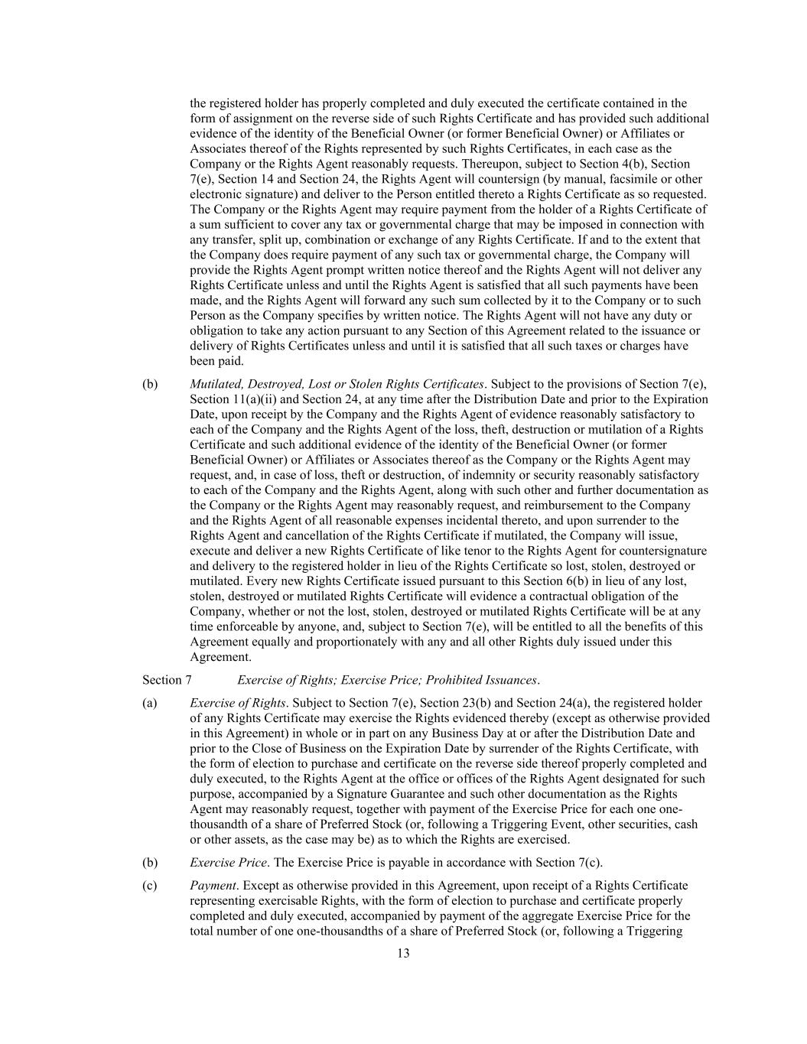
13 the registered holder has properly completed and duly executed the certificate contained in the form of assignment on the reverse side of such Rights Certificate and has provided such additional evidence of the identity of the Beneficial Owner (or former Beneficial Owner) or Affiliates or Associates thereof of the Rights represented by such Rights Certificates, in each case as the Company or the Rights Agent reasonably requests. Thereupon, subject to Section 4(b), Section 7(e), Section 14 and Section 24, the Rights Agent will countersign (by manual, facsimile or other electronic signature) and deliver to the Person entitled thereto a Rights Certificate as so requested. The Company or the Rights Agent may require payment from the holder of a Rights Certificate of a sum sufficient to cover any tax or governmental charge that may be imposed in connection with any transfer, split up, combination or exchange of any Rights Certificate. If and to the extent that the Company does require payment of any such tax or governmental charge, the Company will provide the Rights Agent prompt written notice thereof and the Rights Agent will not deliver any Rights Certificate unless and until the Rights Agent is satisfied that all such payments have been made, and the Rights Agent will forward any such sum collected by it to the Company or to such Person as the Company specifies by written notice. The Rights Agent will not have any duty or obligation to take any action pursuant to any Section of this Agreement related to the issuance or delivery of Rights Certificates unless and until it is satisfied that all such taxes or charges have been paid. (b) Mutilated, Destroyed, Lost or Stolen Rights Certificates. Subject to the provisions of Section 7(e), Section 11(a)(ii) and Section 24, at any time after the Distribution Date and prior to the Expiration Date, upon receipt by the Company and the Rights Agent of evidence reasonably satisfactory to each of the Company and the Rights Agent of the loss, theft, destruction or mutilation of a Rights Certificate and such additional evidence of the identity of the Beneficial Owner (or former Beneficial Owner) or Affiliates or Associates thereof as the Company or the Rights Agent may request, and, in case of loss, theft or destruction, of indemnity or security reasonably satisfactory to each of the Company and the Rights Agent, along with such other and further documentation as the Company or the Rights Agent may reasonably request, and reimbursement to the Company and the Rights Agent of all reasonable expenses incidental thereto, and upon surrender to the Rights Agent and cancellation of the Rights Certificate if mutilated, the Company will issue, execute and deliver a new Rights Certificate of like tenor to the Rights Agent for countersignature and delivery to the registered holder in lieu of the Rights Certificate so lost, stolen, destroyed or mutilated. Every new Rights Certificate issued pursuant to this Section 6(b) in lieu of any lost, stolen, destroyed or mutilated Rights Certificate will evidence a contractual obligation of the Company, whether or not the lost, stolen, destroyed or mutilated Rights Certificate will be at any time enforceable by anyone, and, subject to Section 7(e), will be entitled to all the benefits of this Agreement equally and proportionately with any and all other Rights duly issued under this Agreement. Section 7 Exercise of Rights; Exercise Price; Prohibited Issuances. (a) Exercise of Rights. Subject to Section 7(e), Section 23(b) and Section 24(a), the registered holder of any Rights Certificate may exercise the Rights evidenced thereby (except as otherwise provided in this Agreement) in whole or in part on any Business Day at or after the Distribution Date and prior to the Close of Business on the Expiration Date by surrender of the Rights Certificate, with the form of election to purchase and certificate on the reverse side thereof properly completed and duly executed, to the Rights Agent at the office or offices of the Rights Agent designated for such purpose, accompanied by a Signature Guarantee and such other documentation as the Rights Agent may reasonably request, together with payment of the Exercise Price for each one one- thousandth of a share of Preferred Stock (or, following a Triggering Event, other securities, cash or other assets, as the case may be) as to which the Rights are exercised. (b) Exercise Price. The Exercise Price is payable in accordance with Section 7(c). (c) Payment. Except as otherwise provided in this Agreement, upon receipt of a Rights Certificate representing exercisable Rights, with the form of election to purchase and certificate properly completed and duly executed, accompanied by payment of the aggregate Exercise Price for the total number of one one-thousandths of a share of Preferred Stock (or, following a Triggering

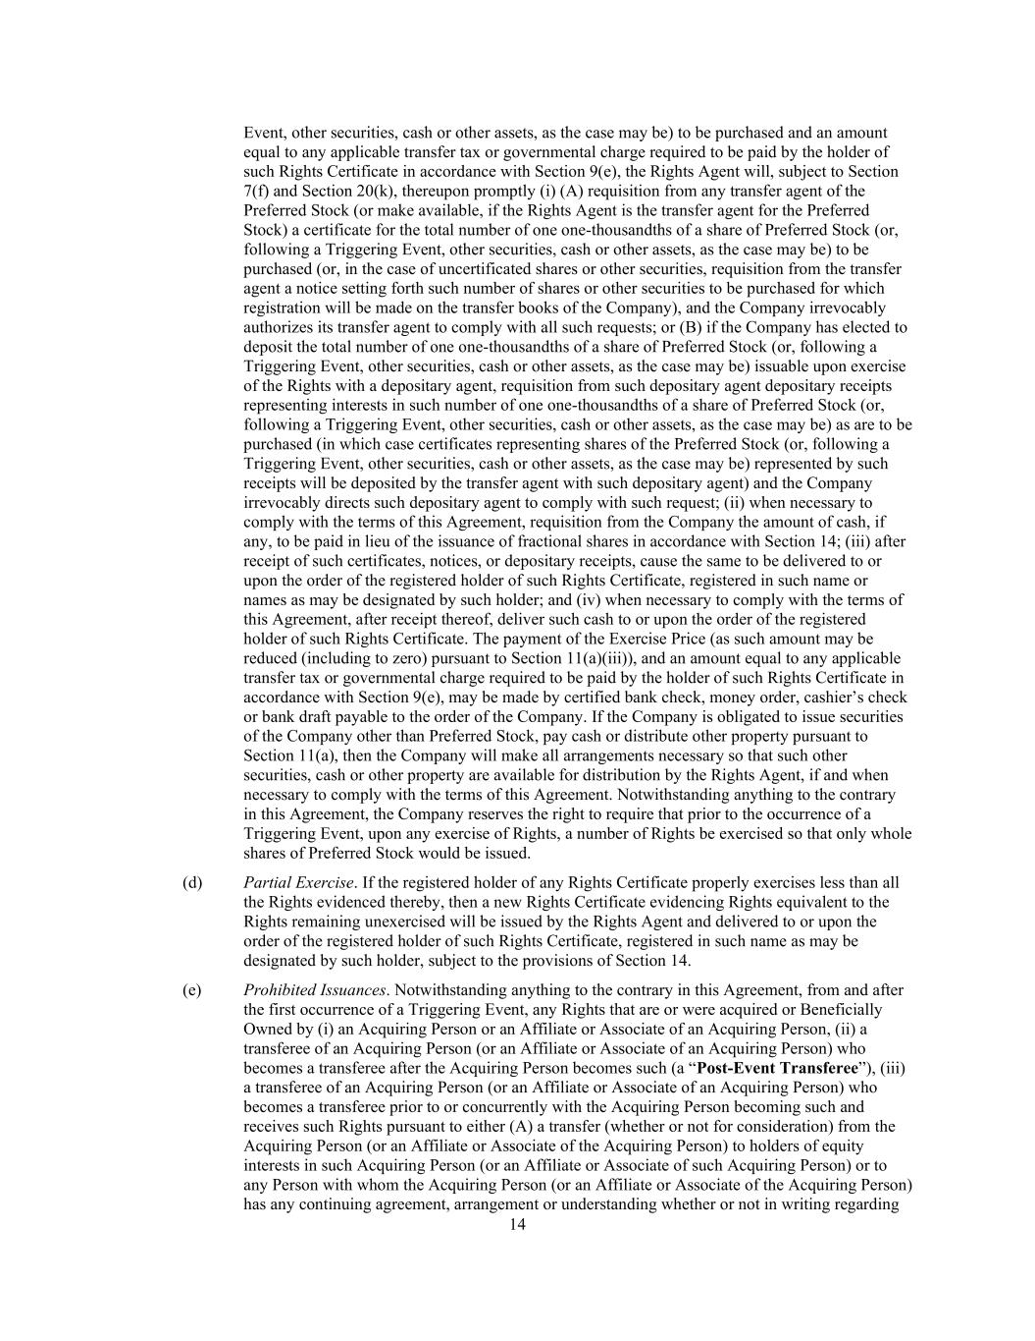
14 Event, other securities, cash or other assets, as the case may be) to be purchased and an amount equal to any applicable transfer tax or governmental charge required to be paid by the holder of such Rights Certificate in accordance with Section 9(e), the Rights Agent will, subject to Section 7(f) and Section 20(k), thereupon promptly (i) (A) requisition from any transfer agent of the Preferred Stock (or make available, if the Rights Agent is the transfer agent for the Preferred Stock) a certificate for the total number of one one-thousandths of a share of Preferred Stock (or, following a Triggering Event, other securities, cash or other assets, as the case may be) to be purchased (or, in the case of uncertificated shares or other securities, requisition from the transfer agent a notice setting forth such number of shares or other securities to be purchased for which registration will be made on the transfer books of the Company), and the Company irrevocably authorizes its transfer agent to comply with all such requests; or (B) if the Company has elected to deposit the total number of one one-thousandths of a share of Preferred Stock (or, following a Triggering Event, other securities, cash or other assets, as the case may be) issuable upon exercise of the Rights with a depositary agent, requisition from such depositary agent depositary receipts representing interests in such number of one one-thousandths of a share of Preferred Stock (or, following a Triggering Event, other securities, cash or other assets, as the case may be) as are to be purchased (in which case certificates representing shares of the Preferred Stock (or, following a Triggering Event, other securities, cash or other assets, as the case may be) represented by such receipts will be deposited by the transfer agent with such depositary agent) and the Company irrevocably directs such depositary agent to comply with such request; (ii) when necessary to comply with the terms of this Agreement, requisition from the Company the amount of cash, if any, to be paid in lieu of the issuance of fractional shares in accordance with Section 14; (iii) after receipt of such certificates, notices, or depositary receipts, cause the same to be delivered to or upon the order of the registered holder of such Rights Certificate, registered in such name or names as may be designated by such holder; and (iv) when necessary to comply with the terms of this Agreement, after receipt thereof, deliver such cash to or upon the order of the registered holder of such Rights Certificate. The payment of the Exercise Price (as such amount may be reduced (including to zero) pursuant to Section 11(a)(iii)), and an amount equal to any applicable transfer tax or governmental charge required to be paid by the holder of such Rights Certificate in accordance with Section 9(e), may be made by certified bank check, money order, cashier’s check or bank draft payable to the order of the Company. If the Company is obligated to issue securities of the Company other than Preferred Stock, pay cash or distribute other property pursuant to Section 11(a), then the Company will make all arrangements necessary so that such other securities, cash or other property are available for distribution by the Rights Agent, if and when necessary to comply with the terms of this Agreement. Notwithstanding anything to the contrary in this Agreement, the Company reserves the right to require that prior to the occurrence of a Triggering Event, upon any exercise of Rights, a number of Rights be exercised so that only whole shares of Preferred Stock would be issued. (d) Partial Exercise. If the registered holder of any Rights Certificate properly exercises less than all the Rights evidenced thereby, then a new Rights Certificate evidencing Rights equivalent to the Rights remaining unexercised will be issued by the Rights Agent and delivered to or upon the order of the registered holder of such Rights Certificate, registered in such name as may be designated by such holder, subject to the provisions of Section 14. (e) Prohibited Issuances. Notwithstanding anything to the contrary in this Agreement, from and after the first occurrence of a Triggering Event, any Rights that are or were acquired or Beneficially Owned by (i) an Acquiring Person or an Affiliate or Associate of an Acquiring Person, (ii) a transferee of an Acquiring Person (or an Affiliate or Associate of an Acquiring Person) who becomes a transferee after the Acquiring Person becomes such (a “Post-Event Transferee”), (iii) a transferee of an Acquiring Person (or an Affiliate or Associate of an Acquiring Person) who becomes a transferee prior to or concurrently with the Acquiring Person becoming such and receives such Rights pursuant to either (A) a transfer (whether or not for consideration) from the Acquiring Person (or an Affiliate or Associate of the Acquiring Person) to holders of equity interests in such Acquiring Person (or an Affiliate or Associate of such Acquiring Person) or to any Person with whom the Acquiring Person (or an Affiliate or Associate of the Acquiring Person) has any continuing agreement, arrangement or understanding whether or not in writing regarding

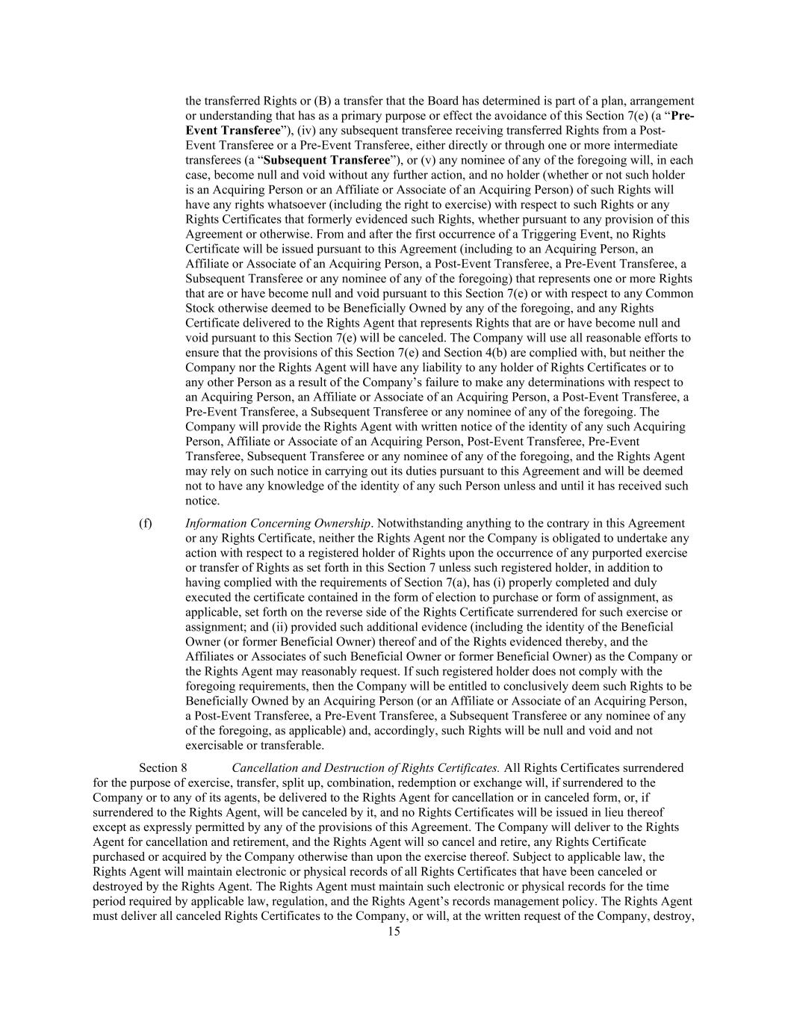
15 the transferred Rights or (B) a transfer that the Board has determined is part of a plan, arrangement or understanding that has as a primary purpose or effect the avoidance of this Section 7(e) (a “Pre- Event Transferee”), (iv) any subsequent transferee receiving transferred Rights from a Post- Event Transferee or a Pre-Event Transferee, either directly or through one or more intermediate transferees (a “Subsequent Transferee”), or (v) any nominee of any of the foregoing will, in each case, become null and void without any further action, and no holder (whether or not such holder is an Acquiring Person or an Affiliate or Associate of an Acquiring Person) of such Rights will have any rights whatsoever (including the right to exercise) with respect to such Rights or any Rights Certificates that formerly evidenced such Rights, whether pursuant to any provision of this Agreement or otherwise. From and after the first occurrence of a Triggering Event, no Rights Certificate will be issued pursuant to this Agreement (including to an Acquiring Person, an Affiliate or Associate of an Acquiring Person, a Post-Event Transferee, a Pre-Event Transferee, a Subsequent Transferee or any nominee of any of the foregoing) that represents one or more Rights that are or have become null and void pursuant to this Section 7(e) or with respect to any Common Stock otherwise deemed to be Beneficially Owned by any of the foregoing, and any Rights Certificate delivered to the Rights Agent that represents Rights that are or have become null and void pursuant to this Section 7(e) will be canceled. The Company will use all reasonable efforts to ensure that the provisions of this Section 7(e) and Section 4(b) are complied with, but neither the Company nor the Rights Agent will have any liability to any holder of Rights Certificates or to any other Person as a result of the Company’s failure to make any determinations with respect to an Acquiring Person, an Affiliate or Associate of an Acquiring Person, a Post-Event Transferee, a Pre-Event Transferee, a Subsequent Transferee or any nominee of any of the foregoing. The Company will provide the Rights Agent with written notice of the identity of any such Acquiring Person, Affiliate or Associate of an Acquiring Person, Post-Event Transferee, Pre-Event Transferee, Subsequent Transferee or any nominee of any of the foregoing, and the Rights Agent may rely on such notice in carrying out its duties pursuant to this Agreement and will be deemed not to have any knowledge of the identity of any such Person unless and until it has received such notice. (f) Information Concerning Ownership. Notwithstanding anything to the contrary in this Agreement or any Rights Certificate, neither the Rights Agent nor the Company is obligated to undertake any action with respect to a registered holder of Rights upon the occurrence of any purported exercise or transfer of Rights as set forth in this Section 7 unless such registered holder, in addition to having complied with the requirements of Section 7(a), has (i) properly completed and duly executed the certificate contained in the form of election to purchase or form of assignment, as applicable, set forth on the reverse side of the Rights Certificate surrendered for such exercise or assignment; and (ii) provided such additional evidence (including the identity of the Beneficial Owner (or former Beneficial Owner) thereof and of the Rights evidenced thereby, and the Affiliates or Associates of such Beneficial Owner or former Beneficial Owner) as the Company or the Rights Agent may reasonably request. If such registered holder does not comply with the foregoing requirements, then the Company will be entitled to conclusively deem such Rights to be Beneficially Owned by an Acquiring Person (or an Affiliate or Associate of an Acquiring Person, a Post-Event Transferee, a Pre-Event Transferee, a Subsequent Transferee or any nominee of any of the foregoing, as applicable) and, accordingly, such Rights will be null and void and not exercisable or transferable. Section 8 Cancellation and Destruction of Rights Certificates. All Rights Certificates surrendered for the purpose of exercise, transfer, split up, combination, redemption or exchange will, if surrendered to the Company or to any of its agents, be delivered to the Rights Agent for cancellation or in canceled form, or, if surrendered to the Rights Agent, will be canceled by it, and no Rights Certificates will be issued in lieu thereof except as expressly permitted by any of the provisions of this Agreement. The Company will deliver to the Rights Agent for cancellation and retirement, and the Rights Agent will so cancel and retire, any Rights Certificate purchased or acquired by the Company otherwise than upon the exercise thereof. Subject to applicable law, the Rights Agent will maintain electronic or physical records of all Rights Certificates that have been canceled or destroyed by the Rights Agent. The Rights Agent must maintain such electronic or physical records for the time period required by applicable law, regulation, and the Rights Agent’s records management policy. The Rights Agent must deliver all canceled Rights Certificates to the Company, or will, at the written request of the Company, destroy,

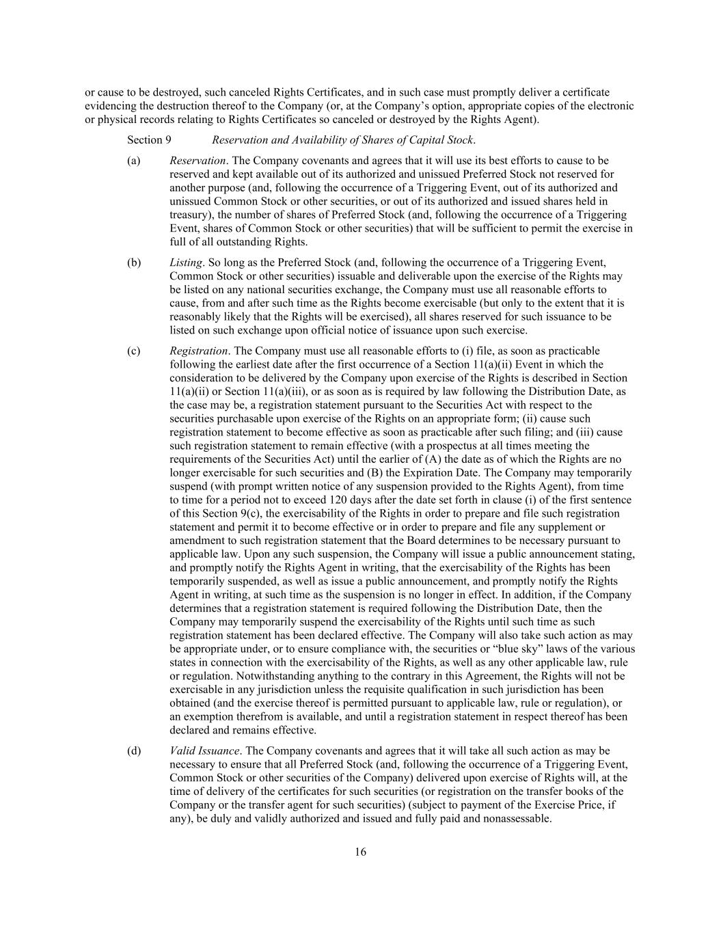
16 or cause to be destroyed, such canceled Rights Certificates, and in such case must promptly deliver a certificate evidencing the destruction thereof to the Company (or, at the Company’s option, appropriate copies of the electronic or physical records relating to Rights Certificates so canceled or destroyed by the Rights Agent). Section 9 Reservation and Availability of Shares of Capital Stock. (a) Reservation. The Company covenants and agrees that it will use its best efforts to cause to be reserved and kept available out of its authorized and unissued Preferred Stock not reserved for another purpose (and, following the occurrence of a Triggering Event, out of its authorized and unissued Common Stock or other securities, or out of its authorized and issued shares held in treasury), the number of shares of Preferred Stock (and, following the occurrence of a Triggering Event, shares of Common Stock or other securities) that will be sufficient to permit the exercise in full of all outstanding Rights. (b) Listing. So long as the Preferred Stock (and, following the occurrence of a Triggering Event, Common Stock or other securities) issuable and deliverable upon the exercise of the Rights may be listed on any national securities exchange, the Company must use all reasonable efforts to cause, from and after such time as the Rights become exercisable (but only to the extent that it is reasonably likely that the Rights will be exercised), all shares reserved for such issuance to be listed on such exchange upon official notice of issuance upon such exercise. (c) Registration. The Company must use all reasonable efforts to (i) file, as soon as practicable following the earliest date after the first occurrence of a Section 11(a)(ii) Event in which the consideration to be delivered by the Company upon exercise of the Rights is described in Section 11(a)(ii) or Section 11(a)(iii), or as soon as is required by law following the Distribution Date, as the case may be, a registration statement pursuant to the Securities Act with respect to the securities purchasable upon exercise of the Rights on an appropriate form; (ii) cause such registration statement to become effective as soon as practicable after such filing; and (iii) cause such registration statement to remain effective (with a prospectus at all times meeting the requirements of the Securities Act) until the earlier of (A) the date as of which the Rights are no longer exercisable for such securities and (B) the Expiration Date. The Company may temporarily suspend (with prompt written notice of any suspension provided to the Rights Agent), from time to time for a period not to exceed 120 days after the date set forth in clause (i) of the first sentence of this Section 9(c), the exercisability of the Rights in order to prepare and file such registration statement and permit it to become effective or in order to prepare and file any supplement or amendment to such registration statement that the Board determines to be necessary pursuant to applicable law. Upon any such suspension, the Company will issue a public announcement stating, and promptly notify the Rights Agent in writing, that the exercisability of the Rights has been temporarily suspended, as well as issue a public announcement, and promptly notify the Rights Agent in writing, at such time as the suspension is no longer in effect. In addition, if the Company determines that a registration statement is required following the Distribution Date, then the Company may temporarily suspend the exercisability of the Rights until such time as such registration statement has been declared effective. The Company will also take such action as may be appropriate under, or to ensure compliance with, the securities or “blue sky” laws of the various states in connection with the exercisability of the Rights, as well as any other applicable law, rule or regulation. Notwithstanding anything to the contrary in this Agreement, the Rights will not be exercisable in any jurisdiction unless the requisite qualification in such jurisdiction has been obtained (and the exercise thereof is permitted pursuant to applicable law, rule or regulation), or an exemption therefrom is available, and until a registration statement in respect thereof has been declared and remains effective. (d) Valid Issuance. The Company covenants and agrees that it will take all such action as may be necessary to ensure that all Preferred Stock (and, following the occurrence of a Triggering Event, Common Stock or other securities of the Company) delivered upon exercise of Rights will, at the time of delivery of the certificates for such securities (or registration on the transfer books of the Company or the transfer agent for such securities) (subject to payment of the Exercise Price, if any), be duly and validly authorized and issued and fully paid and nonassessable.

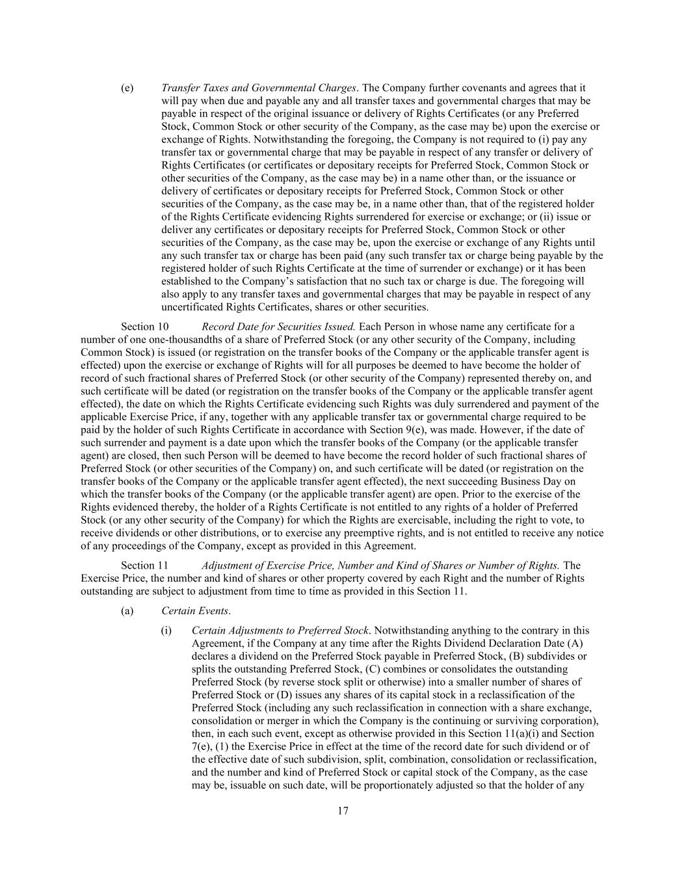
17 (e) Transfer Taxes and Governmental Charges. The Company further covenants and agrees that it will pay when due and payable any and all transfer taxes and governmental charges that may be payable in respect of the original issuance or delivery of Rights Certificates (or any Preferred Stock, Common Stock or other security of the Company, as the case may be) upon the exercise or exchange of Rights. Notwithstanding the foregoing, the Company is not required to (i) pay any transfer tax or governmental charge that may be payable in respect of any transfer or delivery of Rights Certificates (or certificates or depositary receipts for Preferred Stock, Common Stock or other securities of the Company, as the case may be) in a name other than, or the issuance or delivery of certificates or depositary receipts for Preferred Stock, Common Stock or other securities of the Company, as the case may be, in a name other than, that of the registered holder of the Rights Certificate evidencing Rights surrendered for exercise or exchange; or (ii) issue or deliver any certificates or depositary receipts for Preferred Stock, Common Stock or other securities of the Company, as the case may be, upon the exercise or exchange of any Rights until any such transfer tax or charge has been paid (any such transfer tax or charge being payable by the registered holder of such Rights Certificate at the time of surrender or exchange) or it has been established to the Company’s satisfaction that no such tax or charge is due. The foregoing will also apply to any transfer taxes and governmental charges that may be payable in respect of any uncertificated Rights Certificates, shares or other securities. Section 10 Record Date for Securities Issued. Each Person in whose name any certificate for a number of one one-thousandths of a share of Preferred Stock (or any other security of the Company, including Common Stock) is issued (or registration on the transfer books of the Company or the applicable transfer agent is effected) upon the exercise or exchange of Rights will for all purposes be deemed to have become the holder of record of such fractional shares of Preferred Stock (or other security of the Company) represented thereby on, and such certificate will be dated (or registration on the transfer books of the Company or the applicable transfer agent effected), the date on which the Rights Certificate evidencing such Rights was duly surrendered and payment of the applicable Exercise Price, if any, together with any applicable transfer tax or governmental charge required to be paid by the holder of such Rights Certificate in accordance with Section 9(e), was made. However, if the date of such surrender and payment is a date upon which the transfer books of the Company (or the applicable transfer agent) are closed, then such Person will be deemed to have become the record holder of such fractional shares of Preferred Stock (or other securities of the Company) on, and such certificate will be dated (or registration on the transfer books of the Company or the applicable transfer agent effected), the next succeeding Business Day on which the transfer books of the Company (or the applicable transfer agent) are open. Prior to the exercise of the Rights evidenced thereby, the holder of a Rights Certificate is not entitled to any rights of a holder of Preferred Stock (or any other security of the Company) for which the Rights are exercisable, including the right to vote, to receive dividends or other distributions, or to exercise any preemptive rights, and is not entitled to receive any notice of any proceedings of the Company, except as provided in this Agreement. Section 11 Adjustment of Exercise Price, Number and Kind of Shares or Number of Rights. The Exercise Price, the number and kind of shares or other property covered by each Right and the number of Rights outstanding are subject to adjustment from time to time as provided in this Section 11. (a) Certain Events. (i) Certain Adjustments to Preferred Stock. Notwithstanding anything to the contrary in this Agreement, if the Company at any time after the Rights Dividend Declaration Date (A) declares a dividend on the Preferred Stock payable in Preferred Stock, (B) subdivides or splits the outstanding Preferred Stock, (C) combines or consolidates the outstanding Preferred Stock (by reverse stock split or otherwise) into a smaller number of shares of Preferred Stock or (D) issues any shares of its capital stock in a reclassification of the Preferred Stock (including any such reclassification in connection with a share exchange, consolidation or merger in which the Company is the continuing or surviving corporation), then, in each such event, except as otherwise provided in this Section 11(a)(i) and Section 7(e), (1) the Exercise Price in effect at the time of the record date for such dividend or of the effective date of such subdivision, split, combination, consolidation or reclassification, and the number and kind of Preferred Stock or capital stock of the Company, as the case may be, issuable on such date, will be proportionately adjusted so that the holder of any

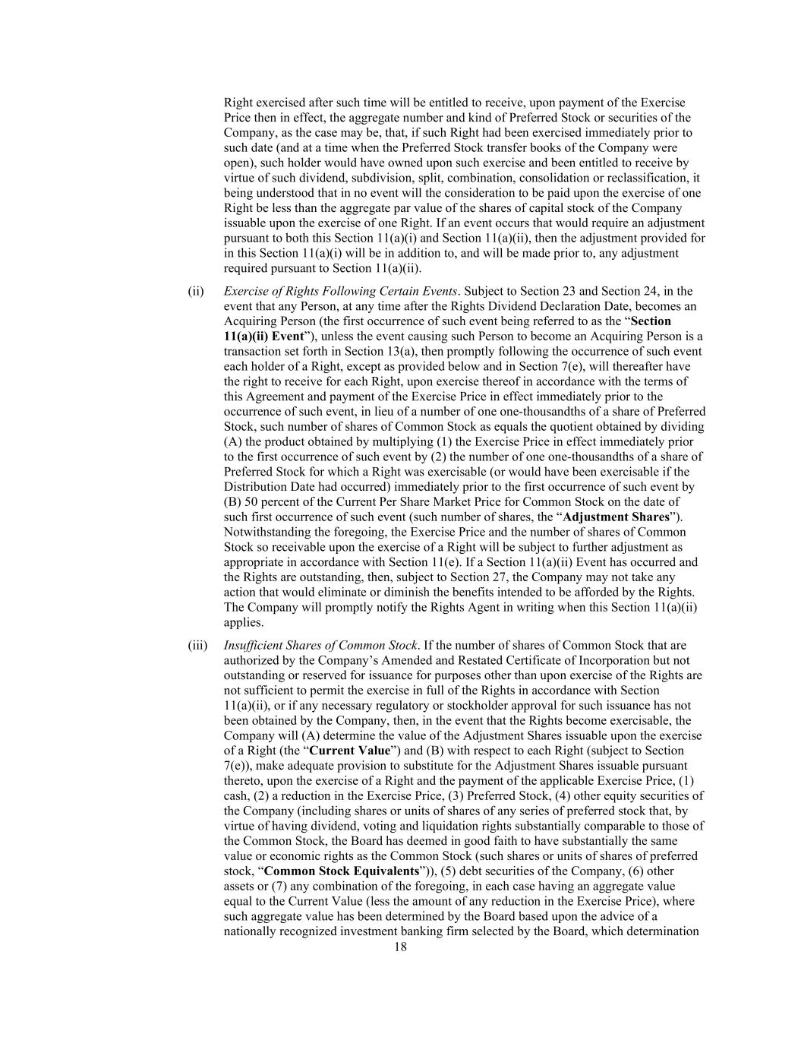
18 Right exercised after such time will be entitled to receive, upon payment of the Exercise Price then in effect, the aggregate number and kind of Preferred Stock or securities of the Company, as the case may be, that, if such Right had been exercised immediately prior to such date (and at a time when the Preferred Stock transfer books of the Company were open), such holder would have owned upon such exercise and been entitled to receive by virtue of such dividend, subdivision, split, combination, consolidation or reclassification, it being understood that in no event will the consideration to be paid upon the exercise of one Right be less than the aggregate par value of the shares of capital stock of the Company issuable upon the exercise of one Right. If an event occurs that would require an adjustment pursuant to both this Section 11(a)(i) and Section 11(a)(ii), then the adjustment provided for in this Section 11(a)(i) will be in addition to, and will be made prior to, any adjustment required pursuant to Section 11(a)(ii). (ii) Exercise of Rights Following Certain Events. Subject to Section 23 and Section 24, in the event that any Person, at any time after the Rights Dividend Declaration Date, becomes an Acquiring Person (the first occurrence of such event being referred to as the “Section 11(a)(ii) Event”), unless the event causing such Person to become an Acquiring Person is a transaction set forth in Section 13(a), then promptly following the occurrence of such event each holder of a Right, except as provided below and in Section 7(e), will thereafter have the right to receive for each Right, upon exercise thereof in accordance with the terms of this Agreement and payment of the Exercise Price in effect immediately prior to the occurrence of such event, in lieu of a number of one one-thousandths of a share of Preferred Stock, such number of shares of Common Stock as equals the quotient obtained by dividing (A) the product obtained by multiplying (1) the Exercise Price in effect immediately prior to the first occurrence of such event by (2) the number of one one-thousandths of a share of Preferred Stock for which a Right was exercisable (or would have been exercisable if the Distribution Date had occurred) immediately prior to the first occurrence of such event by (B) 50 percent of the Current Per Share Market Price for Common Stock on the date of such first occurrence of such event (such number of shares, the “Adjustment Shares”). Notwithstanding the foregoing, the Exercise Price and the number of shares of Common Stock so receivable upon the exercise of a Right will be subject to further adjustment as appropriate in accordance with Section 11(e). If a Section 11(a)(ii) Event has occurred and the Rights are outstanding, then, subject to Section 27, the Company may not take any action that would eliminate or diminish the benefits intended to be afforded by the Rights. The Company will promptly notify the Rights Agent in writing when this Section 11(a)(ii) applies. (iii) Insufficient Shares of Common Stock. If the number of shares of Common Stock that are authorized by the Company’s Amended and Restated Certificate of Incorporation but not outstanding or reserved for issuance for purposes other than upon exercise of the Rights are not sufficient to permit the exercise in full of the Rights in accordance with Section 11(a)(ii), or if any necessary regulatory or stockholder approval for such issuance has not been obtained by the Company, then, in the event that the Rights become exercisable, the Company will (A) determine the value of the Adjustment Shares issuable upon the exercise of a Right (the “Current Value”) and (B) with respect to each Right (subject to Section 7(e)), make adequate provision to substitute for the Adjustment Shares issuable pursuant thereto, upon the exercise of a Right and the payment of the applicable Exercise Price, (1) cash, (2) a reduction in the Exercise Price, (3) Preferred Stock, (4) other equity securities of the Company (including shares or units of shares of any series of preferred stock that, by virtue of having dividend, voting and liquidation rights substantially comparable to those of the Common Stock, the Board has deemed in good faith to have substantially the same value or economic rights as the Common Stock (such shares or units of shares of preferred stock, “Common Stock Equivalents”)), (5) debt securities of the Company, (6) other assets or (7) any combination of the foregoing, in each case having an aggregate value equal to the Current Value (less the amount of any reduction in the Exercise Price), where such aggregate value has been determined by the Board based upon the advice of a nationally recognized investment banking firm selected by the Board, which determination

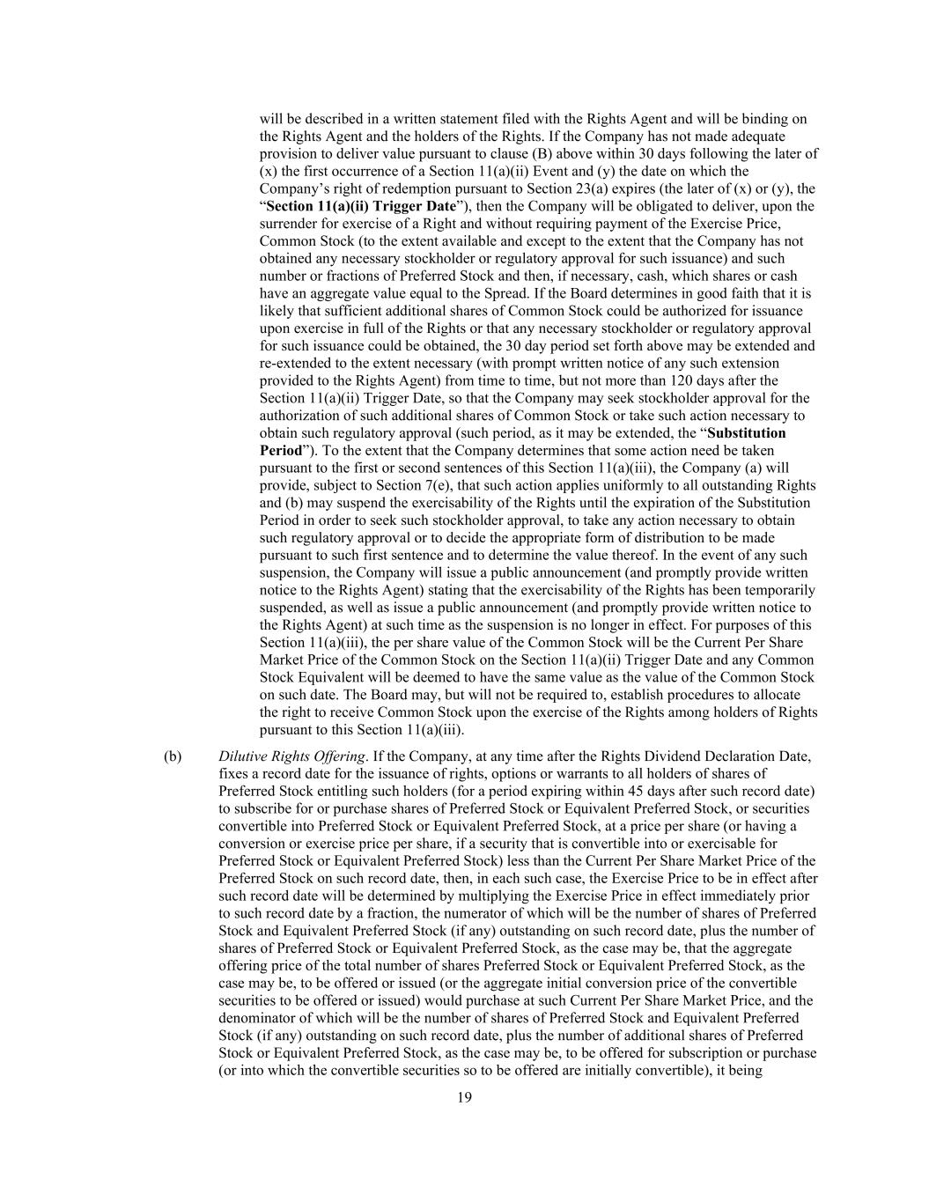
19 will be described in a written statement filed with the Rights Agent and will be binding on the Rights Agent and the holders of the Rights. If the Company has not made adequate provision to deliver value pursuant to clause (B) above within 30 days following the later of (x) the first occurrence of a Section 11(a)(ii) Event and (y) the date on which the Company’s right of redemption pursuant to Section 23(a) expires (the later of (x) or (y), the “Section 11(a)(ii) Trigger Date”), then the Company will be obligated to deliver, upon the surrender for exercise of a Right and without requiring payment of the Exercise Price, Common Stock (to the extent available and except to the extent that the Company has not obtained any necessary stockholder or regulatory approval for such issuance) and such number or fractions of Preferred Stock and then, if necessary, cash, which shares or cash have an aggregate value equal to the Spread. If the Board determines in good faith that it is likely that sufficient additional shares of Common Stock could be authorized for issuance upon exercise in full of the Rights or that any necessary stockholder or regulatory approval for such issuance could be obtained, the 30 day period set forth above may be extended and re-extended to the extent necessary (with prompt written notice of any such extension provided to the Rights Agent) from time to time, but not more than 120 days after the Section 11(a)(ii) Trigger Date, so that the Company may seek stockholder approval for the authorization of such additional shares of Common Stock or take such action necessary to obtain such regulatory approval (such period, as it may be extended, the “Substitution Period”). To the extent that the Company determines that some action need be taken pursuant to the first or second sentences of this Section 11(a)(iii), the Company (a) will provide, subject to Section 7(e), that such action applies uniformly to all outstanding Rights and (b) may suspend the exercisability of the Rights until the expiration of the Substitution Period in order to seek such stockholder approval, to take any action necessary to obtain such regulatory approval or to decide the appropriate form of distribution to be made pursuant to such first sentence and to determine the value thereof. In the event of any such suspension, the Company will issue a public announcement (and promptly provide written notice to the Rights Agent) stating that the exercisability of the Rights has been temporarily suspended, as well as issue a public announcement (and promptly provide written notice to the Rights Agent) at such time as the suspension is no longer in effect. For purposes of this Section 11(a)(iii), the per share value of the Common Stock will be the Current Per Share Market Price of the Common Stock on the Section 11(a)(ii) Trigger Date and any Common Stock Equivalent will be deemed to have the same value as the value of the Common Stock on such date. The Board may, but will not be required to, establish procedures to allocate the right to receive Common Stock upon the exercise of the Rights among holders of Rights pursuant to this Section 11(a)(iii). (b) Dilutive Rights Offering. If the Company, at any time after the Rights Dividend Declaration Date, fixes a record date for the issuance of rights, options or warrants to all holders of shares of Preferred Stock entitling such holders (for a period expiring within 45 days after such record date) to subscribe for or purchase shares of Preferred Stock or Equivalent Preferred Stock, or securities convertible into Preferred Stock or Equivalent Preferred Stock, at a price per share (or having a conversion or exercise price per share, if a security that is convertible into or exercisable for Preferred Stock or Equivalent Preferred Stock) less than the Current Per Share Market Price of the Preferred Stock on such record date, then, in each such case, the Exercise Price to be in effect after such record date will be determined by multiplying the Exercise Price in effect immediately prior to such record date by a fraction, the numerator of which will be the number of shares of Preferred Stock and Equivalent Preferred Stock (if any) outstanding on such record date, plus the number of shares of Preferred Stock or Equivalent Preferred Stock, as the case may be, that the aggregate offering price of the total number of shares Preferred Stock or Equivalent Preferred Stock, as the case may be, to be offered or issued (or the aggregate initial conversion price of the convertible securities to be offered or issued) would purchase at such Current Per Share Market Price, and the denominator of which will be the number of shares of Preferred Stock and Equivalent Preferred Stock (if any) outstanding on such record date, plus the number of additional shares of Preferred Stock or Equivalent Preferred Stock, as the case may be, to be offered for subscription or purchase (or into which the convertible securities so to be offered are initially convertible), it being

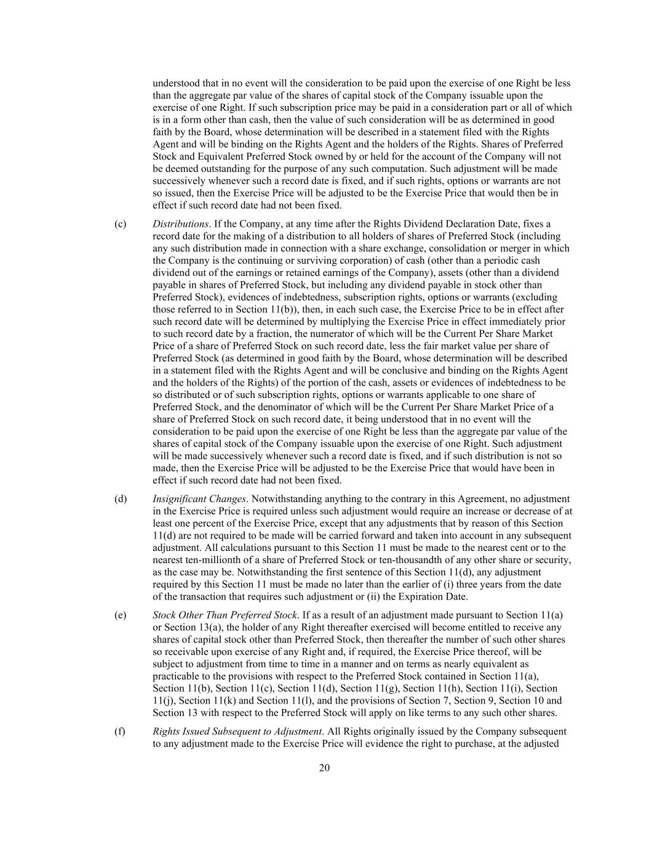
20 understood that in no event will the consideration to be paid upon the exercise of one Right be less than the aggregate par value of the shares of capital stock of the Company issuable upon the exercise of one Right. If such subscription price may be paid in a consideration part or all of which is in a form other than cash, then the value of such consideration will be as determined in good faith by the Board, whose determination will be described in a statement filed with the Rights Agent and will be binding on the Rights Agent and the holders of the Rights. Shares of Preferred Stock and Equivalent Preferred Stock owned by or held for the account of the Company will not be deemed outstanding for the purpose of any such computation. Such adjustment will be made successively whenever such a record date is fixed, and if such rights, options or warrants are not so issued, then the Exercise Price will be adjusted to be the Exercise Price that would then be in effect if such record date had not been fixed. (c) Distributions. If the Company, at any time after the Rights Dividend Declaration Date, fixes a record date for the making of a distribution to all holders of shares of Preferred Stock (including any such distribution made in connection with a share exchange, consolidation or merger in which the Company is the continuing or surviving corporation) of cash (other than a periodic cash dividend out of the earnings or retained earnings of the Company), assets (other than a dividend payable in shares of Preferred Stock, but including any dividend payable in stock other than Preferred Stock), evidences of indebtedness, subscription rights, options or warrants (excluding those referred to in Section 11(b)), then, in each such case, the Exercise Price to be in effect after such record date will be determined by multiplying the Exercise Price in effect immediately prior to such record date by a fraction, the numerator of which will be the Current Per Share Market Price of a share of Preferred Stock on such record date, less the fair market value per share of Preferred Stock (as determined in good faith by the Board, whose determination will be described in a statement filed with the Rights Agent and will be conclusive and binding on the Rights Agent and the holders of the Rights) of the portion of the cash, assets or evidences of indebtedness to be so distributed or of such subscription rights, options or warrants applicable to one share of Preferred Stock, and the denominator of which will be the Current Per Share Market Price of a share of Preferred Stock on such record date, it being understood that in no event will the consideration to be paid upon the exercise of one Right be less than the aggregate par value of the shares of capital stock of the Company issuable upon the exercise of one Right. Such adjustment will be made successively whenever such a record date is fixed, and if such distribution is not so made, then the Exercise Price will be adjusted to be the Exercise Price that would have been in effect if such record date had not been fixed. (d) Insignificant Changes. Notwithstanding anything to the contrary in this Agreement, no adjustment in the Exercise Price is required unless such adjustment would require an increase or decrease of at least one percent of the Exercise Price, except that any adjustments that by reason of this Section 11(d) are not required to be made will be carried forward and taken into account in any subsequent adjustment. All calculations pursuant to this Section 11 must be made to the nearest cent or to the nearest ten-millionth of a share of Preferred Stock or ten-thousandth of any other share or security, as the case may be. Notwithstanding the first sentence of this Section 11(d), any adjustment required by this Section 11 must be made no later than the earlier of (i) three years from the date of the transaction that requires such adjustment or (ii) the Expiration Date. (e) Stock Other Than Preferred Stock. If as a result of an adjustment made pursuant to Section 11(a) or Section 13(a), the holder of any Right thereafter exercised will become entitled to receive any shares of capital stock other than Preferred Stock, then thereafter the number of such other shares so receivable upon exercise of any Right and, if required, the Exercise Price thereof, will be subject to adjustment from time to time in a manner and on terms as nearly equivalent as practicable to the provisions with respect to the Preferred Stock contained in Section 11(a), Section 11(b), Section 11(c), Section 11(d), Section 11(g), Section 11(h), Section 11(i), Section 11(j), Section 11(k) and Section 11(l), and the provisions of Section 7, Section 9, Section 10 and Section 13 with respect to the Preferred Stock will apply on like terms to any such other shares. (f) Rights Issued Subsequent to Adjustment. All Rights originally issued by the Company subsequent to any adjustment made to the Exercise Price will evidence the right to purchase, at the adjusted

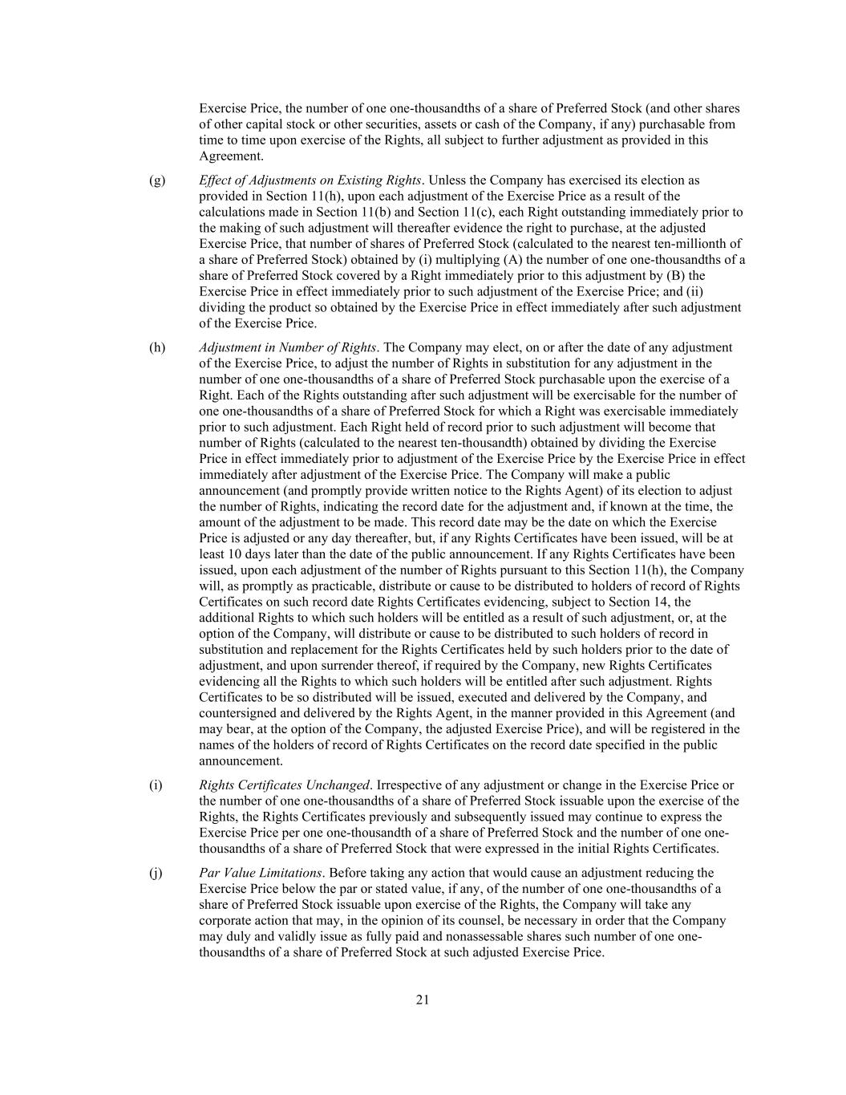
21 Exercise Price, the number of one one-thousandths of a share of Preferred Stock (and other shares of other capital stock or other securities, assets or cash of the Company, if any) purchasable from time to time upon exercise of the Rights, all subject to further adjustment as provided in this Agreement. (g) Effect of Adjustments on Existing Rights. Unless the Company has exercised its election as provided in Section 11(h), upon each adjustment of the Exercise Price as a result of the calculations made in Section 11(b) and Section 11(c), each Right outstanding immediately prior to the making of such adjustment will thereafter evidence the right to purchase, at the adjusted Exercise Price, that number of shares of Preferred Stock (calculated to the nearest ten-millionth of a share of Preferred Stock) obtained by (i) multiplying (A) the number of one one-thousandths of a share of Preferred Stock covered by a Right immediately prior to this adjustment by (B) the Exercise Price in effect immediately prior to such adjustment of the Exercise Price; and (ii) dividing the product so obtained by the Exercise Price in effect immediately after such adjustment of the Exercise Price. (h) Adjustment in Number of Rights. The Company may elect, on or after the date of any adjustment of the Exercise Price, to adjust the number of Rights in substitution for any adjustment in the number of one one-thousandths of a share of Preferred Stock purchasable upon the exercise of a Right. Each of the Rights outstanding after such adjustment will be exercisable for the number of one one-thousandths of a share of Preferred Stock for which a Right was exercisable immediately prior to such adjustment. Each Right held of record prior to such adjustment will become that number of Rights (calculated to the nearest ten-thousandth) obtained by dividing the Exercise Price in effect immediately prior to adjustment of the Exercise Price by the Exercise Price in effect immediately after adjustment of the Exercise Price. The Company will make a public announcement (and promptly provide written notice to the Rights Agent) of its election to adjust the number of Rights, indicating the record date for the adjustment and, if known at the time, the amount of the adjustment to be made. This record date may be the date on which the Exercise Price is adjusted or any day thereafter, but, if any Rights Certificates have been issued, will be at least 10 days later than the date of the public announcement. If any Rights Certificates have been issued, upon each adjustment of the number of Rights pursuant to this Section 11(h), the Company will, as promptly as practicable, distribute or cause to be distributed to holders of record of Rights Certificates on such record date Rights Certificates evidencing, subject to Section 14, the additional Rights to which such holders will be entitled as a result of such adjustment, or, at the option of the Company, will distribute or cause to be distributed to such holders of record in substitution and replacement for the Rights Certificates held by such holders prior to the date of adjustment, and upon surrender thereof, if required by the Company, new Rights Certificates evidencing all the Rights to which such holders will be entitled after such adjustment. Rights Certificates to be so distributed will be issued, executed and delivered by the Company, and countersigned and delivered by the Rights Agent, in the manner provided in this Agreement (and may bear, at the option of the Company, the adjusted Exercise Price), and will be registered in the names of the holders of record of Rights Certificates on the record date specified in the public announcement. (i) Rights Certificates Unchanged. Irrespective of any adjustment or change in the Exercise Price or the number of one one-thousandths of a share of Preferred Stock issuable upon the exercise of the Rights, the Rights Certificates previously and subsequently issued may continue to express the Exercise Price per one one-thousandth of a share of Preferred Stock and the number of one one- thousandths of a share of Preferred Stock that were expressed in the initial Rights Certificates. (j) Par Value Limitations. Before taking any action that would cause an adjustment reducing the Exercise Price below the par or stated value, if any, of the number of one one-thousandths of a share of Preferred Stock issuable upon exercise of the Rights, the Company will take any corporate action that may, in the opinion of its counsel, be necessary in order that the Company may duly and validly issue as fully paid and nonassessable shares such number of one one- thousandths of a share of Preferred Stock at such adjusted Exercise Price.

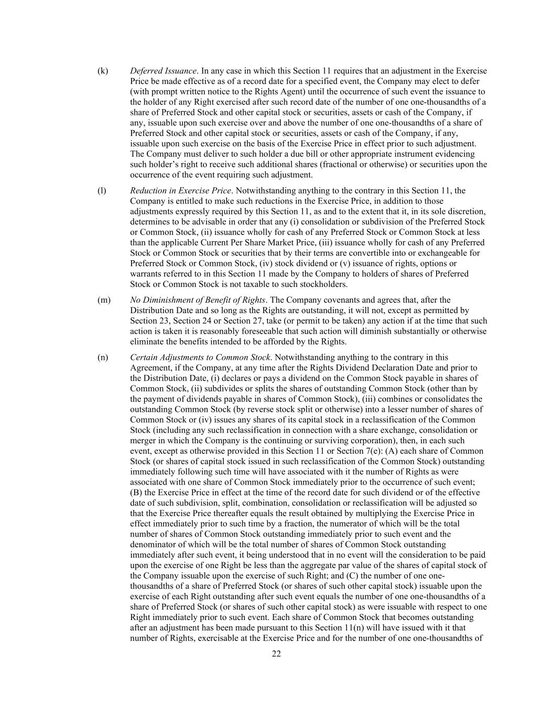
22 (k) Deferred Issuance. In any case in which this Section 11 requires that an adjustment in the Exercise Price be made effective as of a record date for a specified event, the Company may elect to defer (with prompt written notice to the Rights Agent) until the occurrence of such event the issuance to the holder of any Right exercised after such record date of the number of one one-thousandths of a share of Preferred Stock and other capital stock or securities, assets or cash of the Company, if any, issuable upon such exercise over and above the number of one one-thousandths of a share of Preferred Stock and other capital stock or securities, assets or cash of the Company, if any, issuable upon such exercise on the basis of the Exercise Price in effect prior to such adjustment. The Company must deliver to such holder a due bill or other appropriate instrument evidencing such holder’s right to receive such additional shares (fractional or otherwise) or securities upon the occurrence of the event requiring such adjustment. (l) Reduction in Exercise Price. Notwithstanding anything to the contrary in this Section 11, the Company is entitled to make such reductions in the Exercise Price, in addition to those adjustments expressly required by this Section 11, as and to the extent that it, in its sole discretion, determines to be advisable in order that any (i) consolidation or subdivision of the Preferred Stock or Common Stock, (ii) issuance wholly for cash of any Preferred Stock or Common Stock at less than the applicable Current Per Share Market Price, (iii) issuance wholly for cash of any Preferred Stock or Common Stock or securities that by their terms are convertible into or exchangeable for Preferred Stock or Common Stock, (iv) stock dividend or (v) issuance of rights, options or warrants referred to in this Section 11 made by the Company to holders of shares of Preferred Stock or Common Stock is not taxable to such stockholders. (m) No Diminishment of Benefit of Rights. The Company covenants and agrees that, after the Distribution Date and so long as the Rights are outstanding, it will not, except as permitted by Section 23, Section 24 or Section 27, take (or permit to be taken) any action if at the time that such action is taken it is reasonably foreseeable that such action will diminish substantially or otherwise eliminate the benefits intended to be afforded by the Rights. (n) Certain Adjustments to Common Stock. Notwithstanding anything to the contrary in this Agreement, if the Company, at any time after the Rights Dividend Declaration Date and prior to the Distribution Date, (i) declares or pays a dividend on the Common Stock payable in shares of Common Stock, (ii) subdivides or splits the shares of outstanding Common Stock (other than by the payment of dividends payable in shares of Common Stock), (iii) combines or consolidates the outstanding Common Stock (by reverse stock split or otherwise) into a lesser number of shares of Common Stock or (iv) issues any shares of its capital stock in a reclassification of the Common Stock (including any such reclassification in connection with a share exchange, consolidation or merger in which the Company is the continuing or surviving corporation), then, in each such event, except as otherwise provided in this Section 11 or Section 7(e): (A) each share of Common Stock (or shares of capital stock issued in such reclassification of the Common Stock) outstanding immediately following such time will have associated with it the number of Rights as were associated with one share of Common Stock immediately prior to the occurrence of such event; (B) the Exercise Price in effect at the time of the record date for such dividend or of the effective date of such subdivision, split, combination, consolidation or reclassification will be adjusted so that the Exercise Price thereafter equals the result obtained by multiplying the Exercise Price in effect immediately prior to such time by a fraction, the numerator of which will be the total number of shares of Common Stock outstanding immediately prior to such event and the denominator of which will be the total number of shares of Common Stock outstanding immediately after such event, it being understood that in no event will the consideration to be paid upon the exercise of one Right be less than the aggregate par value of the shares of capital stock of the Company issuable upon the exercise of such Right; and (C) the number of one one- thousandths of a share of Preferred Stock (or shares of such other capital stock) issuable upon the exercise of each Right outstanding after such event equals the number of one one-thousandths of a share of Preferred Stock (or shares of such other capital stock) as were issuable with respect to one Right immediately prior to such event. Each share of Common Stock that becomes outstanding after an adjustment has been made pursuant to this Section 11(n) will have issued with it that number of Rights, exercisable at the Exercise Price and for the number of one one-thousandths of

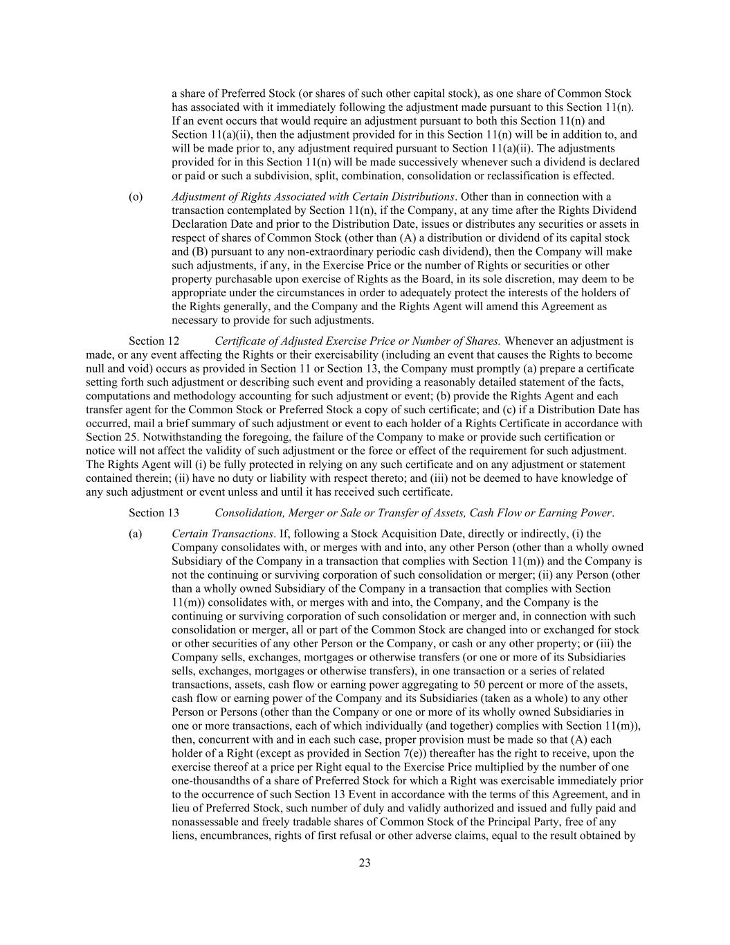
23 a share of Preferred Stock (or shares of such other capital stock), as one share of Common Stock has associated with it immediately following the adjustment made pursuant to this Section 11(n). If an event occurs that would require an adjustment pursuant to both this Section 11(n) and Section 11(a)(ii), then the adjustment provided for in this Section 11(n) will be in addition to, and will be made prior to, any adjustment required pursuant to Section 11(a)(ii). The adjustments provided for in this Section 11(n) will be made successively whenever such a dividend is declared or paid or such a subdivision, split, combination, consolidation or reclassification is effected. (o) Adjustment of Rights Associated with Certain Distributions. Other than in connection with a transaction contemplated by Section 11(n), if the Company, at any time after the Rights Dividend Declaration Date and prior to the Distribution Date, issues or distributes any securities or assets in respect of shares of Common Stock (other than (A) a distribution or dividend of its capital stock and (B) pursuant to any non-extraordinary periodic cash dividend), then the Company will make such adjustments, if any, in the Exercise Price or the number of Rights or securities or other property purchasable upon exercise of Rights as the Board, in its sole discretion, may deem to be appropriate under the circumstances in order to adequately protect the interests of the holders of the Rights generally, and the Company and the Rights Agent will amend this Agreement as necessary to provide for such adjustments. Section 12 Certificate of Adjusted Exercise Price or Number of Shares. Whenever an adjustment is made, or any event affecting the Rights or their exercisability (including an event that causes the Rights to become null and void) occurs as provided in Section 11 or Section 13, the Company must promptly (a) prepare a certificate setting forth such adjustment or describing such event and providing a reasonably detailed statement of the facts, computations and methodology accounting for such adjustment or event; (b) provide the Rights Agent and each transfer agent for the Common Stock or Preferred Stock a copy of such certificate; and (c) if a Distribution Date has occurred, mail a brief summary of such adjustment or event to each holder of a Rights Certificate in accordance with Section 25. Notwithstanding the foregoing, the failure of the Company to make or provide such certification or notice will not affect the validity of such adjustment or the force or effect of the requirement for such adjustment. The Rights Agent will (i) be fully protected in relying on any such certificate and on any adjustment or statement contained therein; (ii) have no duty or liability with respect thereto; and (iii) not be deemed to have knowledge of any such adjustment or event unless and until it has received such certificate. Section 13 Consolidation, Merger or Sale or Transfer of Assets, Cash Flow or Earning Power. (a) Certain Transactions. If, following a Stock Acquisition Date, directly or indirectly, (i) the Company consolidates with, or merges with and into, any other Person (other than a wholly owned Subsidiary of the Company in a transaction that complies with Section 11(m)) and the Company is not the continuing or surviving corporation of such consolidation or merger; (ii) any Person (other than a wholly owned Subsidiary of the Company in a transaction that complies with Section 11(m)) consolidates with, or merges with and into, the Company, and the Company is the continuing or surviving corporation of such consolidation or merger and, in connection with such consolidation or merger, all or part of the Common Stock are changed into or exchanged for stock or other securities of any other Person or the Company, or cash or any other property; or (iii) the Company sells, exchanges, mortgages or otherwise transfers (or one or more of its Subsidiaries sells, exchanges, mortgages or otherwise transfers), in one transaction or a series of related transactions, assets, cash flow or earning power aggregating to 50 percent or more of the assets, cash flow or earning power of the Company and its Subsidiaries (taken as a whole) to any other Person or Persons (other than the Company or one or more of its wholly owned Subsidiaries in one or more transactions, each of which individually (and together) complies with Section 11(m)), then, concurrent with and in each such case, proper provision must be made so that (A) each holder of a Right (except as provided in Section 7(e)) thereafter has the right to receive, upon the exercise thereof at a price per Right equal to the Exercise Price multiplied by the number of one one-thousandths of a share of Preferred Stock for which a Right was exercisable immediately prior to the occurrence of such Section 13 Event in accordance with the terms of this Agreement, and in lieu of Preferred Stock, such number of duly and validly authorized and issued and fully paid and nonassessable and freely tradable shares of Common Stock of the Principal Party, free of any liens, encumbrances, rights of first refusal or other adverse claims, equal to the result obtained by

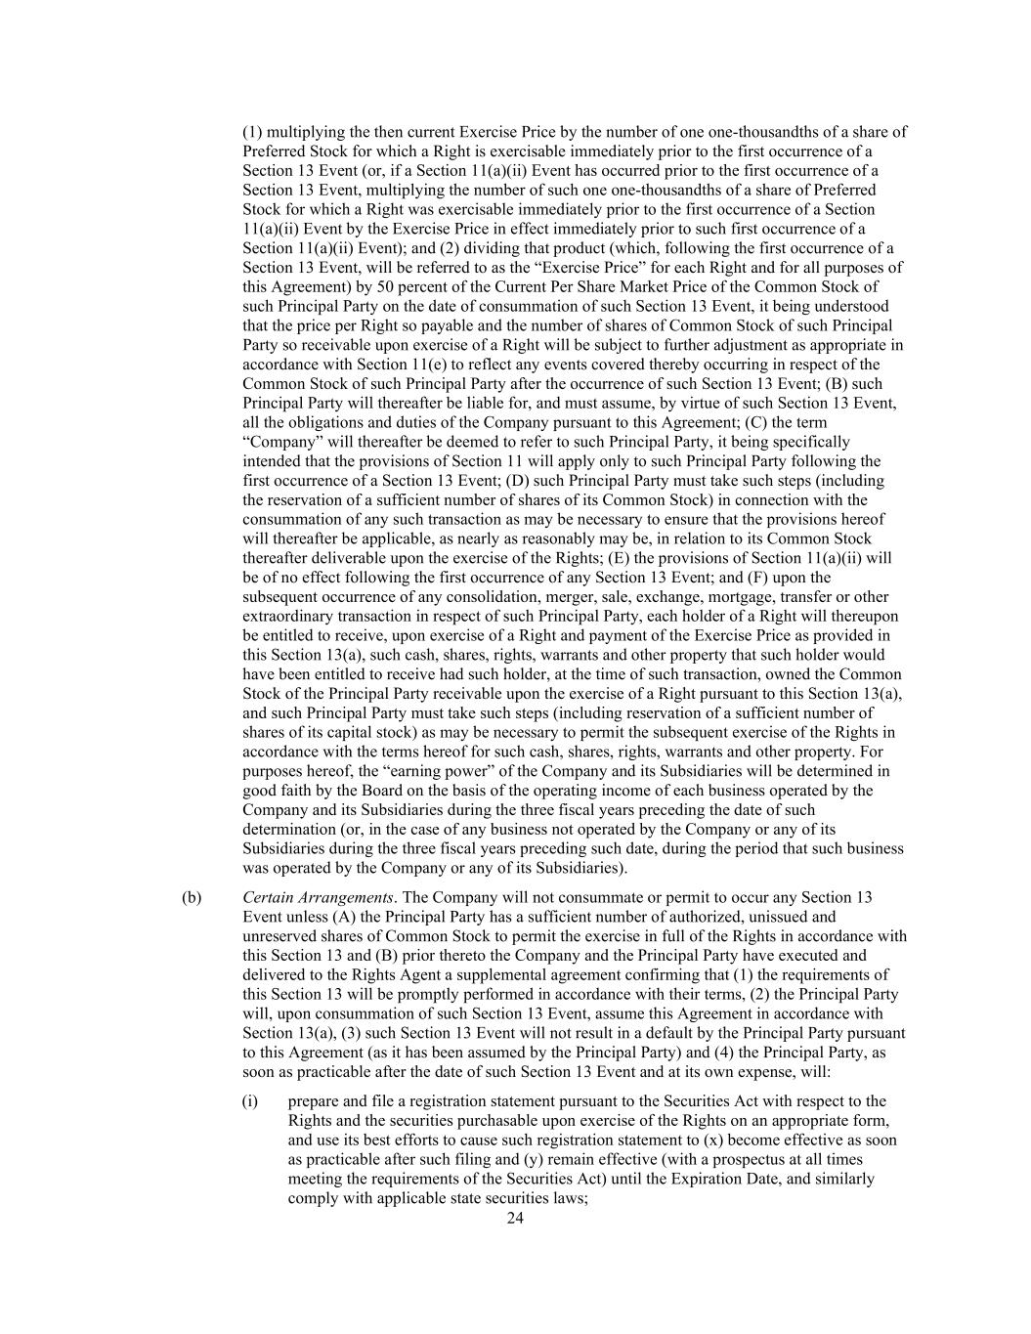
24 (1) multiplying the then current Exercise Price by the number of one one-thousandths of a share of Preferred Stock for which a Right is exercisable immediately prior to the first occurrence of a Section 13 Event (or, if a Section 11(a)(ii) Event has occurred prior to the first occurrence of a Section 13 Event, multiplying the number of such one one-thousandths of a share of Preferred Stock for which a Right was exercisable immediately prior to the first occurrence of a Section 11(a)(ii) Event by the Exercise Price in effect immediately prior to such first occurrence of a Section 11(a)(ii) Event); and (2) dividing that product (which, following the first occurrence of a Section 13 Event, will be referred to as the “Exercise Price” for each Right and for all purposes of this Agreement) by 50 percent of the Current Per Share Market Price of the Common Stock of such Principal Party on the date of consummation of such Section 13 Event, it being understood that the price per Right so payable and the number of shares of Common Stock of such Principal Party so receivable upon exercise of a Right will be subject to further adjustment as appropriate in accordance with Section 11(e) to reflect any events covered thereby occurring in respect of the Common Stock of such Principal Party after the occurrence of such Section 13 Event; (B) such Principal Party will thereafter be liable for, and must assume, by virtue of such Section 13 Event, all the obligations and duties of the Company pursuant to this Agreement; (C) the term “Company” will thereafter be deemed to refer to such Principal Party, it being specifically intended that the provisions of Section 11 will apply only to such Principal Party following the first occurrence of a Section 13 Event; (D) such Principal Party must take such steps (including the reservation of a sufficient number of shares of its Common Stock) in connection with the consummation of any such transaction as may be necessary to ensure that the provisions hereof will thereafter be applicable, as nearly as reasonably may be, in relation to its Common Stock thereafter deliverable upon the exercise of the Rights; (E) the provisions of Section 11(a)(ii) will be of no effect following the first occurrence of any Section 13 Event; and (F) upon the subsequent occurrence of any consolidation, merger, sale, exchange, mortgage, transfer or other extraordinary transaction in respect of such Principal Party, each holder of a Right will thereupon be entitled to receive, upon exercise of a Right and payment of the Exercise Price as provided in this Section 13(a), such cash, shares, rights, warrants and other property that such holder would have been entitled to receive had such holder, at the time of such transaction, owned the Common Stock of the Principal Party receivable upon the exercise of a Right pursuant to this Section 13(a), and such Principal Party must take such steps (including reservation of a sufficient number of shares of its capital stock) as may be necessary to permit the subsequent exercise of the Rights in accordance with the terms hereof for such cash, shares, rights, warrants and other property. For purposes hereof, the “earning power” of the Company and its Subsidiaries will be determined in good faith by the Board on the basis of the operating income of each business operated by the Company and its Subsidiaries during the three fiscal years preceding the date of such determination (or, in the case of any business not operated by the Company or any of its Subsidiaries during the three fiscal years preceding such date, during the period that such business was operated by the Company or any of its Subsidiaries). (b) Certain Arrangements. The Company will not consummate or permit to occur any Section 13 Event unless (A) the Principal Party has a sufficient number of authorized, unissued and unreserved shares of Common Stock to permit the exercise in full of the Rights in accordance with this Section 13 and (B) prior thereto the Company and the Principal Party have executed and delivered to the Rights Agent a supplemental agreement confirming that (1) the requirements of this Section 13 will be promptly performed in accordance with their terms, (2) the Principal Party will, upon consummation of such Section 13 Event, assume this Agreement in accordance with Section 13(a), (3) such Section 13 Event will not result in a default by the Principal Party pursuant to this Agreement (as it has been assumed by the Principal Party) and (4) the Principal Party, as soon as practicable after the date of such Section 13 Event and at its own expense, will: (i) prepare and file a registration statement pursuant to the Securities Act with respect to the Rights and the securities purchasable upon exercise of the Rights on an appropriate form, and use its best efforts to cause such registration statement to (x) become effective as soon as practicable after such filing and (y) remain effective (with a prospectus at all times meeting the requirements of the Securities Act) until the Expiration Date, and similarly comply with applicable state securities laws;

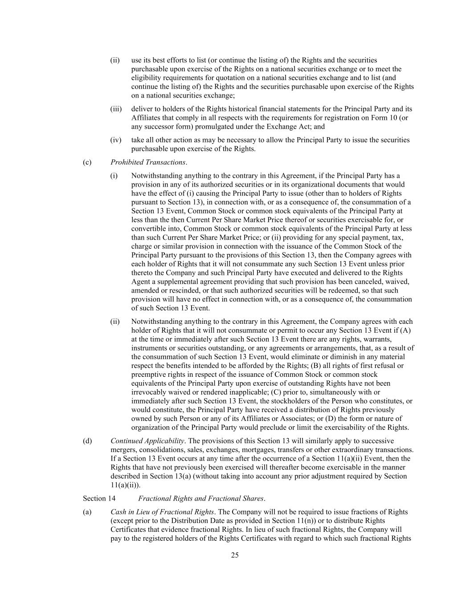
25 (ii) use its best efforts to list (or continue the listing of) the Rights and the securities purchasable upon exercise of the Rights on a national securities exchange or to meet the eligibility requirements for quotation on a national securities exchange and to list (and continue the listing of) the Rights and the securities purchasable upon exercise of the Rights on a national securities exchange; (iii) deliver to holders of the Rights historical financial statements for the Principal Party and its Affiliates that comply in all respects with the requirements for registration on Form 10 (or any successor form) promulgated under the Exchange Act; and (iv) take all other action as may be necessary to allow the Principal Party to issue the securities purchasable upon exercise of the Rights. (c) Prohibited Transactions. (i) Notwithstanding anything to the contrary in this Agreement, if the Principal Party has a provision in any of its authorized securities or in its organizational documents that would have the effect of (i) causing the Principal Party to issue (other than to holders of Rights pursuant to Section 13), in connection with, or as a consequence of, the consummation of a Section 13 Event, Common Stock or common stock equivalents of the Principal Party at less than the then Current Per Share Market Price thereof or securities exercisable for, or convertible into, Common Stock or common stock equivalents of the Principal Party at less than such Current Per Share Market Price; or (ii) providing for any special payment, tax, charge or similar provision in connection with the issuance of the Common Stock of the Principal Party pursuant to the provisions of this Section 13, then the Company agrees with each holder of Rights that it will not consummate any such Section 13 Event unless prior thereto the Company and such Principal Party have executed and delivered to the Rights Agent a supplemental agreement providing that such provision has been canceled, waived, amended or rescinded, or that such authorized securities will be redeemed, so that such provision will have no effect in connection with, or as a consequence of, the consummation of such Section 13 Event. (ii) Notwithstanding anything to the contrary in this Agreement, the Company agrees with each holder of Rights that it will not consummate or permit to occur any Section 13 Event if (A) at the time or immediately after such Section 13 Event there are any rights, warrants, instruments or securities outstanding, or any agreements or arrangements, that, as a result of the consummation of such Section 13 Event, would eliminate or diminish in any material respect the benefits intended to be afforded by the Rights; (B) all rights of first refusal or preemptive rights in respect of the issuance of Common Stock or common stock equivalents of the Principal Party upon exercise of outstanding Rights have not been irrevocably waived or rendered inapplicable; (C) prior to, simultaneously with or immediately after such Section 13 Event, the stockholders of the Person who constitutes, or would constitute, the Principal Party have received a distribution of Rights previously owned by such Person or any of its Affiliates or Associates; or (D) the form or nature of organization of the Principal Party would preclude or limit the exercisability of the Rights. (d) Continued Applicability. The provisions of this Section 13 will similarly apply to successive mergers, consolidations, sales, exchanges, mortgages, transfers or other extraordinary transactions. If a Section 13 Event occurs at any time after the occurrence of a Section 11(a)(ii) Event, then the Rights that have not previously been exercised will thereafter become exercisable in the manner described in Section 13(a) (without taking into account any prior adjustment required by Section 11(a)(ii)). Section 14 Fractional Rights and Fractional Shares. (a) Cash in Lieu of Fractional Rights. The Company will not be required to issue fractions of Rights (except prior to the Distribution Date as provided in Section 11(n)) or to distribute Rights Certificates that evidence fractional Rights. In lieu of such fractional Rights, the Company will pay to the registered holders of the Rights Certificates with regard to which such fractional Rights

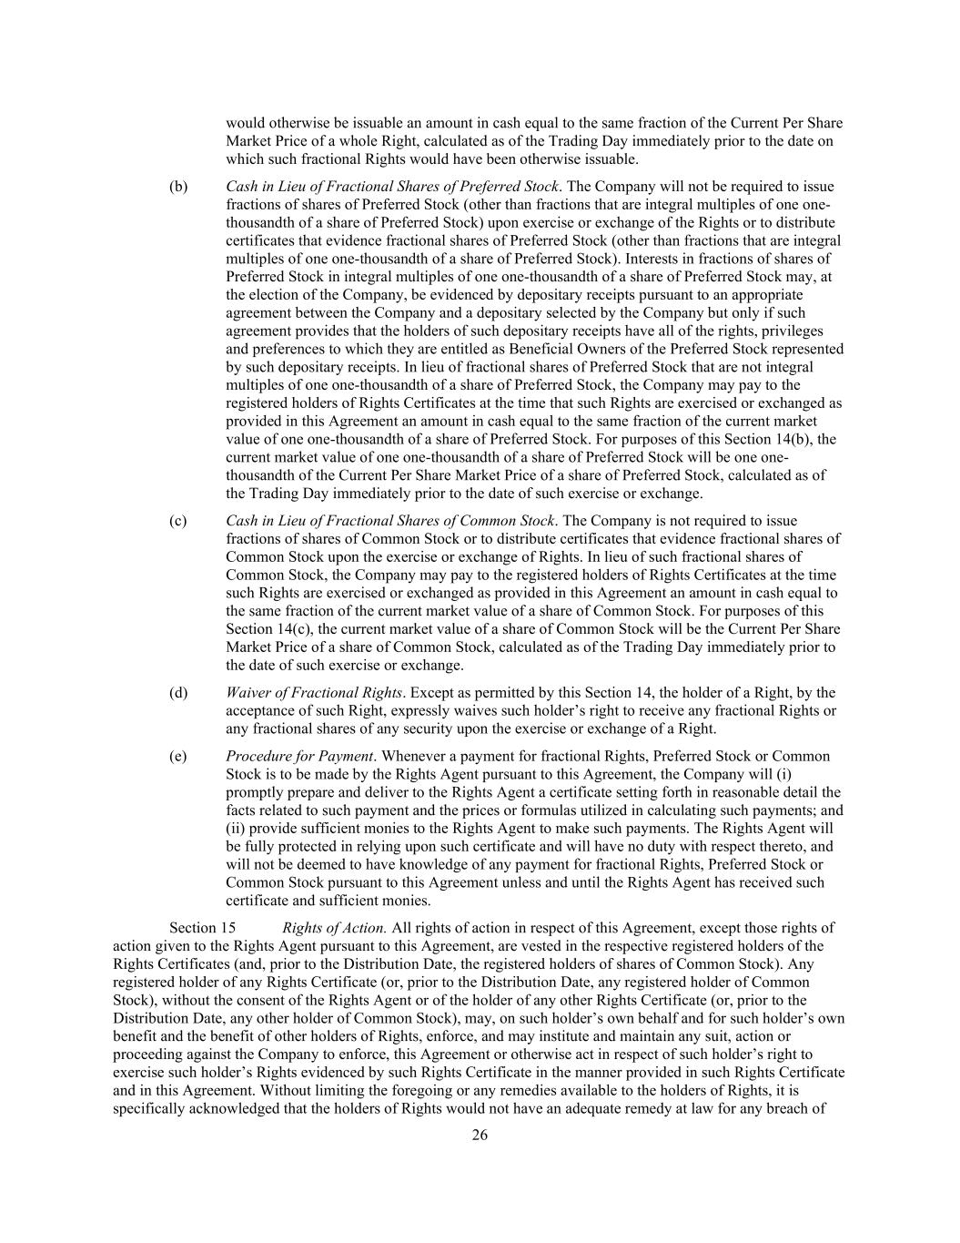
26 would otherwise be issuable an amount in cash equal to the same fraction of the Current Per Share Market Price of a whole Right, calculated as of the Trading Day immediately prior to the date on which such fractional Rights would have been otherwise issuable. (b) Cash in Lieu of Fractional Shares of Preferred Stock. The Company will not be required to issue fractions of shares of Preferred Stock (other than fractions that are integral multiples of one one- thousandth of a share of Preferred Stock) upon exercise or exchange of the Rights or to distribute certificates that evidence fractional shares of Preferred Stock (other than fractions that are integral multiples of one one-thousandth of a share of Preferred Stock). Interests in fractions of shares of Preferred Stock in integral multiples of one one-thousandth of a share of Preferred Stock may, at the election of the Company, be evidenced by depositary receipts pursuant to an appropriate agreement between the Company and a depositary selected by the Company but only if such agreement provides that the holders of such depositary receipts have all of the rights, privileges and preferences to which they are entitled as Beneficial Owners of the Preferred Stock represented by such depositary receipts. In lieu of fractional shares of Preferred Stock that are not integral multiples of one one-thousandth of a share of Preferred Stock, the Company may pay to the registered holders of Rights Certificates at the time that such Rights are exercised or exchanged as provided in this Agreement an amount in cash equal to the same fraction of the current market value of one one-thousandth of a share of Preferred Stock. For purposes of this Section 14(b), the current market value of one one-thousandth of a share of Preferred Stock will be one one- thousandth of the Current Per Share Market Price of a share of Preferred Stock, calculated as of the Trading Day immediately prior to the date of such exercise or exchange. (c) Cash in Lieu of Fractional Shares of Common Stock. The Company is not required to issue fractions of shares of Common Stock or to distribute certificates that evidence fractional shares of Common Stock upon the exercise or exchange of Rights. In lieu of such fractional shares of Common Stock, the Company may pay to the registered holders of Rights Certificates at the time such Rights are exercised or exchanged as provided in this Agreement an amount in cash equal to the same fraction of the current market value of a share of Common Stock. For purposes of this Section 14(c), the current market value of a share of Common Stock will be the Current Per Share Market Price of a share of Common Stock, calculated as of the Trading Day immediately prior to the date of such exercise or exchange. (d) Waiver of Fractional Rights. Except as permitted by this Section 14, the holder of a Right, by the acceptance of such Right, expressly waives such holder’s right to receive any fractional Rights or any fractional shares of any security upon the exercise or exchange of a Right. (e) Procedure for Payment. Whenever a payment for fractional Rights, Preferred Stock or Common Stock is to be made by the Rights Agent pursuant to this Agreement, the Company will (i) promptly prepare and deliver to the Rights Agent a certificate setting forth in reasonable detail the facts related to such payment and the prices or formulas utilized in calculating such payments; and (ii) provide sufficient monies to the Rights Agent to make such payments. The Rights Agent will be fully protected in relying upon such certificate and will have no duty with respect thereto, and will not be deemed to have knowledge of any payment for fractional Rights, Preferred Stock or Common Stock pursuant to this Agreement unless and until the Rights Agent has received such certificate and sufficient monies. Section 15 Rights of Action. All rights of action in respect of this Agreement, except those rights of action given to the Rights Agent pursuant to this Agreement, are vested in the respective registered holders of the Rights Certificates (and, prior to the Distribution Date, the registered holders of shares of Common Stock). Any registered holder of any Rights Certificate (or, prior to the Distribution Date, any registered holder of Common Stock), without the consent of the Rights Agent or of the holder of any other Rights Certificate (or, prior to the Distribution Date, any other holder of Common Stock), may, on such holder’s own behalf and for such holder’s own benefit and the benefit of other holders of Rights, enforce, and may institute and maintain any suit, action or proceeding against the Company to enforce, this Agreement or otherwise act in respect of such holder’s right to exercise such holder’s Rights evidenced by such Rights Certificate in the manner provided in such Rights Certificate and in this Agreement. Without limiting the foregoing or any remedies available to the holders of Rights, it is specifically acknowledged that the holders of Rights would not have an adequate remedy at law for any breach of

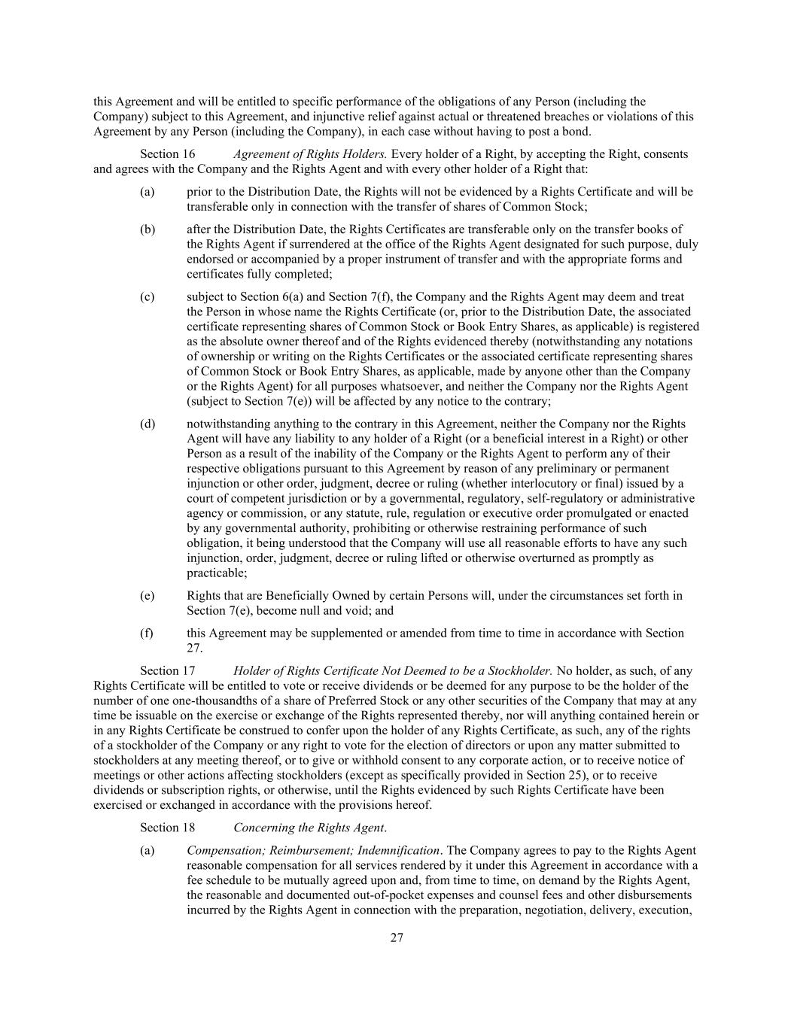
27 this Agreement and will be entitled to specific performance of the obligations of any Person (including the Company) subject to this Agreement, and injunctive relief against actual or threatened breaches or violations of this Agreement by any Person (including the Company), in each case without having to post a bond. Section 16 Agreement of Rights Holders. Every holder of a Right, by accepting the Right, consents and agrees with the Company and the Rights Agent and with every other holder of a Right that: (a) prior to the Distribution Date, the Rights will not be evidenced by a Rights Certificate and will be transferable only in connection with the transfer of shares of Common Stock; (b) after the Distribution Date, the Rights Certificates are transferable only on the transfer books of the Rights Agent if surrendered at the office of the Rights Agent designated for such purpose, duly endorsed or accompanied by a proper instrument of transfer and with the appropriate forms and certificates fully completed; (c) subject to Section 6(a) and Section 7(f), the Company and the Rights Agent may deem and treat the Person in whose name the Rights Certificate (or, prior to the Distribution Date, the associated certificate representing shares of Common Stock or Book Entry Shares, as applicable) is registered as the absolute owner thereof and of the Rights evidenced thereby (notwithstanding any notations of ownership or writing on the Rights Certificates or the associated certificate representing shares of Common Stock or Book Entry Shares, as applicable, made by anyone other than the Company or the Rights Agent) for all purposes whatsoever, and neither the Company nor the Rights Agent (subject to Section 7(e)) will be affected by any notice to the contrary; (d) notwithstanding anything to the contrary in this Agreement, neither the Company nor the Rights Agent will have any liability to any holder of a Right (or a beneficial interest in a Right) or other Person as a result of the inability of the Company or the Rights Agent to perform any of their respective obligations pursuant to this Agreement by reason of any preliminary or permanent injunction or other order, judgment, decree or ruling (whether interlocutory or final) issued by a court of competent jurisdiction or by a governmental, regulatory, self-regulatory or administrative agency or commission, or any statute, rule, regulation or executive order promulgated or enacted by any governmental authority, prohibiting or otherwise restraining performance of such obligation, it being understood that the Company will use all reasonable efforts to have any such injunction, order, judgment, decree or ruling lifted or otherwise overturned as promptly as practicable; (e) Rights that are Beneficially Owned by certain Persons will, under the circumstances set forth in Section 7(e), become null and void; and (f) this Agreement may be supplemented or amended from time to time in accordance with Section 27. Section 17 Holder of Rights Certificate Not Deemed to be a Stockholder. No holder, as such, of any Rights Certificate will be entitled to vote or receive dividends or be deemed for any purpose to be the holder of the number of one one-thousandths of a share of Preferred Stock or any other securities of the Company that may at any time be issuable on the exercise or exchange of the Rights represented thereby, nor will anything contained herein or in any Rights Certificate be construed to confer upon the holder of any Rights Certificate, as such, any of the rights of a stockholder of the Company or any right to vote for the election of directors or upon any matter submitted to stockholders at any meeting thereof, or to give or withhold consent to any corporate action, or to receive notice of meetings or other actions affecting stockholders (except as specifically provided in Section 25), or to receive dividends or subscription rights, or otherwise, until the Rights evidenced by such Rights Certificate have been exercised or exchanged in accordance with the provisions hereof. Section 18 Concerning the Rights Agent. (a) Compensation; Reimbursement; Indemnification. The Company agrees to pay to the Rights Agent reasonable compensation for all services rendered by it under this Agreement in accordance with a fee schedule to be mutually agreed upon and, from time to time, on demand by the Rights Agent, the reasonable and documented out-of-pocket expenses and counsel fees and other disbursements incurred by the Rights Agent in connection with the preparation, negotiation, delivery, execution,

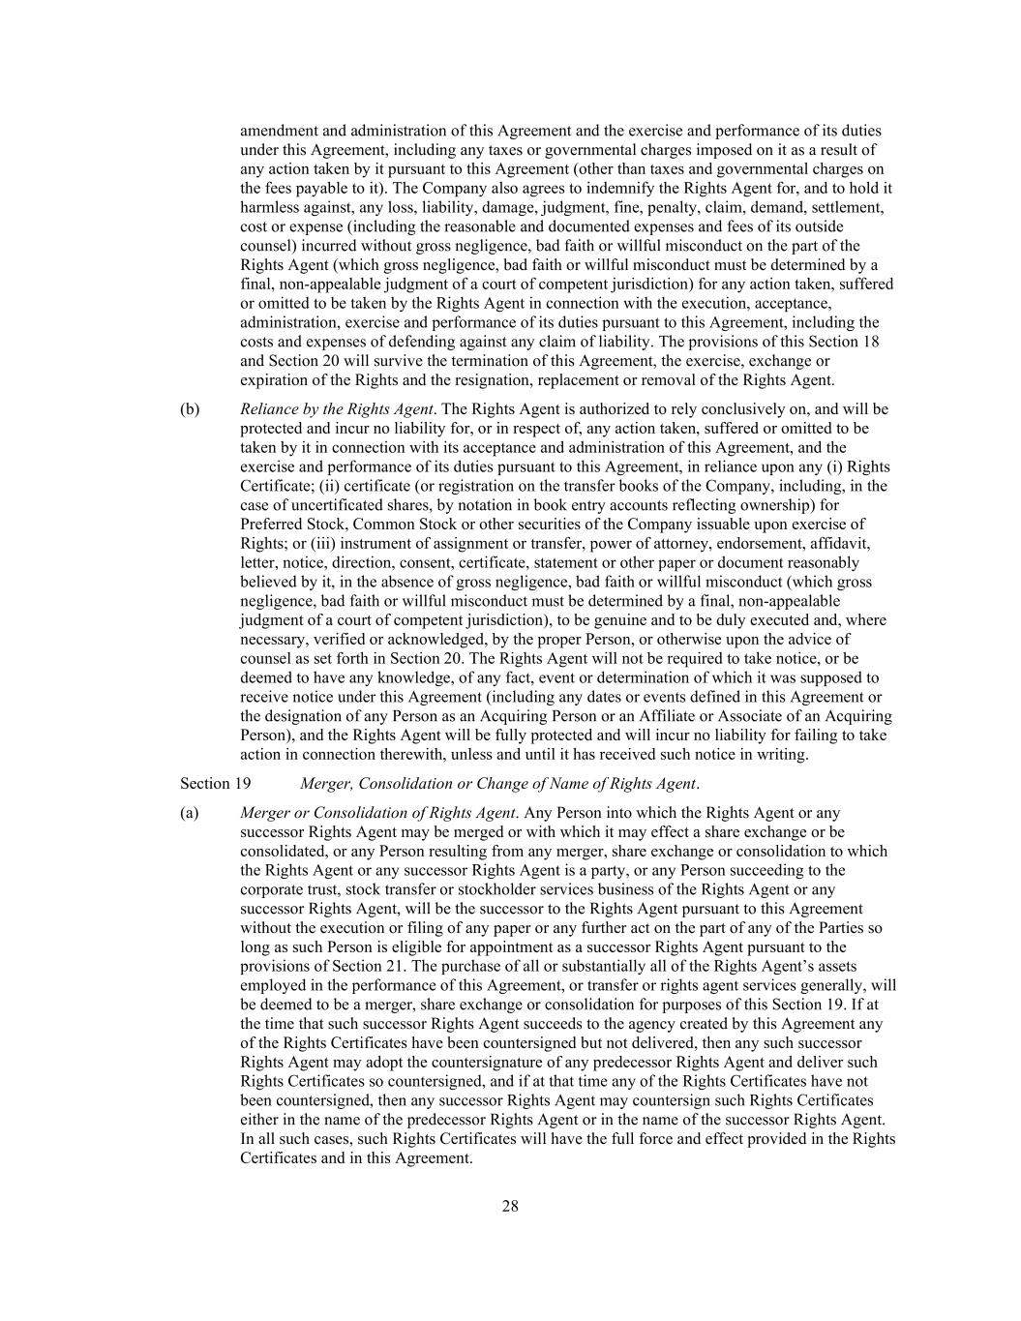
28 amendment and administration of this Agreement and the exercise and performance of its duties under this Agreement, including any taxes or governmental charges imposed on it as a result of any action taken by it pursuant to this Agreement (other than taxes and governmental charges on the fees payable to it). The Company also agrees to indemnify the Rights Agent for, and to hold it harmless against, any loss, liability, damage, judgment, fine, penalty, claim, demand, settlement, cost or expense (including the reasonable and documented expenses and fees of its outside counsel) incurred without gross negligence, bad faith or willful misconduct on the part of the Rights Agent (which gross negligence, bad faith or willful misconduct must be determined by a final, non-appealable judgment of a court of competent jurisdiction) for any action taken, suffered or omitted to be taken by the Rights Agent in connection with the execution, acceptance, administration, exercise and performance of its duties pursuant to this Agreement, including the costs and expenses of defending against any claim of liability. The provisions of this Section 18 and Section 20 will survive the termination of this Agreement, the exercise, exchange or expiration of the Rights and the resignation, replacement or removal of the Rights Agent. (b) Reliance by the Rights Agent. The Rights Agent is authorized to rely conclusively on, and will be protected and incur no liability for, or in respect of, any action taken, suffered or omitted to be taken by it in connection with its acceptance and administration of this Agreement, and the exercise and performance of its duties pursuant to this Agreement, in reliance upon any (i) Rights Certificate; (ii) certificate (or registration on the transfer books of the Company, including, in the case of uncertificated shares, by notation in book entry accounts reflecting ownership) for Preferred Stock, Common Stock or other securities of the Company issuable upon exercise of Rights; or (iii) instrument of assignment or transfer, power of attorney, endorsement, affidavit, letter, notice, direction, consent, certificate, statement or other paper or document reasonably believed by it, in the absence of gross negligence, bad faith or willful misconduct (which gross negligence, bad faith or willful misconduct must be determined by a final, non-appealable judgment of a court of competent jurisdiction), to be genuine and to be duly executed and, where necessary, verified or acknowledged, by the proper Person, or otherwise upon the advice of counsel as set forth in Section 20. The Rights Agent will not be required to take notice, or be deemed to have any knowledge, of any fact, event or determination of which it was supposed to receive notice under this Agreement (including any dates or events defined in this Agreement or the designation of any Person as an Acquiring Person or an Affiliate or Associate of an Acquiring Person), and the Rights Agent will be fully protected and will incur no liability for failing to take action in connection therewith, unless and until it has received such notice in writing. Section 19 Merger, Consolidation or Change of Name of Rights Agent. (a) Merger or Consolidation of Rights Agent. Any Person into which the Rights Agent or any successor Rights Agent may be merged or with which it may effect a share exchange or be consolidated, or any Person resulting from any merger, share exchange or consolidation to which the Rights Agent or any successor Rights Agent is a party, or any Person succeeding to the corporate trust, stock transfer or stockholder services business of the Rights Agent or any successor Rights Agent, will be the successor to the Rights Agent pursuant to this Agreement without the execution or filing of any paper or any further act on the part of any of the Parties so long as such Person is eligible for appointment as a successor Rights Agent pursuant to the provisions of Section 21. The purchase of all or substantially all of the Rights Agent’s assets employed in the performance of this Agreement, or transfer or rights agent services generally, will be deemed to be a merger, share exchange or consolidation for purposes of this Section 19. If at the time that such successor Rights Agent succeeds to the agency created by this Agreement any of the Rights Certificates have been countersigned but not delivered, then any such successor Rights Agent may adopt the countersignature of any predecessor Rights Agent and deliver such Rights Certificates so countersigned, and if at that time any of the Rights Certificates have not been countersigned, then any successor Rights Agent may countersign such Rights Certificates either in the name of the predecessor Rights Agent or in the name of the successor Rights Agent. In all such cases, such Rights Certificates will have the full force and effect provided in the Rights Certificates and in this Agreement.

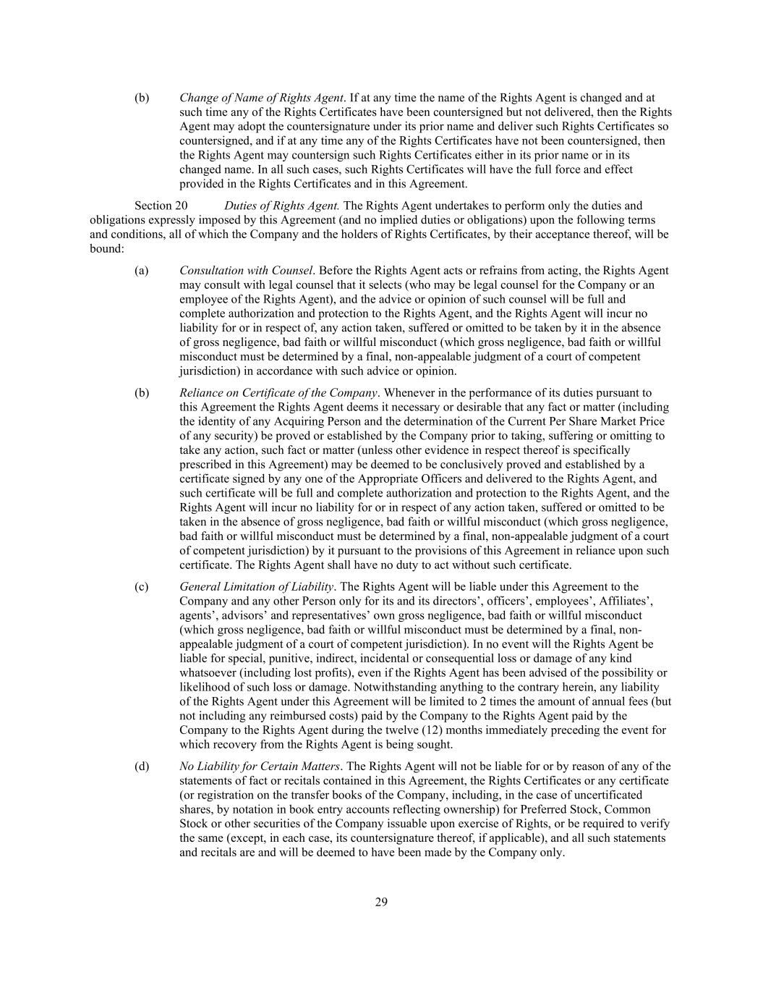
29 (b) Change of Name of Rights Agent. If at any time the name of the Rights Agent is changed and at such time any of the Rights Certificates have been countersigned but not delivered, then the Rights Agent may adopt the countersignature under its prior name and deliver such Rights Certificates so countersigned, and if at any time any of the Rights Certificates have not been countersigned, then the Rights Agent may countersign such Rights Certificates either in its prior name or in its changed name. In all such cases, such Rights Certificates will have the full force and effect provided in the Rights Certificates and in this Agreement. Section 20 Duties of Rights Agent. The Rights Agent undertakes to perform only the duties and obligations expressly imposed by this Agreement (and no implied duties or obligations) upon the following terms and conditions, all of which the Company and the holders of Rights Certificates, by their acceptance thereof, will be bound: (a) Consultation with Counsel. Before the Rights Agent acts or refrains from acting, the Rights Agent may consult with legal counsel that it selects (who may be legal counsel for the Company or an employee of the Rights Agent), and the advice or opinion of such counsel will be full and complete authorization and protection to the Rights Agent, and the Rights Agent will incur no liability for or in respect of, any action taken, suffered or omitted to be taken by it in the absence of gross negligence, bad faith or willful misconduct (which gross negligence, bad faith or willful misconduct must be determined by a final, non-appealable judgment of a court of competent jurisdiction) in accordance with such advice or opinion. (b) Reliance on Certificate of the Company. Whenever in the performance of its duties pursuant to this Agreement the Rights Agent deems it necessary or desirable that any fact or matter (including the identity of any Acquiring Person and the determination of the Current Per Share Market Price of any security) be proved or established by the Company prior to taking, suffering or omitting to take any action, such fact or matter (unless other evidence in respect thereof is specifically prescribed in this Agreement) may be deemed to be conclusively proved and established by a certificate signed by any one of the Appropriate Officers and delivered to the Rights Agent, and such certificate will be full and complete authorization and protection to the Rights Agent, and the Rights Agent will incur no liability for or in respect of any action taken, suffered or omitted to be taken in the absence of gross negligence, bad faith or willful misconduct (which gross negligence, bad faith or willful misconduct must be determined by a final, non-appealable judgment of a court of competent jurisdiction) by it pursuant to the provisions of this Agreement in reliance upon such certificate. The Rights Agent shall have no duty to act without such certificate. (c) General Limitation of Liability. The Rights Agent will be liable under this Agreement to the Company and any other Person only for its and its directors’, officers’, employees’, Affiliates’, agents’, advisors’ and representatives’ own gross negligence, bad faith or willful misconduct (which gross negligence, bad faith or willful misconduct must be determined by a final, non- appealable judgment of a court of competent jurisdiction). In no event will the Rights Agent be liable for special, punitive, indirect, incidental or consequential loss or damage of any kind whatsoever (including lost profits), even if the Rights Agent has been advised of the possibility or likelihood of such loss or damage. Notwithstanding anything to the contrary herein, any liability of the Rights Agent under this Agreement will be limited to 2 times the amount of annual fees (but not including any reimbursed costs) paid by the Company to the Rights Agent paid by the Company to the Rights Agent during the twelve (12) months immediately preceding the event for which recovery from the Rights Agent is being sought. (d) No Liability for Certain Matters. The Rights Agent will not be liable for or by reason of any of the statements of fact or recitals contained in this Agreement, the Rights Certificates or any certificate (or registration on the transfer books of the Company, including, in the case of uncertificated shares, by notation in book entry accounts reflecting ownership) for Preferred Stock, Common Stock or other securities of the Company issuable upon exercise of Rights, or be required to verify the same (except, in each case, its countersignature thereof, if applicable), and all such statements and recitals are and will be deemed to have been made by the Company only.

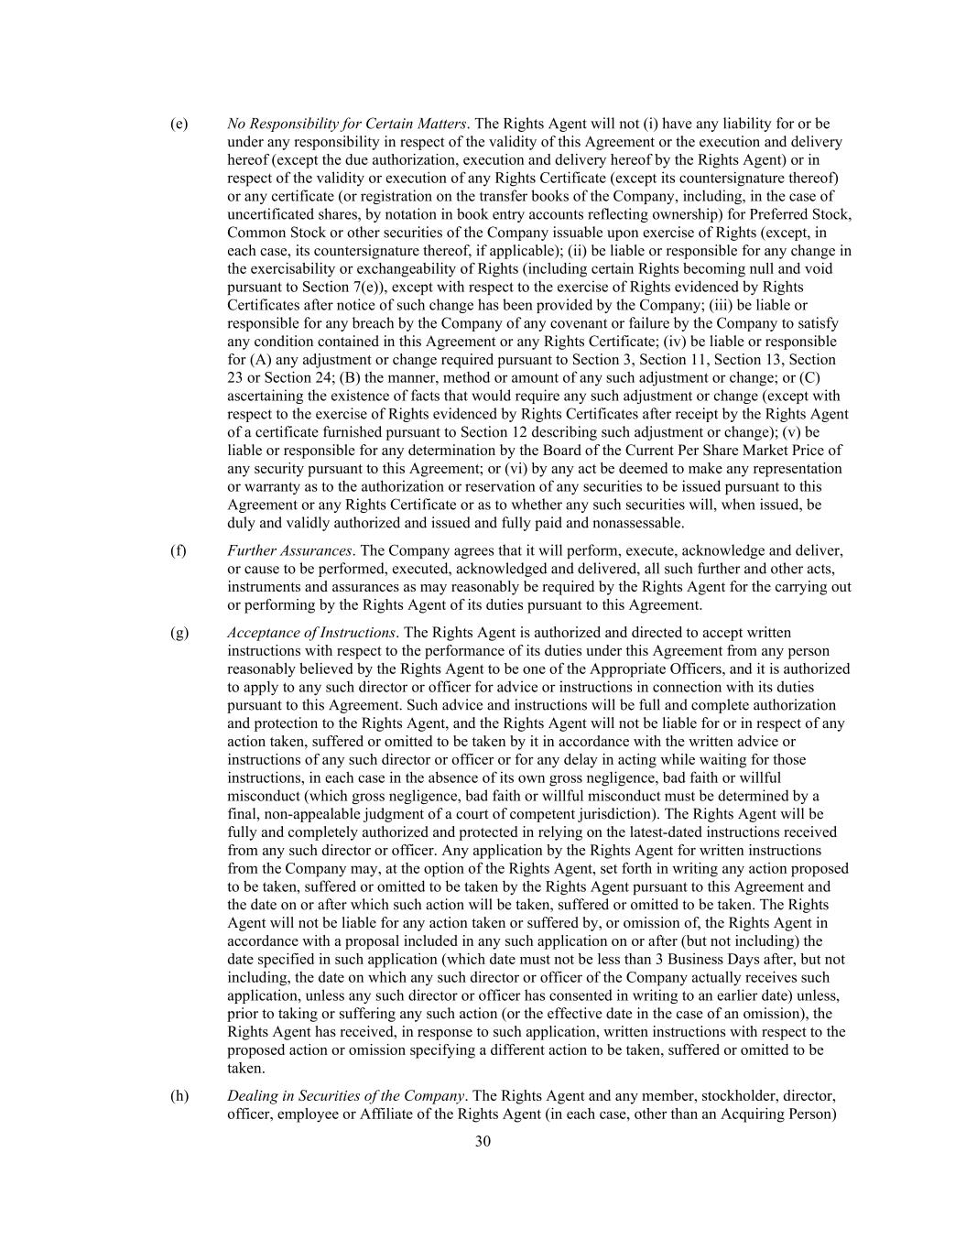
30 (e) No Responsibility for Certain Matters. The Rights Agent will not (i) have any liability for or be under any responsibility in respect of the validity of this Agreement or the execution and delivery hereof (except the due authorization, execution and delivery hereof by the Rights Agent) or in respect of the validity or execution of any Rights Certificate (except its countersignature thereof) or any certificate (or registration on the transfer books of the Company, including, in the case of uncertificated shares, by notation in book entry accounts reflecting ownership) for Preferred Stock, Common Stock or other securities of the Company issuable upon exercise of Rights (except, in each case, its countersignature thereof, if applicable); (ii) be liable or responsible for any change in the exercisability or exchangeability of Rights (including certain Rights becoming null and void pursuant to Section 7(e)), except with respect to the exercise of Rights evidenced by Rights Certificates after notice of such change has been provided by the Company; (iii) be liable or responsible for any breach by the Company of any covenant or failure by the Company to satisfy any condition contained in this Agreement or any Rights Certificate; (iv) be liable or responsible for (A) any adjustment or change required pursuant to Section 3, Section 11, Section 13, Section 23 or Section 24; (B) the manner, method or amount of any such adjustment or change; or (C) ascertaining the existence of facts that would require any such adjustment or change (except with respect to the exercise of Rights evidenced by Rights Certificates after receipt by the Rights Agent of a certificate furnished pursuant to Section 12 describing such adjustment or change); (v) be liable or responsible for any determination by the Board of the Current Per Share Market Price of any security pursuant to this Agreement; or (vi) by any act be deemed to make any representation or warranty as to the authorization or reservation of any securities to be issued pursuant to this Agreement or any Rights Certificate or as to whether any such securities will, when issued, be duly and validly authorized and issued and fully paid and nonassessable. (f) Further Assurances. The Company agrees that it will perform, execute, acknowledge and deliver, or cause to be performed, executed, acknowledged and delivered, all such further and other acts, instruments and assurances as may reasonably be required by the Rights Agent for the carrying out or performing by the Rights Agent of its duties pursuant to this Agreement. (g) Acceptance of Instructions. The Rights Agent is authorized and directed to accept written instructions with respect to the performance of its duties under this Agreement from any person reasonably believed by the Rights Agent to be one of the Appropriate Officers, and it is authorized to apply to any such director or officer for advice or instructions in connection with its duties pursuant to this Agreement. Such advice and instructions will be full and complete authorization and protection to the Rights Agent, and the Rights Agent will not be liable for or in respect of any action taken, suffered or omitted to be taken by it in accordance with the written advice or instructions of any such director or officer or for any delay in acting while waiting for those instructions, in each case in the absence of its own gross negligence, bad faith or willful misconduct (which gross negligence, bad faith or willful misconduct must be determined by a final, non-appealable judgment of a court of competent jurisdiction). The Rights Agent will be fully and completely authorized and protected in relying on the latest-dated instructions received from any such director or officer. Any application by the Rights Agent for written instructions from the Company may, at the option of the Rights Agent, set forth in writing any action proposed to be taken, suffered or omitted to be taken by the Rights Agent pursuant to this Agreement and the date on or after which such action will be taken, suffered or omitted to be taken. The Rights Agent will not be liable for any action taken or suffered by, or omission of, the Rights Agent in accordance with a proposal included in any such application on or after (but not including) the date specified in such application (which date must not be less than 3 Business Days after, but not including, the date on which any such director or officer of the Company actually receives such application, unless any such director or officer has consented in writing to an earlier date) unless, prior to taking or suffering any such action (or the effective date in the case of an omission), the Rights Agent has received, in response to such application, written instructions with respect to the proposed action or omission specifying a different action to be taken, suffered or omitted to be taken. (h) Dealing in Securities of the Company. The Rights Agent and any member, stockholder, director, officer, employee or Affiliate of the Rights Agent (in each case, other than an Acquiring Person)

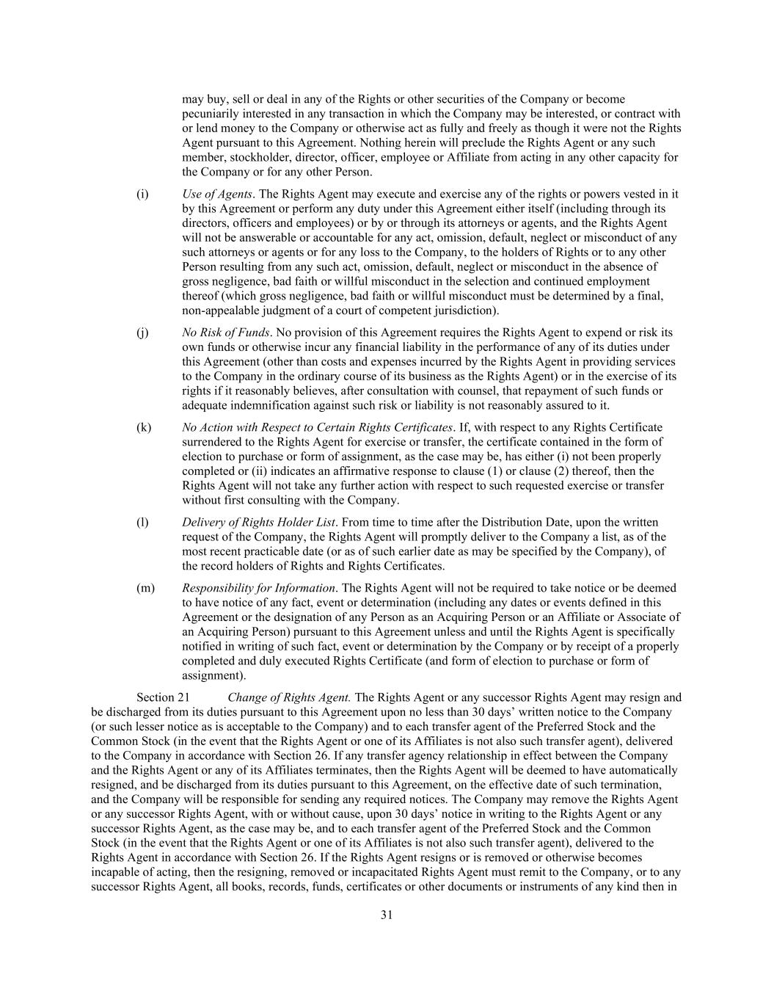
31 may buy, sell or deal in any of the Rights or other securities of the Company or become pecuniarily interested in any transaction in which the Company may be interested, or contract with or lend money to the Company or otherwise act as fully and freely as though it were not the Rights Agent pursuant to this Agreement. Nothing herein will preclude the Rights Agent or any such member, stockholder, director, officer, employee or Affiliate from acting in any other capacity for the Company or for any other Person. (i) Use of Agents. The Rights Agent may execute and exercise any of the rights or powers vested in it by this Agreement or perform any duty under this Agreement either itself (including through its directors, officers and employees) or by or through its attorneys or agents, and the Rights Agent will not be answerable or accountable for any act, omission, default, neglect or misconduct of any such attorneys or agents or for any loss to the Company, to the holders of Rights or to any other Person resulting from any such act, omission, default, neglect or misconduct in the absence of gross negligence, bad faith or willful misconduct in the selection and continued employment thereof (which gross negligence, bad faith or willful misconduct must be determined by a final, non-appealable judgment of a court of competent jurisdiction). (j) No Risk of Funds. No provision of this Agreement requires the Rights Agent to expend or risk its own funds or otherwise incur any financial liability in the performance of any of its duties under this Agreement (other than costs and expenses incurred by the Rights Agent in providing services to the Company in the ordinary course of its business as the Rights Agent) or in the exercise of its rights if it reasonably believes, after consultation with counsel, that repayment of such funds or adequate indemnification against such risk or liability is not reasonably assured to it. (k) No Action with Respect to Certain Rights Certificates. If, with respect to any Rights Certificate surrendered to the Rights Agent for exercise or transfer, the certificate contained in the form of election to purchase or form of assignment, as the case may be, has either (i) not been properly completed or (ii) indicates an affirmative response to clause (1) or clause (2) thereof, then the Rights Agent will not take any further action with respect to such requested exercise or transfer without first consulting with the Company. (l) Delivery of Rights Holder List. From time to time after the Distribution Date, upon the written request of the Company, the Rights Agent will promptly deliver to the Company a list, as of the most recent practicable date (or as of such earlier date as may be specified by the Company), of the record holders of Rights and Rights Certificates. (m) Responsibility for Information. The Rights Agent will not be required to take notice or be deemed to have notice of any fact, event or determination (including any dates or events defined in this Agreement or the designation of any Person as an Acquiring Person or an Affiliate or Associate of an Acquiring Person) pursuant to this Agreement unless and until the Rights Agent is specifically notified in writing of such fact, event or determination by the Company or by receipt of a properly completed and duly executed Rights Certificate (and form of election to purchase or form of assignment). Section 21 Change of Rights Agent. The Rights Agent or any successor Rights Agent may resign and be discharged from its duties pursuant to this Agreement upon no less than 30 days’ written notice to the Company (or such lesser notice as is acceptable to the Company) and to each transfer agent of the Preferred Stock and the Common Stock (in the event that the Rights Agent or one of its Affiliates is not also such transfer agent), delivered to the Company in accordance with Section 26. If any transfer agency relationship in effect between the Company and the Rights Agent or any of its Affiliates terminates, then the Rights Agent will be deemed to have automatically resigned, and be discharged from its duties pursuant to this Agreement, on the effective date of such termination, and the Company will be responsible for sending any required notices. The Company may remove the Rights Agent or any successor Rights Agent, with or without cause, upon 30 days’ notice in writing to the Rights Agent or any successor Rights Agent, as the case may be, and to each transfer agent of the Preferred Stock and the Common Stock (in the event that the Rights Agent or one of its Affiliates is not also such transfer agent), delivered to the Rights Agent in accordance with Section 26. If the Rights Agent resigns or is removed or otherwise becomes incapable of acting, then the resigning, removed or incapacitated Rights Agent must remit to the Company, or to any successor Rights Agent, all books, records, funds, certificates or other documents or instruments of any kind then in

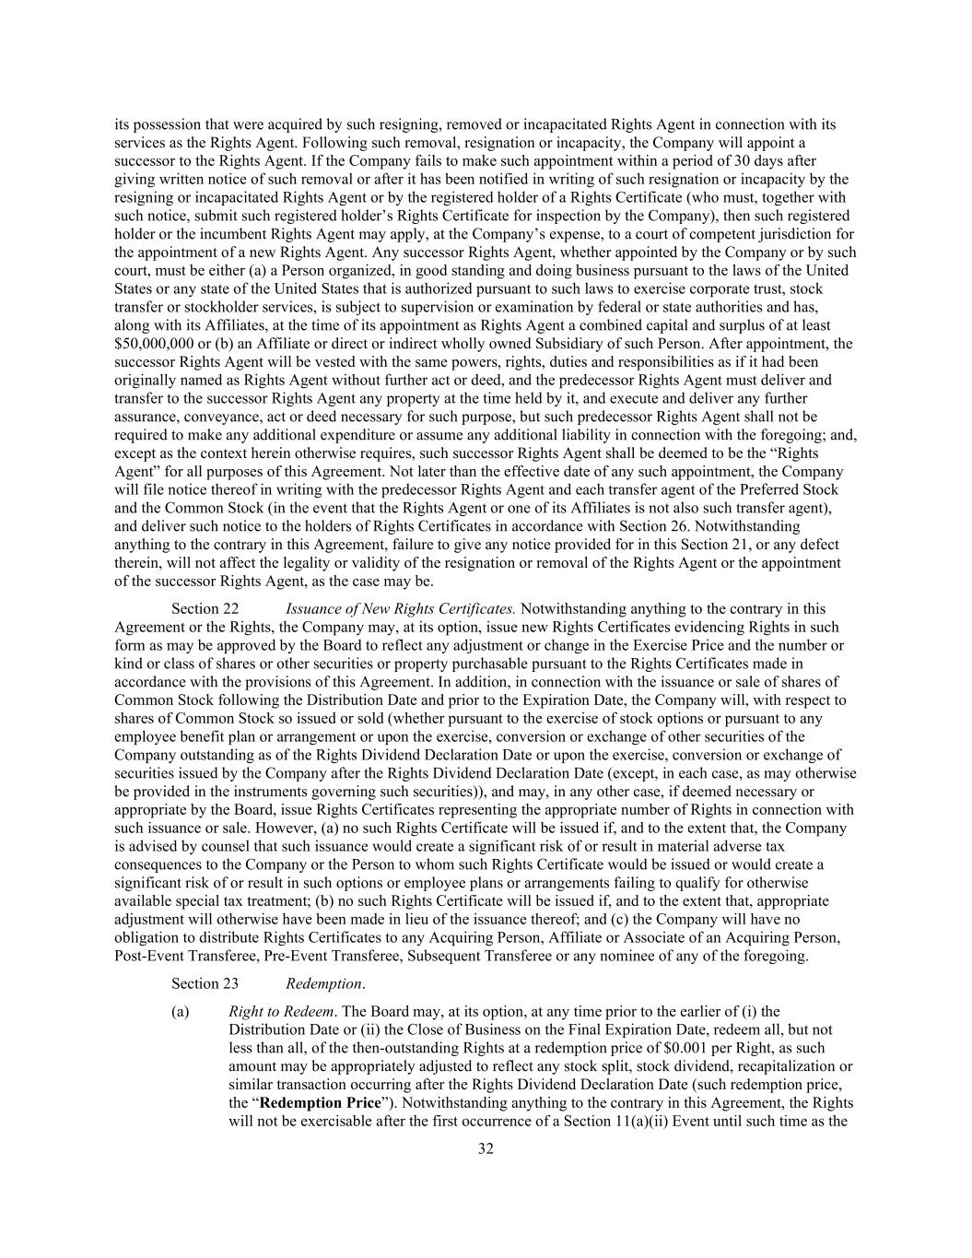
32 its possession that were acquired by such resigning, removed or incapacitated Rights Agent in connection with its services as the Rights Agent. Following such removal, resignation or incapacity, the Company will appoint a successor to the Rights Agent. If the Company fails to make such appointment within a period of 30 days after giving written notice of such removal or after it has been notified in writing of such resignation or incapacity by the resigning or incapacitated Rights Agent or by the registered holder of a Rights Certificate (who must, together with such notice, submit such registered holder’s Rights Certificate for inspection by the Company), then such registered holder or the incumbent Rights Agent may apply, at the Company’s expense, to a court of competent jurisdiction for the appointment of a new Rights Agent. Any successor Rights Agent, whether appointed by the Company or by such court, must be either (a) a Person organized, in good standing and doing business pursuant to the laws of the United States or any state of the United States that is authorized pursuant to such laws to exercise corporate trust, stock transfer or stockholder services, is subject to supervision or examination by federal or state authorities and has, along with its Affiliates, at the time of its appointment as Rights Agent a combined capital and surplus of at least $50,000,000 or (b) an Affiliate or direct or indirect wholly owned Subsidiary of such Person. After appointment, the successor Rights Agent will be vested with the same powers, rights, duties and responsibilities as if it had been originally named as Rights Agent without further act or deed, and the predecessor Rights Agent must deliver and transfer to the successor Rights Agent any property at the time held by it, and execute and deliver any further assurance, conveyance, act or deed necessary for such purpose, but such predecessor Rights Agent shall not be required to make any additional expenditure or assume any additional liability in connection with the foregoing; and, except as the context herein otherwise requires, such successor Rights Agent shall be deemed to be the “Rights Agent” for all purposes of this Agreement. Not later than the effective date of any such appointment, the Company will file notice thereof in writing with the predecessor Rights Agent and each transfer agent of the Preferred Stock and the Common Stock (in the event that the Rights Agent or one of its Affiliates is not also such transfer agent), and deliver such notice to the holders of Rights Certificates in accordance with Section 26. Notwithstanding anything to the contrary in this Agreement, failure to give any notice provided for in this Section 21, or any defect therein, will not affect the legality or validity of the resignation or removal of the Rights Agent or the appointment of the successor Rights Agent, as the case may be. Section 22 Issuance of New Rights Certificates. Notwithstanding anything to the contrary in this Agreement or the Rights, the Company may, at its option, issue new Rights Certificates evidencing Rights in such form as may be approved by the Board to reflect any adjustment or change in the Exercise Price and the number or kind or class of shares or other securities or property purchasable pursuant to the Rights Certificates made in accordance with the provisions of this Agreement. In addition, in connection with the issuance or sale of shares of Common Stock following the Distribution Date and prior to the Expiration Date, the Company will, with respect to shares of Common Stock so issued or sold (whether pursuant to the exercise of stock options or pursuant to any employee benefit plan or arrangement or upon the exercise, conversion or exchange of other securities of the Company outstanding as of the Rights Dividend Declaration Date or upon the exercise, conversion or exchange of securities issued by the Company after the Rights Dividend Declaration Date (except, in each case, as may otherwise be provided in the instruments governing such securities)), and may, in any other case, if deemed necessary or appropriate by the Board, issue Rights Certificates representing the appropriate number of Rights in connection with such issuance or sale. However, (a) no such Rights Certificate will be issued if, and to the extent that, the Company is advised by counsel that such issuance would create a significant risk of or result in material adverse tax consequences to the Company or the Person to whom such Rights Certificate would be issued or would create a significant risk of or result in such options or employee plans or arrangements failing to qualify for otherwise available special tax treatment; (b) no such Rights Certificate will be issued if, and to the extent that, appropriate adjustment will otherwise have been made in lieu of the issuance thereof; and (c) the Company will have no obligation to distribute Rights Certificates to any Acquiring Person, Affiliate or Associate of an Acquiring Person, Post-Event Transferee, Pre-Event Transferee, Subsequent Transferee or any nominee of any of the foregoing. Section 23 Redemption. (a) Right to Redeem. The Board may, at its option, at any time prior to the earlier of (i) the Distribution Date or (ii) the Close of Business on the Final Expiration Date, redeem all, but not less than all, of the then-outstanding Rights at a redemption price of $0.001 per Right, as such amount may be appropriately adjusted to reflect any stock split, stock dividend, recapitalization or similar transaction occurring after the Rights Dividend Declaration Date (such redemption price, the “Redemption Price”). Notwithstanding anything to the contrary in this Agreement, the Rights will not be exercisable after the first occurrence of a Section 11(a)(ii) Event until such time as the

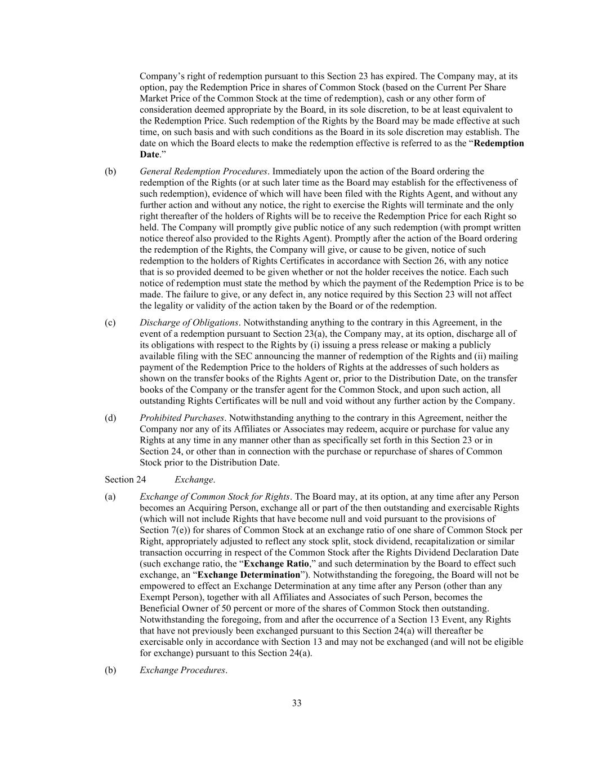
33 Company’s right of redemption pursuant to this Section 23 has expired. The Company may, at its option, pay the Redemption Price in shares of Common Stock (based on the Current Per Share Market Price of the Common Stock at the time of redemption), cash or any other form of consideration deemed appropriate by the Board, in its sole discretion, to be at least equivalent to the Redemption Price. Such redemption of the Rights by the Board may be made effective at such time, on such basis and with such conditions as the Board in its sole discretion may establish. The date on which the Board elects to make the redemption effective is referred to as the “Redemption Date.” (b) General Redemption Procedures. Immediately upon the action of the Board ordering the redemption of the Rights (or at such later time as the Board may establish for the effectiveness of such redemption), evidence of which will have been filed with the Rights Agent, and without any further action and without any notice, the right to exercise the Rights will terminate and the only right thereafter of the holders of Rights will be to receive the Redemption Price for each Right so held. The Company will promptly give public notice of any such redemption (with prompt written notice thereof also provided to the Rights Agent). Promptly after the action of the Board ordering the redemption of the Rights, the Company will give, or cause to be given, notice of such redemption to the holders of Rights Certificates in accordance with Section 26, with any notice that is so provided deemed to be given whether or not the holder receives the notice. Each such notice of redemption must state the method by which the payment of the Redemption Price is to be made. The failure to give, or any defect in, any notice required by this Section 23 will not affect the legality or validity of the action taken by the Board or of the redemption. (c) Discharge of Obligations. Notwithstanding anything to the contrary in this Agreement, in the event of a redemption pursuant to Section 23(a), the Company may, at its option, discharge all of its obligations with respect to the Rights by (i) issuing a press release or making a publicly available filing with the SEC announcing the manner of redemption of the Rights and (ii) mailing payment of the Redemption Price to the holders of Rights at the addresses of such holders as shown on the transfer books of the Rights Agent or, prior to the Distribution Date, on the transfer books of the Company or the transfer agent for the Common Stock, and upon such action, all outstanding Rights Certificates will be null and void without any further action by the Company. (d) Prohibited Purchases. Notwithstanding anything to the contrary in this Agreement, neither the Company nor any of its Affiliates or Associates may redeem, acquire or purchase for value any Rights at any time in any manner other than as specifically set forth in this Section 23 or in Section 24, or other than in connection with the purchase or repurchase of shares of Common Stock prior to the Distribution Date. Section 24 Exchange. (a) Exchange of Common Stock for Rights. The Board may, at its option, at any time after any Person becomes an Acquiring Person, exchange all or part of the then outstanding and exercisable Rights (which will not include Rights that have become null and void pursuant to the provisions of Section 7(e)) for shares of Common Stock at an exchange ratio of one share of Common Stock per Right, appropriately adjusted to reflect any stock split, stock dividend, recapitalization or similar transaction occurring in respect of the Common Stock after the Rights Dividend Declaration Date (such exchange ratio, the “Exchange Ratio,” and such determination by the Board to effect such exchange, an “Exchange Determination”). Notwithstanding the foregoing, the Board will not be empowered to effect an Exchange Determination at any time after any Person (other than any Exempt Person), together with all Affiliates and Associates of such Person, becomes the Beneficial Owner of 50 percent or more of the shares of Common Stock then outstanding. Notwithstanding the foregoing, from and after the occurrence of a Section 13 Event, any Rights that have not previously been exchanged pursuant to this Section 24(a) will thereafter be exercisable only in accordance with Section 13 and may not be exchanged (and will not be eligible for exchange) pursuant to this Section 24(a). (b) Exchange Procedures.

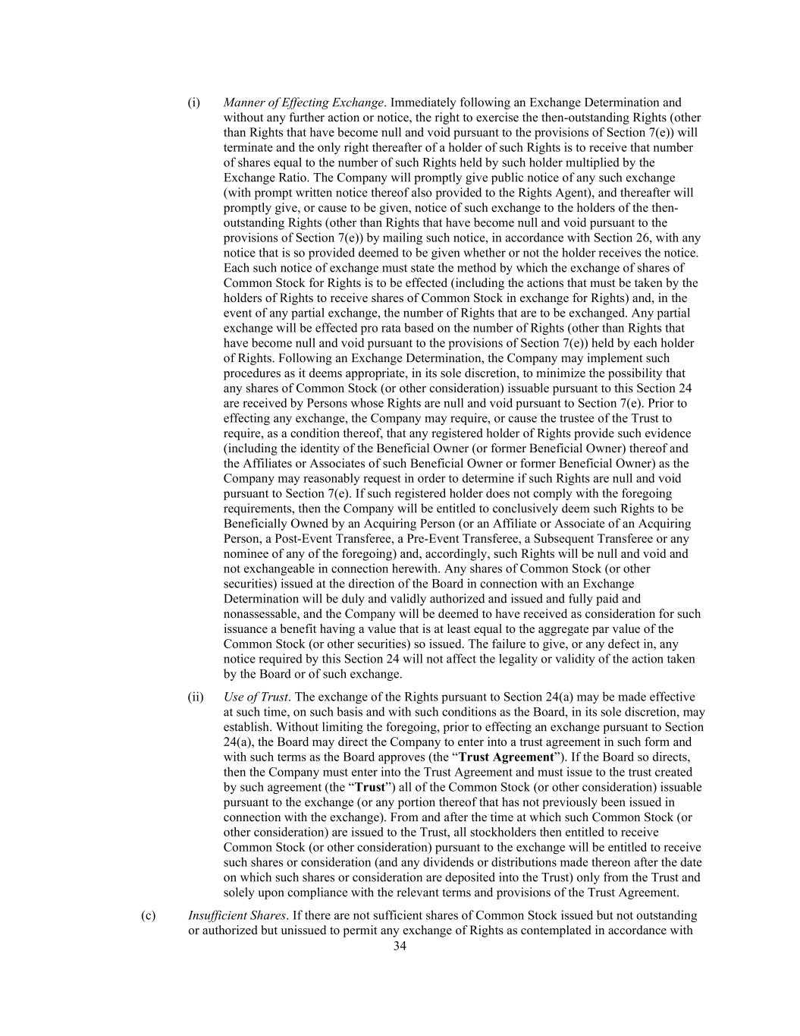
34 (i) Manner of Effecting Exchange. Immediately following an Exchange Determination and without any further action or notice, the right to exercise the then-outstanding Rights (other than Rights that have become null and void pursuant to the provisions of Section 7(e)) will terminate and the only right thereafter of a holder of such Rights is to receive that number of shares equal to the number of such Rights held by such holder multiplied by the Exchange Ratio. The Company will promptly give public notice of any such exchange (with prompt written notice thereof also provided to the Rights Agent), and thereafter will promptly give, or cause to be given, notice of such exchange to the holders of the then- outstanding Rights (other than Rights that have become null and void pursuant to the provisions of Section 7(e)) by mailing such notice, in accordance with Section 26, with any notice that is so provided deemed to be given whether or not the holder receives the notice. Each such notice of exchange must state the method by which the exchange of shares of Common Stock for Rights is to be effected (including the actions that must be taken by the holders of Rights to receive shares of Common Stock in exchange for Rights) and, in the event of any partial exchange, the number of Rights that are to be exchanged. Any partial exchange will be effected pro rata based on the number of Rights (other than Rights that have become null and void pursuant to the provisions of Section 7(e)) held by each holder of Rights. Following an Exchange Determination, the Company may implement such procedures as it deems appropriate, in its sole discretion, to minimize the possibility that any shares of Common Stock (or other consideration) issuable pursuant to this Section 24 are received by Persons whose Rights are null and void pursuant to Section 7(e). Prior to effecting any exchange, the Company may require, or cause the trustee of the Trust to require, as a condition thereof, that any registered holder of Rights provide such evidence (including the identity of the Beneficial Owner (or former Beneficial Owner) thereof and the Affiliates or Associates of such Beneficial Owner or former Beneficial Owner) as the Company may reasonably request in order to determine if such Rights are null and void pursuant to Section 7(e). If such registered holder does not comply with the foregoing requirements, then the Company will be entitled to conclusively deem such Rights to be Beneficially Owned by an Acquiring Person (or an Affiliate or Associate of an Acquiring Person, a Post-Event Transferee, a Pre-Event Transferee, a Subsequent Transferee or any nominee of any of the foregoing) and, accordingly, such Rights will be null and void and not exchangeable in connection herewith. Any shares of Common Stock (or other securities) issued at the direction of the Board in connection with an Exchange Determination will be duly and validly authorized and issued and fully paid and nonassessable, and the Company will be deemed to have received as consideration for such issuance a benefit having a value that is at least equal to the aggregate par value of the Common Stock (or other securities) so issued. The failure to give, or any defect in, any notice required by this Section 24 will not affect the legality or validity of the action taken by the Board or of such exchange. (ii) Use of Trust. The exchange of the Rights pursuant to Section 24(a) may be made effective at such time, on such basis and with such conditions as the Board, in its sole discretion, may establish. Without limiting the foregoing, prior to effecting an exchange pursuant to Section 24(a), the Board may direct the Company to enter into a trust agreement in such form and with such terms as the Board approves (the “Trust Agreement”). If the Board so directs, then the Company must enter into the Trust Agreement and must issue to the trust created by such agreement (the “Trust”) all of the Common Stock (or other consideration) issuable pursuant to the exchange (or any portion thereof that has not previously been issued in connection with the exchange). From and after the time at which such Common Stock (or other consideration) are issued to the Trust, all stockholders then entitled to receive Common Stock (or other consideration) pursuant to the exchange will be entitled to receive such shares or consideration (and any dividends or distributions made thereon after the date on which such shares or consideration are deposited into the Trust) only from the Trust and solely upon compliance with the relevant terms and provisions of the Trust Agreement. (c) Insufficient Shares. If there are not sufficient shares of Common Stock issued but not outstanding or authorized but unissued to permit any exchange of Rights as contemplated in accordance with

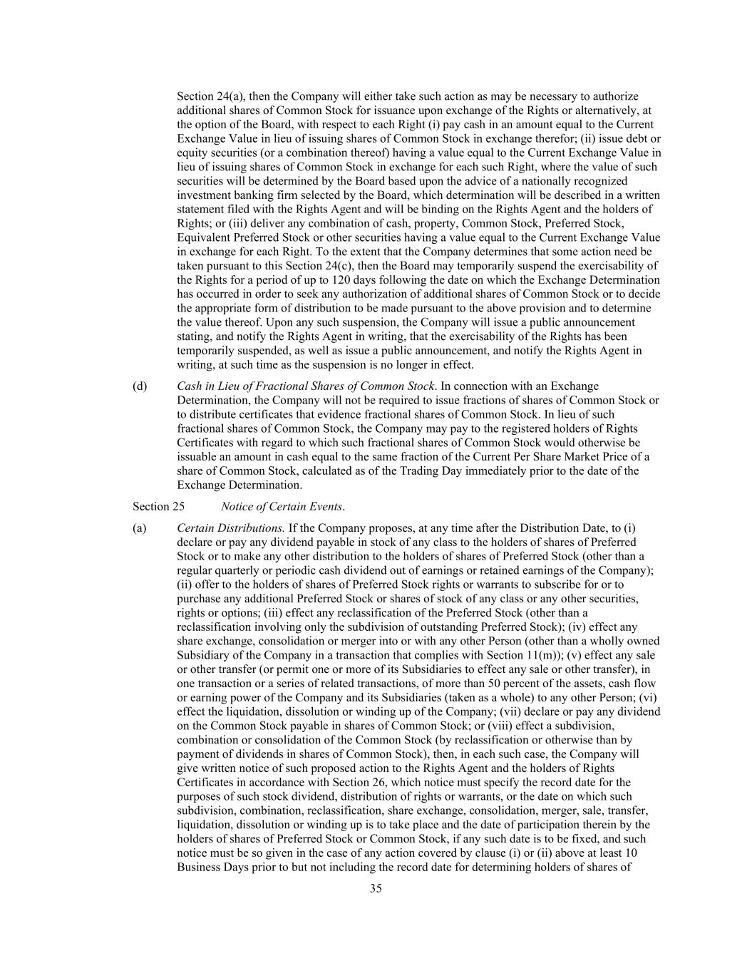
35 Section 24(a), then the Company will either take such action as may be necessary to authorize additional shares of Common Stock for issuance upon exchange of the Rights or alternatively, at the option of the Board, with respect to each Right (i) pay cash in an amount equal to the Current Exchange Value in lieu of issuing shares of Common Stock in exchange therefor; (ii) issue debt or equity securities (or a combination thereof) having a value equal to the Current Exchange Value in lieu of issuing shares of Common Stock in exchange for each such Right, where the value of such securities will be determined by the Board based upon the advice of a nationally recognized investment banking firm selected by the Board, which determination will be described in a written statement filed with the Rights Agent and will be binding on the Rights Agent and the holders of Rights; or (iii) deliver any combination of cash, property, Common Stock, Preferred Stock, Equivalent Preferred Stock or other securities having a value equal to the Current Exchange Value in exchange for each Right. To the extent that the Company determines that some action need be taken pursuant to this Section 24(c), then the Board may temporarily suspend the exercisability of the Rights for a period of up to 120 days following the date on which the Exchange Determination has occurred in order to seek any authorization of additional shares of Common Stock or to decide the appropriate form of distribution to be made pursuant to the above provision and to determine the value thereof. Upon any such suspension, the Company will issue a public announcement stating, and notify the Rights Agent in writing, that the exercisability of the Rights has been temporarily suspended, as well as issue a public announcement, and notify the Rights Agent in writing, at such time as the suspension is no longer in effect. (d) Cash in Lieu of Fractional Shares of Common Stock. In connection with an Exchange Determination, the Company will not be required to issue fractions of shares of Common Stock or to distribute certificates that evidence fractional shares of Common Stock. In lieu of such fractional shares of Common Stock, the Company may pay to the registered holders of Rights Certificates with regard to which such fractional shares of Common Stock would otherwise be issuable an amount in cash equal to the same fraction of the Current Per Share Market Price of a share of Common Stock, calculated as of the Trading Day immediately prior to the date of the Exchange Determination. Section 25 Notice of Certain Events. (a) Certain Distributions. If the Company proposes, at any time after the Distribution Date, to (i) declare or pay any dividend payable in stock of any class to the holders of shares of Preferred Stock or to make any other distribution to the holders of shares of Preferred Stock (other than a regular quarterly or periodic cash dividend out of earnings or retained earnings of the Company); (ii) offer to the holders of shares of Preferred Stock rights or warrants to subscribe for or to purchase any additional Preferred Stock or shares of stock of any class or any other securities, rights or options; (iii) effect any reclassification of the Preferred Stock (other than a reclassification involving only the subdivision of outstanding Preferred Stock); (iv) effect any share exchange, consolidation or merger into or with any other Person (other than a wholly owned Subsidiary of the Company in a transaction that complies with Section 11(m)); (v) effect any sale or other transfer (or permit one or more of its Subsidiaries to effect any sale or other transfer), in one transaction or a series of related transactions, of more than 50 percent of the assets, cash flow or earning power of the Company and its Subsidiaries (taken as a whole) to any other Person; (vi) effect the liquidation, dissolution or winding up of the Company; (vii) declare or pay any dividend on the Common Stock payable in shares of Common Stock; or (viii) effect a subdivision, combination or consolidation of the Common Stock (by reclassification or otherwise than by payment of dividends in shares of Common Stock), then, in each such case, the Company will give written notice of such proposed action to the Rights Agent and the holders of Rights Certificates in accordance with Section 26, which notice must specify the record date for the purposes of such stock dividend, distribution of rights or warrants, or the date on which such subdivision, combination, reclassification, share exchange, consolidation, merger, sale, transfer, liquidation, dissolution or winding up is to take place and the date of participation therein by the holders of shares of Preferred Stock or Common Stock, if any such date is to be fixed, and such notice must be so given in the case of any action covered by clause (i) or (ii) above at least 10 Business Days prior to but not including the record date for determining holders of shares of

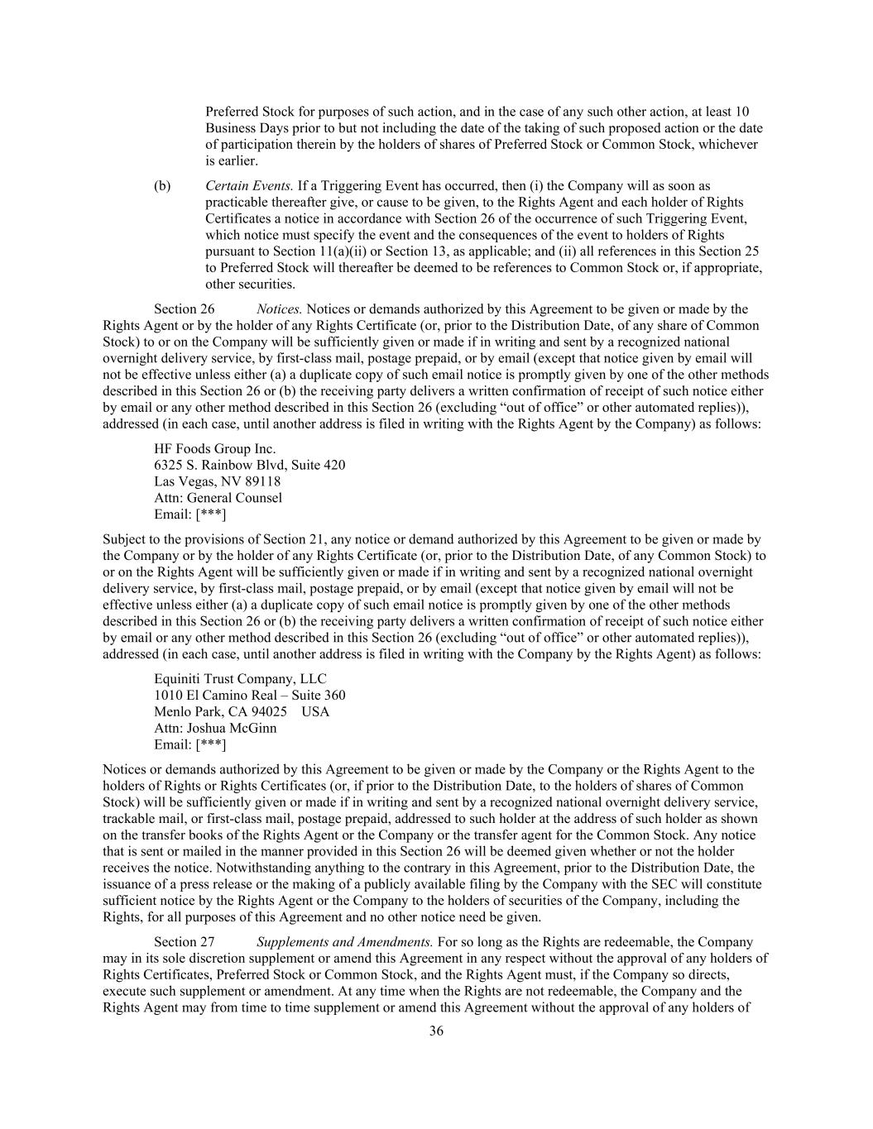
36 Preferred Stock for purposes of such action, and in the case of any such other action, at least 10 Business Days prior to but not including the date of the taking of such proposed action or the date of participation therein by the holders of shares of Preferred Stock or Common Stock, whichever is earlier. (b) Certain Events. If a Triggering Event has occurred, then (i) the Company will as soon as practicable thereafter give, or cause to be given, to the Rights Agent and each holder of Rights Certificates a notice in accordance with Section 26 of the occurrence of such Triggering Event, which notice must specify the event and the consequences of the event to holders of Rights pursuant to Section 11(a)(ii) or Section 13, as applicable; and (ii) all references in this Section 25 to Preferred Stock will thereafter be deemed to be references to Common Stock or, if appropriate, other securities. Section 26 Notices. Notices or demands authorized by this Agreement to be given or made by the Rights Agent or by the holder of any Rights Certificate (or, prior to the Distribution Date, of any share of Common Stock) to or on the Company will be sufficiently given or made if in writing and sent by a recognized national overnight delivery service, by first-class mail, postage prepaid, or by email (except that notice given by email will not be effective unless either (a) a duplicate copy of such email notice is promptly given by one of the other methods described in this Section 26 or (b) the receiving party delivers a written confirmation of receipt of such notice either by email or any other method described in this Section 26 (excluding “out of office” or other automated replies)), addressed (in each case, until another address is filed in writing with the Rights Agent by the Company) as follows: HF Foods Group Inc. 6325 S. Rainbow Blvd, Suite 420 Las Vegas, NV 89118 Attn: General Counsel Email: [***] Subject to the provisions of Section 21, any notice or demand authorized by this Agreement to be given or made by the Company or by the holder of any Rights Certificate (or, prior to the Distribution Date, of any Common Stock) to or on the Rights Agent will be sufficiently given or made if in writing and sent by a recognized national overnight delivery service, by first-class mail, postage prepaid, or by email (except that notice given by email will not be effective unless either (a) a duplicate copy of such email notice is promptly given by one of the other methods described in this Section 26 or (b) the receiving party delivers a written confirmation of receipt of such notice either by email or any other method described in this Section 26 (excluding “out of office” or other automated replies)), addressed (in each case, until another address is filed in writing with the Company by the Rights Agent) as follows: Equiniti Trust Company, LLC 1010 El Camino Real – Suite 360 Menlo Park, CA 94025 USA Attn: Joshua McGinn Email: [***] Notices or demands authorized by this Agreement to be given or made by the Company or the Rights Agent to the holders of Rights or Rights Certificates (or, if prior to the Distribution Date, to the holders of shares of Common Stock) will be sufficiently given or made if in writing and sent by a recognized national overnight delivery service, trackable mail, or first-class mail, postage prepaid, addressed to such holder at the address of such holder as shown on the transfer books of the Rights Agent or the Company or the transfer agent for the Common Stock. Any notice that is sent or mailed in the manner provided in this Section 26 will be deemed given whether or not the holder receives the notice. Notwithstanding anything to the contrary in this Agreement, prior to the Distribution Date, the issuance of a press release or the making of a publicly available filing by the Company with the SEC will constitute sufficient notice by the Rights Agent or the Company to the holders of securities of the Company, including the Rights, for all purposes of this Agreement and no other notice need be given. Section 27 Supplements and Amendments. For so long as the Rights are redeemable, the Company may in its sole discretion supplement or amend this Agreement in any respect without the approval of any holders of Rights Certificates, Preferred Stock or Common Stock, and the Rights Agent must, if the Company so directs, execute such supplement or amendment. At any time when the Rights are not redeemable, the Company and the Rights Agent may from time to time supplement or amend this Agreement without the approval of any holders of

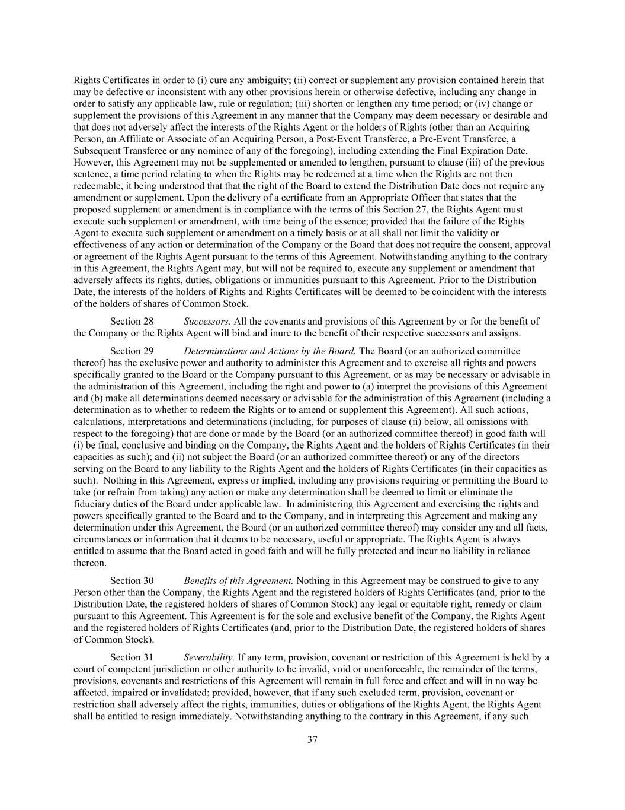
37 Rights Certificates in order to (i) cure any ambiguity; (ii) correct or supplement any provision contained herein that may be defective or inconsistent with any other provisions herein or otherwise defective, including any change in order to satisfy any applicable law, rule or regulation; (iii) shorten or lengthen any time period; or (iv) change or supplement the provisions of this Agreement in any manner that the Company may deem necessary or desirable and that does not adversely affect the interests of the Rights Agent or the holders of Rights (other than an Acquiring Person, an Affiliate or Associate of an Acquiring Person, a Post-Event Transferee, a Pre-Event Transferee, a Subsequent Transferee or any nominee of any of the foregoing), including extending the Final Expiration Date. However, this Agreement may not be supplemented or amended to lengthen, pursuant to clause (iii) of the previous sentence, a time period relating to when the Rights may be redeemed at a time when the Rights are not then redeemable, it being understood that that the right of the Board to extend the Distribution Date does not require any amendment or supplement. Upon the delivery of a certificate from an Appropriate Officer that states that the proposed supplement or amendment is in compliance with the terms of this Section 27, the Rights Agent must execute such supplement or amendment, with time being of the essence; provided that the failure of the Rights Agent to execute such supplement or amendment on a timely basis or at all shall not limit the validity or effectiveness of any action or determination of the Company or the Board that does not require the consent, approval or agreement of the Rights Agent pursuant to the terms of this Agreement. Notwithstanding anything to the contrary in this Agreement, the Rights Agent may, but will not be required to, execute any supplement or amendment that adversely affects its rights, duties, obligations or immunities pursuant to this Agreement. Prior to the Distribution Date, the interests of the holders of Rights and Rights Certificates will be deemed to be coincident with the interests of the holders of shares of Common Stock. Section 28 Successors. All the covenants and provisions of this Agreement by or for the benefit of the Company or the Rights Agent will bind and inure to the benefit of their respective successors and assigns. Section 29 Determinations and Actions by the Board. The Board (or an authorized committee thereof) has the exclusive power and authority to administer this Agreement and to exercise all rights and powers specifically granted to the Board or the Company pursuant to this Agreement, or as may be necessary or advisable in the administration of this Agreement, including the right and power to (a) interpret the provisions of this Agreement and (b) make all determinations deemed necessary or advisable for the administration of this Agreement (including a determination as to whether to redeem the Rights or to amend or supplement this Agreement). All such actions, calculations, interpretations and determinations (including, for purposes of clause (ii) below, all omissions with respect to the foregoing) that are done or made by the Board (or an authorized committee thereof) in good faith will (i) be final, conclusive and binding on the Company, the Rights Agent and the holders of Rights Certificates (in their capacities as such); and (ii) not subject the Board (or an authorized committee thereof) or any of the directors serving on the Board to any liability to the Rights Agent and the holders of Rights Certificates (in their capacities as such). Nothing in this Agreement, express or implied, including any provisions requiring or permitting the Board to take (or refrain from taking) any action or make any determination shall be deemed to limit or eliminate the fiduciary duties of the Board under applicable law. In administering this Agreement and exercising the rights and powers specifically granted to the Board and to the Company, and in interpreting this Agreement and making any determination under this Agreement, the Board (or an authorized committee thereof) may consider any and all facts, circumstances or information that it deems to be necessary, useful or appropriate. The Rights Agent is always entitled to assume that the Board acted in good faith and will be fully protected and incur no liability in reliance thereon. Section 30 Benefits of this Agreement. Nothing in this Agreement may be construed to give to any Person other than the Company, the Rights Agent and the registered holders of Rights Certificates (and, prior to the Distribution Date, the registered holders of shares of Common Stock) any legal or equitable right, remedy or claim pursuant to this Agreement. This Agreement is for the sole and exclusive benefit of the Company, the Rights Agent and the registered holders of Rights Certificates (and, prior to the Distribution Date, the registered holders of shares of Common Stock). Section 31 Severability. If any term, provision, covenant or restriction of this Agreement is held by a court of competent jurisdiction or other authority to be invalid, void or unenforceable, the remainder of the terms, provisions, covenants and restrictions of this Agreement will remain in full force and effect and will in no way be affected, impaired or invalidated; provided, however, that if any such excluded term, provision, covenant or restriction shall adversely affect the rights, immunities, duties or obligations of the Rights Agent, the Rights Agent shall be entitled to resign immediately. Notwithstanding anything to the contrary in this Agreement, if any such

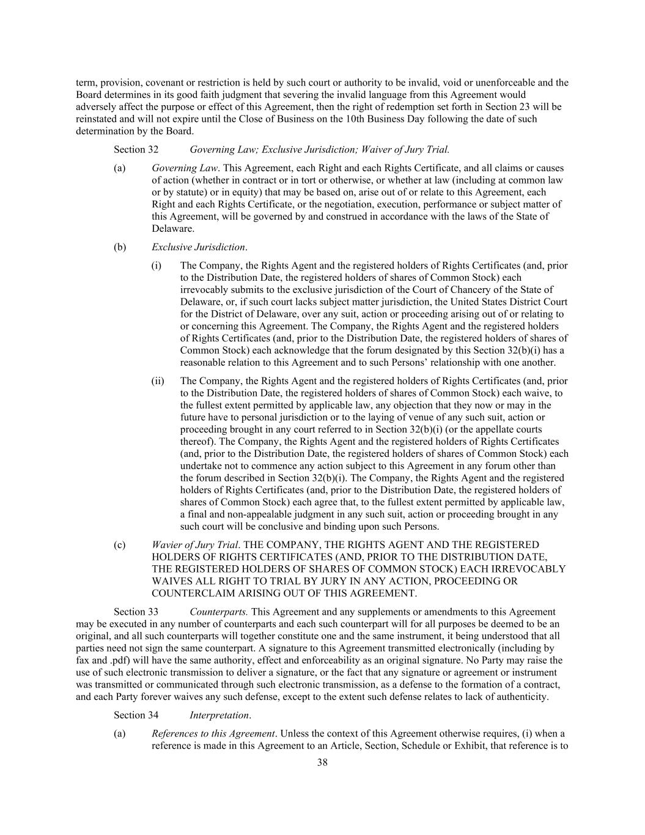
38 term, provision, covenant or restriction is held by such court or authority to be invalid, void or unenforceable and the Board determines in its good faith judgment that severing the invalid language from this Agreement would adversely affect the purpose or effect of this Agreement, then the right of redemption set forth in Section 23 will be reinstated and will not expire until the Close of Business on the 10th Business Day following the date of such determination by the Board. Section 32 Governing Law; Exclusive Jurisdiction; Waiver of Jury Trial. (a) Governing Law. This Agreement, each Right and each Rights Certificate, and all claims or causes of action (whether in contract or in tort or otherwise, or whether at law (including at common law or by statute) or in equity) that may be based on, arise out of or relate to this Agreement, each Right and each Rights Certificate, or the negotiation, execution, performance or subject matter of this Agreement, will be governed by and construed in accordance with the laws of the State of Delaware. (b) Exclusive Jurisdiction. (i) The Company, the Rights Agent and the registered holders of Rights Certificates (and, prior to the Distribution Date, the registered holders of shares of Common Stock) each irrevocably submits to the exclusive jurisdiction of the Court of Chancery of the State of Delaware, or, if such court lacks subject matter jurisdiction, the United States District Court for the District of Delaware, over any suit, action or proceeding arising out of or relating to or concerning this Agreement. The Company, the Rights Agent and the registered holders of Rights Certificates (and, prior to the Distribution Date, the registered holders of shares of Common Stock) each acknowledge that the forum designated by this Section 32(b)(i) has a reasonable relation to this Agreement and to such Persons’ relationship with one another. (ii) The Company, the Rights Agent and the registered holders of Rights Certificates (and, prior to the Distribution Date, the registered holders of shares of Common Stock) each waive, to the fullest extent permitted by applicable law, any objection that they now or may in the future have to personal jurisdiction or to the laying of venue of any such suit, action or proceeding brought in any court referred to in Section 32(b)(i) (or the appellate courts thereof). The Company, the Rights Agent and the registered holders of Rights Certificates (and, prior to the Distribution Date, the registered holders of shares of Common Stock) each undertake not to commence any action subject to this Agreement in any forum other than the forum described in Section 32(b)(i). The Company, the Rights Agent and the registered holders of Rights Certificates (and, prior to the Distribution Date, the registered holders of shares of Common Stock) each agree that, to the fullest extent permitted by applicable law, a final and non-appealable judgment in any such suit, action or proceeding brought in any such court will be conclusive and binding upon such Persons. (c) Wavier of Jury Trial. THE COMPANY, THE RIGHTS AGENT AND THE REGISTERED HOLDERS OF RIGHTS CERTIFICATES (AND, PRIOR TO THE DISTRIBUTION DATE, THE REGISTERED HOLDERS OF SHARES OF COMMON STOCK) EACH IRREVOCABLY WAIVES ALL RIGHT TO TRIAL BY JURY IN ANY ACTION, PROCEEDING OR COUNTERCLAIM ARISING OUT OF THIS AGREEMENT. Section 33 Counterparts. This Agreement and any supplements or amendments to this Agreement may be executed in any number of counterparts and each such counterpart will for all purposes be deemed to be an original, and all such counterparts will together constitute one and the same instrument, it being understood that all parties need not sign the same counterpart. A signature to this Agreement transmitted electronically (including by fax and .pdf) will have the same authority, effect and enforceability as an original signature. No Party may raise the use of such electronic transmission to deliver a signature, or the fact that any signature or agreement or instrument was transmitted or communicated through such electronic transmission, as a defense to the formation of a contract, and each Party forever waives any such defense, except to the extent such defense relates to lack of authenticity. Section 34 Interpretation. (a) References to this Agreement. Unless the context of this Agreement otherwise requires, (i) when a reference is made in this Agreement to an Article, Section, Schedule or Exhibit, that reference is to

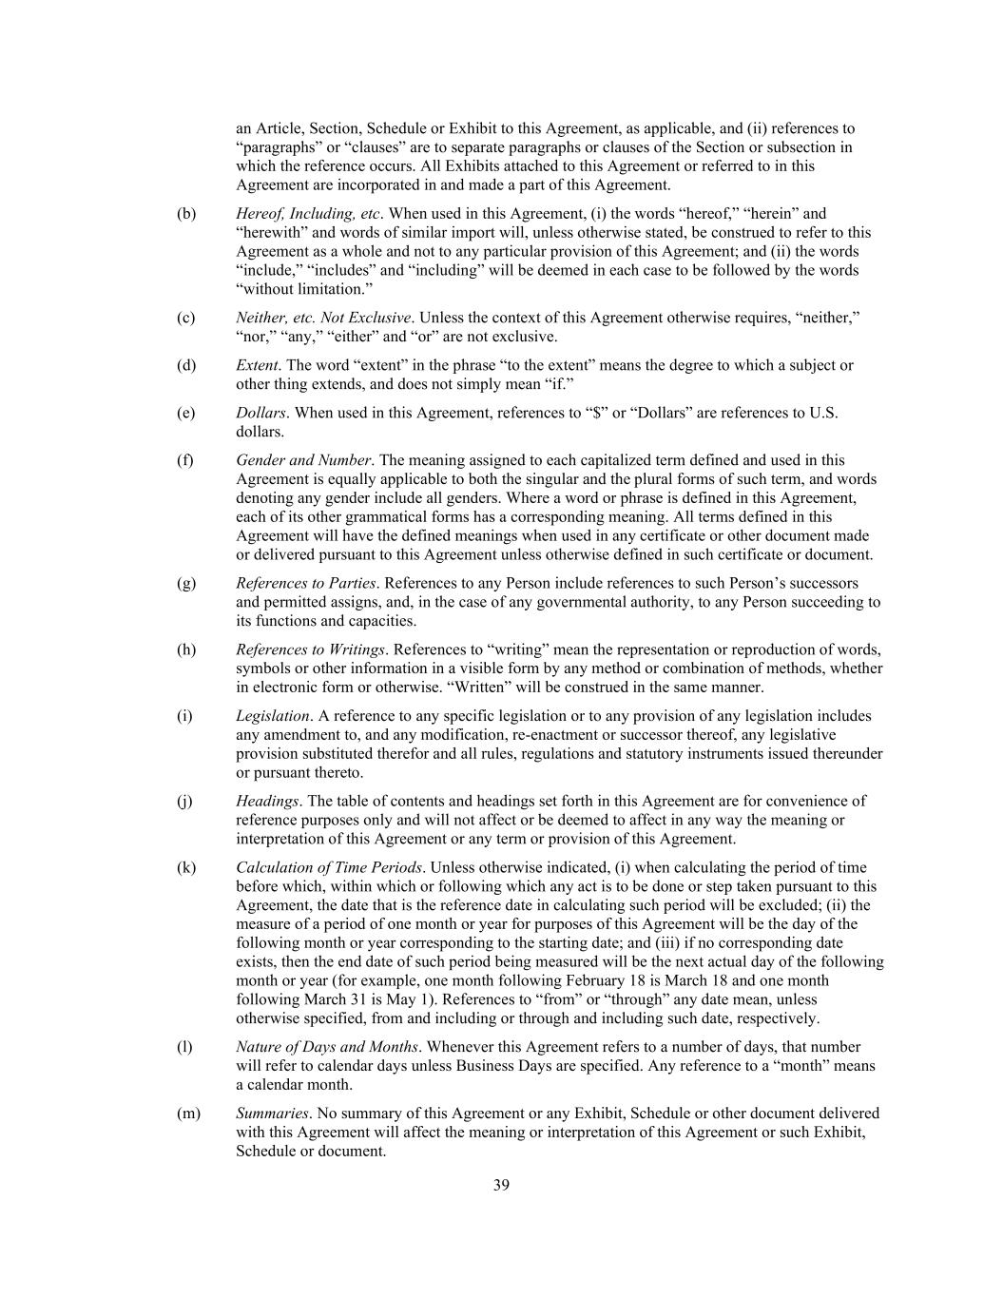
39 an Article, Section, Schedule or Exhibit to this Agreement, as applicable, and (ii) references to “paragraphs” or “clauses” are to separate paragraphs or clauses of the Section or subsection in which the reference occurs. All Exhibits attached to this Agreement or referred to in this Agreement are incorporated in and made a part of this Agreement. (b) Hereof, Including, etc. When used in this Agreement, (i) the words “hereof,” “herein” and “herewith” and words of similar import will, unless otherwise stated, be construed to refer to this Agreement as a whole and not to any particular provision of this Agreement; and (ii) the words “include,” “includes” and “including” will be deemed in each case to be followed by the words “without limitation.” (c) Neither, etc. Not Exclusive. Unless the context of this Agreement otherwise requires, “neither,” “nor,” “any,” “either” and “or” are not exclusive. (d) Extent. The word “extent” in the phrase “to the extent” means the degree to which a subject or other thing extends, and does not simply mean “if.” (e) Dollars. When used in this Agreement, references to “$” or “Dollars” are references to U.S. dollars. (f) Gender and Number. The meaning assigned to each capitalized term defined and used in this Agreement is equally applicable to both the singular and the plural forms of such term, and words denoting any gender include all genders. Where a word or phrase is defined in this Agreement, each of its other grammatical forms has a corresponding meaning. All terms defined in this Agreement will have the defined meanings when used in any certificate or other document made or delivered pursuant to this Agreement unless otherwise defined in such certificate or document. (g) References to Parties. References to any Person include references to such Person’s successors and permitted assigns, and, in the case of any governmental authority, to any Person succeeding to its functions and capacities. (h) References to Writings. References to “writing” mean the representation or reproduction of words, symbols or other information in a visible form by any method or combination of methods, whether in electronic form or otherwise. “Written” will be construed in the same manner. (i) Legislation. A reference to any specific legislation or to any provision of any legislation includes any amendment to, and any modification, re-enactment or successor thereof, any legislative provision substituted therefor and all rules, regulations and statutory instruments issued thereunder or pursuant thereto. (j) Headings. The table of contents and headings set forth in this Agreement are for convenience of reference purposes only and will not affect or be deemed to affect in any way the meaning or interpretation of this Agreement or any term or provision of this Agreement. (k) Calculation of Time Periods. Unless otherwise indicated, (i) when calculating the period of time before which, within which or following which any act is to be done or step taken pursuant to this Agreement, the date that is the reference date in calculating such period will be excluded; (ii) the measure of a period of one month or year for purposes of this Agreement will be the day of the following month or year corresponding to the starting date; and (iii) if no corresponding date exists, then the end date of such period being measured will be the next actual day of the following month or year (for example, one month following February 18 is March 18 and one month following March 31 is May 1). References to “from” or “through” any date mean, unless otherwise specified, from and including or through and including such date, respectively. (l) Nature of Days and Months. Whenever this Agreement refers to a number of days, that number will refer to calendar days unless Business Days are specified. Any reference to a “month” means a calendar month. (m) Summaries. No summary of this Agreement or any Exhibit, Schedule or other document delivered with this Agreement will affect the meaning or interpretation of this Agreement or such Exhibit, Schedule or document.

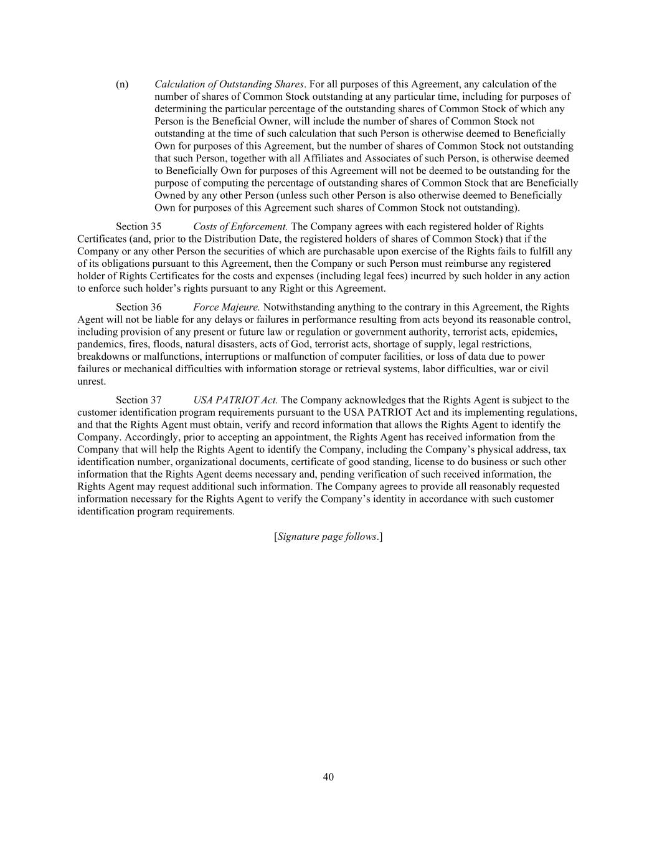
40 (n) Calculation of Outstanding Shares. For all purposes of this Agreement, any calculation of the number of shares of Common Stock outstanding at any particular time, including for purposes of determining the particular percentage of the outstanding shares of Common Stock of which any Person is the Beneficial Owner, will include the number of shares of Common Stock not outstanding at the time of such calculation that such Person is otherwise deemed to Beneficially Own for purposes of this Agreement, but the number of shares of Common Stock not outstanding that such Person, together with all Affiliates and Associates of such Person, is otherwise deemed to Beneficially Own for purposes of this Agreement will not be deemed to be outstanding for the purpose of computing the percentage of outstanding shares of Common Stock that are Beneficially Owned by any other Person (unless such other Person is also otherwise deemed to Beneficially Own for purposes of this Agreement such shares of Common Stock not outstanding). Section 35 Costs of Enforcement. The Company agrees with each registered holder of Rights Certificates (and, prior to the Distribution Date, the registered holders of shares of Common Stock) that if the Company or any other Person the securities of which are purchasable upon exercise of the Rights fails to fulfill any of its obligations pursuant to this Agreement, then the Company or such Person must reimburse any registered holder of Rights Certificates for the costs and expenses (including legal fees) incurred by such holder in any action to enforce such holder’s rights pursuant to any Right or this Agreement. Section 36 Force Majeure. Notwithstanding anything to the contrary in this Agreement, the Rights Agent will not be liable for any delays or failures in performance resulting from acts beyond its reasonable control, including provision of any present or future law or regulation or government authority, terrorist acts, epidemics, pandemics, fires, floods, natural disasters, acts of God, terrorist acts, shortage of supply, legal restrictions, breakdowns or malfunctions, interruptions or malfunction of computer facilities, or loss of data due to power failures or mechanical difficulties with information storage or retrieval systems, labor difficulties, war or civil unrest. Section 37 USA PATRIOT Act. The Company acknowledges that the Rights Agent is subject to the customer identification program requirements pursuant to the USA PATRIOT Act and its implementing regulations, and that the Rights Agent must obtain, verify and record information that allows the Rights Agent to identify the Company. Accordingly, prior to accepting an appointment, the Rights Agent has received information from the Company that will help the Rights Agent to identify the Company, including the Company’s physical address, tax identification number, organizational documents, certificate of good standing, license to do business or such other information that the Rights Agent deems necessary and, pending verification of such received information, the Rights Agent may request additional such information. The Company agrees to provide all reasonably requested information necessary for the Rights Agent to verify the Company’s identity in accordance with such customer identification program requirements. [Signature page follows.]


The parties are signing this Agreement on the date stated in the introductory clause. HF FOODS GROUP INC. By: /s/Felix Lin Name: Felix Lin Title: President and Chief Executive Officer EQUINITI TRUST COMPANY LLC By: /s/Stephen Hoffman Name: Stephen Hoffman Title: Regional Director


Exhibit A Form of Certificate of Designation of Rights, Preferences and Privileges of Series AA Participating Preferred Stock

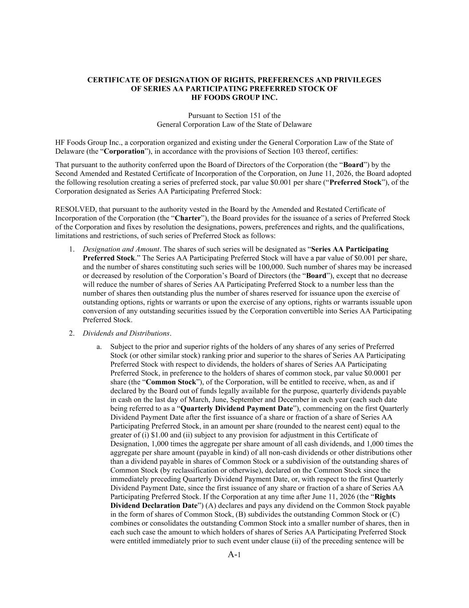
A-1 CERTIFICATE OF DESIGNATION OF RIGHTS, PREFERENCES AND PRIVILEGES OF SERIES AA PARTICIPATING PREFERRED STOCK OF HF FOODS GROUP INC. Pursuant to Section 151 of the General Corporation Law of the State of Delaware HF Foods Group Inc., a corporation organized and existing under the General Corporation Law of the State of Delaware (the “Corporation”), in accordance with the provisions of Section 103 thereof, certifies: That pursuant to the authority conferred upon the Board of Directors of the Corporation (the “Board”) by the Second Amended and Restated Certificate of Incorporation of the Corporation, on June 11, 2026, the Board adopted the following resolution creating a series of preferred stock, par value $0.001 per share (“Preferred Stock”), of the Corporation designated as Series AA Participating Preferred Stock: RESOLVED, that pursuant to the authority vested in the Board by the Amended and Restated Certificate of Incorporation of the Corporation (the “Charter”), the Board provides for the issuance of a series of Preferred Stock of the Corporation and fixes by resolution the designations, powers, preferences and rights, and the qualifications, limitations and restrictions, of such series of Preferred Stock as follows: 1. Designation and Amount. The shares of such series will be designated as “Series AA Participating Preferred Stock.” The Series AA Participating Preferred Stock will have a par value of $0.001 per share, and the number of shares constituting such series will be 100,000. Such number of shares may be increased or decreased by resolution of the Corporation’s Board of Directors (the “Board”), except that no decrease will reduce the number of shares of Series AA Participating Preferred Stock to a number less than the number of shares then outstanding plus the number of shares reserved for issuance upon the exercise of outstanding options, rights or warrants or upon the exercise of any options, rights or warrants issuable upon conversion of any outstanding securities issued by the Corporation convertible into Series AA Participating Preferred Stock. 2. Dividends and Distributions. a. Subject to the prior and superior rights of the holders of any shares of any series of Preferred Stock (or other similar stock) ranking prior and superior to the shares of Series AA Participating Preferred Stock with respect to dividends, the holders of shares of Series AA Participating Preferred Stock, in preference to the holders of shares of common stock, par value $0.0001 per share (the “Common Stock”), of the Corporation, will be entitled to receive, when, as and if declared by the Board out of funds legally available for the purpose, quarterly dividends payable in cash on the last day of March, June, September and December in each year (each such date being referred to as a “Quarterly Dividend Payment Date”), commencing on the first Quarterly Dividend Payment Date after the first issuance of a share or fraction of a share of Series AA Participating Preferred Stock, in an amount per share (rounded to the nearest cent) equal to the greater of (i) $1.00 and (ii) subject to any provision for adjustment in this Certificate of Designation, 1,000 times the aggregate per share amount of all cash dividends, and 1,000 times the aggregate per share amount (payable in kind) of all non-cash dividends or other distributions other than a dividend payable in shares of Common Stock or a subdivision of the outstanding shares of Common Stock (by reclassification or otherwise), declared on the Common Stock since the immediately preceding Quarterly Dividend Payment Date, or, with respect to the first Quarterly Dividend Payment Date, since the first issuance of any share or fraction of a share of Series AA Participating Preferred Stock. If the Corporation at any time after June 11, 2026 (the “Rights Dividend Declaration Date”) (A) declares and pays any dividend on the Common Stock payable in the form of shares of Common Stock, (B) subdivides the outstanding Common Stock or (C) combines or consolidates the outstanding Common Stock into a smaller number of shares, then in each such case the amount to which holders of shares of Series AA Participating Preferred Stock were entitled immediately prior to such event under clause (ii) of the preceding sentence will be

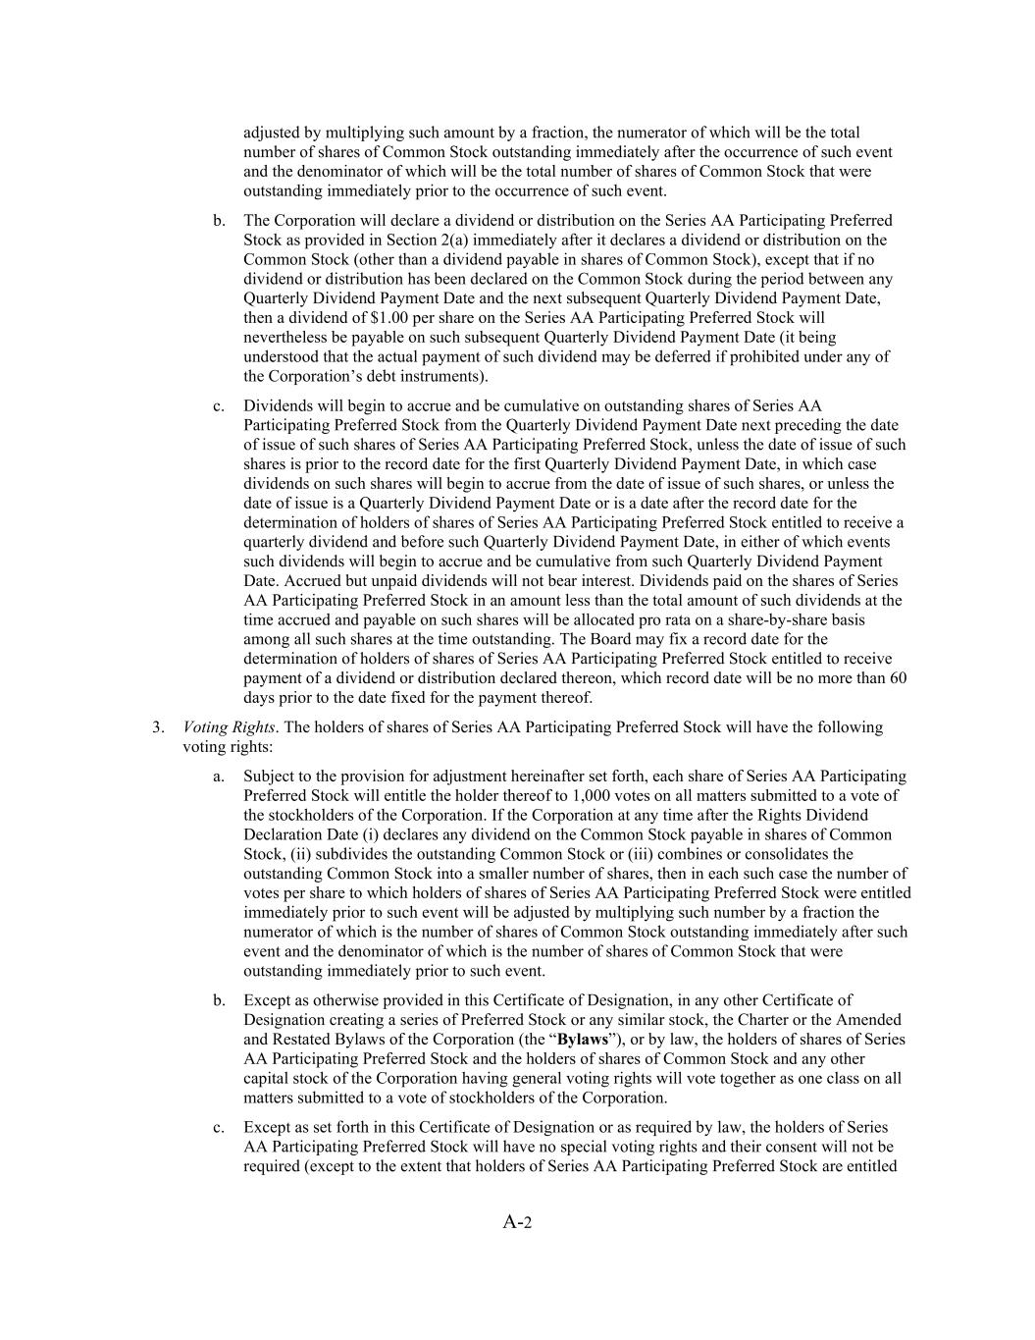
A-2 adjusted by multiplying such amount by a fraction, the numerator of which will be the total number of shares of Common Stock outstanding immediately after the occurrence of such event and the denominator of which will be the total number of shares of Common Stock that were outstanding immediately prior to the occurrence of such event. b. The Corporation will declare a dividend or distribution on the Series AA Participating Preferred Stock as provided in Section 2(a) immediately after it declares a dividend or distribution on the Common Stock (other than a dividend payable in shares of Common Stock), except that if no dividend or distribution has been declared on the Common Stock during the period between any Quarterly Dividend Payment Date and the next subsequent Quarterly Dividend Payment Date, then a dividend of $1.00 per share on the Series AA Participating Preferred Stock will nevertheless be payable on such subsequent Quarterly Dividend Payment Date (it being understood that the actual payment of such dividend may be deferred if prohibited under any of the Corporation’s debt instruments). c. Dividends will begin to accrue and be cumulative on outstanding shares of Series AA Participating Preferred Stock from the Quarterly Dividend Payment Date next preceding the date of issue of such shares of Series AA Participating Preferred Stock, unless the date of issue of such shares is prior to the record date for the first Quarterly Dividend Payment Date, in which case dividends on such shares will begin to accrue from the date of issue of such shares, or unless the date of issue is a Quarterly Dividend Payment Date or is a date after the record date for the determination of holders of shares of Series AA Participating Preferred Stock entitled to receive a quarterly dividend and before such Quarterly Dividend Payment Date, in either of which events such dividends will begin to accrue and be cumulative from such Quarterly Dividend Payment Date. Accrued but unpaid dividends will not bear interest. Dividends paid on the shares of Series AA Participating Preferred Stock in an amount less than the total amount of such dividends at the time accrued and payable on such shares will be allocated pro rata on a share-by-share basis among all such shares at the time outstanding. The Board may fix a record date for the determination of holders of shares of Series AA Participating Preferred Stock entitled to receive payment of a dividend or distribution declared thereon, which record date will be no more than 60 days prior to the date fixed for the payment thereof. 3. Voting Rights. The holders of shares of Series AA Participating Preferred Stock will have the following voting rights: a. Subject to the provision for adjustment hereinafter set forth, each share of Series AA Participating Preferred Stock will entitle the holder thereof to 1,000 votes on all matters submitted to a vote of the stockholders of the Corporation. If the Corporation at any time after the Rights Dividend Declaration Date (i) declares any dividend on the Common Stock payable in shares of Common Stock, (ii) subdivides the outstanding Common Stock or (iii) combines or consolidates the outstanding Common Stock into a smaller number of shares, then in each such case the number of votes per share to which holders of shares of Series AA Participating Preferred Stock were entitled immediately prior to such event will be adjusted by multiplying such number by a fraction the numerator of which is the number of shares of Common Stock outstanding immediately after such event and the denominator of which is the number of shares of Common Stock that were outstanding immediately prior to such event. b. Except as otherwise provided in this Certificate of Designation, in any other Certificate of Designation creating a series of Preferred Stock or any similar stock, the Charter or the Amended and Restated Bylaws of the Corporation (the “Bylaws”), or by law, the holders of shares of Series AA Participating Preferred Stock and the holders of shares of Common Stock and any other capital stock of the Corporation having general voting rights will vote together as one class on all matters submitted to a vote of stockholders of the Corporation. c. Except as set forth in this Certificate of Designation or as required by law, the holders of Series AA Participating Preferred Stock will have no special voting rights and their consent will not be required (except to the extent that holders of Series AA Participating Preferred Stock are entitled

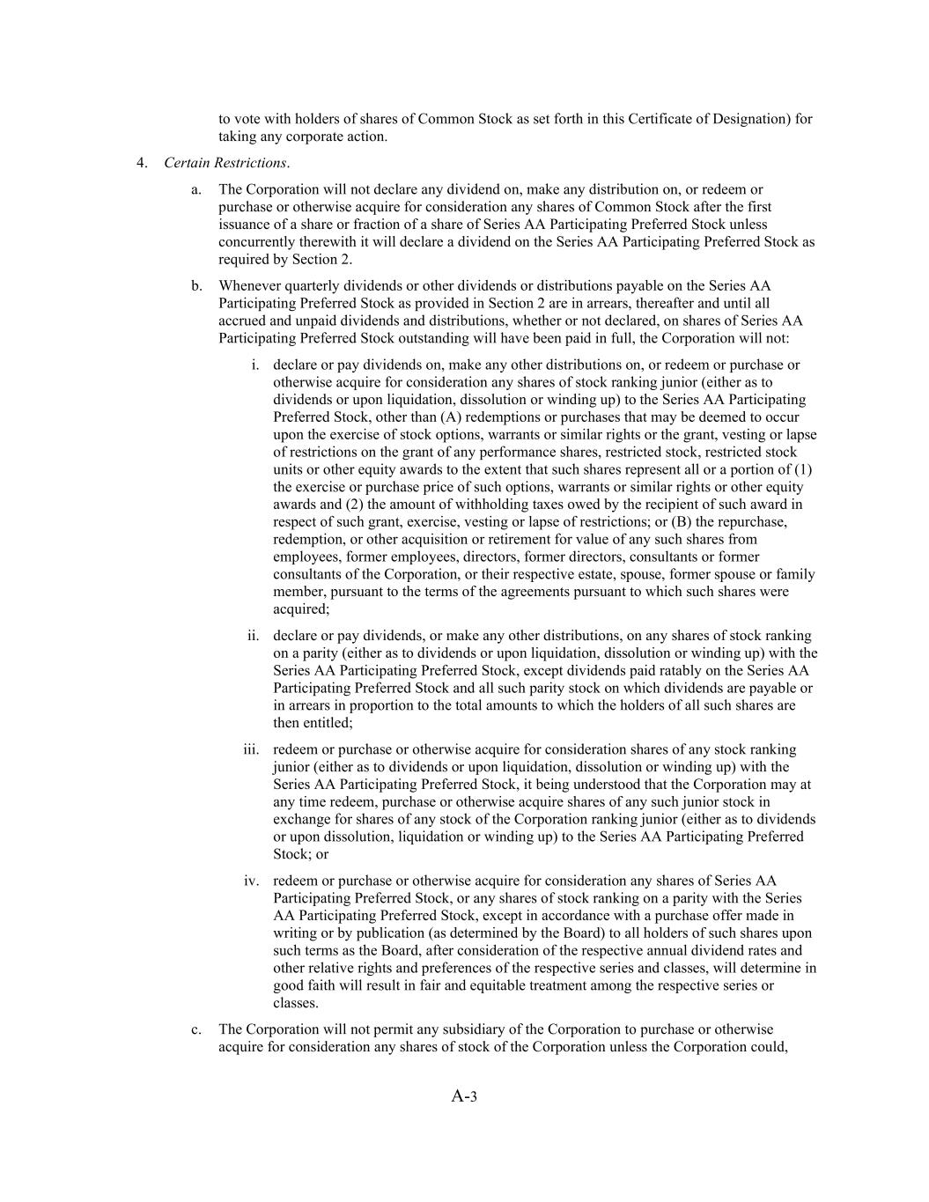
A-3 to vote with holders of shares of Common Stock as set forth in this Certificate of Designation) for taking any corporate action. 4. Certain Restrictions. a. The Corporation will not declare any dividend on, make any distribution on, or redeem or purchase or otherwise acquire for consideration any shares of Common Stock after the first issuance of a share or fraction of a share of Series AA Participating Preferred Stock unless concurrently therewith it will declare a dividend on the Series AA Participating Preferred Stock as required by Section 2. b. Whenever quarterly dividends or other dividends or distributions payable on the Series AA Participating Preferred Stock as provided in Section 2 are in arrears, thereafter and until all accrued and unpaid dividends and distributions, whether or not declared, on shares of Series AA Participating Preferred Stock outstanding will have been paid in full, the Corporation will not: i. declare or pay dividends on, make any other distributions on, or redeem or purchase or otherwise acquire for consideration any shares of stock ranking junior (either as to dividends or upon liquidation, dissolution or winding up) to the Series AA Participating Preferred Stock, other than (A) redemptions or purchases that may be deemed to occur upon the exercise of stock options, warrants or similar rights or the grant, vesting or lapse of restrictions on the grant of any performance shares, restricted stock, restricted stock units or other equity awards to the extent that such shares represent all or a portion of (1) the exercise or purchase price of such options, warrants or similar rights or other equity awards and (2) the amount of withholding taxes owed by the recipient of such award in respect of such grant, exercise, vesting or lapse of restrictions; or (B) the repurchase, redemption, or other acquisition or retirement for value of any such shares from employees, former employees, directors, former directors, consultants or former consultants of the Corporation, or their respective estate, spouse, former spouse or family member, pursuant to the terms of the agreements pursuant to which such shares were acquired; ii. declare or pay dividends, or make any other distributions, on any shares of stock ranking on a parity (either as to dividends or upon liquidation, dissolution or winding up) with the Series AA Participating Preferred Stock, except dividends paid ratably on the Series AA Participating Preferred Stock and all such parity stock on which dividends are payable or in arrears in proportion to the total amounts to which the holders of all such shares are then entitled; iii. redeem or purchase or otherwise acquire for consideration shares of any stock ranking junior (either as to dividends or upon liquidation, dissolution or winding up) with the Series AA Participating Preferred Stock, it being understood that the Corporation may at any time redeem, purchase or otherwise acquire shares of any such junior stock in exchange for shares of any stock of the Corporation ranking junior (either as to dividends or upon dissolution, liquidation or winding up) to the Series AA Participating Preferred Stock; or iv. redeem or purchase or otherwise acquire for consideration any shares of Series AA Participating Preferred Stock, or any shares of stock ranking on a parity with the Series AA Participating Preferred Stock, except in accordance with a purchase offer made in writing or by publication (as determined by the Board) to all holders of such shares upon such terms as the Board, after consideration of the respective annual dividend rates and other relative rights and preferences of the respective series and classes, will determine in good faith will result in fair and equitable treatment among the respective series or classes. c. The Corporation will not permit any subsidiary of the Corporation to purchase or otherwise acquire for consideration any shares of stock of the Corporation unless the Corporation could,

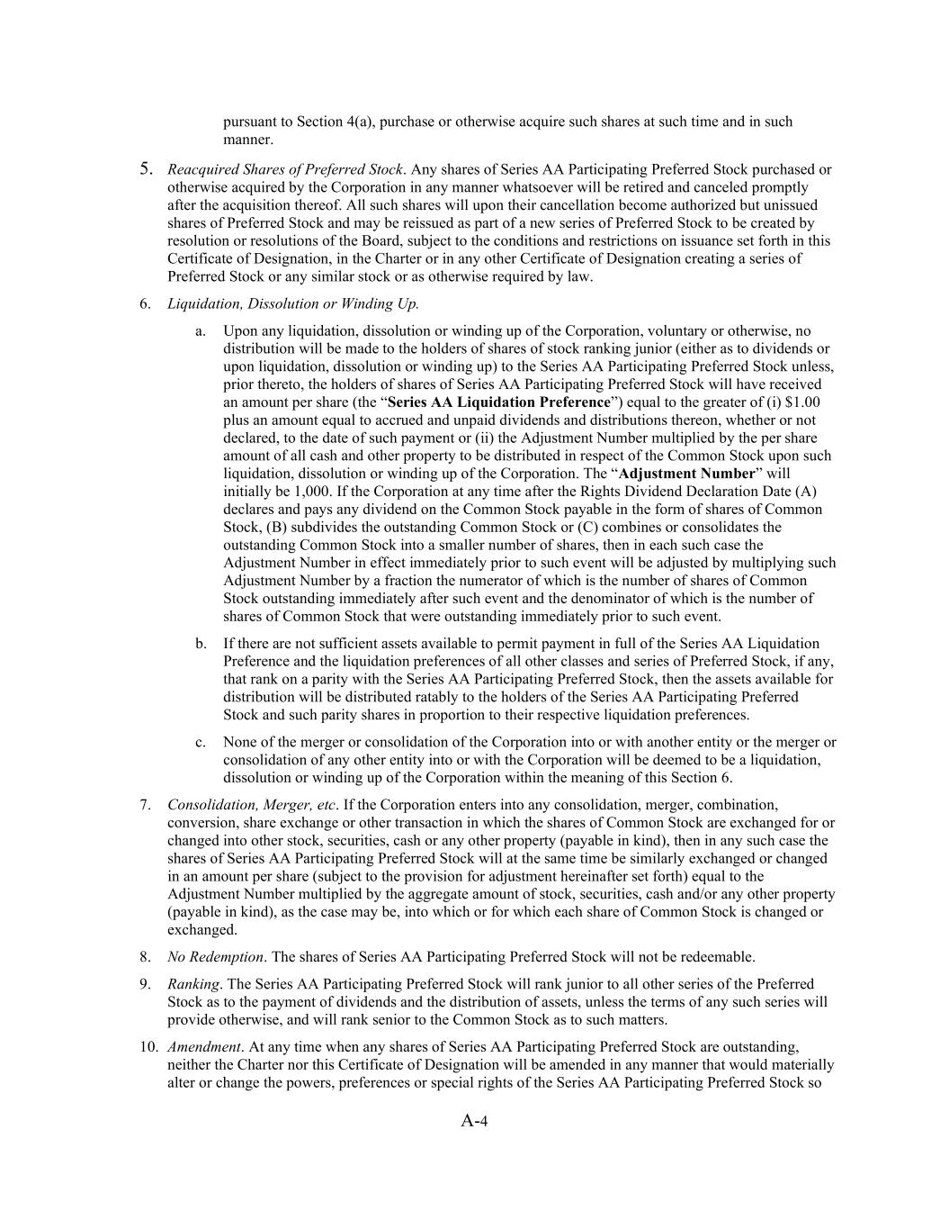
A-4 pursuant to Section 4(a), purchase or otherwise acquire such shares at such time and in such manner. 5. Reacquired Shares of Preferred Stock. Any shares of Series AA Participating Preferred Stock purchased or otherwise acquired by the Corporation in any manner whatsoever will be retired and canceled promptly after the acquisition thereof. All such shares will upon their cancellation become authorized but unissued shares of Preferred Stock and may be reissued as part of a new series of Preferred Stock to be created by resolution or resolutions of the Board, subject to the conditions and restrictions on issuance set forth in this Certificate of Designation, in the Charter or in any other Certificate of Designation creating a series of Preferred Stock or any similar stock or as otherwise required by law. 6. Liquidation, Dissolution or Winding Up. a. Upon any liquidation, dissolution or winding up of the Corporation, voluntary or otherwise, no distribution will be made to the holders of shares of stock ranking junior (either as to dividends or upon liquidation, dissolution or winding up) to the Series AA Participating Preferred Stock unless, prior thereto, the holders of shares of Series AA Participating Preferred Stock will have received an amount per share (the “Series AA Liquidation Preference”) equal to the greater of (i) $1.00 plus an amount equal to accrued and unpaid dividends and distributions thereon, whether or not declared, to the date of such payment or (ii) the Adjustment Number multiplied by the per share amount of all cash and other property to be distributed in respect of the Common Stock upon such liquidation, dissolution or winding up of the Corporation. The “Adjustment Number” will initially be 1,000. If the Corporation at any time after the Rights Dividend Declaration Date (A) declares and pays any dividend on the Common Stock payable in the form of shares of Common Stock, (B) subdivides the outstanding Common Stock or (C) combines or consolidates the outstanding Common Stock into a smaller number of shares, then in each such case the Adjustment Number in effect immediately prior to such event will be adjusted by multiplying such Adjustment Number by a fraction the numerator of which is the number of shares of Common Stock outstanding immediately after such event and the denominator of which is the number of shares of Common Stock that were outstanding immediately prior to such event. b. If there are not sufficient assets available to permit payment in full of the Series AA Liquidation Preference and the liquidation preferences of all other classes and series of Preferred Stock, if any, that rank on a parity with the Series AA Participating Preferred Stock, then the assets available for distribution will be distributed ratably to the holders of the Series AA Participating Preferred Stock and such parity shares in proportion to their respective liquidation preferences. c. None of the merger or consolidation of the Corporation into or with another entity or the merger or consolidation of any other entity into or with the Corporation will be deemed to be a liquidation, dissolution or winding up of the Corporation within the meaning of this Section 6. 7. Consolidation, Merger, etc. If the Corporation enters into any consolidation, merger, combination, conversion, share exchange or other transaction in which the shares of Common Stock are exchanged for or changed into other stock, securities, cash or any other property (payable in kind), then in any such case the shares of Series AA Participating Preferred Stock will at the same time be similarly exchanged or changed in an amount per share (subject to the provision for adjustment hereinafter set forth) equal to the Adjustment Number multiplied by the aggregate amount of stock, securities, cash and/or any other property (payable in kind), as the case may be, into which or for which each share of Common Stock is changed or exchanged. 8. No Redemption. The shares of Series AA Participating Preferred Stock will not be redeemable. 9. Ranking. The Series AA Participating Preferred Stock will rank junior to all other series of the Preferred Stock as to the payment of dividends and the distribution of assets, unless the terms of any such series will provide otherwise, and will rank senior to the Common Stock as to such matters. 10. Amendment. At any time when any shares of Series AA Participating Preferred Stock are outstanding, neither the Charter nor this Certificate of Designation will be amended in any manner that would materially alter or change the powers, preferences or special rights of the Series AA Participating Preferred Stock so


A-5 as to affect them adversely without the affirmative vote of the holders of at least two-thirds of the outstanding shares of Series AA Participating Preferred Stock, voting separately as a class. 11. Fractional Shares of Preferred Stock. Series AA Participating Preferred Stock may be issued in fractions of a share that will entitle the holder, in proportion to such holder’s fractional shares, to exercise voting rights, receive dividends, participate in distributions and to have the benefit of all other rights of holders of Series AA Participating Preferred Stock. * * *


A-6 IN WITNESS WHEREOF, the undersigned has executed this Certificate as of the 12th day of June, 2026. HF FOODS GROUP INC. By: Name: Felix Lin Title: President and Chief Executive Officer


Exhibit B Form of Rights Certificate

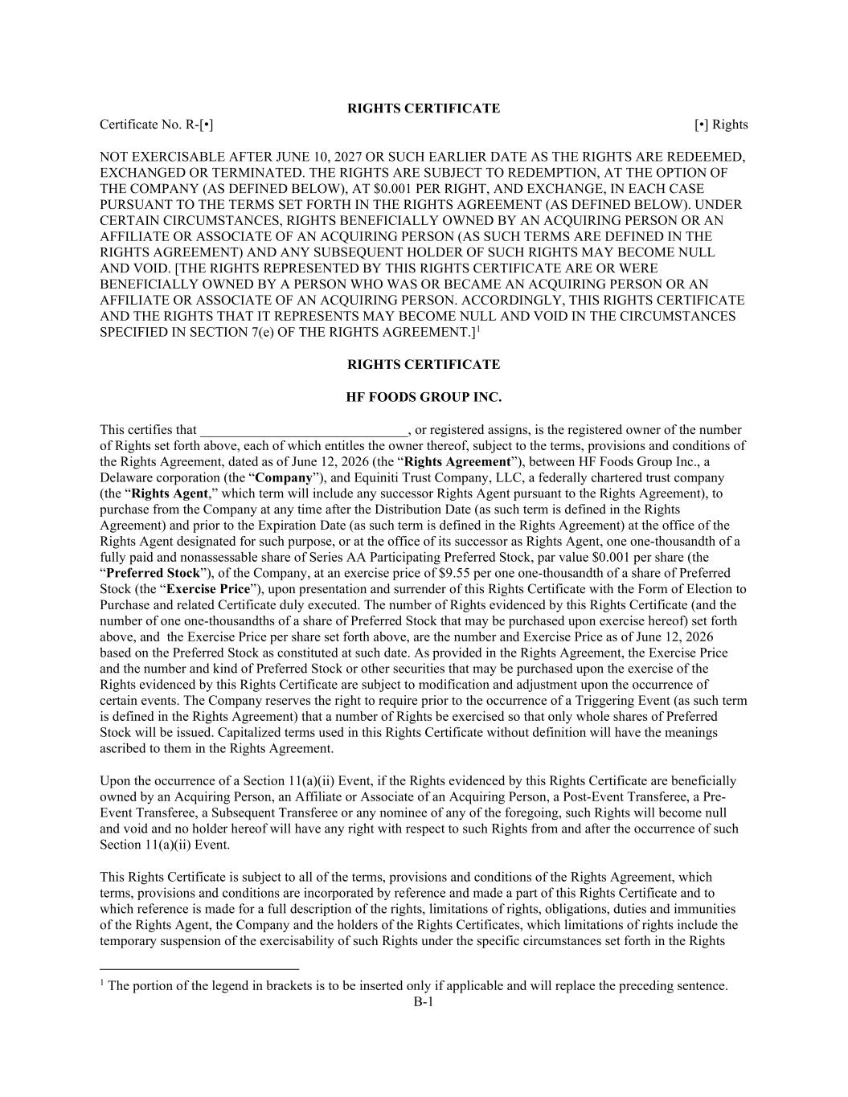
B-1 RIGHTS CERTIFICATE Certificate No. R-[•] [•] Rights NOT EXERCISABLE AFTER JUNE 10, 2027 OR SUCH EARLIER DATE AS THE RIGHTS ARE REDEEMED, EXCHANGED OR TERMINATED. THE RIGHTS ARE SUBJECT TO REDEMPTION, AT THE OPTION OF THE COMPANY (AS DEFINED BELOW), AT $0.001 PER RIGHT, AND EXCHANGE, IN EACH CASE PURSUANT TO THE TERMS SET FORTH IN THE RIGHTS AGREEMENT (AS DEFINED BELOW). UNDER CERTAIN CIRCUMSTANCES, RIGHTS BENEFICIALLY OWNED BY AN ACQUIRING PERSON OR AN AFFILIATE OR ASSOCIATE OF AN ACQUIRING PERSON (AS SUCH TERMS ARE DEFINED IN THE RIGHTS AGREEMENT) AND ANY SUBSEQUENT HOLDER OF SUCH RIGHTS MAY BECOME NULL AND VOID. [THE RIGHTS REPRESENTED BY THIS RIGHTS CERTIFICATE ARE OR WERE BENEFICIALLY OWNED BY A PERSON WHO WAS OR BECAME AN ACQUIRING PERSON OR AN AFFILIATE OR ASSOCIATE OF AN ACQUIRING PERSON. ACCORDINGLY, THIS RIGHTS CERTIFICATE AND THE RIGHTS THAT IT REPRESENTS MAY BECOME NULL AND VOID IN THE CIRCUMSTANCES SPECIFIED IN SECTION 7(e) OF THE RIGHTS AGREEMENT.]1 RIGHTS CERTIFICATE HF FOODS GROUP INC. This certifies that ______________________________, or registered assigns, is the registered owner of the number of Rights set forth above, each of which entitles the owner thereof, subject to the terms, provisions and conditions of the Rights Agreement, dated as of June 12, 2026 (the “Rights Agreement”), between HF Foods Group Inc., a Delaware corporation (the “Company”), and Equiniti Trust Company, LLC, a federally chartered trust company (the “Rights Agent,” which term will include any successor Rights Agent pursuant to the Rights Agreement), to purchase from the Company at any time after the Distribution Date (as such term is defined in the Rights Agreement) and prior to the Expiration Date (as such term is defined in the Rights Agreement) at the office of the Rights Agent designated for such purpose, or at the office of its successor as Rights Agent, one one-thousandth of a fully paid and nonassessable share of Series AA Participating Preferred Stock, par value $0.001 per share (the “Preferred Stock”), of the Company, at an exercise price of $9.55 per one one-thousandth of a share of Preferred Stock (the “Exercise Price”), upon presentation and surrender of this Rights Certificate with the Form of Election to Purchase and related Certificate duly executed. The number of Rights evidenced by this Rights Certificate (and the number of one one-thousandths of a share of Preferred Stock that may be purchased upon exercise hereof) set forth above, and the Exercise Price per share set forth above, are the number and Exercise Price as of June 12, 2026 based on the Preferred Stock as constituted at such date. As provided in the Rights Agreement, the Exercise Price and the number and kind of Preferred Stock or other securities that may be purchased upon the exercise of the Rights evidenced by this Rights Certificate are subject to modification and adjustment upon the occurrence of certain events. The Company reserves the right to require prior to the occurrence of a Triggering Event (as such term is defined in the Rights Agreement) that a number of Rights be exercised so that only whole shares of Preferred Stock will be issued. Capitalized terms used in this Rights Certificate without definition will have the meanings ascribed to them in the Rights Agreement. Upon the occurrence of a Section 11(a)(ii) Event, if the Rights evidenced by this Rights Certificate are beneficially owned by an Acquiring Person, an Affiliate or Associate of an Acquiring Person, a Post-Event Transferee, a Pre- Event Transferee, a Subsequent Transferee or any nominee of any of the foregoing, such Rights will become null and void and no holder hereof will have any right with respect to such Rights from and after the occurrence of such Section 11(a)(ii) Event. This Rights Certificate is subject to all of the terms, provisions and conditions of the Rights Agreement, which terms, provisions and conditions are incorporated by reference and made a part of this Rights Certificate and to which reference is made for a full description of the rights, limitations of rights, obligations, duties and immunities of the Rights Agent, the Company and the holders of the Rights Certificates, which limitations of rights include the temporary suspension of the exercisability of such Rights under the specific circumstances set forth in the Rights 1 The portion of the legend in brackets is to be inserted only if applicable and will replace the preceding sentence.

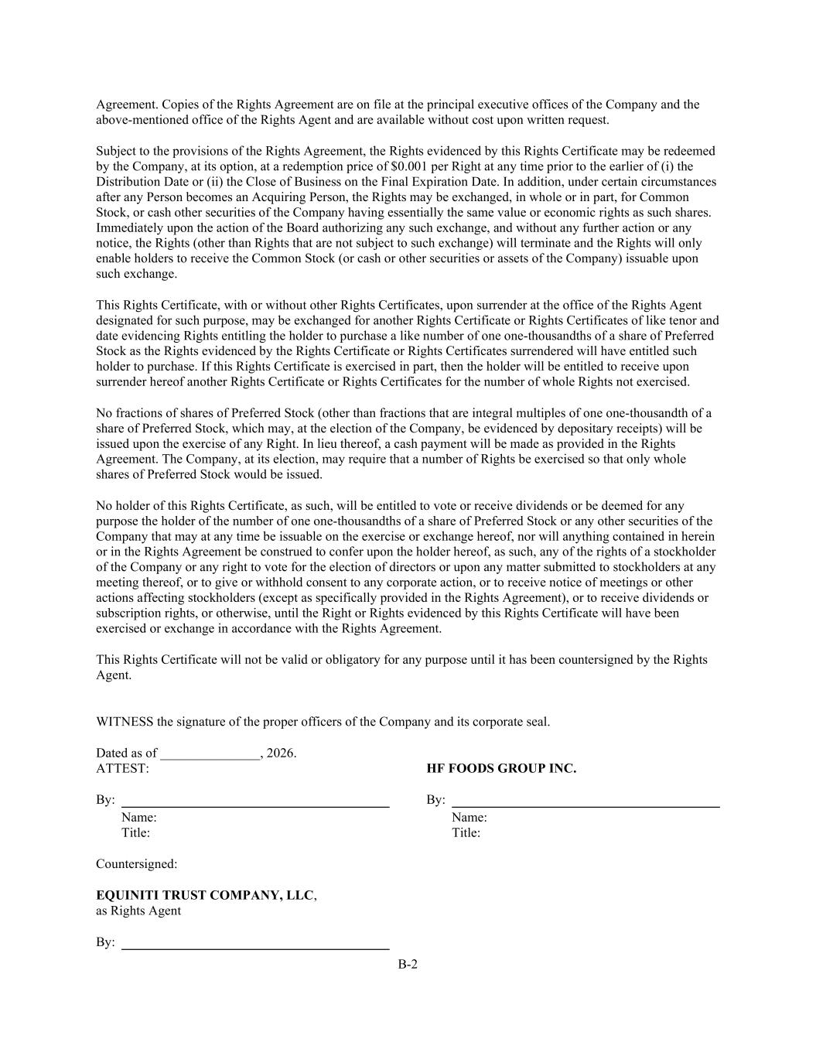
B-2 Agreement. Copies of the Rights Agreement are on file at the principal executive offices of the Company and the above-mentioned office of the Rights Agent and are available without cost upon written request. Subject to the provisions of the Rights Agreement, the Rights evidenced by this Rights Certificate may be redeemed by the Company, at its option, at a redemption price of $0.001 per Right at any time prior to the earlier of (i) the Distribution Date or (ii) the Close of Business on the Final Expiration Date. In addition, under certain circumstances after any Person becomes an Acquiring Person, the Rights may be exchanged, in whole or in part, for Common Stock, or cash other securities of the Company having essentially the same value or economic rights as such shares. Immediately upon the action of the Board authorizing any such exchange, and without any further action or any notice, the Rights (other than Rights that are not subject to such exchange) will terminate and the Rights will only enable holders to receive the Common Stock (or cash or other securities or assets of the Company) issuable upon such exchange. This Rights Certificate, with or without other Rights Certificates, upon surrender at the office of the Rights Agent designated for such purpose, may be exchanged for another Rights Certificate or Rights Certificates of like tenor and date evidencing Rights entitling the holder to purchase a like number of one one-thousandths of a share of Preferred Stock as the Rights evidenced by the Rights Certificate or Rights Certificates surrendered will have entitled such holder to purchase. If this Rights Certificate is exercised in part, then the holder will be entitled to receive upon surrender hereof another Rights Certificate or Rights Certificates for the number of whole Rights not exercised. No fractions of shares of Preferred Stock (other than fractions that are integral multiples of one one-thousandth of a share of Preferred Stock, which may, at the election of the Company, be evidenced by depositary receipts) will be issued upon the exercise of any Right. In lieu thereof, a cash payment will be made as provided in the Rights Agreement. The Company, at its election, may require that a number of Rights be exercised so that only whole shares of Preferred Stock would be issued. No holder of this Rights Certificate, as such, will be entitled to vote or receive dividends or be deemed for any purpose the holder of the number of one one-thousandths of a share of Preferred Stock or any other securities of the Company that may at any time be issuable on the exercise or exchange hereof, nor will anything contained in herein or in the Rights Agreement be construed to confer upon the holder hereof, as such, any of the rights of a stockholder of the Company or any right to vote for the election of directors or upon any matter submitted to stockholders at any meeting thereof, or to give or withhold consent to any corporate action, or to receive notice of meetings or other actions affecting stockholders (except as specifically provided in the Rights Agreement), or to receive dividends or subscription rights, or otherwise, until the Right or Rights evidenced by this Rights Certificate will have been exercised or exchange in accordance with the Rights Agreement. This Rights Certificate will not be valid or obligatory for any purpose until it has been countersigned by the Rights Agent. WITNESS the signature of the proper officers of the Company and its corporate seal. Dated as of _______________, 2026. ATTEST: HF FOODS GROUP INC. By: By: Name: Name: Title: Title: Countersigned: EQUINITI TRUST COMPANY, LLC, as Rights Agent By:


B-3 Name: Title:


B-4 [Form of Reverse Side of Rights Certificate] FORM OF ASSIGNMENT (To be executed by the registered holder if such holder desires to transfer the Rights Certificate.) FOR VALUE RECEIVED _____________________ sells, assigns and transfers unto (Please print name and address of transferee) this Rights Certificate, together with all right, title and interest therein, and irrevocably constitutes and appoints ______________________________ as attorney-in-fact to transfer this Rights Certificate on the books of the Company, with full power of substitution. Dated: ____________________ Signature Signature Medallion Guaranteed: Signatures must be guaranteed by a member or participant in the Medallion Signature Guarantee Program at a guarantee level acceptable to the Company’s transfer agent. Guarantees by a notary public are not acceptable. CERTIFICATE The undersigned certifies, for the benefit of the Company and all holders of Rights and Common Stock, by checking the appropriate boxes that: (1) the Right(s) evidenced by this Rights Certificate are not Beneficially Owned and ☐ are ☐ are not being sold, assigned and transferred by or on behalf of a Person who is or was an Acquiring Person, an Affiliate or Associate of an Acquiring Person, a Post-Event Transferee, a Pre-Event Transferee, a Subsequent Transferee or any nominee of any of the foregoing; and (2) after due inquiry and to the best knowledge of the undersigned, it ☐ did ☐ did not acquire the Rights evidenced by this Rights Certificate from any Person who is, was or subsequently became an Acquiring Person, an Affiliate or Associate of an Acquiring Person, a Post-Event Transferee, a Pre-Event Transferee, a Subsequent Transferee or any nominee of any of the foregoing. Dated: ____________________. Signature Signature Medallion Guaranteed: Signatures must be guaranteed by a member or participant in the Medallion Signature Guarantee Program at a guarantee level acceptable to the Company’s transfer agent. Guarantees by a notary public are not acceptable.

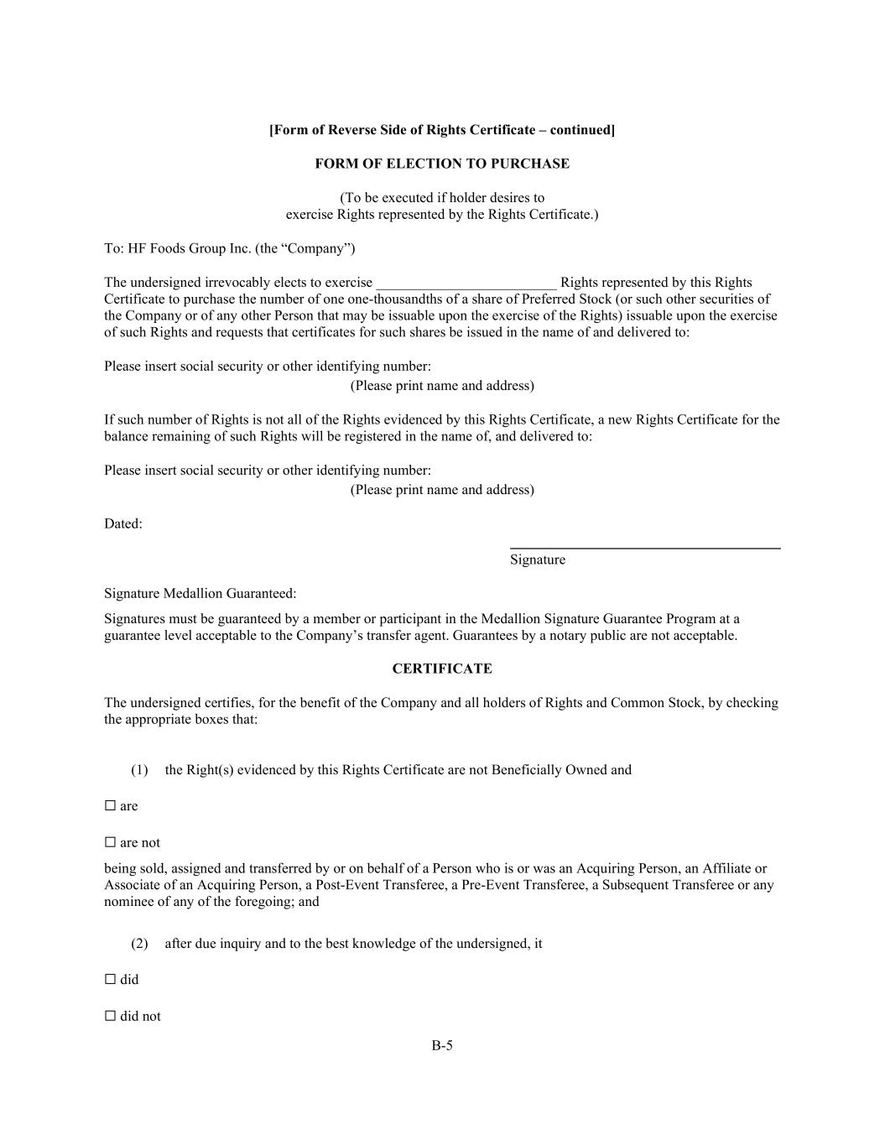
B-5 [Form of Reverse Side of Rights Certificate – continued] FORM OF ELECTION TO PURCHASE (To be executed if holder desires to exercise Rights represented by the Rights Certificate.) To: HF Foods Group Inc. (the “Company”) The undersigned irrevocably elects to exercise _________________________ Rights represented by this Rights Certificate to purchase the number of one one-thousandths of a share of Preferred Stock (or such other securities of the Company or of any other Person that may be issuable upon the exercise of the Rights) issuable upon the exercise of such Rights and requests that certificates for such shares be issued in the name of and delivered to: Please insert social security or other identifying number: (Please print name and address) If such number of Rights is not all of the Rights evidenced by this Rights Certificate, a new Rights Certificate for the balance remaining of such Rights will be registered in the name of, and delivered to: Please insert social security or other identifying number: (Please print name and address) Dated: Signature Signature Medallion Guaranteed: Signatures must be guaranteed by a member or participant in the Medallion Signature Guarantee Program at a guarantee level acceptable to the Company’s transfer agent. Guarantees by a notary public are not acceptable. CERTIFICATE The undersigned certifies, for the benefit of the Company and all holders of Rights and Common Stock, by checking the appropriate boxes that: (1) the Right(s) evidenced by this Rights Certificate are not Beneficially Owned and ☐ are ☐ are not being sold, assigned and transferred by or on behalf of a Person who is or was an Acquiring Person, an Affiliate or Associate of an Acquiring Person, a Post-Event Transferee, a Pre-Event Transferee, a Subsequent Transferee or any nominee of any of the foregoing; and (2) after due inquiry and to the best knowledge of the undersigned, it ☐ did ☐ did not


B-6 acquire the Rights evidenced by this Rights Certificate from any Person who is, was or subsequently became an Acquiring Person, an Affiliate or Associate of an Acquiring Person, a Post-Event Transferee, a Pre-Event Transferee, a Subsequent Transferee or any nominee of any of the foregoing. Dated: . Signature Signature Medallion Guaranteed: Signatures must be guaranteed by a member or participant in the Medallion Signature Guarantee Program at a guarantee level acceptable to the Company’s transfer agent. Guarantees by a notary public are not acceptable. [Form of Reverse Side of Rights Certificate – continued] NOTICE The signature in the foregoing Forms of Assignment and Election to Purchase, as the case may be, must conform to the name as written upon the face of this Rights Certificate in every particular, without alteration or enlargement or any change whatsoever. IF THE CERTIFICATIONS SET FORTH IN THE FOREGOING FORMS OF ASSIGNMENT AND ELECTION TO PURCHASE, AS THE CASE MAY BE, ARE NOT COMPLETED, THEN THE COMPANY AND THE RIGHTS AGENT WILL DEEM THE BENEFICIAL OWNER OF THE RIGHTS EVIDENCED BY THIS RIGHT CERTIFICATE TO BE AN ACQUIRING PERSON, AN AFFILIATE OR ASSOCIATE OF AN ACQUIRING PERSON, A POST-EVENT TRANSFEREE, A PRE-EVENT TRANSFEREE, A SUBSEQUENT TRANSFEREE OR ANY NOMINEE OF ANY OF THE FOREGOING, AS THE CASE MAY BE, AND SUCH ASSIGNMENT OR ELECTION TO PURCHASE WILL NOT BE HONORED AND THE RIGHTS EVIDENCED BY THIS RIGHTS CERTIFICATE WILL BE DEEMED TO BE NULL AND VOID.


Exhibit C Form of Summary of Rights

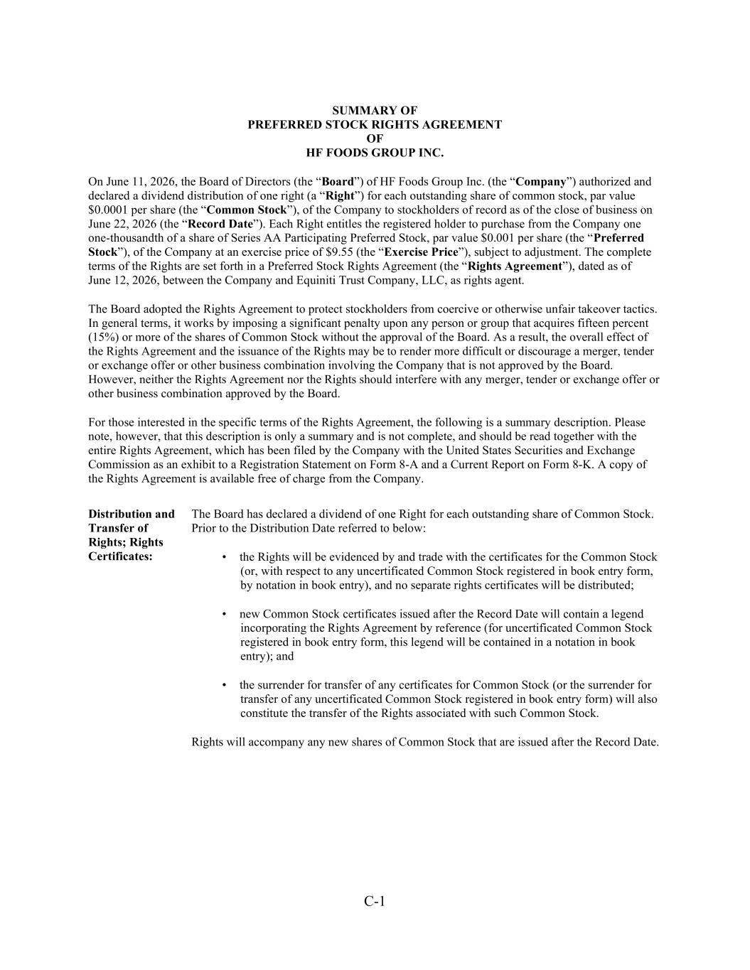
C-1 SUMMARY OF PREFERRED STOCK RIGHTS AGREEMENT OF HF FOODS GROUP INC. On June 11, 2026, the Board of Directors (the “Board”) of HF Foods Group Inc. (the “Company”) authorized and declared a dividend distribution of one right (a “Right”) for each outstanding share of common stock, par value $0.0001 per share (the “Common Stock”), of the Company to stockholders of record as of the close of business on June 22, 2026 (the “Record Date”). Each Right entitles the registered holder to purchase from the Company one one-thousandth of a share of Series AA Participating Preferred Stock, par value $0.001 per share (the “Preferred Stock”), of the Company at an exercise price of $9.55 (the “Exercise Price”), subject to adjustment. The complete terms of the Rights are set forth in a Preferred Stock Rights Agreement (the “Rights Agreement”), dated as of June 12, 2026, between the Company and Equiniti Trust Company, LLC, as rights agent. The Board adopted the Rights Agreement to protect stockholders from coercive or otherwise unfair takeover tactics. In general terms, it works by imposing a significant penalty upon any person or group that acquires fifteen percent (15%) or more of the shares of Common Stock without the approval of the Board. As a result, the overall effect of the Rights Agreement and the issuance of the Rights may be to render more difficult or discourage a merger, tender or exchange offer or other business combination involving the Company that is not approved by the Board. However, neither the Rights Agreement nor the Rights should interfere with any merger, tender or exchange offer or other business combination approved by the Board. For those interested in the specific terms of the Rights Agreement, the following is a summary description. Please note, however, that this description is only a summary and is not complete, and should be read together with the entire Rights Agreement, which has been filed by the Company with the United States Securities and Exchange Commission as an exhibit to a Registration Statement on Form 8-A and a Current Report on Form 8-K. A copy of the Rights Agreement is available free of charge from the Company. Distribution and Transfer of Rights; Rights Certificates: The Board has declared a dividend of one Right for each outstanding share of Common Stock. Prior to the Distribution Date referred to below: • the Rights will be evidenced by and trade with the certificates for the Common Stock (or, with respect to any uncertificated Common Stock registered in book entry form, by notation in book entry), and no separate rights certificates will be distributed; • new Common Stock certificates issued after the Record Date will contain a legend incorporating the Rights Agreement by reference (for uncertificated Common Stock registered in book entry form, this legend will be contained in a notation in book entry); and • the surrender for transfer of any certificates for Common Stock (or the surrender for transfer of any uncertificated Common Stock registered in book entry form) will also constitute the transfer of the Rights associated with such Common Stock. Rights will accompany any new shares of Common Stock that are issued after the Record Date.

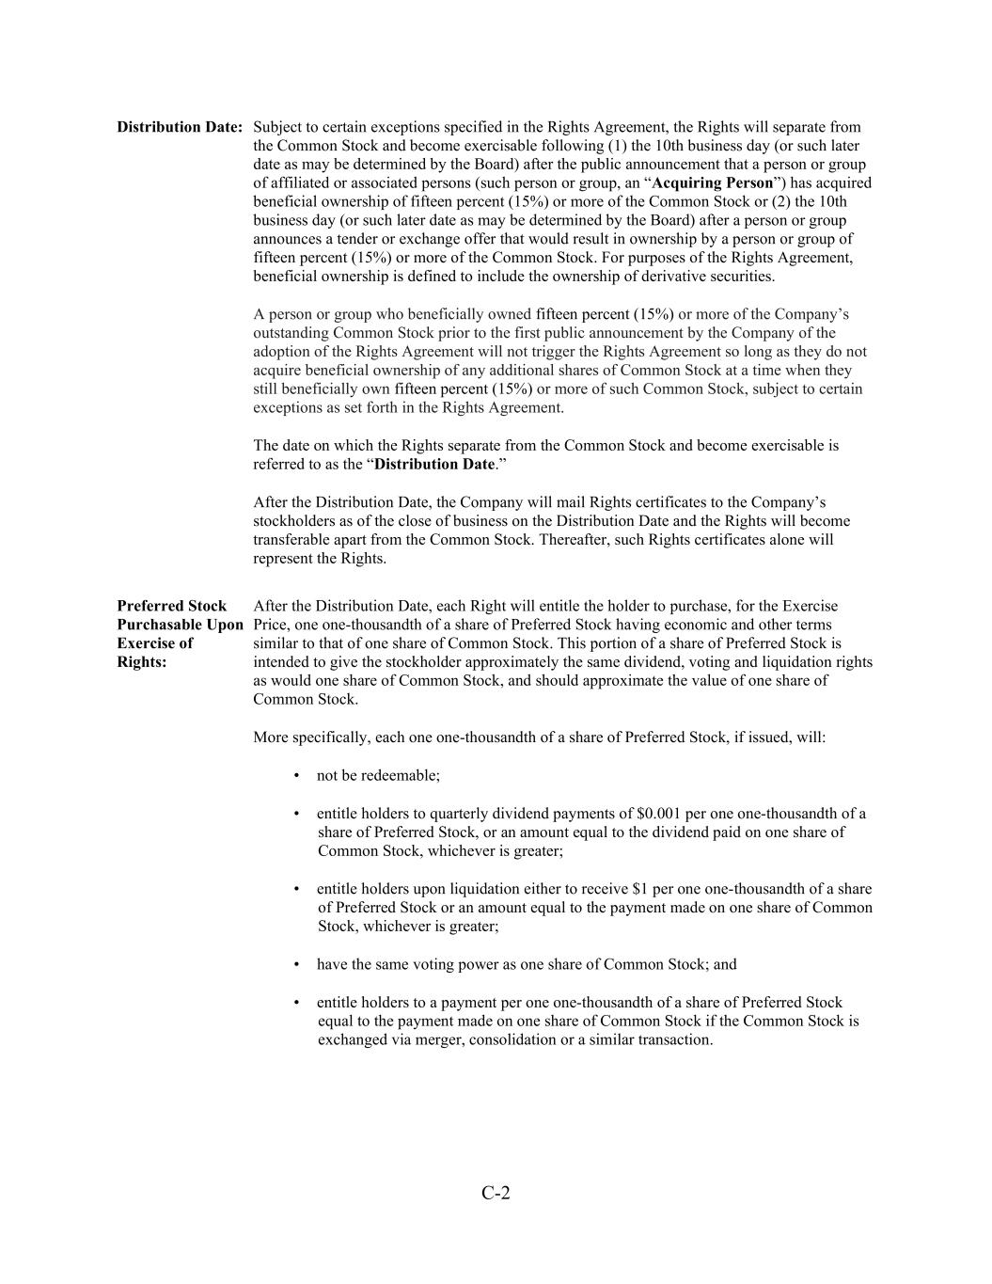
C-2 Distribution Date: Subject to certain exceptions specified in the Rights Agreement, the Rights will separate from the Common Stock and become exercisable following (1) the 10th business day (or such later date as may be determined by the Board) after the public announcement that a person or group of affiliated or associated persons (such person or group, an “Acquiring Person”) has acquired beneficial ownership of fifteen percent (15%) or more of the Common Stock or (2) the 10th business day (or such later date as may be determined by the Board) after a person or group announces a tender or exchange offer that would result in ownership by a person or group of fifteen percent (15%) or more of the Common Stock. For purposes of the Rights Agreement, beneficial ownership is defined to include the ownership of derivative securities. A person or group who beneficially owned fifteen percent (15%) or more of the Company’s outstanding Common Stock prior to the first public announcement by the Company of the adoption of the Rights Agreement will not trigger the Rights Agreement so long as they do not acquire beneficial ownership of any additional shares of Common Stock at a time when they still beneficially own fifteen percent (15%) or more of such Common Stock, subject to certain exceptions as set forth in the Rights Agreement. The date on which the Rights separate from the Common Stock and become exercisable is referred to as the “Distribution Date.” After the Distribution Date, the Company will mail Rights certificates to the Company’s stockholders as of the close of business on the Distribution Date and the Rights will become transferable apart from the Common Stock. Thereafter, such Rights certificates alone will represent the Rights. Preferred Stock Purchasable Upon Exercise of Rights: After the Distribution Date, each Right will entitle the holder to purchase, for the Exercise Price, one one-thousandth of a share of Preferred Stock having economic and other terms similar to that of one share of Common Stock. This portion of a share of Preferred Stock is intended to give the stockholder approximately the same dividend, voting and liquidation rights as would one share of Common Stock, and should approximate the value of one share of Common Stock. More specifically, each one one-thousandth of a share of Preferred Stock, if issued, will: • not be redeemable; • entitle holders to quarterly dividend payments of $0.001 per one one-thousandth of a share of Preferred Stock, or an amount equal to the dividend paid on one share of Common Stock, whichever is greater; • entitle holders upon liquidation either to receive $1 per one one-thousandth of a share of Preferred Stock or an amount equal to the payment made on one share of Common Stock, whichever is greater; • have the same voting power as one share of Common Stock; and • entitle holders to a payment per one one-thousandth of a share of Preferred Stock equal to the payment made on one share of Common Stock if the Common Stock is exchanged via merger, consolidation or a similar transaction.

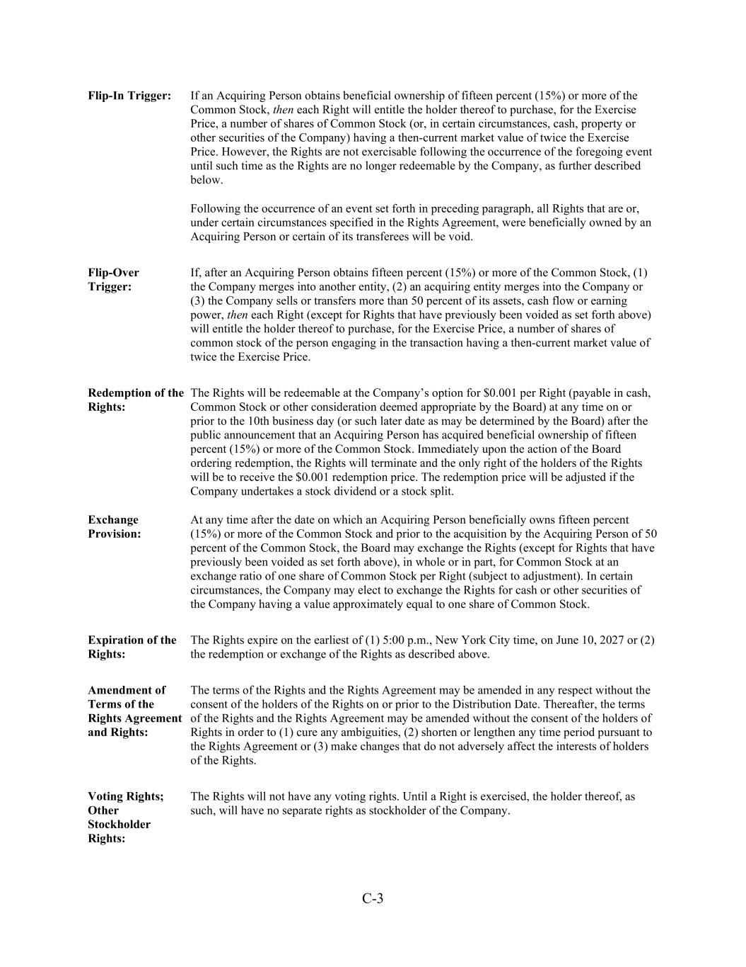
C-3 Flip-In Trigger: If an Acquiring Person obtains beneficial ownership of fifteen percent (15%) or more of the Common Stock, then each Right will entitle the holder thereof to purchase, for the Exercise Price, a number of shares of Common Stock (or, in certain circumstances, cash, property or other securities of the Company) having a then-current market value of twice the Exercise Price. However, the Rights are not exercisable following the occurrence of the foregoing event until such time as the Rights are no longer redeemable by the Company, as further described below. Following the occurrence of an event set forth in preceding paragraph, all Rights that are or, under certain circumstances specified in the Rights Agreement, were beneficially owned by an Acquiring Person or certain of its transferees will be void. Flip-Over Trigger: If, after an Acquiring Person obtains fifteen percent (15%) or more of the Common Stock, (1) the Company merges into another entity, (2) an acquiring entity merges into the Company or (3) the Company sells or transfers more than 50 percent of its assets, cash flow or earning power, then each Right (except for Rights that have previously been voided as set forth above) will entitle the holder thereof to purchase, for the Exercise Price, a number of shares of common stock of the person engaging in the transaction having a then-current market value of twice the Exercise Price. Redemption of the Rights: The Rights will be redeemable at the Company’s option for $0.001 per Right (payable in cash, Common Stock or other consideration deemed appropriate by the Board) at any time on or prior to the 10th business day (or such later date as may be determined by the Board) after the public announcement that an Acquiring Person has acquired beneficial ownership of fifteen percent (15%) or more of the Common Stock. Immediately upon the action of the Board ordering redemption, the Rights will terminate and the only right of the holders of the Rights will be to receive the $0.001 redemption price. The redemption price will be adjusted if the Company undertakes a stock dividend or a stock split. Exchange Provision: At any time after the date on which an Acquiring Person beneficially owns fifteen percent (15%) or more of the Common Stock and prior to the acquisition by the Acquiring Person of 50 percent of the Common Stock, the Board may exchange the Rights (except for Rights that have previously been voided as set forth above), in whole or in part, for Common Stock at an exchange ratio of one share of Common Stock per Right (subject to adjustment). In certain circumstances, the Company may elect to exchange the Rights for cash or other securities of the Company having a value approximately equal to one share of Common Stock. Expiration of the Rights: The Rights expire on the earliest of (1) 5:00 p.m., New York City time, on June 10, 2027 or (2) the redemption or exchange of the Rights as described above. Amendment of Terms of the Rights Agreement and Rights: The terms of the Rights and the Rights Agreement may be amended in any respect without the consent of the holders of the Rights on or prior to the Distribution Date. Thereafter, the terms of the Rights and the Rights Agreement may be amended without the consent of the holders of Rights in order to (1) cure any ambiguities, (2) shorten or lengthen any time period pursuant to the Rights Agreement or (3) make changes that do not adversely affect the interests of holders of the Rights. Voting Rights; Other Stockholder Rights: The Rights will not have any voting rights. Until a Right is exercised, the holder thereof, as such, will have no separate rights as stockholder of the Company.


C-4 Anti-Dilution Provisions: The Board may adjust the Exercise Price, the number of shares of Preferred Stock issuable and the number of outstanding Rights to prevent dilution that may occur from a stock dividend, a stock split or a reclassification of the Preferred Stock or Common Stock. With certain exceptions, no adjustments to the Exercise Price will be made until the cumulative adjustments amount to at least one percent of the Exercise Price. No fractional shares of Preferred Stock will be issued and, in lieu thereof, an adjustment in cash will be made based on the current market price of the Preferred Stock. Taxes: The distribution of Rights should not be taxable for federal income tax purposes. However, following an event that renders the Rights exercisable or upon redemption of the Rights, stockholders may recognize taxable income.

